Flexural stresses

# Lecture Goals

* Basic Concepts
* Rectangular Beams
* Non-uniform beams
* Balanced Beams

# Flexural Stress

**Example**

Consider a simple rectangular beam( b x h ) reinforced with steel reinforcement of As.

1. Determine the centroid ( neutral axis, NA ) and moment of inertia Izz of the beam for an ideal beam (no cracks).
2. Determine the NA and moment of inertia, Izz, of beam if the beam is cracked and tensile forces are in the steel only.

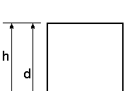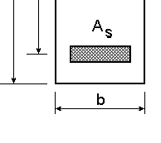

Ec – Modulus of Elasticity - concrete

Es – Modulus of Elasticity - steel As – Area of steel

d – distance to steel

b – width

h – height

*n*  s

Ec

E

*y*  

Ai

*I* 



*I* 

*i*





*y*  *y*

*i*



2

*A*

*i*

Moment of Inertia

yi Ai

Centroid (NA)

|  |  |  |  |  |  |  |
| --- | --- | --- | --- | --- | --- | --- |
|  | Area | yi | yiA | I | yi - y | (yi -y)2 A |
| Concrete | bh | h/2 | bh2/2 | bh3/12 | (h/2-y) | (h/2-y)bd |
| Steel | (n-1)As | d | d(n-1)As | --- | (d-y) | (d-y)2(n-1)As |

2

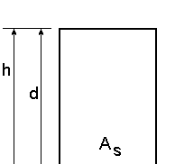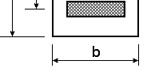

**Example (uncracked)**

*y* 

y A

*bh*

Ai

i i



2

 *n* 1 *A d*

s

*bh*  *n* 1 *A*s

*I*   *Ii*

  *yi*

− *y* 2 *A*

 *bh*3

12

 *h* 2

 2 *y* 



−

*bh*  *d*

− *y* 2 *n* 1 *A*

 

*i*

s

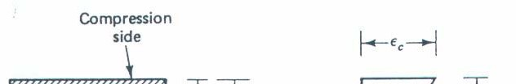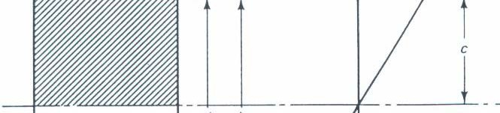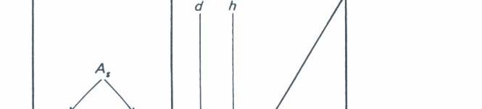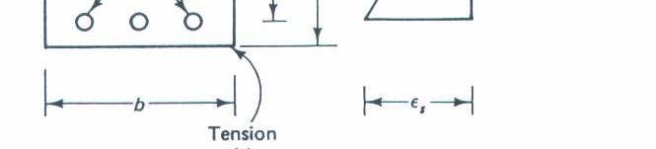

For a cracked section the concrete is in compression and steel is in tension.

The strain in the beam is linear.

*C*  *yb* 1 *f*

2 c

*T*  *A*s *f*s

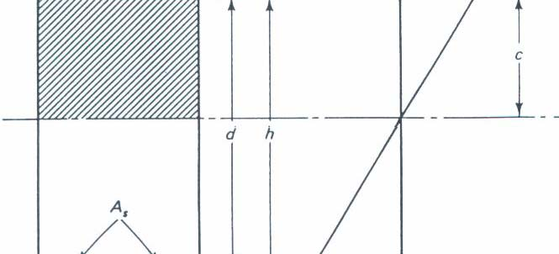

Using Equilibrium

*T*  *C*

*A f*  *yb* 1 *f*

s s

2

c

*f*   *yb*  *f*

s

 2 *A* 



s 

c

Using Hooke’s law  *f*

 *E*

## E



 

*yb*



## E

 

c 



*E*s



2 *A*s  

2*nA*s

However, this is an indeterminate problem to

s s



 2 *A* 

s 

c c



s



 *E*  *yb* 

c 



*yb*

find *y* . We will need to use a compatibility

condition.

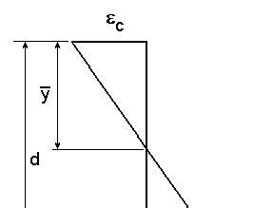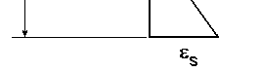

Using a compatibility

condition.

s

d  *y*

 c

*y*

⇒ c

s



*y*

d  *y*

Substitute into the first equation.

Substitute in for the strain relationship.

*y*  2*nA*s

*d y yb*

Rearrange the equation into a quadratic equation.

*y* 

2





2*nA*

s



*b*











2*nA*

s



*b*







*d*  0

*y* 

# Example (cracked

Use a ratio of areas of concrete and steel.

❒  *A*s

*bd*

*y* 2  2*n**d y*  2*n**d* 2  0

Modify the equation to create a non-dimensional ratio.

2

 *y* 

 *d*   2*n*  *d*   2*n*  0

 *y* 









# Example - (cracked)

Use the quadratic formula

2*n* 

2*n* 2  8*n*



 *d*  





 *y*  

 *d* 





2

*n* 2  2*n*  *n*

*y* 

Solve for the centroid by multiplying the result by d.

# Example (cracked

The moment of inertia using the parallel axis

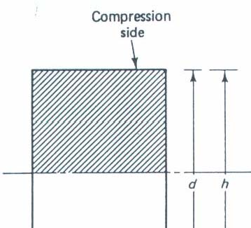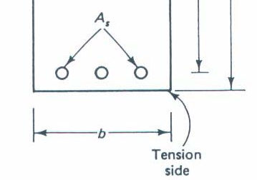



*I* 

*i*





*y*  *y*

*i*



2

*A*

*i*



*by* 3

12

 

*I* 

 2 



*by*  *d*



−

2

*y*



*nA*

s

 *by*

3

3

 *d*  *y* 2 *nA*

s

 *y* 2

For the following example find centroid and moment of inertia for an uncracked and cracked section and compare the results.

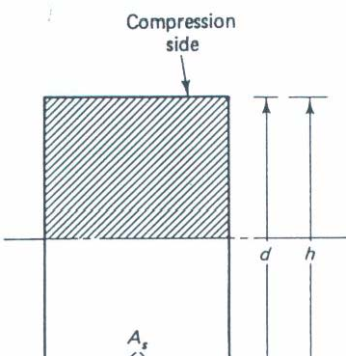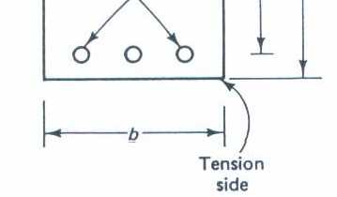

Es = 29000 ksi Ec = 3625 ksi

d = 15.5 in b = 12 in. h = 18 in. Use 4 # 7 bars for the steel.

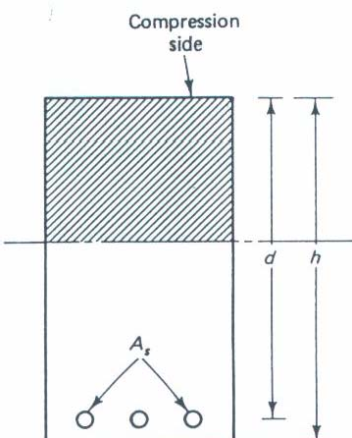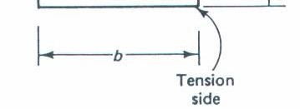

*n*  Es

Ec

 29000 ksi  8

3625 ksi

A #7 bar has an As = 0.6 in2

*A*  4 0.6 in2

s

 2.4 in2

The uncracked centroid is

*bh*2

*y*  2

 *n* 1

*A*s *d*

*bh*  *n* 1 *A*s

12 in18 in2

 8 12.4 in2 15.5 in

2



12 in18 in  8 12.4 in2 

 2204.4 in3

232.8 in2

 9.47 in

The uncracked moment of inertia

*I* 

*bh*3

12

 

 *h*

2

 2

− *y*





*bh*  *d*  *y*



2

 

*n* 1 *A*



s

12 in18 in3

 18 in 2

 12   2

− 9.47 in 

12 in18 in

 

15.5 in

− 9.47 in2 8 12.4 in2 

 6491 in4

The cracked centroid is defined by:

0.0129

❒  *A* 

s

2.4 in2 

 *y* 

 *d* 

*bd* 12 in15.5 in

− *n*

*n* 2  2*n*



 

80.01292  2 80.0129



 0.3627

*y*  0.3627 15.5 in

 5.62 in

− 80.0129

The cracked moment of inertia is

*I* 

*by* 3

3

 *d*  *y*



2



*nA*

s

 1 12 in5.62 in3 3

15.5 in  5.62 in2

82.4 in2 

 2584.2 in4

 *A f*

 *d* 

*a* 