**كلية العلوم**

**قسم الفيزياء الطبية**

MedicalPhysics

**Lecture: ( 3 ) Practical part**

**Subject: Application of Inverse Square Law in MRI**

|  |
| --- |
|  |

|  |  |
| --- | --- |
|  |  |

**3dr Stage الي كدامي مو طلاب..... صُناع مستقبل بلد**

**Lecturer: 1..By..Afrah Hussein & NoorAlhuda Ahmed**

**First: Inverse Square Law**

**Introduction**

---

**MRI (Magnetic Resonance Imaging) machine** relies on complex techniques to generate strong magnetic fields to capture detailed images of the inside of the body. Although the fundamental principle governing the device is the interaction of magnetic fields and radiofrequency signals with body tissues,

the **Inverse Square Law** plays an important role in understanding the distribution of magnetic force around the machine and its main magnetic field.

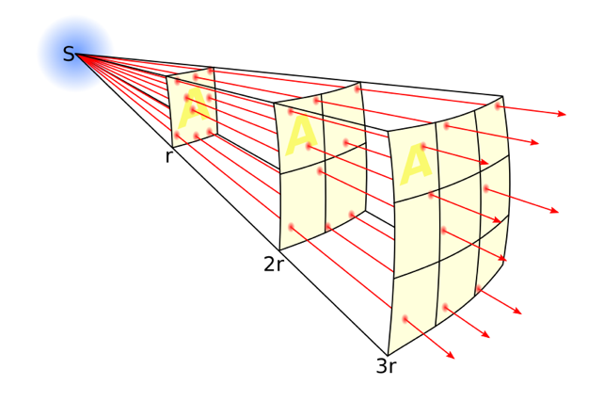The **Inverse Square Law** is a physical principle that states that a certain force, whether gravitational, electrical, or magnetic, decreases in proportion to the square of the distance from its source. In the case of magnetism, the effect of the magnetic field decreases significantly as we move away from its source (the magnet). In 1785, the inverse square law became part of the foundation of physics.

**Magnetic Field in an MRI Machine:**

The MRI machine generates a very strong magnetic field, typically between **1.5 - 3 Tesla or higher.** This magnetic field is produced by a very strong magnet.

**Safe Magnetic Field Strength Limits:**

1. **For Patients:**

   - MRI machines used in hospitals usually operate with magnetic fields between **1.5 Tesla and 3 Tesla.**

 - Research indicates that short-term exposure to fields

up to **4 Tesla** is safe for most patients, as long as the procedure is supervised medically.

  - **Fields above 4 Tesla** are used only in special cases (such as research) and may require special approval.

  - At intensities **above 8 Tesla,** exposure poses higher health risks,

2. **For Workers in the Area:**

   - According to the **International Commission on Non-Ionizing Radiation Protection (ICNIRP),** the maximum recommended exposure for workers over the long term is **0.2 Tesla.**

   - Workers can be exposed to higher intensities for short periods, but it is preferable that the exposure does not exceed **1 Tesla** in the area surrounding the MRI machine.

# **Potential Risks of Exposure to High Magnetic Field Strength:**

1. **Tissue Heating:** Exposure to strong magnetic fields can cause localized tissue heating.

2. **Neurological Effects:** Strong magnetic fields may cause adverse neurological effects, such as nausea, dizziness, and may lead to harmful neurological effects.

## **Magnetic Inverse Square Law:**

The law states that the magnetic field strength decreases inversely with the square of the distance (r) from the field source (such as the strong magnet in the MRI machine)

Where

:

$Mr=\frac{M_{O}}{r^{2}}$

**Mr** is the magnetic field strength at a distance from the field source

$M_{o}$ is the magnetic field strength at a reference distance very close to the source (e.g., at the center of the machine).

$r^{2}$ is a distance from the magnetic field source

#### **Calculation Steps:**

1. **Determine the distance (r).**

2. **Determine the magnetic field strength at the center \( ).**

3. **Calculate the magnetic field strength at a specific distance using the equation.**

|  |  |  |
| --- | --- | --- |
| Mo | r | $$Mr=\frac{M_{O}}{r^{2}}$$ |
| 0.2 | 10m |  |
| 1.5 | 20cm |  |
| 1.5 | 30cm |  |
| 1.5 | 40cm |  |
| 1.5 | 50cm |  |

**Second: Possible Alternatives**

1. **X-ray:**

   Primarily used for imaging bones but may not be sufficient for soft tissue imaging. It is fast, convenient, and affordable but does not offer the detailed views that MRI provides.

2. **Computed Tomography (CT Scan):**

   A good alternative for imaging solid structures and providing detailed anatomy of organs. It uses X-rays to create 3D images and can be used when MRI is not suitable, but it does expose the patient to radiation.

3. **Ultrasound:**

   Often used for imaging internal organs such as the heart, liver, and kidneys, as well as for pregnancy scans. It is entirely safe and radiation-free but may not be suitable for deep organs or bony structures.

4. **Nuclear Medicine Imaging:**

   Radioactive materials are used to capture body images, such as in PET or SPECT scans. These techniques are useful for imaging specific areas like the brain, heart, or cancer, and provide functional information about organs.

5. **Positron Emission Tomography (PET Scan):**

   Provides information about biochemical processes in the body and can be used to diagnose cancer or assess brain activity.

6. **Interventional Radiology:**

   Allows certain examinations using less complex imaging techniques with minimal invasion, such as catheter-based procedures or angiography.