* 1. **Introduction**

Power electronics (PE): A field of Electrical Engineering that deals with the application of power semiconductor devices for the control and conversion of electric power.

Power electronics systems can operate in the range from few watts up to GW, with frequency range from 50 Hz up to more than 100 kHz, depending on the power handled and the requirements.

**The goals of Power Electronics:**

* + - To process and control the flow of electrical power by supplying voltages and currents in a form that is optimally suited for user loads.
    - To convert electrical energy from one form to another with highest efficiency, availability and reliability, with the lowest cost, smallest size, and weight.

As shown in Figure 1.1, power electronics represents a median point at which the topics of energy systems, electronics, and control converge. Any useful circuit design for the control of power must address issues of both devices and control, as well as of the energy itself. Among the unique aspects of power electronics are its emphasis on large semiconductor devices, the application of magnetic devices for energy storage.

The development of semiconductor switches manufacturing regarding their very high ratings and their ability in high frequency systems are the basic keys in the development of power electronics engineering.

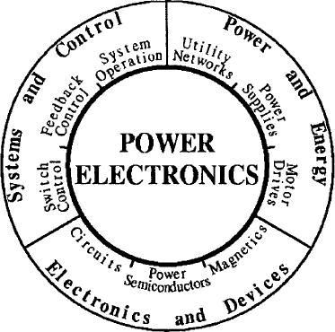

Figure 1.1: Control, energy, and power electronics are interrelated.

A basic power electronic system is shown in Figure 1.2. It consists of an energy source, an electrical load, a power electronic circuit, and control circuit. The function of the power electronic positioned at the middle is that of controlling energy flow between the energy load and the electrical load. The power electronic circuit contains high power switches, lossless energy storage elements, and magnetic transformers. The control circuit take information from the source, load, and designer and then determine how the switches operate to achieve the desired conversion. The control circuit is usually built up with conventional low-power analog and digital electronics.

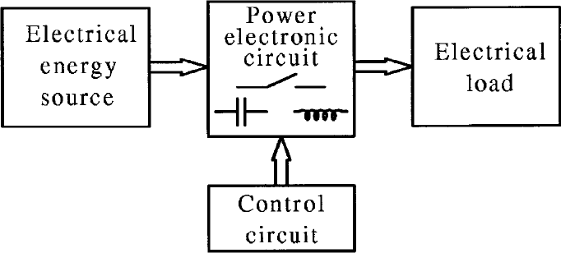

Figure 1.2: A basic power electronic system.

**Classification of power electronics**



The power electronics can be classified as:

1. AC to DC Converters (Rectifiers).

Applications: Battery chargers, High voltage dc (HVDC) transmission line.

1. DC to DC Converters (Choppers).

Applications: space-satellite power system, Robots, DC motor control.

1. DC to AC Converters (Inverters).

Applications: Photovoltaic cell, UPS (uninterruptible power supplies).

1. AC to AC Converters (Ac Power Controllers).

Applications: Fun regulator, Lighting system for theatres.

* 1. **Power Semiconductor Switching Devices**

At first, a power semiconductor switching device is either ON or OFF. An ideal switch, when ON, will carry the current without any voltage drop across the switch. When OFF, no current will pass through it. It is entirely lossless and changes from its ON state to its OFF state instantaneously. Those aspects of real switches that differ from the ideal include the following:

* Limits on the direction of on-state current.
* A nonzero on-state voltage drop (such as a diode forward voltage).
* Some level of leakage current when the device is supposed to be off.
* Limitations on the voltage that can be applied when off.
* Operating speed. The time of transition between the on and off states is significant (Not equal to zero).

**Classifications of power semiconductor switching devices:**

**Uncontrolled switch:** The switch has no control terminal. The state of the switch is determined by the external voltage or current conditions of the circuit in which the switch is connected. A diode is an example of such switch.

**Semi-controlled switch:** In this case the circuit designer has limited control over the switch. For example, the switch can be turned-on from the control terminal. However, once ON, it cannot be turned-off from the control signal. The switch can be switched off by the operation of the circuit or by an auxiliary circuit that is added to force the switch to turn-off. A thyristor or a SCR is an example of this switch type.

**Fully controlled switch:** The switch can be turned ON and OFF via the control terminal. Examples of this switch are the BJT, the MOSFET, the IGBT, the GTO thyristor, and the MOS-controlled thyristor (MCT).