**1.3. Power Components**

There are many type of power components:

* + 1. **Power Diodes**

Among all the static switching devices used in power electronics, the power diode is perhaps the simplest. Its circuit symbol shown in Figure 1.3 (a), is a two-terminal device involves the anode terminal (**A)** and the cathode terminal (**K).**

If anode terminal is at a higher potential compared to cathode terminal, the device is said to be forward biased and a forward current will flow through the device. This causes a small voltage drop across the device (<1 V), which under ideal conditions is usually ignored.

However, when cathode terminal is at a higher potential compared to anode terminal, the diode is reverse biased. It does not conduct, and the diode then experiences a small current flowing in the reverse direction called the leakage current. This current is dependent on the reverse voltage until the breakdown voltage is reached.

After that, the diode voltage remains essentially constant while the current increases dramatically. Only the resistance of the circuit limits the maximum value of the current. Simultaneous large current and large voltage in the breakdown operation lead to excessive power dissipation that could quickly destroy the diode. Therefore, the breakdown operation of the diode must be avoided. Figure 1.3 (b) illustrates diode characteristics where breakdown voltage is shown.

Both forward voltage drop and leakage current are ignored in an ideal diode. In power electronic applications, a diode is usually considered to be an ideal static switch (Figure 1.3 (c).

(a)

(b) (c)

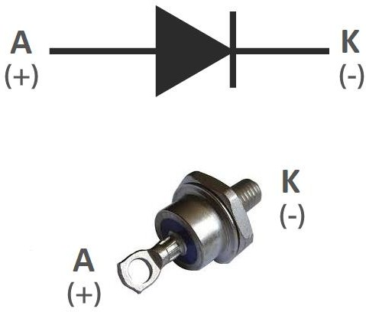

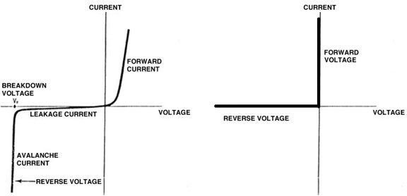

Figure 1.3: (a) Diode symbol, (b) Practical characteristics, and

(c) Ideal characteristics.

A bi-directional diode that can be triggered into conduction by reaching a specific voltage (avalanche breakdown voltage), is called a **DIAC (diode for alternating current).**

When the applied voltage across the DIAC increases above the avalanche breakdown voltage, only then it can conduct. However, when the voltage across DIAC decreases below its avalanche breakdown voltage it will be turned OFF.

The DIAC symbol is a combination of two diodes in parallel with each other but connected in opposite directions. DIACs have no gate terminal, unlike some other thyristors that they are commonly used to trigger, such as TRIACs.

* + 1. **Power Thyristors**

Thyristors known as **Silicon-controlled rectifiers (SCR)** are usually three-terminal devices. The control terminal of the thyristor, called the gate **(G)** electrode, may be connected to an integrated and complex structure as part of the device. The other two terminals, anode **(A)** and cathode **(K)**, handle the large applied potentials (often of both polarities) and conduct the major current through the thyristor. The anode and cathode terminals are connected with the load to which power is to be controlled.

Thyristors are capable of handling large blocking voltages and large currents for use in high-power applications, but their frequency capabilities are not very high, being lower than 10 kHz.

If positive voltage is applied without gate current, the thyristor constitutes the state of forward blocking. A low-power pulse of gate current switches the thyristor to the ON state. The output characteristic of a conducting thyristor in the forward bias is similar to the characteristic of the diode with a small leakage current. Thus, the thyristor assumes very low resistance in the forward direction. Once turned on.

The thyristor remains in this state after the end of the gate pulse if its current is higher than the latching value. If the current drops below the holding value, the device switches back to the non- conducting region. Switching off by gate pulse is impossible. Therefore, using the same arguments as for diodes, the thyristor can be represented by the idealized switch.

The output characteristic of SCR in the reverse bias is similar to the characteristic of the diode with a small leakage current. With negative voltage between anode and cathode, this corresponds to the reverse blocking state. If the maximum reverse voltage exceeds the permissible value, the leakage current rises rapidly, as with

diodes, leading to breakdown and thermal destruction of the thyristor. Figure 1.4 (a) and (b) illustrate the SCR symbol and its practical characteristics, respectively.

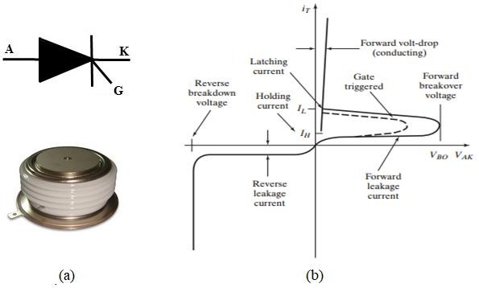

Figure 1.4: (a) SCR symbol, and (b) Practical characteristics.

**TRIAC (Triode for alternating current)**

A TRIAC (bi-directional thyristor) is a member of the thyristor family which can conduct in both directions. It is the equivalent of two reverse parallel connected thyristors with the common gate.

TRIACs differ from SCRs in that they allow current flow in both directions, whereas an SCR can only conduct current in a single direction. Most TRIACs can be triggered by applying either a positive or negative voltage to the gate (an SCR requires a

positive voltage).

As the TRIAC can conduct in both the directions, the terms “anode” and “cathode” are not used for TRIACs. The three terminals are marked as MT1 (Main Terminal 1), MT2 (Main Terminal 2) and G (Gate Terminal). Figure 1.5 (a) shows the TRIAC symbol.

The conduction of a TRIAC is initiated by injecting a current pulse into the gate terminal. The TRIAC turns off only when the current through the main terminals become zero.

To understand how TRIACs work, consider the triggering in each of the four quadrants. The four quadrants are illustrated in Figure 1.5 (b). They are depending on the gate and MT2 voltages with respect to MT1, as given below.

* **Quadrant 1** operation occurs when the gate and MT2 are positive with respect to MT1.
* **Quadrant 2** operation occurs when the gate is negative and MT2 is positive with respect to MT1.
* **Quadrant 3** operation occurs when the gate and MT2 are negative with respect to MT1.
* **Quadrant 4** operation occurs when the gate is positive and MT2 is negative with respect to MT1.

In almost all applications, both gate and MT2 positive or negative against MT1, so quadrants 1 and 3 are the only operating modes. Figure 1.5 (c) illustrates the TRIAC charecterstics.

practical 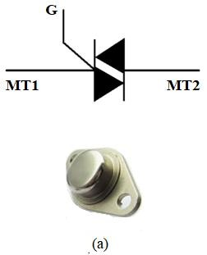

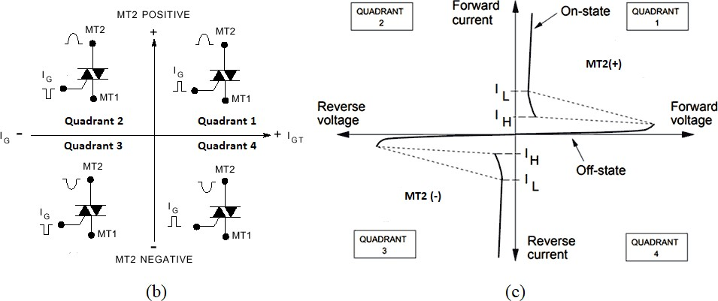

Figure 1.5: (a) TRIAC symbol, (b) Quadrant diagram, and (c) Practical characteristics.

**Gate turn-off thyristor (GTO)**

GTO is a special type of thyristor, which provides more control. As opposed to normal thyristors, GTOs are fully controllable switches which can be turned ON and OFF by switching the polarity of the gate signal.

The GTO thyristor turns ON similarly to the SCR thyristor, i.e. after a current pulse is applied to the gate terminal. To turn it OFF, a powerful negative current control pulse must be applied to the gate terminal.

Figure 1.6 (a) and (b) illustrate the GTO symbol and its practical characteristics, respectively.

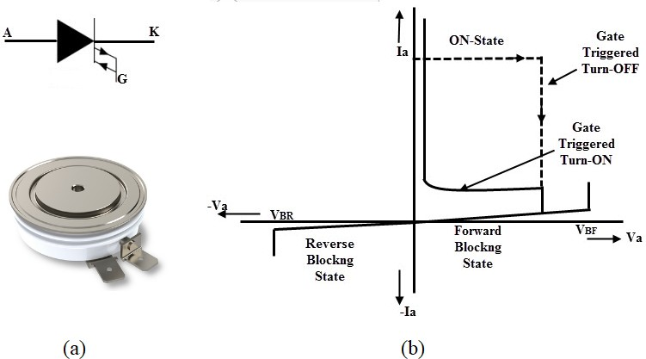

Figure 1.6: (a) GTO symbol, and (b) Practical characteristics.

**The MOS-Controlled Thyristor (MCT)**

The MCT has many of the properties of a GTO thyristor, including a low voltage drop at high current. Nevertheless, it is a voltage-controlled device. Here, turning ON is controlled by applying a positive voltage signal to the gate, and turning OFF by a negative voltage. Therefore, the MCT has two principle advantages over the GTO, including much simpler drive requirements (voltage instead of current) and faster

switching speeds (few microseconds).

* + 1. **Power Transistors**

Power transistors are three-terminal semiconductor electronic devices that can be used as switches. Transistors are turned ON when a current or voltage signal is applied to the control terminal. The transistor remains in the ON-state so long as control signal is present. When this control signal is removed, the power transistor is turned OFF. The switching speed of modern transistors is much higher than that of thyristors. In addition, the control circuit is much simpler than that used in thyristors. Power transistors are classified as follows:

**Bipolar junction transistors (BJTs)**

The power BJT has three terminals, Collector (C), Emitter (E) and Base (B), as shown in Figure 1.7 (a). BJT is a current-controlled device. The Base (B) is connected to the control signal, while the power terminals are the Collector (C) and the Emitter (E).

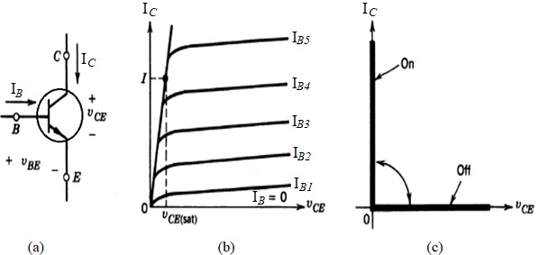The device has three regions as shown in Figure 1.7 (b). However, the only two regions that are used in power electronics are, the on-state region where VCE is less than VCE(Sat) and the off-state region where IB= 0. Neglecting the middle region, the idealized device characteristics as a switch are shown in Figure 1.7 (c).

Figure 1.7: (a) BJT symbol, (b) practical characteristics of BJT, and (c) idealized characteristics of BJT.

**Metal-oxide-semiconductor field-effect transistors (MOSFETs).**

MOSFET is a voltage-controlled device which has three terminals. The Gate (G) is connected to the control signal, while the power terminals are the Drain (D) and Source (S), as shown in Figure 1.8 (a).

Similar to BJT, the MOSFET has three regions as shown in Figure 1.8 (b). The device is controlled by supplying a voltage (VGS) between the gate and the source. To maintain the MOSFET in the off-state, VGS must be less than a threshold voltage known as VT. However, VGS must be high enough (depending on its specifications) to make the MOSFET in on-state. Neglecting the middle region, the idealized device characteristics as a switch are shown in Figure 1.8 (c).

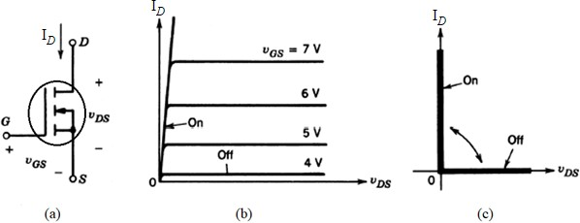Figure 1.8: (a) MOSFET symbol, (b) practical characteristics of MOSFET, and (c) idealized characteristics of MOSFET.

**Insulated gate bipolar transistors (IGBTs).**

The IGBT Transistor takes the best parts of BJT and MOSFET, the high input impedance and high switching speeds of a MOSFET with the low saturation voltage

of a bipolar transistor, and combines them together to produce another type of transistor switching device that is capable of handling large collector-emitter currents with virtually zero gate current drive.

As shown in Figure 1.9 (a), the Gate (G) is connected to the control signal, while the power terminals are the collector (C) and emitter (E). The device is controlled by applying a voltage (VGE) between the gate and the emitter. Figure 1.9 (b) and (c) illustrate the practical and idealized characteristics of the IGBT, respectively.

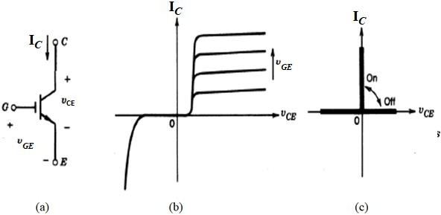

Figure 1.9: (a) IGBT symbol, (b) practical characteristics of IGBT, and

(c) idealized characteristics of IGBT.