 

Oral Histology

**Frontonasal Process and Upper Face Formation**

Lecture 4

Dr. Muna Merza

During the fourth week, the frontonasal process is a bulge of tissue in the upper facial area, at most cephalic end of embryo, which is also the cranial boundary of the stomodeum. In the future, frontonasal process will form upper face, which includes forehead, bridge of nose, primary palate, nasal septum, and all structures related to medial nasal processes

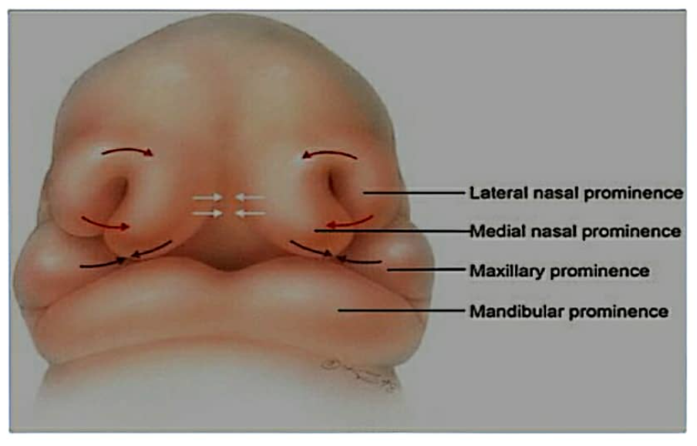

Nasal placodes become submerged, forming depression in the centre of each side from nasal (olfactory) pits, which develop into nasal cavities.

Deepening of nasal pits produces a nasal sac that grows internally toward the developing brain; separated from the stomodeum by the oronasal membrane.

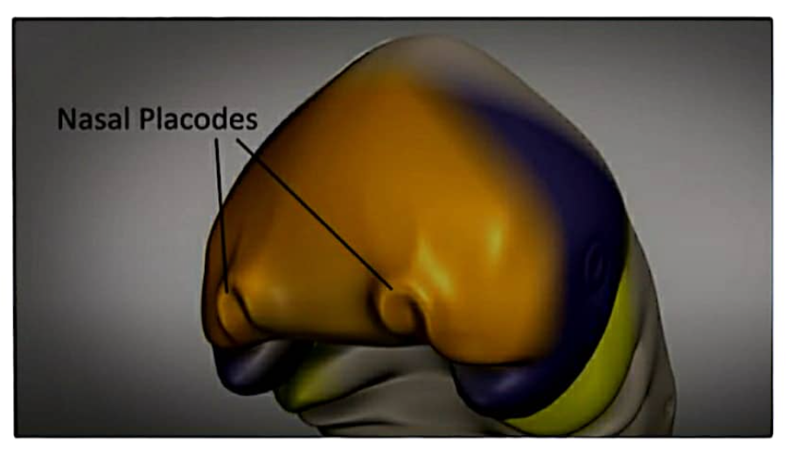

On the outer portion of nasal pits are two crescent-shaped swellings, lateral nasal processes that form the alae (sides of the nose).

Middle portion of the tissue growing around nasal placodes appears as medial nasal processes. both fuse together externally to form the middle portion of the nose from root to apex, centre portion of upper lip, philtrum region.

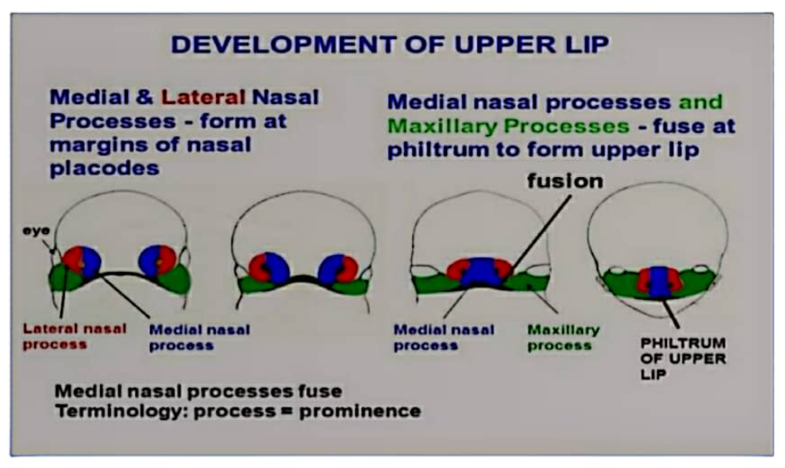

Both paired medial nasal processes also fuse internally and grow inferiorly on inside of intermaxillary (premaxillary) segment, most anterior portion stomodeum to form of the tissues and involved in formation of maxillary incisor teeth and associated tissues, primary palate, nasal septum.

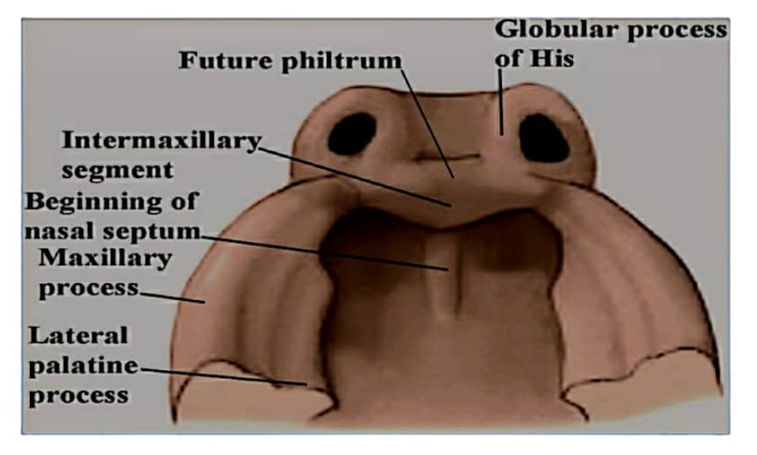

**Maxillary Process and midface Formation**

During the fourth week, adjacent swellings, the maxillary processes, form increased growth of mandibular processes that grow superiorly and anteriorly on arch.

Maxillary each side of stomodeum

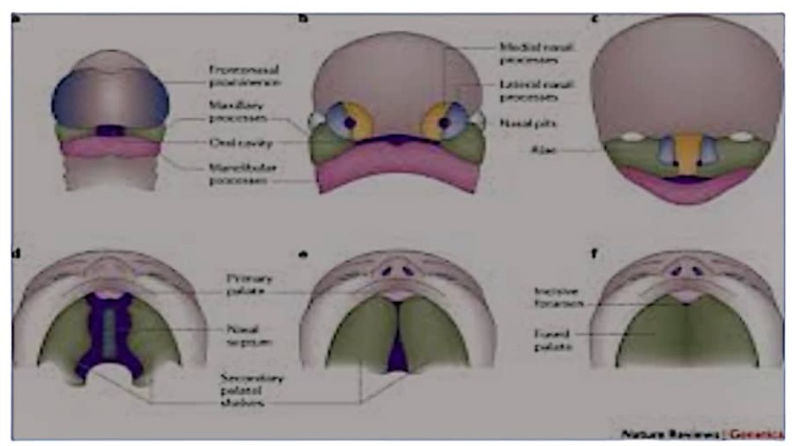

Maxillary process will form the midface includes:

1. Sides of upper lip, cheeks, secondary palate.
2. Posterior portion of maxilla, with maxillary canines and posteriors teeth and associated tissues.
3. Zygomatic bones and portions of temporal bones.

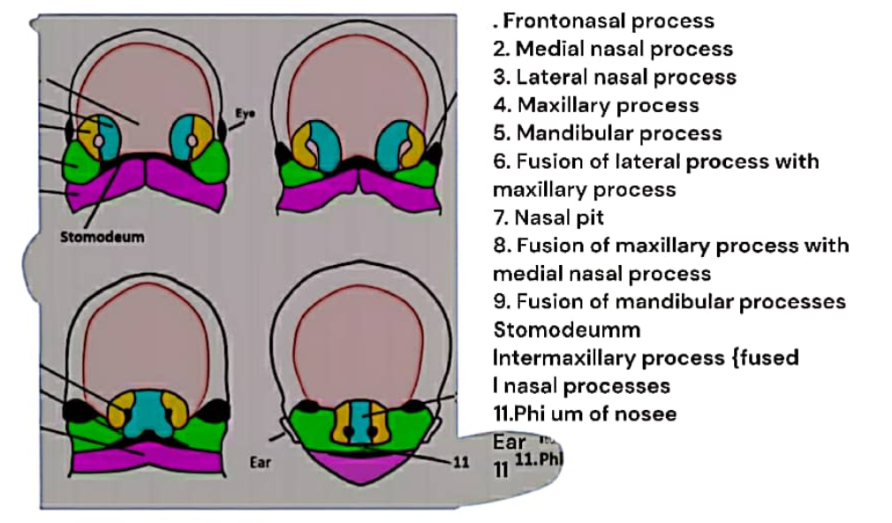

Each maxillary process fuses with each medial nasal process and contributes to sides of the upper lip, contributing to the middle of upper lip and lip, and the two medial nasal processes. If the maxillary process on each side does NOT fuse with medial nasal process, cleft lip can result

