**First lecture:**

***Physiology:*** It’s the science that seeksيهدف to explain the physical and chemical mechanisms that are responsible for the origin, development, and progression تقدم of life .

***Types of physiology fields:***

1. Viral physiology.
2. Bacterial physiology.
3. Cellular physiology.
4. Plant physiology.
5. Invertebrate physiology.
6. Vertebrate physiology.
7. Mammalian physiology.
8. Human physiology.

***Human Physiology :***The science that attempts to explain the specific characteristics and mechanisms of the human body that make it a living being.

***Cell physiology*:**The basic living unit of the body is the cell. Each organ is an aggregate of many different cells held together by intercellular supporting structures.

Each type of cell is specially adapted to perform one or a few particular functions.

General functions of the cells:

The main functions of the cells are: 1-Absorption.

1. Digestion.
2. Respiration.
3. Biosynthesis.
4. Excretion.,
5. Secretion.
6. Movement.
7. Homeostasis
8. Reproduction.

.

**Cell membrane:**

**1- Cell Membrane:**

The cell membrane (also called the plasma membrane) envelops the cell and is thin, pliableمرن , elastic structure only 7.5 to 10 nanometers thick.

It is composed almost entirely of proteins and lipids.

The approximate composition is proteins, 55 % phospholipids, 25 %; cholesterol, 13 % other lipids, 4 %; and carbohydrates, 3 %

The cell membrane lipid barrier impedes penetration يمنع اختراقby water-soluble substances. Its basic structure is a **lipid bilayer**.

The basic lipid bilayer is composed of three main types of lipids: A-phospholipids, (most abundant of the cell membrane lipids) B-Sphingolipids,

C-Cholesterol.

The lipid layer in the middle of the membrane is impermeableغير نفاذ to the usual water-soluble substances, such as **ions, glucose, and urea.**

Conversely, fat-soluble substances, such as oxygen, carbon dioxide, and alcohol, can penetrate this portion of the membrane with ease.

Sphingolipids,.

**Glycocalyx function: ( Cell membrane )**

1. Many of them have a negative electrical charge, which gives most cells an overall negative surface charge that repelsيصد other negatively charged objects.
2. The glycocalyx of some cells attaches to the glycocalyx of other cells, thus attaching cells to one another.
3. Many of the carbohydrates act as receptor substances for binding hormones, such as insulin;
4. Some carbohydrate moieties enter into immune reactions.

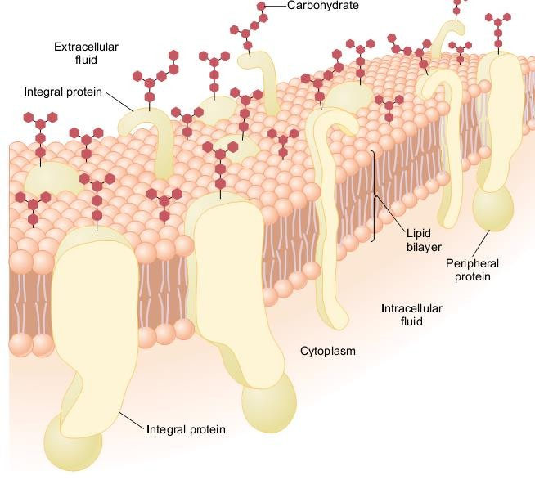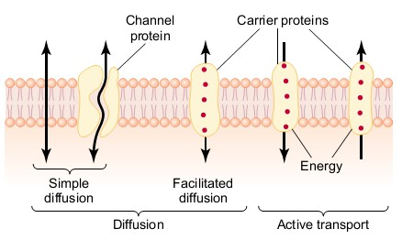

**Cell Membrane Transport :**

**The substances can penetrate this lipid bilayer by:**

**1- Diffusing directly**. Or Free diffusion:

it's t h e migration of molecules from a region of higher concentration to one of lower concentration as a result of random motion . Free diffusion energy and does not require external is therefore passive – Example:

**Oxygen and carbon dioxide** move across cell membranes down their concentration gradients by diffusion.

1. **Carrier-mediated Transport :( facilitated diffusion):**

**Bind with molecules or ions that are to be transported,** Carriers are integral membrane proteins that transport substances that are **hydrophilic** or too large to cross the membrane by simple diffusion .

They also permit faster transport of **lipid soluble substances** than simple diffusion.

1. **Active transport: -**

Active transport occurs when a substance i s transported across a membrane against its electrochemical gradient by transport proteins. This process **requires energy** i n the form of adenosinetriosphate (ATP), therefore it is active.

1. **Osmosis:**

Osmosis is the net diffusion of water across a semipermeable membrane. (Permeable to water but not solutes membrane).

The net movement of water across asemipermeable membrane is due to the concentration differences of the no penetrating solutes. Water diffuse from a low osmolality solution (high water).