 

Oral Histology

Development and Growth ofTeeth

Lecture 6

Prof. Dr. Muna Merza

Development and Growth ofTeeth

Two or three weeks after the rupture of the buccopharyngeal membrane, when the embryo is about 6 wecks old, certain areas of basal cells of the oral ectoderm proliferate mare rapidly than do the cells of the adjacent areas. This leads to the formation of the Primary epithelial band which is a band of epithelium that has invaded the underlying ectomesenchyme along each of the horseshoe-shaped future dental arches

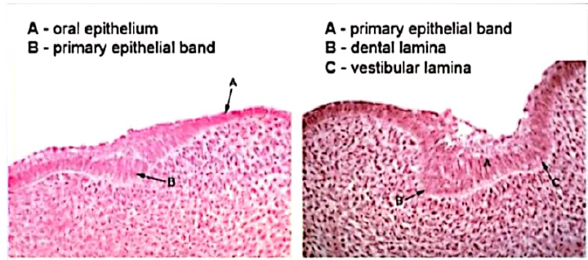

At about 7th week the primary epithelial band divides into an inner (lingual) process called Dental lamina and an outer (buccal) process called Vestibular lamina. The dental laminae serve as the primordium for the ectodermal portion of the deciduous teeth. Later, during the development of the jaws, the permanent molars arise directly from a distal extension of the dental lamina

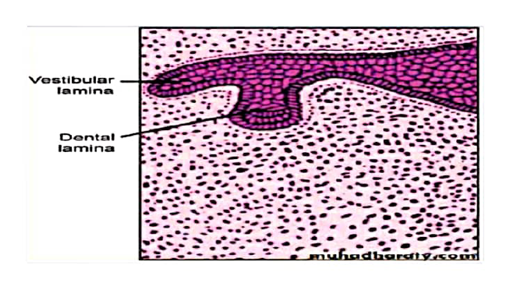

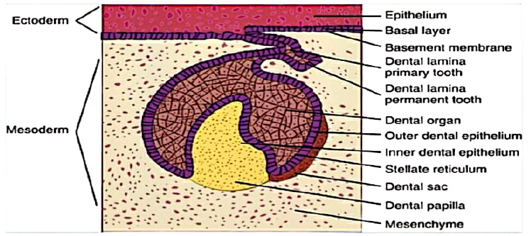

The development of the first permanent molar is initiated at the fourth month in utero. The second molar is initiated at about the first year after birth, the third molar at the fourth or fifth years, The distal proliferation of the dental lamina is responsible for the location of the germs of the permanent molars in the ramus of the mandible and the tuberosity of the maxilla. The successors of the deciduous teeth develop from a lingual extension of the free end of the dental lamina opposite to the enamel organ of each deciduous tooth

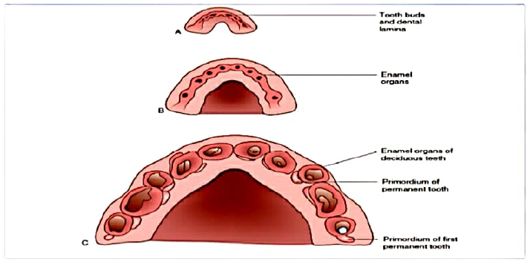

DEVELOPMENTAL STAGEs

Although tooth development is divided into several morphologic 'stages' and are called the bud, cap, and bell stages

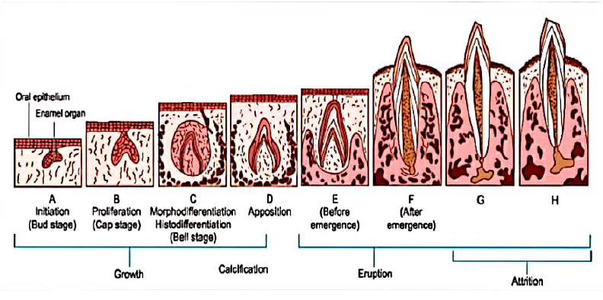

Bud Stage

The epithelium of the dental laminae is separated from the underlying ectomesenchyme by a basement membrane, round or ovoid swellings arise from the basement membrane at 10 different points, corresponding to the future positions of the deciduous teeth. These are the primordia of the enamel organs, the tooth buds.

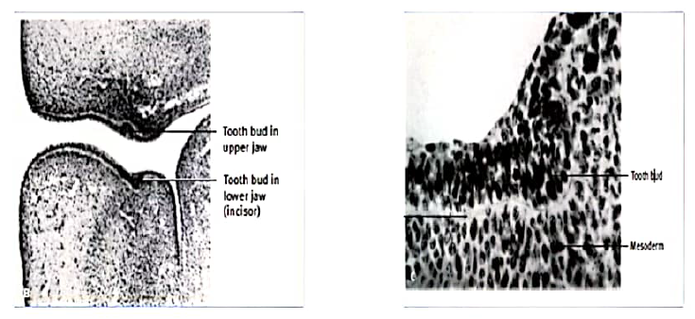

In the bud stage, the enamel organ consists of peripherally located low columnar cells and centrally located polygonal cells. Many cells of the tooth bud and the surrounding mesenchyme undergo mitosis. As a result of the increased mitotic activity and the migration of neural crest cells into the area ,the ectomesenchymal cells surrounding the tooth bud condense. The area of ectamesenchymal condensation immediately subjacent to the enamel organ is the dental papilla. The condensed ectomesenchyme that surrounds the tooth bud and the dental papilla is the dental sac.

