**Lec (1) Blood transfusion Dr. Ahlam mousa**

**Blood Bank Introduction**

**Definition**

**Blood Banking, is the process of collecting and preparing blood and other blood components for transfusion, as well as selection of appropriate, compatible blood components for transfusion.**

**The main and major role of blood bank laboratory is to provide the safest and compatible blood and/or blood components to all recipients/patient**

**BLOOD BANK ANTIGENS AND ANTIBODIES**

**Antigens**

**Antigens are defined as substances recognized by the body as foreign, causing the body to produce an antibody to react specifically with it.**

**Characteristics of antigens:**

**Autologous antigens are  your own antigens (not foreign to you)**

**Homologous, or allogeneic antigens are antigens from someone else (within the same species) that are foreign to you.**

**Blood group antigens:**

**There are over 300 known blood group antigens .These antigens are attached to proteins or lipids on the red cell membrane and are usually complex sugar groups.**

**Blood group antigens are chemical structures embedded in or protruding from RBCs, WBCs, and platelets and have three common forms:**

**Blood group antigen forms**

**a. Glycoproteins - HLA system.**

**b. Glycolipids - ABH, and Lewis blood group systems.**

**c. Proteins - Rh, M, N blood group systems.**

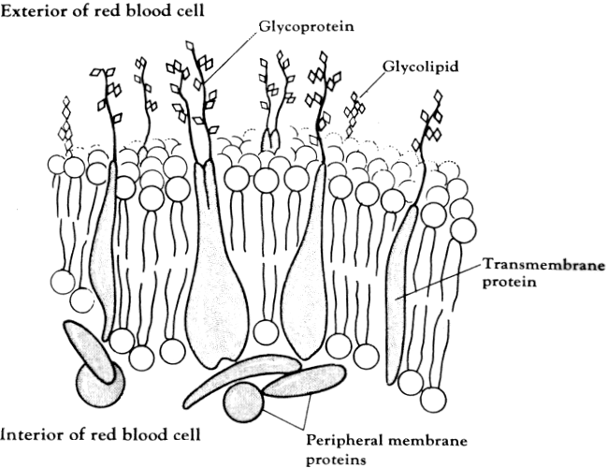

**Antibodies:**

**Definition:**

**Proteins produced by lymphocytes as a result of stimulation by an antigen which can then interact specifically with that particular antigen.**

**Parts of an antibody:**

**Heavy chains - made of alpha, gamma, delta, mu, or epsilon chains**

**Light chains - made of either kappa or lambda chains**

**Disulfide bonds – to hold chains together**

**Hinge region - allows antibody to flex to reach more antigen sites**

**Fab fragments - contains variable portion of antibody: antigen-binding sites**

**Fc fragment - contains constant portion of antibody; also site of complement activation**

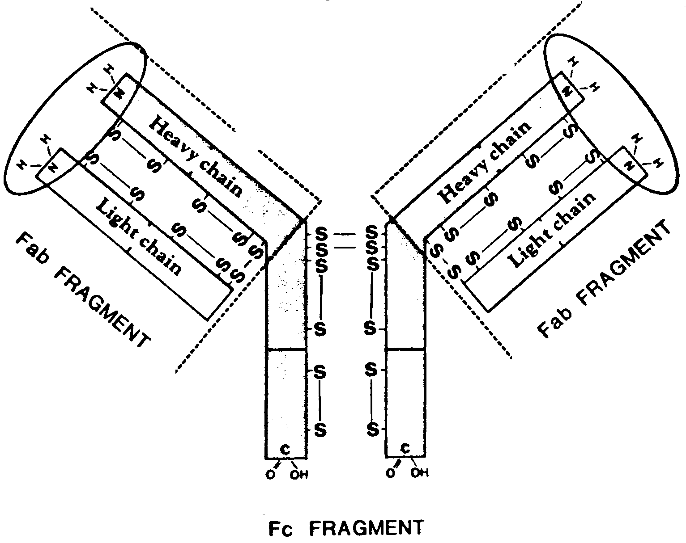

**Classes of antibodies**

**IgG - provides long-term immunity or protection**

**IgM - first antibody produced in response to an antigenic stimulus**

**IgA - found in secretions. Protects against infections in urinary, GI, and respiratory tracts**

**IgE - involved in allergic reactions**

**IgD - not much known about it. Surface receptor of B lymphocytes**

**Most important classes of antibodies in blood banking are IgM and IgG**

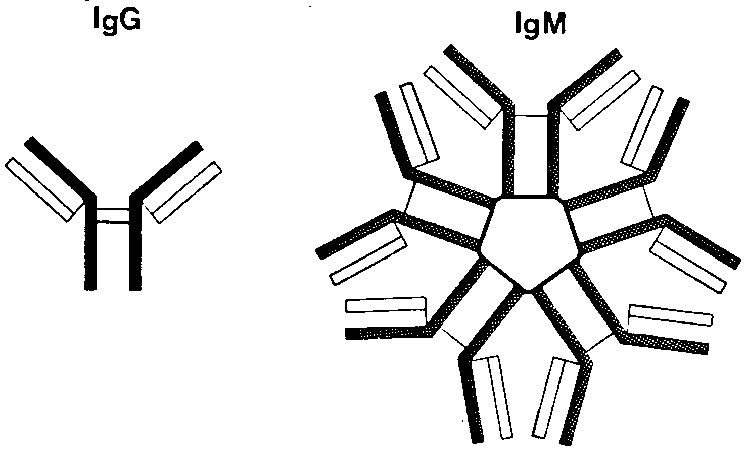

**Characteristics of IgG and IgM antibodies**

**Clinical significance:**

**Clinical of red cell antibodies in blood bank depend on whether they can cause in vivo hemolysis, which in turn will cause transfusion reactions or hemolytic disease of the newborn.**

**IgG  will frequently cause in vivo hemolysis due to antibody coating the red blood cells.**

**IgM, with a few important exceptions, usually does NOT cause in vivo hemolysis.  The most important of these exceptions are ABO antibodies.**

**1)Size of the antibodies:**

**IgG is relatively small since it is comprised of only one immunoglobulin subunit. (monomer)**

**IgM is relatively large since it is comprised of 5 immunoglobulin subunits. (pentamer)**

**2)Serum concentration**

**IgG > IgM**

**3)Complement activation**

**IgG = will do it if conditions are optimal IgM = Excellent complement fixation**

**4)Placental transfer**

**IgG is small enough to easily cross placenta and is the only immunoglobulin capable of doing so.**

**IgM and the other classes do not cross placenta**

**5)Optimum temperature of reactivity**

**a. IgG = 37C b. IgM = 4 C (may react at any temperature below 30C)**

**6)Number of antigen-binding sites**

**IgG has 2 binding sites IgM has 10 binding sites**

**Terms used to describe antibodies**

**Immunoglobulin:**

**Antibody formed as a result of immune stimulus (exposure to foreign antigen)**

**Naturally occurring**

**Antibody formed without prior exposure to foreign antigen**

**Autoantibody:**

**Antibody formed to one's own antigens (abnormal condition)**

**Alloantibody**

**antibody formed to foreign antigens, but within the same species**

**Agglutinin:**

**Antibody capable of causing agglutination when reacting with corresponding antigen**

**Hemolysin:**

**Antibody capable of causing hemolysis when reacting with corresponding antigen**

**Cold antibody (cold agglutinin):**

**Antibody whose optimal temperature of reactivity is less than 30C**

**Warm antibody:**

**Antibody whose optimal temperature of reactivity is greater than 35C**

**ANTIGEN-ANTIBODY REACTIONS IN GENERAL**

**Rules of Thumb For in vivo Antigen-Antibody Reactions**

**If a person's cell have the antigen, the antibody should NOT be present in that person's serum .**

**If an antibody to a blood group antigen is present in the serum of a person, his or her cells should lack that antigen**

**The antigens are on the cells and the antibodies are in the serum**

**Stages of Antigen-Antibody Interaction**

**The first stage is sensitization (coating of cells).**

**Sensitization occurs when antibodies react with antigens on the cells and coat the cells.**

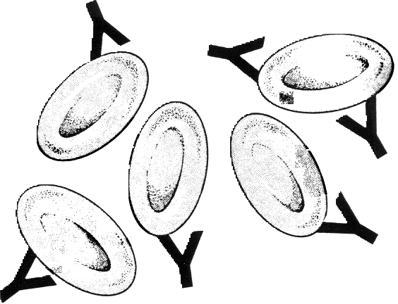

**Agglutination**

**The second stage of the reaction is agglutination.  Agglutination occurs when antibodies on coated cells form cross-linkages between cells resulting in visible clumping.**

