**Lab4**

**The Soxhlet extraction**

The Soxhlet extraction is a combination of both, percolation and [maceration](https://www.sciencedirect.com/topics/agricultural-and-biological-sciences/maceration) methods. The extraction is carried out in a special apparatus known as Soxhlet apparatus that was designed by Franz von Soxhlet in 1879 . It has been one of the most widely used extraction method which is still used extensively.

Apparatus consists of an extraction chamber connected to a vapor duct and siphon tube which extends down to the joint where a round bottom flak can be attached. A thimble of filter paper or a cotton plug is placed in extraction chamber to prevent the blockage of siphon tube when powdered drug material is added.

The drug is packed in the extraction chamber, and a condenser and a round bottom flask is attached to the Soxhlet apparatus at their respective positions. The solvent is then added from the top which enter the extraction chamber

. Once the level of solvent reaches above the siphon bend, solvent flows into the flask through siphon tube. Flask is heated on a water bath making solvent to boil and its vapors, through vapor duct, go to condenser, gets condensed and condensed droplets then fall on to drug material in extraction chamber (percolation). The extraction chamber slowly gets filled with solvent (drug remains in contact with solvent in the chamber—maceration) till its level reaches above the siphon tube after which the solvent flows, through siphon tube, back to the round bottom flask and the cycle continues. Every time the extraction chamber receives fresh solvent, preventing saturation of solvent with solutes and therefore Soxhlet extraction is also known as continuous extraction and provides an exhaustive extraction of the plant material. By virtue of its simplicity and exhaustive nature, Soxhlet extraction is still used as a reference method in official methods of United States Environmental Protection Agency (US EPA),

**advantages**

. The major advantages of Soxhlet extraction is the increase in mass transfer rate due to use of high temperatures and recycling of fresh solvent (which further improves the transfer equilibrium). These advantages make this technique better in term of extraction efficiency in comparison to the other conventional techniques.

**On the other hand utility of the technique only for the thermostable constituents is its major limitation [5,6]. Amount of solvent, temperature, time of extraction, particle size of the drug powder and solvent to drug ratio are the major variables that affect the extraction efficiency of this technique**

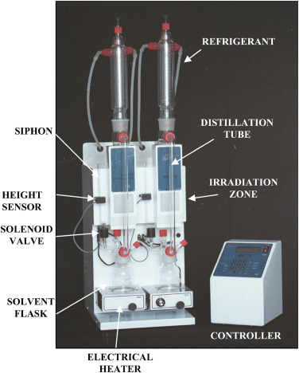

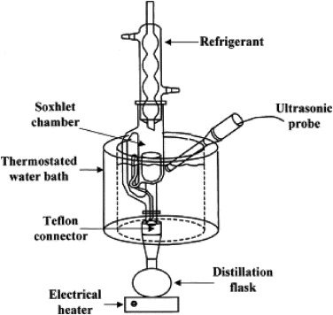

FRACTIONAL CRYSTALLIZATION

A detailed file on the fractional Crystallization process

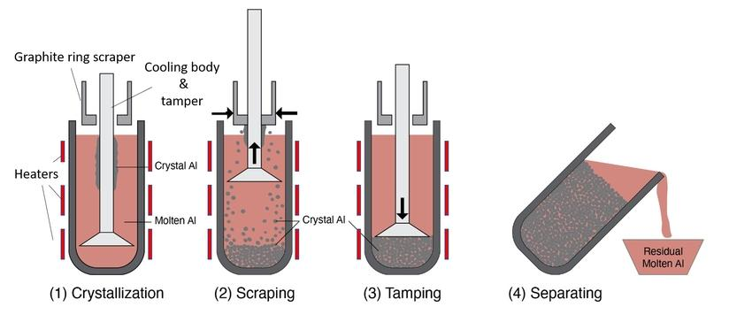

Partial crystallization (Fractional Crystallization) Introduction Fractional crystallization is a technique used to separate the components of a liquid mixture based on differences in their solubility. This process is widely used in chemistry, geology and industry for the separation of chemicals.

Basic principle

1. ** * Solubility**: fractional crystallization is based on the idea that different substances dissolve in a given solvent in different concentrations.

2. ** Temperature change**: when changing the temperature of the solution, the solubility of the substance can change, which leads to the crystallization of some components

. Basic steps

1. ** Solution preparation**: a solution saturated with the substance to be separated is prepared.

2. ** Solution heating**: the solution is heated to increase the solubility of the components.

3. ** Solution cooling**: the solution is cooled slowly, allowing components with less solubility to crystallize first.

4. ** * Crystal separation**: the resulting crystals are separated from the solution using methods such as filtration.

5. ** Re-solution**: the remaining solution may be re-melted to recover more components. Applications - **In chemistry**: used to separate pure chemicals. - **In geology**: to separate minerals from magma. - **In industry**: for refining chemicals such as sugar and salt.

Advantages and disadvantages

Advantages – High ability to separate large quantities.

– Simple technique, easy to use.

Disadvantages – It may require a long time to get results

. – Not always effective in the case of materials with similar properties.

Conclusion Fractional crystallization is an important process used to separate substances in multiple domains.

By understanding the principles and process of crystallization, separation techniques can be improved in various applications

.