Al-Mustaqbal University College

College of Administrative Sciences

Department of Business Administration

(4th lecture)

(3ed class)

Present Continuous Tense

by

Iltifat Al-husseini

**The main goal of this lecture is to make students how to use the present continuous tense in everyday conversations**

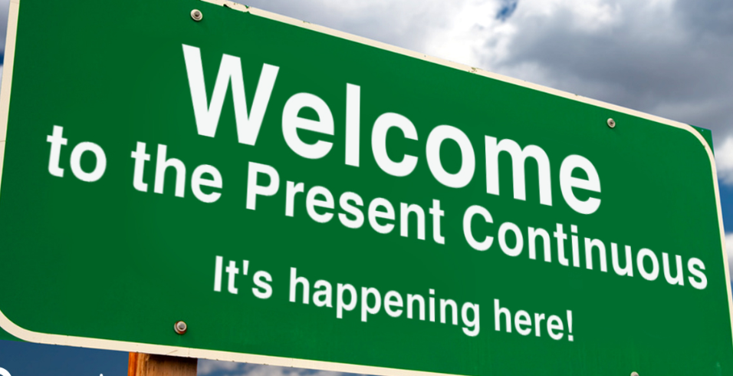

**Short paragraphs by using the present continuous tense**

"I’m staring at my textbook, but nothing is making sense. My brain is doing everything it can to avoid studying. I’m doodling in the margins, I’m refreshing my email, and I’m even counting the number of tiles on the ceiling. Meanwhile, my friend is texting me, asking if I’m actually studying, and I’m saying, ‘Of course!’ while doing absolutely anything but studying."

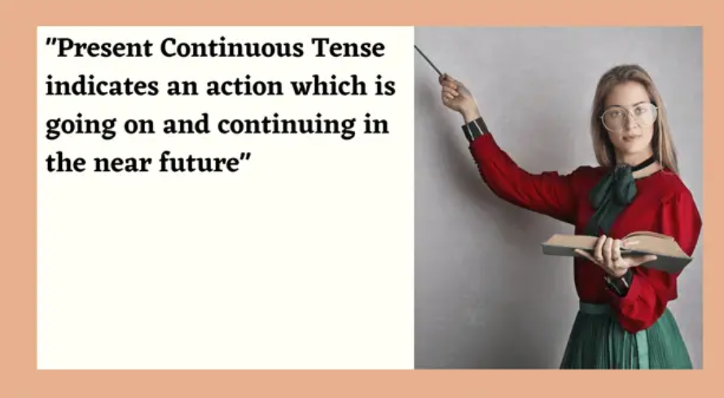

The present continuous tense describes actions that are happening right now or are ongoing. It can also refer to future arrangements.

Structure of the Present Continuous Tense

To form the present continuous tense, we use the following structure:

I → am

He/She/It → is

You/We/They → are

Main Verb: The action verb in its -ing form.

Affirmative: Subject + am/is/are + verb(-ing)

Example: She is dancing.

She is reading a book.

I am playing football right now

Negative: Subject + am/is/are + not + verb(-ing)

Example: He is not playing soccer.

They are not watching TV.

He is not playing soccer today.

Interrogative: Am/Is/Are + subject + verb(-ing)?

Example: Are they studying for the test?

Are you listening to the teacher?

Is she working on her project?

This tense is used for actions happening at the moment of speaking.

Example: I am listening to music. (It is happening now.)

Temporary Situations:

It describes actions or situations that are temporary, not permanent.

Example: They are staying with their friends for the week. (This situation is short-term.)

Future Arrangements:

The present continuous can express planned future events or arrangements.

Example: We are meeting the new team on Monday. (This is a scheduled future event.)

Changing Situations:

It can express situations that are gradually changing.

Example: The population of the city is increasing rapidly. (Indicates a change over time.)

The **present continuous** verb tense indicates that an action or condition is happening now, frequently, and may continue into the future.

The Present Continuous Formula:**to be [am, is, are] + verb [present participle]**

Aunt Christine **is warming** up the car while Scott is looking for his new leather coat. They **are eating** at Scott’s favorite restaurant today, Polly’s Pancake Diner

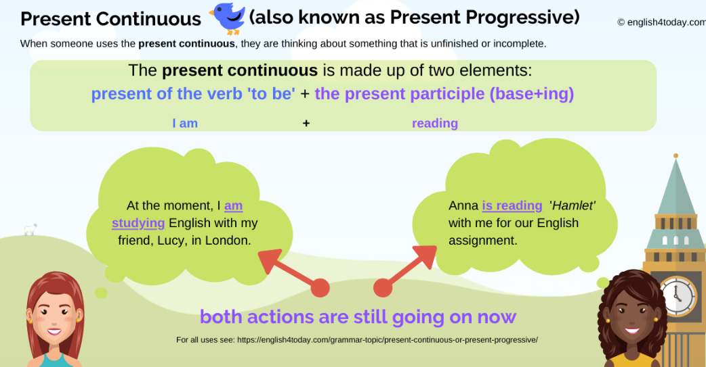

Some examples about the tense

* She is singing a beautiful song.
* He is joining his new workplace.
* Sabeel is teaching English.
* You are doing a good deed now.
* Are they playing cards?
* We are not going outside of our home.
* Am I not requesting you to give up bad habits?
* He is selling his old car.
* You are focusing on your study.
* They are not laughing at you.
* Hasib is reading a new lesson.
* Rana is acknowledging the fact.
* John is traveling now.
* I am feeling nervous today.
* Simi is looking for good friends.
* Joy is running in the field.
* Is he not obeying his responsibility?
* We are finding the best way to overcome it.
* He is suffering from a fever.
* Jolly is starting a business