WHAT IS HEMOLYSIS?

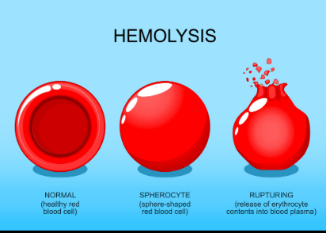 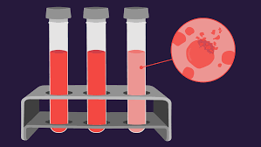

WHAT IS HEMOLYSIS?

Hemolysis or haemolysis : also known by several other names, is the rupturing (lysis) of red blood cells (erythrocytes) and the release of their contents (cytoplasm) into surrounding fluid (e.g. blood plasma). Hemolysis may occur in vivo or in vitro.

1- Inside the body

It includes many types of gram-positive bacteria such as (streptococci, staphylococci, and enterococci), some parasites such as (plasmodium), some autoimmune disorders such as (drug-induced hemolytic anemia), some genetic diseases such as (sickle cell anemia, favism), or low concentration of solute in the blood (hypotonic).

The cause of hemolysis Hemolysis may be intravascular hemolysis inside the vessels or extravascular hemolysis outside the vessels

that intravascular hemolysis is very rare and may be the result of a blood transfusion reaction or hemolytic anemia.

And that extravascular hemolysis is very common and occurs through incorrect blood withdrawal and storage.

Outside the body

Hemolysis is the breakdown of red blood cells (RBC’s). due to the mishandling of blood samples during routine blood collection and transport .

The accuracy of the test results is dependent on the quality of the specimens. A quality serum for diagnostic testing can be obtained by following best practices during collection, handling, and transporting the samples to the diagnostic laboratory.

Hemolysis can be caused by:

Hemolysis can occur as a result of:

• Long-term ligation of the tourniquet

• Using a needle that is too small.

• Drawing blood from a vein too quickly

• Pumping the blood sample too forcefully into the tube

• Shaking the tube too forcefully

• Pressing the plunger of the syringe too forcefully when drawing blood into the blood collection device

• Exposing the blood sample to extreme heat or cold

• Water droplets inside the tube

• Separating the blood sample by centrifugation at high speed

How to avoid hemolysis

1. Choose the right gauge needle.

2. Alcohol used for cleansing the venipuncture site should be allowed to dry completely before drawing the blood.

3. One should collect the blood specimen in the correct blood collection tube (serum separator tube(SST) (Tiger top tubes) or red top tubes withoutanticoagulants).



4. After performing venipuncture and removing the needle, transfer the blood gently down the side of the collection tube

5. Invertقلب the tube gently as recommendedالموصى به by the tube manufacturer

6. Later, the tube should be placed uprightعموديا for 15-33 minutes at room temperature until complete clot.

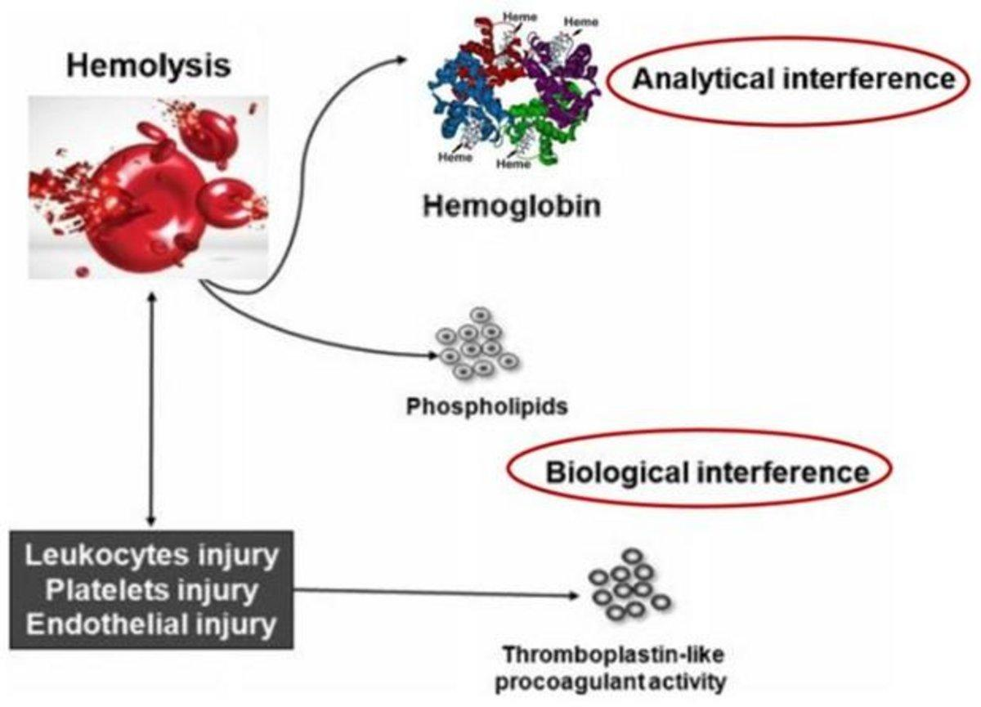

Blood tubes Collecting

Most blood collection tubes contain an additive that either accelerates clotting of the blood (clot activator) or prevents the blood from clotting (anticoagulant).

Some tests require the use of serum, some require plasma, and other tests require anticoagulated whole blood . A vacutainer blood collection tube is a sterile glass or plastic test tube with a colored rubber stopper creating a vacuum seal inside of the tube, facilitating the drawing of a predetermined volume of liquid . Vacutainer tubes may contain additives designed to stabilize and preserve the specimen prior to analytical testing. Tubes are available with a safety-engineered stopper, with a variety of labeling options and draw volumes. The color of the top indicates the additives in the vial





What tests are affected by a lysed blood sample?

increase⬆️⬆️

slightly

1- Calcium (Ca ++)

2- Phosphate (PO4-)

3- Total protein

4-Magnesium (Mg++)

4. Phosphate (PO4-)

5. Creatine Kinase (CK)

6-Albumin

7- Creatine Kinase (CK)

Moderate

1- PT

2- Iron

3- Alkaline Phosphatase (ALP)

Severe:

1-s .Got

2-LDH

3- Potassium (K+)

Decrease⬇️⬇️

1. Troponin T

2. Haptoglobin

3. Bilirubin

4. Amylase

5. Bicarbonate (HCO3–)