

Ministry of Higher Education and Scientific Research

Al-mustaqbal University

Faculty of Engineering and Engineering Technologies

Department / Computer Technology Engineering

***Communications Fundamentals***

***Second stage***

***Lecture Two***

***1- Signal Characteristics:***

* **Amplitude (A)** is the maximum displacement of a particle in a wave from its balance position. It is measured in meters (m).

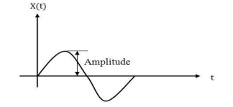

* **Frequency (f)** is the number of complete waves passing a point in one second. It is measured in hertz (Hz).

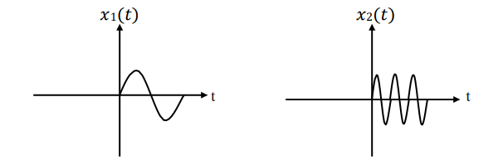

**Note:** 𝑥2(𝑡) has higher frequency than𝑥1(𝑡).

**(1)**

* **Wavelength (λ)** is the distance between two identical points on a wave (i.e. one full wave). It is measured in meters (m).

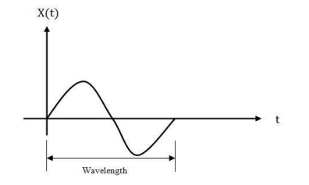

Wave speed (c) is measured in meters per second (m/s). Wave speed (c), frequency (f) and wavelength (λ) are linked together in the following equation.

**c = f λ**

c = wave speed (m/s)

λ = wavelength (m)

* ***Phase***

Points on a wave which are always travelling in the same direction, rising a falling together, are in **phase** with each other. Points on a wave which are always traveling in opposite directions to each other, one is rising while the other is falling, are in anti-phase with each other.

**(2)**

***2- Mathematical Representation of Some Function:***

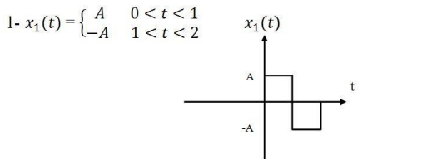

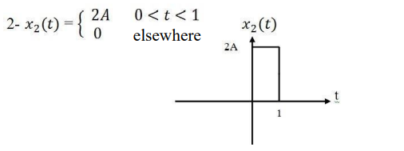

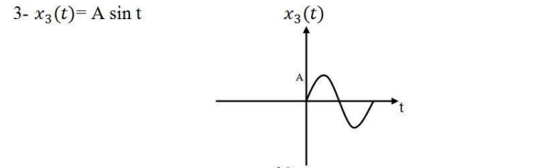

**(3)**

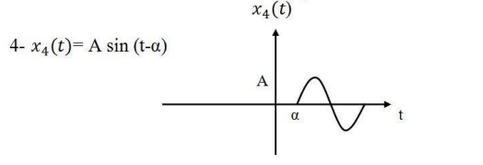

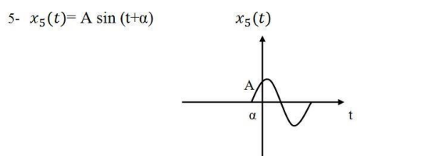

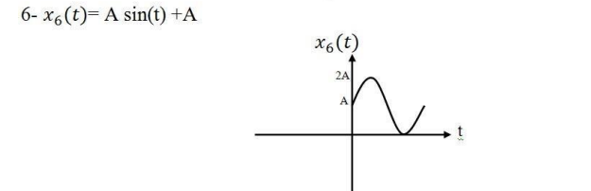

**(4)**

**7-𝑥7(t) = t for 0 < t < 1**

By using slope law:

$\frac{y2-y1}{x2-x1}$**= $\frac{y-y1}{x-x1}$**

**OR;**

$\frac{1-0}{1-0}$**= $\frac{y-0}{x-0}$**

y=x

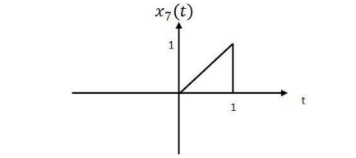

**(5)**

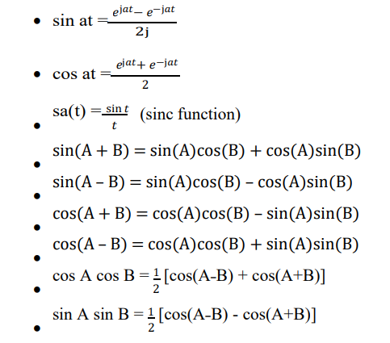

**(6)**