

**Analysis and Design of**

Reinforced Concrete Structures



**Presentation Overview**



1. Building system primary functions
2. Types of load
3. RC structural systems
4. RC structural members

2



## Basic Building System Functions



Support gravity loads for strength and serviceability during:

1. Normal use (service) conditions
2. Maximum considered use conditions
3. Environmental loading of varying intensities

3





Vertical deflection (sag) Lateral deflection (sway)

Dead, Live, etc.

Wind or earthquakes

**Performanc Based Design** Control displacements within acceptable limits during service loading, factored loaded, and varying intensities of environmental loading

4



## Types of Load



Gravity: Lateral

Dead Live

Wind Earthquake

Impact Soil lateral pressure

Snow Rain/floods

Thermal Centrifugal



# RC Structural Systems

* 1. Floor Systems
  2. Lateral Load Systems



# Floor Systems

* Flat plate
* Flat slab (w/ drop panels and/or capitals)
* One-way joist system
* Two-way waffle system

Flat Plate Floor System



Slab-column frame system in two-way bending

Plan Elevation

8



# Flat Plate Floor System

Advantages:

* Simple construction
* Flat ceilings (reduced finishing costs)
* Low story heights due to shallow floors

Typical Applications:

* Short-to-medium spans with light loading
* For LL=50 psi, 15’ - 30’ spans
* For LL=100 psi, 15’ – 25’ spans

9



Plan Elevation

10

# 

Advantages:



* Same as flat plate system, plus
  + Increased gravity and lateral load resistance
  + Increased torsional resistance
  + Decreased slab edge displacements

Typical Applications:

* Same as flat plate systems

11



# Flat Plate w/Beams Floor System



Two-way bending

Gravity and lateral load frames

12



# Flat Plate w/Beams Floor System



Advantages:

* Increased gravity and lateral load resistance
* Simple construction
* Flat ceilings (reduced finishing costs)

Typical Applications:

* Medium spans with light loading
* For LL=50 psi, 25’ - 30’ spans
* For LL=100 psi, 20’ – 30’ spans

13



# Flat Slab Floor System

Flat plate with drop panels,shear capitals, and/or column capitals

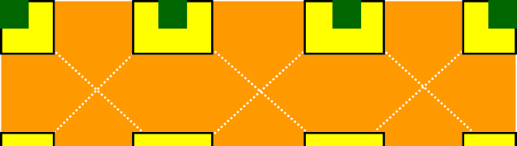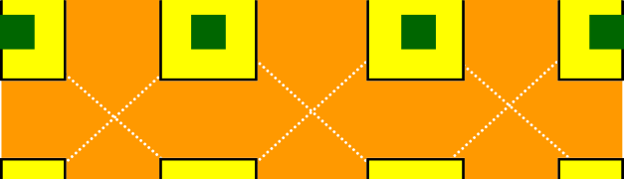

Plan Elevation

14





# Flat Slab Floor System

Advantages:

* Reduced slab displacements
* Increased slab shear resistance
* Relatively flat ceilings (reduced finishing costs)
* Low story heights due to shallow floors

Typical Applications:

* Medium spans with moderate to heavy loading
* For LL=50 psi, 30’ – 35’ spans
* For LL=100 psi, 25’ – 35’ spans

15





# One-Way Joist Floor System

Rib (joist) slab : (One-way bending)

2D gravity or lateral frames

2D lateral frames

Floor joists, type

16





# One-Way Joist Floor System

Rib (joist) slab with beams: (One-way bending)

Lateral space frame

Floor joists, type

17



# One-Way Joist Floor System

Typical Joist

Top of Slab

Width varies 4”, 6” or larger

8-24” for 30” Modules

16-24” for 53” Modules

1:12 Slope, type 14-24” for 66” Modules .

* 2’ or 3’ cc. – Joists
  + 4’ or 6’ cc. – Skip joists



* + 5’ or 6’ cc – Wide-module joists



# One-Way Joist Floor System

Advantages:

* Longer spans with heavy loads
* Reduced dead load due to voids
* Electrical,

mechanical etc.

can be placed between voids

* Good vibration resistance



Typical Applications:

* Medium-to-long spans with heavy loading
* For 30” modules, 35’ – 40’ spans
* For 53” & 66” modules, 35’ – 50’ spans





# Two-Way Joist Floor System

Waffle slab : (Two-way bending)

2D lateral frames

Waffle pans, type

20



# Two-Way Joist Floor System

Advantages:

* Longer spans with heavy loads
* Reduced dead load due to voids
* Electrical,

mechanical etc.

can be placed in voids

* Good vibration resistance



* Attractive Ceiling

Typical Applications:

* Long spans with heavy loading
* For 3’, 4’, and 5’ modules, 40’ – 50’ spans and beyond

# Floor System Effective Cost



(PCA 2000)

100

Live Load, psf

Flat Plate

Flat Slab

One-way joist

50

25 30 35 50