# Lecture 3 - Fundamentals

**Lecture Goal**

* Advantages and disadvantages of concrete structures
* Design Process
* Limit states
* Design Philosophy
* Loading

# Advantages of Concrete Structures

* Economical

– Thinner floor systems

Reduced Building Height

Lower wind loads (< A) Saving in Cladding

– Materials

widely available

# Advantages of Concrete Structures

* + Suitability of material for architectural and structural function
    - Concrete place in plastic condition - desired shape & texture can be obtained with forms and finishing techniques
    - Designer can choose shape and size

# Advantages of Concrete Structures

* + Fire Resistance
    - Concrete building have 1-3 hour fire rating with no fire proofing (steel and timber require fireproofing to obtain this rating)
  + Rigidity
    - Greater stiffness & mass reduces oscillations (wind), floor vibrations (walking)

# Advantages of Concrete Structures

* + Low Maintenance
  + Availability of Materials
    - Sand, gravel, cement, H20 & concrete mixing facilities widely available
    - Reinforcement - easy to transport as compared

to structural steel

# Disadvantages of Concrete Structures

* + Low tensile strength -

~ 0.1 fc

cracking if not properly

reinforced

# Disadvantages of Concrete Structures

* + Forms and Shoring (additional steps)
    - Construction of forms
    - Removal of forms
    - Prepping (or shoring) the new concrete to support weight until strength is adequate.
    - Labor/Materials cost not required for other types of materials

# Disadvantages of Concrete Structures

* Strength per unit volume is relatively low.
  + fc ~ (5-10% of steel)
  + greater volume required
  + long spans typical built with steel

# Disadvantages of Concrete Structures

* Time-dependent volume changes
  + Concrete & steel undergo similar expansion and contraction.
  + Concrete undergoes drying shrinkage, which may cause deflections and cracking.
  + Creep of concrete under sustained loads causes an increase in deflection with time.

# Design Proces

* **Phase 1**: Definition of clients’ needs and priorities.
  + Functional requirements
  + Aesthetic requirements
  + Budgetary requirements

# Design Proces

* **Phase 2**: Development of project concept
  + Develop possible layouts
  + Approximate analysis preliminary members sizes/cost for each arrangement

# Design Proces

* **Phase 2**: Development of project concept
  + Selection most desirable structural system
    - Appropriateness
    - Economical/Cost
    - Maintainability

# Design Proces

* **Phase 3**: Design of individual system
  + Structural analysis (based on preliminary design)
    - Moments
    - Shear forces
    - Axial forces

# Design Proces

* **Phase 3**: Design of individual system(cont.)
  + Member design
    - Prepare construction days and specifications.
    - Proportion members to resist forces
      * aesthetics
      * constructability
      * maintainability

# Limit States and Design

#### Limit State:

##### Condition in which a structure or structural element s no longer acceptable for its intended us .

Major groups for RC structural limit states

* Ultimate
* Serviceability
* Special

# Ultimate Limit Stat

#### Ultimate limit state

* structural collapse of all or part of the structure ( very low probability of occurrence) and loss of life can occur.
* Loss of equilibrium of a part or all of a structure as a rigid body (tipping, sliding of structure).

# Ultimate Limit States

#### Ultimate limit state

– Rupture of critical components causing partial or complete collapse. (flexural, shear failure).

# Ultimate Limit States

* **Progressive Collapse**
  + Minor local failure overloads causing adjacent members to failure entire structure collapses.
  + Structural integrity is provided by tying the structure together with correct detailing of reinforcement provides alternative load paths in case of localized failure

# Ultimate Limit State

* Formation of a plastic mechanism - yielding of reinforced forms plastic hinges at enough sections to make structure unstable.
* Instability cased by deformations of structure causing buckling of members.
* Fatigue - members can fracture under repeated stress cycles of service loads (may cause collapse).

# Serviceability Limit State

* Functional use of structure is disrupted, but collapse is not expected
* More often tolerated than an an ultimate limit state since less danger of loss of life.
  + Excessive crack width  leakage  corrosion of reinforcement  gradual deterioration of structure.

# Serviceability Limit State

* More often tolerated than an an ultimate limit state since less danger of loss of life.
  + Excessive deflections for normal service caused by possible effects
    - malfunction of machinery
    - visually unacceptable

# Serviceability Limit State

* More often tolerated than an an ultimate limit state since less danger of loss of life.
  + Excessive deflections for normal service caused by possible effects
    - damage of nonstructural elements
* changes in force distributions
* ponding on roofs

collapse of roof

# Serviceability Limit States

* More often tolerated than an an ultimate limit state since less danger of loss of life.
  + Undesirable vibrations
    - vertical  floors/ bridges
    - lateral/torsional  tall buildings
    - Change in the loading

# Special Limit States

Damage/failure caused by abnormal conditions or loading.

* + Extreme earthquakes damage/collapse
  + Floods  damage/collapse

# Special Limit State

Damage/failure caused by abnormal conditions or loading.

* + Effects of fire,explosions, or vehicular collisions.

Effects of corrosion, deterioration

* + Long-term physical or chemical instability

# Limit States Design

* Identify all potential modes of failure.
* Determine acceptable safety levels for normal

structures building codes

load

combination/factors.

# Limit States Design

* Consider the significant limits states.
  + Members are designed for ultimate limit states
  + Serviceability is checked.

Exceptions may include

* + - water tanks (crack width)
    - monorails (deflection)

# ACI Building Code

Whenever two different materials , such as steel and

concrete, acting together, it is understandable that the analysis for strength of a reinforced concrete member has to be partial empirical although rational. These semi- rational principles and methods are being constant revised and improved as a result of theoretical and

experimental research accumulate. The American

Concrete Institute (ACI), serves as clearing house for these changes, issues building code requirements.

# Design Philosophy

Two philosophies of design have long prevalent.

* Working stress method focuses on conditions at service loads.
* Strength of design method focusing on conditions at loads greater than the service loads when failure may be imminent.

The strength design method is deemed conceptually more realistic to establish structural safety.

# Strength Design Method

In the strength method, the service loads are increased sufficiently by factors to obtain the load at which failure is considered to be “imminent”. This load is called the **factored load** or **factored service load**.

strength provided

⬆strength required to 

 ⬇ carry factored loads 

 ✗

# Strength Design Metho

Strength provide is computed in accordance with rules and assumptions of behavior prescribed by the building code and the strength required is obtained by performing a structural analysis using factored loads.

The “**strength provided**” has commonly referred to as “**ultimate strength**”. However, it is a code defined value for strength and not necessarily “**ultimate**”. The ACI Code uses a conservative definition of strength.

# Safety Provisions

Structures and structural members must always be designed to carry some reserve load above what is expected under normal use.

# Safety Provisions

There are three main reasons why some sort of safety factor are necessary in structural design.

1. Variability in resistance.
2. Variability in loading.
3. Consequences of failure.

# Variability in Resistance

* + Variability of the strengths of concrete and reinforcement.
  + Differences between the as-built dimensions and those found in structural drawings.
  + Effects of simplification made in the derivation of the members resistance.

# Variability in Resistance

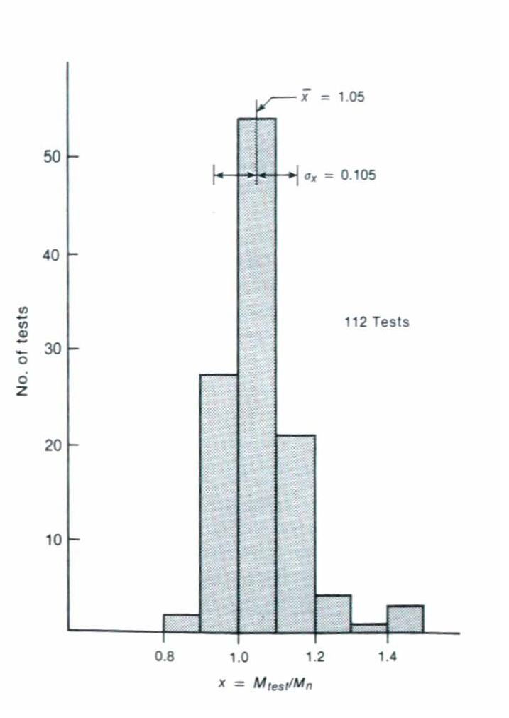

Comparison of measured and computed failure moments based on all data for reinforced concrete beams with fc > 2000 psi.

# Variability in Loadin

Frequency distribution of sustained component of live loads in offices.

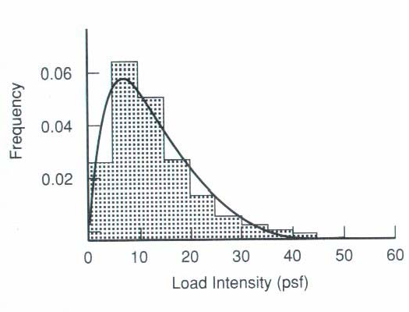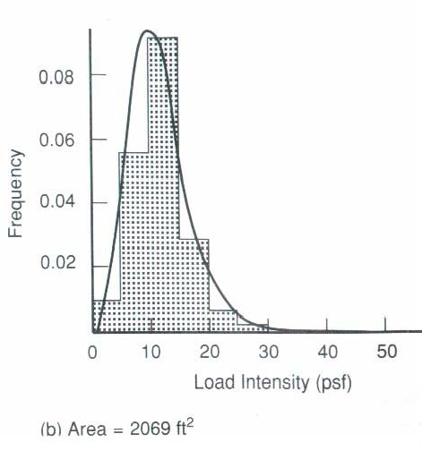

# Consequences of Failur

A number of subjective factors must be considered in determining an acceptable level of safety.

* Potential loss of life.
* Cost of clearing the debris and replacement of the structure and its contents.
* Cost to society.
* Type of failure warning of failure, existence of alternative load paths.

# Margin of Safet

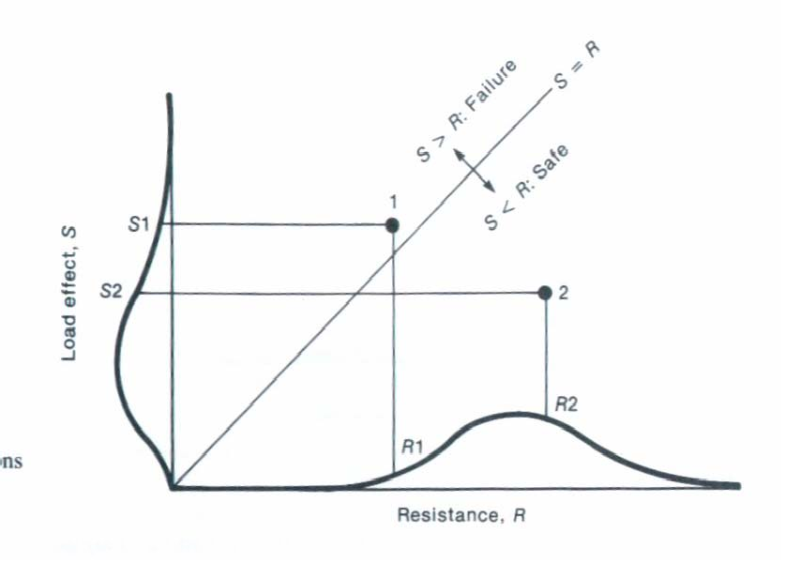

The distributions of the resistance and the loading are used to get a probability of failure of the structure.

The term

# Margin of Safety

 *Y*

*Y*

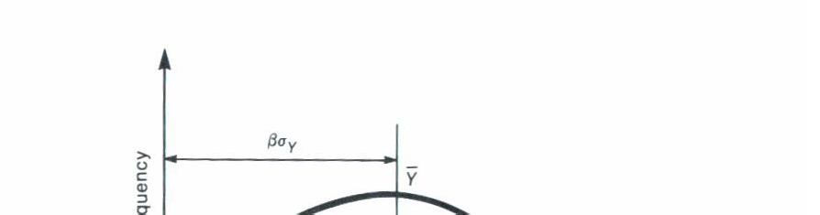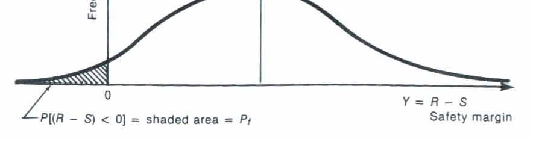

Y = R - S

is called the safety margin. The probability of failure is defined as:

*Pf*  Pr obability of *Y*  0

and the safety index is