**Al- Mustaqbal University **

**College of Sciences**

**Department of Cybersecurity**

**Data Structures**

Second stage

Lecture 1/ Practical Part

2025-2024

Lectuer : Muntather AL-Mousawi

**Introduction**

***C++ Programming Language***

C++ is a general-purpose object-oriented programming (OOP) language, developed by Bjarne Stroustrup, and is an extension of the C language. It is therefore possible to code C++ in a "C style" or "object-oriented style." In certain scenarios, it can be coded in either way and is thus an effective example of a hybrid language.

C++ is considered to be an intermediate-level language, as it encapsulates both highand low-level language features. Initially, the language was called "C with classes" as it had all the properties of the C language with an additional concept of "classes." However, it was renamed C++ in 1983.

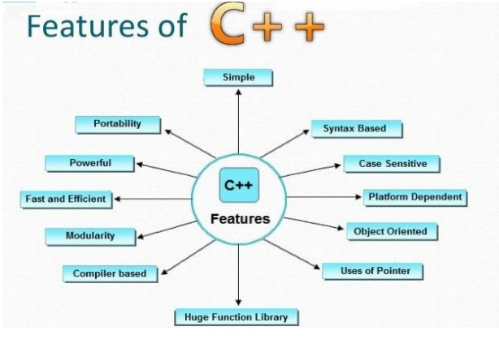

**(1)**

**Simple Programs**

{A Hello World Program}

**1. #include<iostream>**

**2. using namespace std;**

**3. void main() {**

**4. cout << "Hello world";**

**5. return 0;**

**6.}**

{ The Area of Circle}

**1. #include<iostream>**

**2. using namespace std;**

**3. int main(){**

**4. float r,area;**

**5. cout<< "\nEnter radius of circle : ";**

**6. cin>>r;**

**7. area = 3.14*r*r;**

**8. cout<<"Area of circle : "<<area;**

**9. return 0;**

**10. }**

**(2)**

{ Absolute Value of Number}

**1. #include<iostream>**

**2. using namespace std;**

**3. int main()**

**4. {**

**5. int a;**

**6. cout<<"Enter any number:";**

**7. cin>>a;**

**8. if(a>0)**

**9. cout<<"The absolute value of number is:"<<a;**

**10. else**

**11. cout<<"The absolute value of number is:"<<(- a);**

**12. return 0;**

**13. }**

**C++ switch**

switch(expression){

**case** value1:

//code to be executed;

**break;**

**case** value2:

//code to be executed; **(3)**

**break;** ......

**default:**

//code to be executed if all cases are not matched;

**break;**

}

{ Check the grade of Student}

**1. #include<iostream>**

**2. using namespace std;**

**3. int main () {**

**4. int num;**

**5. cout<<"Enter a number to check grade:";**

**6. cin>>num;**

**7. switch (num)**

**8. {**

**9. case 10: cout<<"It is 10"; break;**

**10. case 20: cout<<"It is 20"; break;**

**11. case 30: cout<<"It is 30"; break;**

**12. default: cout<<"Not 10, 20 or 30"; break;**

**13. }**

**14. }**

**(4)**