

Ministry of Higher Education and Scientific Research

Al-mustaqbal University

Faculty of Engineering and Engineering Technologies

Department / Computer Technology Engineering

***Communication Fundamentals***

***Second stage***

***Lecture Two***

Signals

Definitions

In electronics and telecommunications, “**signal”** refers to any time-varying voltage, current, or electromagnetic wave that carries information.

In signal processing, signals are analog and digital representations of analog physical quantities. In information theory, a signal is a codified message,

In a communication system, a transmitter encodes a message to create a signal, which is carried to a receiver by the communication channel. For example, the words "Mary had a little lamb" might be the message spoken into a telephone. The telephone transmitter converts the sounds into an electrical signal. The signal is transmitted to the receiving telephone by wires; at the receiver it is reconverted into sounds.

In telephone networks, signaling, for example common-channel signaling, refers to phone number and other digital control information rather than the actual voice signal.

In Signals and Systems, signals can be classified according to many criteria, mainly: according to the different feature of values, classified into analog signals and digital signals; according to the determinacy of signals, classified into deterministic signals and random signals; according to the strength of signals, classified into energy signals and power signals.

1. ***Signals and Classification Of Signals***

A signal is a function representing a physical quantity or variable, and typically it contains information about the behavior or nature of the phenomenon. Mathematically, a signal is represented as a function of an independent variable t. usually t represents time. Thus, a signal is denoted by x(t).

1. ***Continuous-Time and Discrete-Time Signals:***

A signal x(t) is a continuous-time signal if t is a continuous variable. If t is a discrete variable, that is, x(t) is defined at discrete times, then x(t) is a discrete-time signal. Since a discrete-time signal is defined at discrete times, a discrete-time signal is often identified as a sequence of numbers, denoted by {xn} o r x[n], where n = integer. Illustrations of a continuous-time signal x(t) and of a discrete-time signal x[n] are shown in Fig. 1.

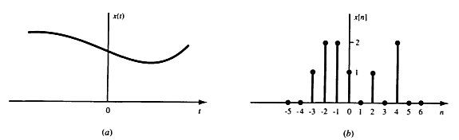

Fig. 1: Graphical representation of (a) continuous-time and (b) discrete-time signals.

1. ***Analog and Digital Signals:***

The concept of continuous time is often confused with that of analog. The two are not the same. The same is true of the concepts of discrete time and digital. A signal whose amplitude can take on any value in a continuous range is an **analog signal**. This means that analog signal amplitude can take on an infinite number of values. A **digital signal**, on the other hand, is one whose amplitude can take on only a finite number of values.

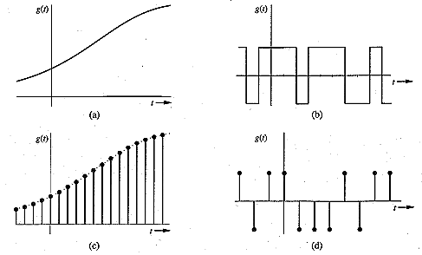

Example of signals is shown above. (a) is an analog signal and its at the same time continuous time. (b) Digital signal and its continuous. (c) Analog signal but its discrete. (d) Digital and discrete time.

1. ***Real and Complex Signals:***

A signal x(*t*) is a real signal if its value is a real number, and a signal x(*t*) is a complex signal if its value is a complex number. A general complex signal x(t) is a function of the form

$$x\left(t\right)=x_{1}\left(t\right)+jx_{2}(t)$$

Where $x_{1}\left(t\right) and x_{2}(t)$ are real signals and $j=\sqrt{-1}$.

***D. Deterministic and Random Signals:***

*Deterministic*signals are those signals whose values are completely specified for any given time. *Random*signals are those signals that take random values at any given time and must be characterized statistically.

***E. Energy and Power Signals***

The normalized energy content E of a signal x(t) is defined as

$E=\int_{-∞}^{∞}{{\left|x(t)\right|}^{2}dt}$ (1)

The normalized average power P of a signal x(t) is defined as

$P=\lim_{T→∞}{\frac{1}{T}\int_{-∞}^{∞}{{\left|x(t)\right|}^{2}}dt}$ (2)

* x(t) is said to be an *energy* signal if and only if 0 < E < ∞ and so P=0.
* x(t) is said to be a *power* signal if and only if 0 < P < ∞, thus implying that E=∞.

***Example 1:***

Determine whether the signal ${x(t)=e}^{-a|t|}$ is power or energy signals or neither

Sol: $x\left(t\right)=e^{-a|t|}=\left\{\begin{aligned}e^{-at} t>0 \\ e^{at} t<0\end{aligned}\right.$

$$E=\int_{-∞}^{∞}{[x\left(t\right)]^{2}dt=\int_{-∞}^{∞}{e^{-2a\left|t\right|}}dt=2\int_{0}^{∞}{e^{-2at}dt=\frac{1}{a}<∞ is an energy signal.}}$$

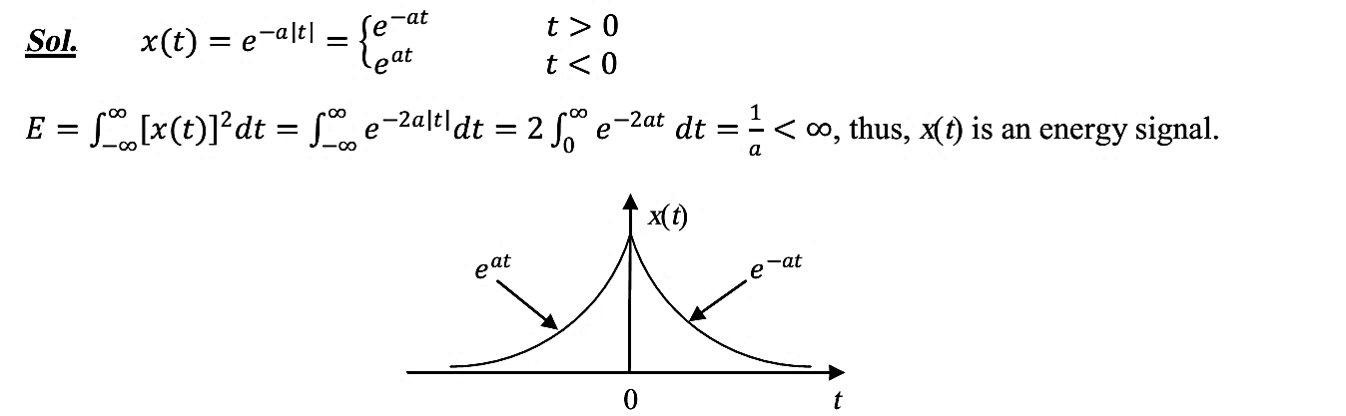

***F. Periodic and Non-periodic Signals***

A signal x(t) is periodic if there is a positive number $T_{o}$ such that

$x\left(t+nT_{o}\right)=x(t)$ all t (3)

The smallest positive number $T_{o}$ is called the period, and the reciprocal of the period is called the fundamental frequency $f_{o}$

$f_{o}=\frac{1}{T_{o}} hertz (Hz)$ (4)

Any signal for which there is no value of $T_{o}$ satisfying Eq.(3) is said to be non-periodic or aperiodic, A periodic signal is a power signal if its energy content per period is finite, and then the average power of the signal need only be calculated over a period.

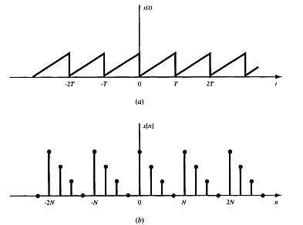

***Example 2:***

Let $x_{1}(t)$ and $x_{2}(t)$ be periodic signals with periods $T_{1}$ and $T_{2},$ respectively:

Under what conditions is the sum.:

$$x\left(t\right)=x_{1}\left(t\right)+x_{2}\left(t\right)$$

periodic, and what is the period of x(t) .if it is periodic?

***Sol:***

From Eq. (3)

$x_{1}\left(t\right)=x_{1}(t+mT_{1})$ m is an integer

$x_{2}\left(t\right)=x_{2}(t+nT_{2})$ n is an integer

If, therefore, $T_{1}$ and $T_{2}$ are such that

$${mT}_{1}=n T_{2}=T$$

then,

${x\left(t+T\right)=x}_{1}\left(t+T\right)+x_{2}\left(t+T\right)=x_{1}\left(t\right)+x_{2}\left(t\right)=x(t)$

that is, x(*t*) is periodic. Thus, the condition for x(*t*) to be periodic is

$$\frac{T_{1}}{T_{2}}=\frac{n}{m}=rational number$$

The smallest common period is the least common multiple of $T_{1}$ and $T_{2}.$ If the ratio is $T_{1}/T_{2}$ an irrational number, then the signals $x_{1}\left(t\right) and x_{2}\left(t\right)$) do not have a common period and x(t( cannot be periodic.

**To check $x\left(t\right)=\cos\left(\frac{1}{3}t\right)+\sin\left(\frac{1}{4}t\right)$** for periodicity, $\cos\left(\frac{1}{3}t\right)$ is periodic with period $T_{1}=6π$, and $\sin\left(\frac{1}{4}t\right)$ is periodic with period $T_{2}=8π$. Since $\frac{T_{1}}{T_{2}}=\frac{6π}{8π}=\frac{3}{4}$ is a rational number, (𝑡) is periodic with period T = 4 $T_{1}$ =3 $T_{2}$ = 24π.

***G. Singularity Functions***

An important subclass of non-periodic signals in communication theory is the singularity functions (or, as they are sometimes called, the generalized functions).

***G.1 Unit Step Function***

The unit step function u(t) is defined as

$u\left(t\right)=\left\{\begin{aligned}1 t>0 \\ 0 t<0\end{aligned}\right.$ (5)

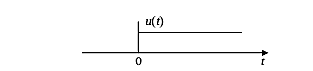

Note that it is discontinuous at t = 0 and that the value at t = 0 is undefined.

***G.2 Unit Impulse Function***

The unit impulse function, also known as the Dirac delta function, δ(t) is not an ordinary function and is defined in terms of the following process:

$\int_{-∞}^{∞}{ϕ\left(t\right)δ\left(t\right)dt=ϕ\left(0\right) (6)}$

where $ϕ$ (t) is any test function continuous at t = 0.

Some additional properties of δ(t) are

$\int_{-∞}^{∞}{ϕ\left(t\right)δ\left(t-t_{0}\right)dt=ϕ\left(t_{0}\right) (7) }$

$δ\left(at\right)=\frac{1}{\left|a\right|}δ\left(t\right) (8)$

$δ\left(-t\right)=δ\left(t\right) (9)$

$$x(t)δ\left(t\right)=x(0)δ\left(t\right) (10)$$

$x(t)δ\left(t-t_{0}\right)=x(t_{0})δ\left(t-t_{0}\right) (11)$

An alternate definition of δ(t) is provided by the following two conditions

$\int_{t_{1}}^{t_{2}}{δ\left(t-t_{0}\right)dt=1 t_{1}<t_{0}<t_{2} \left(12\right)}$

$δ\left(t-t_{0}\right)=0 t≠t_{0}$ (13)

Conditions in Eq.(12) and (13) correspond to the intuitive notion of a unit impulse as the limit of a suitably chosen conventional function having unity area in an infinitesimally small width. For convenience, δ(t) is shown schematically below.

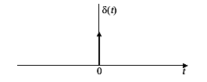

If g(t) is a generalized function, its derivative g'(t) is defined by the following relation:

$\int_{-∞}^{∞}{g^{'}\left(t\right)ϕ\left(t\right)dt=-\int_{-∞}^{∞}{g\left(t\right)ϕ^{'}\left(t\right)dt}}$ (14)

By using Eq. (14), the derivative of u(t) can be shown to be δ(t); that is,

$δ\left(t\right)=u^{'}\left(t\right)=\frac{du(t)}{dt}$ (15)

***Example 3:***

Evaluate the integral, $\int_{-∞}^{∞}{\left(t^{2}+cosπt\right)δ\left(t-1\right)dt}$

***Sol:- $\int_{-∞}^{∞}{\left(t^{2}+cosπt\right)δ\left(t-1\right)dt=t^{2}+cosπt|_{t=1}=1+cosπ=1-1=0}$***