**Loading**

#### SPECIFICATIONS

Cities in the U.S. generally base their building

code on one of the three model codes:

* Uniform Building Code
* Basic Building Code (BOCA)
* Standard Building Code

# Loading

These codes have been consolidated in the 2000 International Building Code.

Loadings in these codes are mainly based on ASCE Minimum Design Loads for Buildings and Other Structures (ASCE 7-95) – has been updated to ASCE 7-98.

# Dead Loading

* Weight of all permanent construction
* Constant magnitude and fixed location

Examples:

# Dead Load

* + Weight of the Structure

(Walls, Floors, Roofs, Ceilings, Stairways)

* + Fixed Service Equipment

(HVAC, Piping Weights, Cable Tray, Etc.)

##### Can Be Uncertain…

* + pavement thickness
  + earth fill over underground structure

# Live Load

* + - Loads produced by use and occupancy of the structure.
    - Maximum loads likely to be produced by the intended use.
    - Not less than the minimum uniformly distributed load given by Code.

# Live Load

See Table 2-1 from ASCE 7-95

Stairs and exitways: 100 psf Storage warehouses: 125 psf (light)

250 psf (heavy)

Minimum concentrated loads are also given in the codes.

# Live Loads

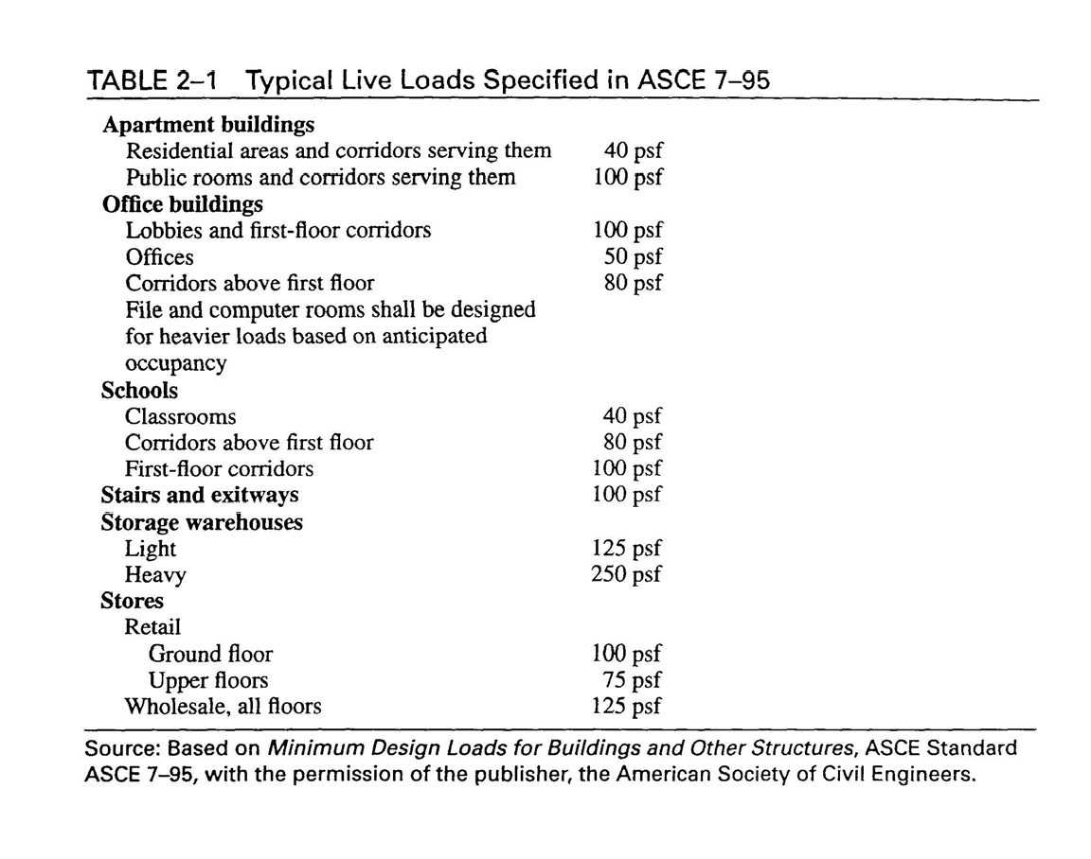

**Live Load**

ASCE 7-95 allows reduced live loads for members with influence area (AI) of 400 sq. ft. or more:



*L*  *L*

*o*





 0 . 25





*A*

*I*





where Lo

 0.50 Lo for members

15 

supporting one floor

 0.40 Lo otherwise

# Live Loads

AI determined by raising member to be designed by a unit amount. Portion of loaded area that is raised = AI

Beam: AI = 2 * tributary area

Column: AI = 4 * tributary area Two-Way Slab: AI = panel area

(see Fig. 2-10, text)

# Load Reduction

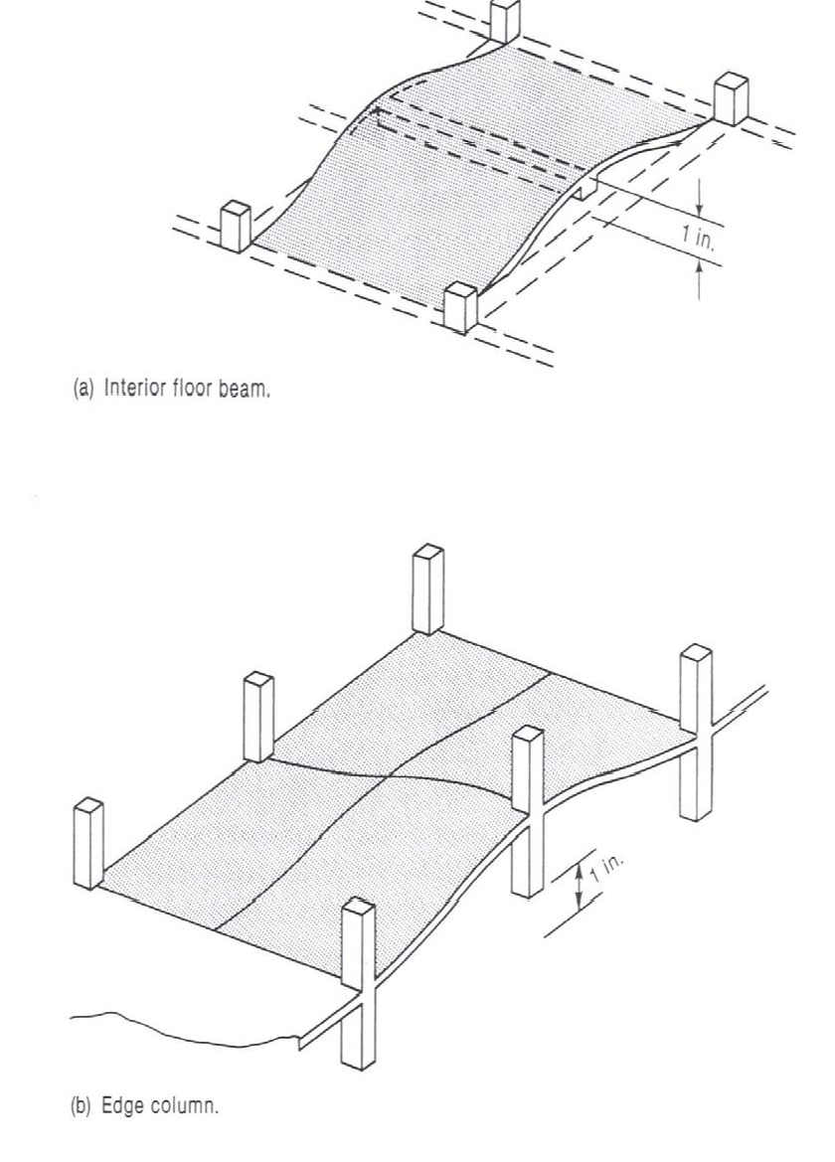

**Environmental Load**

* Snow Loads
* Earthquake
* Wind
* Soil Pressure
* Ponding of Rainwater
* Temperature Differentials

### Classification of Buildings for Wind, Snow and Earthquake Loads

#### Based on Use Categories (I through IV)

1. Buildings and other structures that represent a low hazard to human life in the event of a failure (such as agricultural facilities)
2. Buildings/structures not in categories I, III, and IV

### Classification of Buildings for Wind, Snow and Earthquake Loads

#### Based on Use Categories (I through IV)

1. Buildings/structures that represent a substantial hazard to human life in the event of a failure (assembly halls, schools, colleges, jails, buildings containing toxic/explosive substances)

### Classification of Buildings for Wind, Snow and Earthquake Loads

#### Based on Use Categories (I through IV)

1. Buildings/structures designated essential facilities (hospitals, fire and police stations, communication

centers, power-generating stations)

# Snow Load

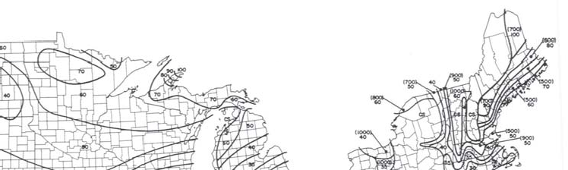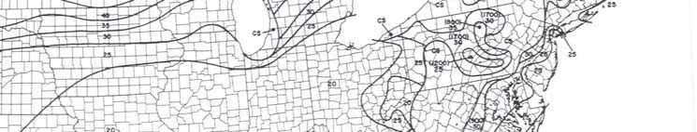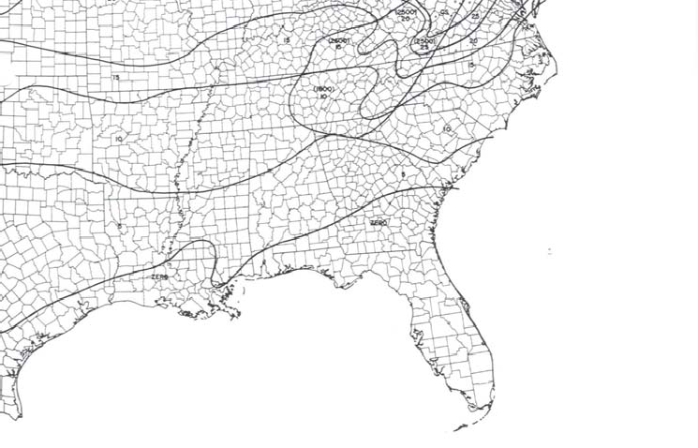

The coefficients of snow loads are defined in weight.

# Snow Load

Ground Snow Loads (Map in Fig. 6, ASCE 7):

* + Based on historical data (not always the maximum values)
  + Basic equation in codes is for flat roof snow loads
  + Additional equations for drifting effects, sloped roofs, etc.
  + Use ACI live load factor
  + No LL reduction factor allowed

# Wind Load

* + - Wind pressure is proportional to velocity squared (v2 )
    - Wind velocity pressure = qz

*qz* 

0.00256 *Kz*

*kzt*

*V* 2 *I*

# Wind Load

where

2

*qz* 

0.00256 *Kz*

*kzt V I*

0.00256 reflects mass density of air and unit conversions.

V = Basic 3-second gust wind speed (mph) at a height of 33 ft. above the ground in open terrain. (1:50 chance of exceedance in 1 year)

Kz = Exposure coefficient (bldg. ht., roughness of terrain) kzt = Coefficient accounting for wind speed up over hills I = Importance factor

# Wind Load

Design wind pressure,

p = qz * G * Cp

|  |  |  |
| --- | --- | --- |
| G = | Gust Response Factor |  |
| Cp = | External pressure coefficients (accounts for  directions on building) | pressure |

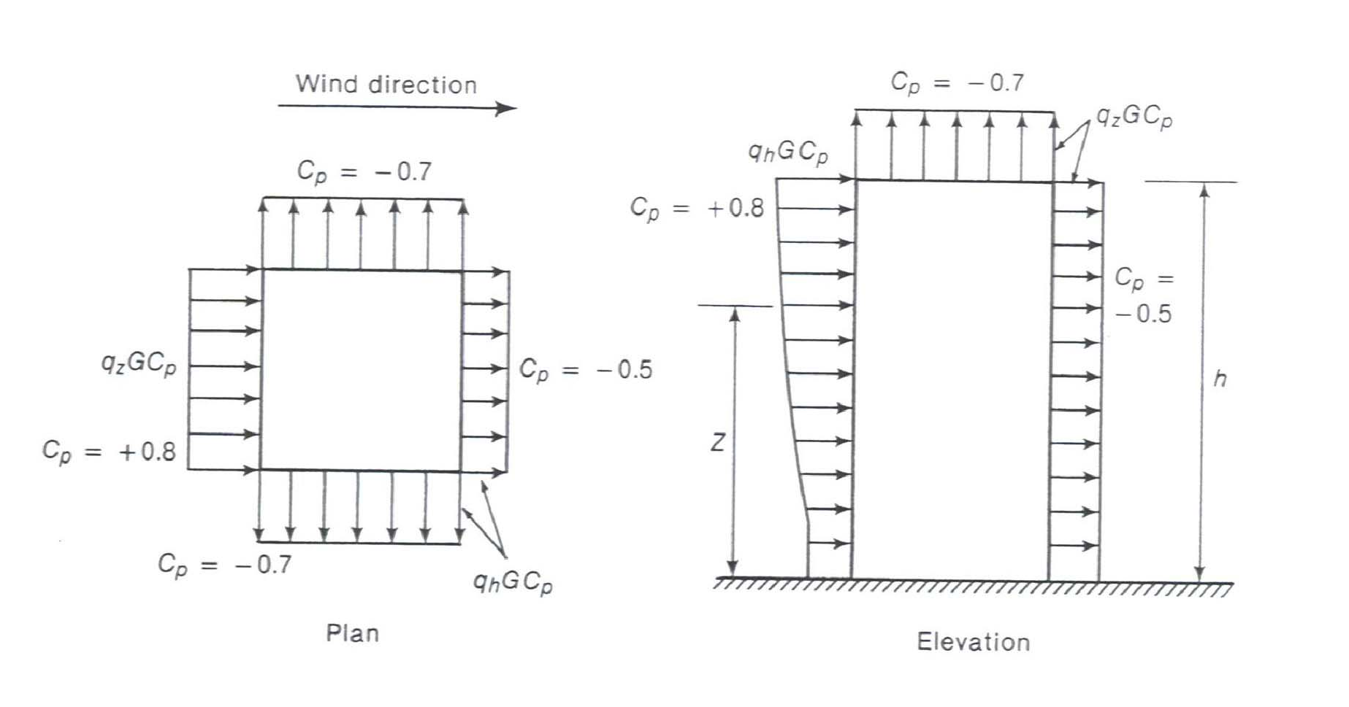

# Earthquake Load

Inertia forces caused by earthquake motion

F = m * a

* Distribution of forces can be found using equivalent

static force procedure (code, not allowed for every

building) or using dynamic analysis procedures

# Earthquake Load

Inertia forces caused by earthquake motion. Equivalent Static Force Procedure for example, in ASCE 7-95:

where

V = Cs * W

V = Total lateral base shear

Cs = Seismic response coefficient W = Total dead load

# Earthquake Load

Total Dead Load, W:

1.0 * Dead Load

+ 0.25 * Storage Loads

+ larger of partition loads or 10 psf

+ Weight of permanent equipment

+ contents of vessels

+ 20% or more of snow load

## Earthquake Loads

1.2 *C*

2.5 *C*

*C*  *smaller of*

 *v*

*and a*

*s*  *R T*

2 / 3 *R*

where

Cv = Seismic coefficient based on soil profile and Av Ca = Seismic coefficient based on soil profiled and Aa

R = Response modification factor (ability to deform in inelastic range)

T = Fundamental period of the structure

## Earthquake Loads

1.2 *C*

2.5 *C*

*C*  *smaller of*

 *v*

*and a*

*s*

where

 *R T*

2 / 3 *R*

T = Fundamental period of the structure

T = CT hn 3/4

where CT = 0.030 for MRF of concrete

0.020 for other concrete buildings. hn = Building height

# Earthquake Map

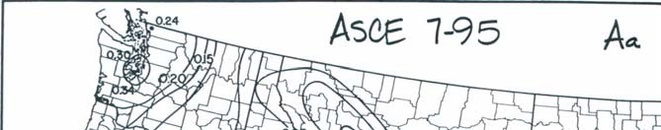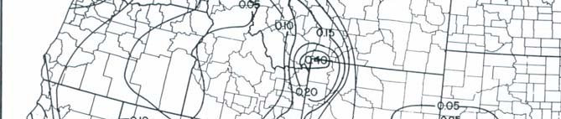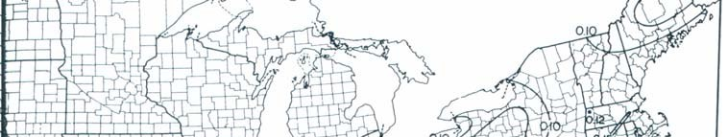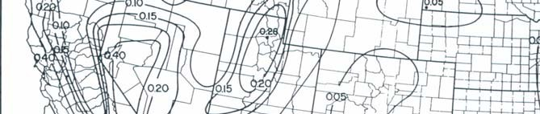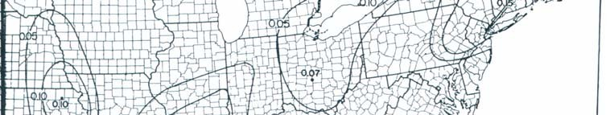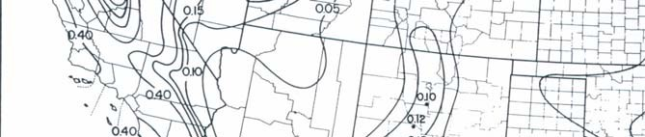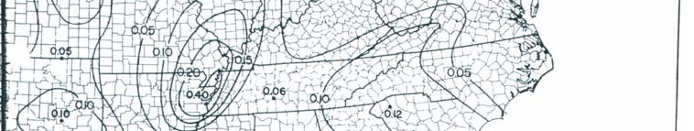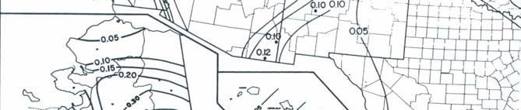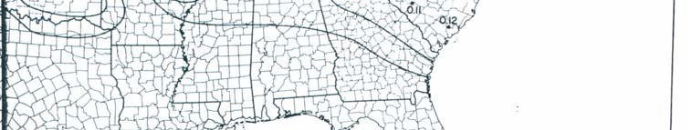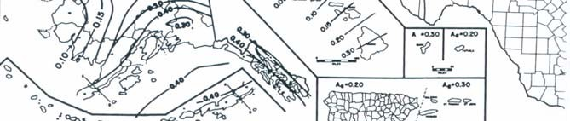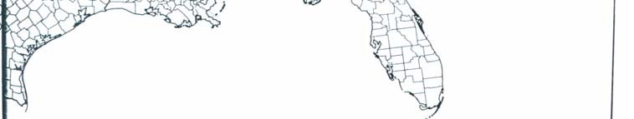

**Roof Load**

* Ponding of rainwater
  + Roof must be able to support all rainwater that could accumulate in an area if primary drains were blocked.
  + Ponding Failure:

→ Rain water ponds in area of maximum deflection

→ increases deflection

→ allows more accumulation of water  cycle continues… potential failure

# Roof Load

* + - Roof loads are in addition to snow loads
    - Minimum loads for workers and construction materials during erection and repair

# Construction Loads

* + - Construction materials
    - Weight of formwork supporting weight of fresh concrete