# B. Lateral Load Systems



* Frame Overview
* Flat plate (& slab)-column (w/ and w/o drop panels and/or capitals) frame systems
* Beam-column frame systems
* Shear wall systems (building frame and bearing wall)
* Dual systems (frames and shear walls)

23

## Frame: Coplanar system of beam (or slab) and column elements dominated by flexural deformation



Planar (2D) Space (3D)

24



# Basic Behavior

**Gravity Load**

**Lateral Loading**

25

# 2D vs. 3D Frames (Plan)



2 or 4 frames , 2 frames 4 frames , 4 frames

Planar

Floor joists, type

Space



26

* Optimum use of floor space, ie. optimal for office buildings, retail, parking structures where open space is required.
* Relatively simple and experienced construction process
* Generally economical for low-to mid-rise construction (less than about 20 stories)
* In Houston, most frames are made of reinforced concrete.

27



* Generally, frames are flexible structures and lateral deflections generally control the design process for buildings with greater than about 4 stories. Note that concrete frames are about 8 times stiffer than steel frames of the same strength.
* Span lengths are limited when using normal reinforced concrete (generally less than about 40 ft, but up to about 50 ft). Span lengths can be increased by using pre-stressed concrete.

28

Flat plate-column frame: Effective



slab width

Plan Elevation

29

Beam-column frame:

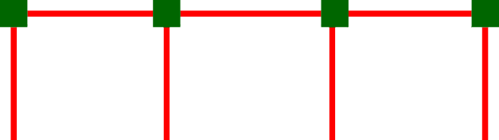

Elevation

30

Diaphragm (shear) element: Carries lateral loading to the lateral load resisting system



Lateral load frame, type.

Plate element

Deformed shape - Lateral load distributes to frames proportional to tributary area

31

For relatively square plans, diaphragms are generally considered rigid

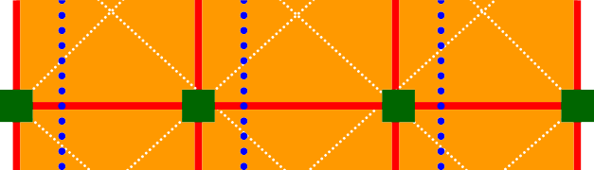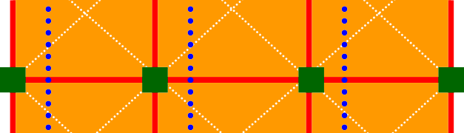

Space frame with square plan

Deformed shape has constant lateral displacement - No diaphragm flexibility, ie. lateral load distributes to frame proportional to frame stiffness

32

Shear wall Edge column Shear deformations

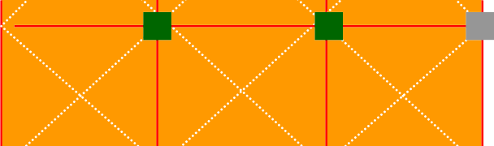

generally govern

Interior gravity frames

Elevation

33

Elevator shaft configuration

Gravity frames

Hole

Shear walls

Coupling beams



34

Wall-Frame Dual System:



Lateral frames – 25% of lateral

load, minimum

Hole

Shear walls

35



## Beams

* Columns

## Slabs/plates/shells/folded plates

* Walls/diaphragms

36

## Defn: Members subject to bending and shear

L V

M

V E,I,A

M



 



Elastic Properties:

kb = f ( EI/Ln) (bending)  = My/I (normal stress) ks = GA/L (shear) v = VQ/Ib (shear stress)

b = f (load, support conditions, L, E, I) (bending)

37

## Defn: Members subject to bending, shear, and axial

L V

F F

M V E,I,A M







Elastic Properties:



ka = EA/L (axial) a = F/A (normal stress) kb = f ( EI/Ln) (bending) b = My/I (normal stress) ks = GA/L (shear) v = VQ/Ib (shear stress)

b = (load, support conditions, L, E, I, A) (normal)

38



Defn: Members subject to bi-directional bending & shear

z

y

Mx, My, and Vz

x x, y, and z

39



Defn: Members subject to shear

y

Vx and Vx

x x and y

40