

Ministry of Higher Education and Scientific Research

Al-mustaqbal University

Faculty of Engineering and Engineering Technologies

Department / Computer Technology Engineering

***Communication Fundamentals***

***Second stage***

***Lecture One***

**Introduction :**

The word “communication” is derived from a Latin word meaning “to share.” Communication can be defined as “purposefully and actively exchanging information between two or more people to convey or receive the intended meanings through a shared system of signs and (symbols)”

[The communication process includes elements such as source, message, channel, receiver, feedback, environment, context, and interference](https://www.bing.com/ck/a?!&&p=c95ccaabdc21b2feJmltdHM9MTcyNjg3NjgwMCZpZ3VpZD0wZjQ3NzA2Yi03YzNmLTY2ZGItMzJmYi03ZjkwN2RiNDY3NjYmaW5zaWQ9NTgwMA&ptn=3&ver=2&hsh=3&fclid=0f47706b-7c3f-66db-32fb-7f907db46766&psq=introduction+to+communication&u=a1aHR0cHM6Ly9lY2FtcHVzb250YXJpby5wcmVzc2Jvb2tzLnB1Yi9wcm9mY29tbXNvbnRhcmlvL2NoYXB0ZXIvbW9kdWxlLW92ZXJ2aWV3LTIv&ntb=1)

So the “ Communications “ is a process by which information is exchanged between individuals through a common system of symbols, signs, or behavior

Think about communication in your daily life. When you make a phone call, send a text message, or like a post on Facebook, what is the purpose of that activity? There are many current models and theories that explain, plan, and predict communication processes and their successes or failures.

Let us break this definition down by way of example. Imagine you are in a coffee shop with a friend, and they are telling you a story about the first goal they scored in hockey as a child. What images come to mind as you hear their story? Is your friend using words you understand to describe the situation? Are they speaking in long, complicated sentences or short, descriptive sentences? Are they leaning back in their chair and speaking calmly, or can you tell they are excited? Are they using words to describe the events leading up to their big goal, or did they draw a diagram of the rink and positions of the players on a napkin? Did your friend pause and wait for you to comment throughout their story or just blast right through? Did you have trouble hearing your friend at any point in the story because other people were talking or because the milk steamer in the coffee shop was whistling?

**(1)**

All of these questions directly relate to the considerations for communication in this module:

1. Analyzing the Audience
2. Choosing a Communications Channel
3. Using Plain Language
4. Using Visual Aids
5. Evaluating Communication via Feedback

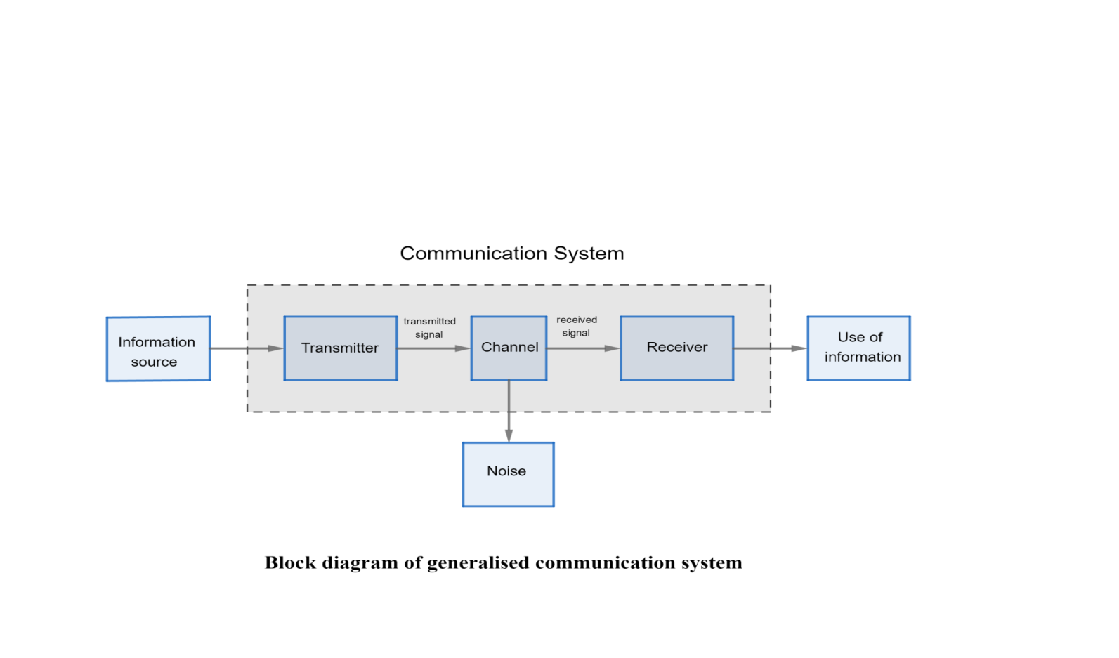

***Source:*** The source sends a message in order to share information with others. The source could be one other person or a group of people.

***Message:*** The message is the information or subject matter the source is intending to share. The information may be an opinion, feelings, instructions, requests, or suggestions.

**(2)**

***Channels :*** The source may encode information in the form of words, images, sounds, body language, etc. There are many definitions and categories of communication channels to describe their role in the communication process. This module identifies the following channels: verbal, non-verbal, written, and digital.

***Receiver :*** The receiver is the person for whom the message is intended. This person is charged with decoding the message in an attempt to understand the intentions of the source.

***Environment :*** The environment is the space in which the communication is happening .

***Context:*** The context is the setting, scene, and psychological and psychosocial expectations of the source and the receiver(s) This is strongly linked to expectations of those who are sending the message and those who are receiving the message.

***Interference:*** There are many kinds of interference (also called “noise”) that inhibit effective communication. Interference may include poor audio quality or too much sound, poor image quality, too much or too little light, attention.

***Note :***The goal of the communication process is to share meaning between a source and a receiver.

There are eight essential elements in the communication process: source, message, channel, receiver, feedback, environment, context, and interference.

**(3)**