

**Fluid Mechanics**

**References**

**1. Dr. Atheer Zaki Mohsin ,** **Al-Furat Al-Awsat Technical University**

**2. A Text Book of Fluid Mechanics and Hydraulic Machines, by Rajput, 1998**

**3. Fluid Mechanics, by Streeter & Wylie,1983,1979**

**4. Fluid Mechanics With Engineering Applications , by Daugherty, 1989**

***Asst. Lec. Safa Ali Hussein***

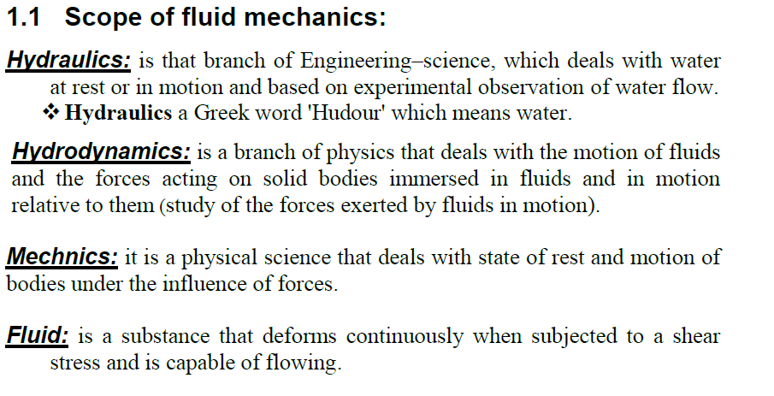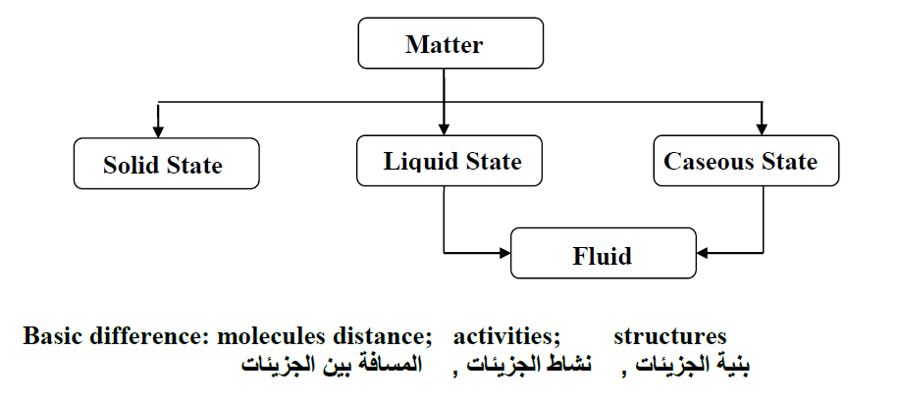

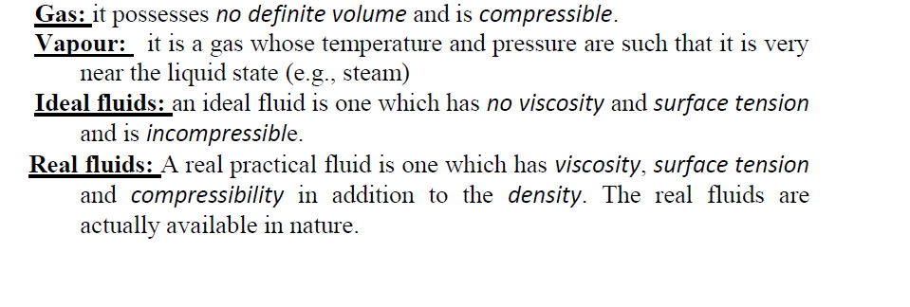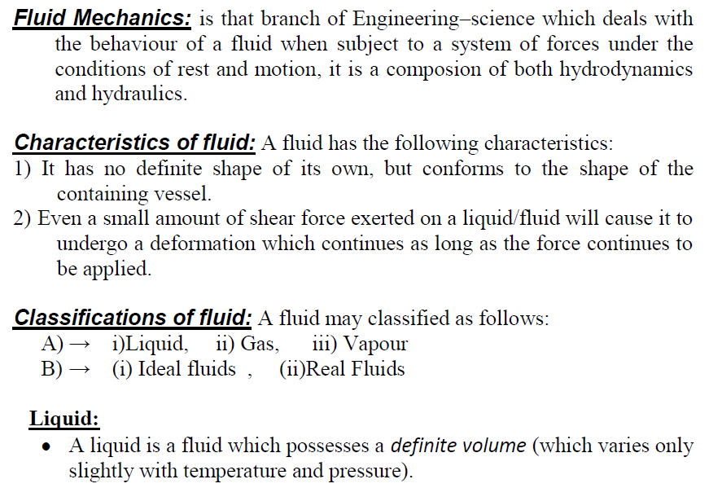

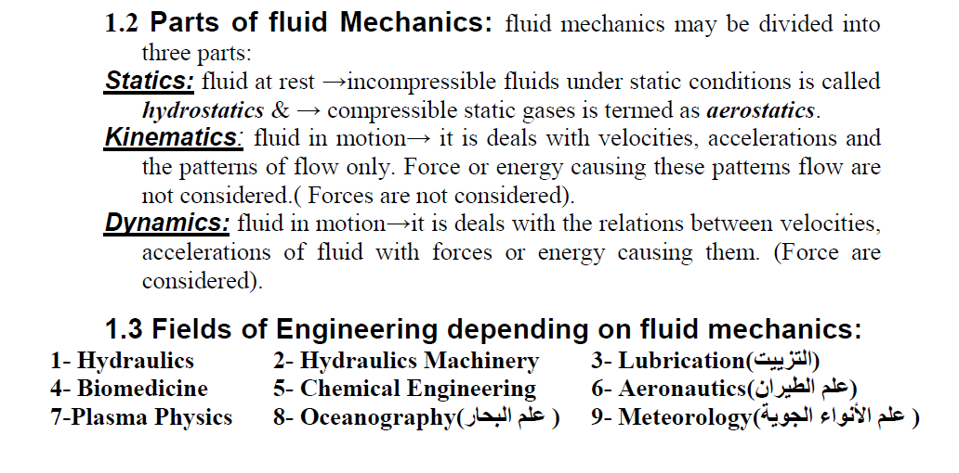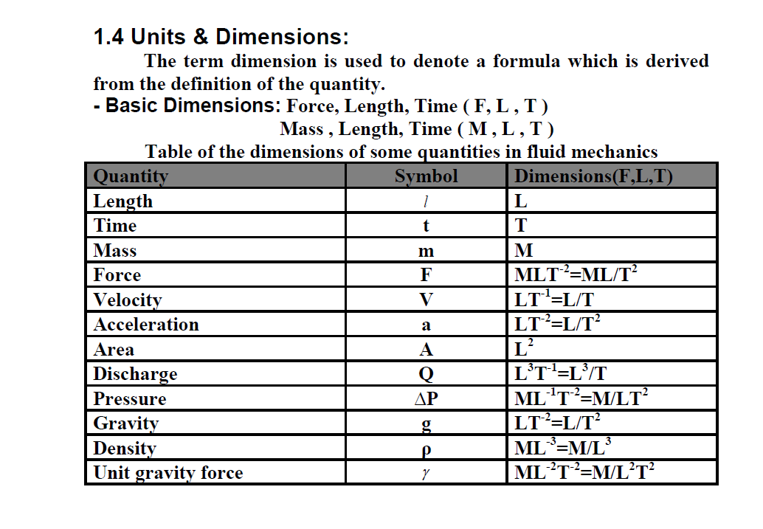

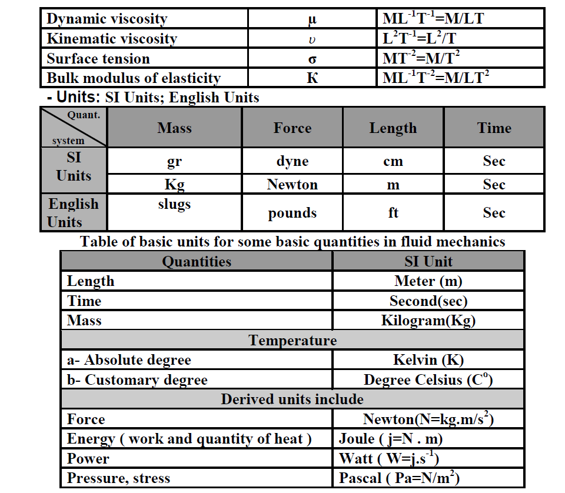

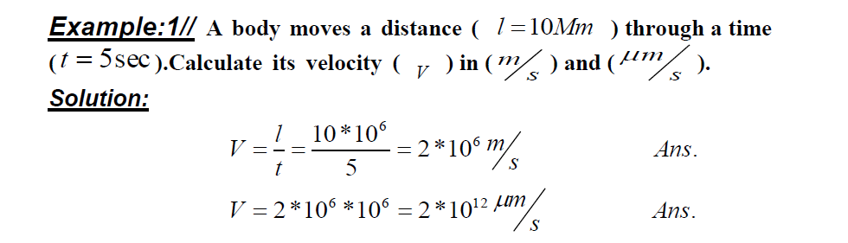

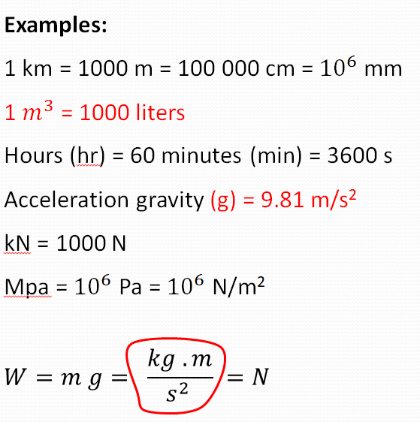

**2//**