كليـــة العلـــــوم
قسم الأمن السيبراني

Subject: Object Oriented Programming (OOP)
Second Stage
Lecturer: Dr. Abdulkadhem A. Abdulkadhem

Lecture (5)
Introduction to Object-Oriented Programming (OOP) -Continue

2.4. Polymorphism:
Polymorphism allows objects of different types to be treated as objects of a common superclass. It enables a single function or method to behave differently based on the object that calls it.
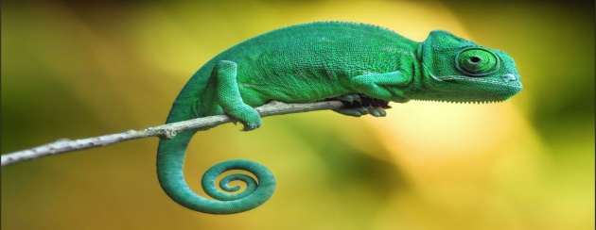
#include <iostream>
using namespace std;

class Animal {
public:
virtual void makeSound() {
cout << "Some generic animal sound" << endl;
}
};

class Dog : public Animal {
public:
void makeSound() override {
cout << "Woof!" << endl;
}
};

class Cat : public Animal {
public:
void makeSound() override {
cout << "Meow!" << endl;
}
};

int main() {
Animal* myAnimal;
Dog myDog;
Cat myCat;

myAnimal = &myDog;
myAnimal->makeSound(); // Outputs: Woof!

myAnimal = &myCat;
myAnimal->makeSound(); // Outputs: Meow!

return 0;
}
Explanation:
- Here, we use polymorphism to treat Dog and Cat objects as Animal objects. The method makeSound() behaves differently depending on whether it's called by a Dog or a Cat.
- Polymorphism enables flexibility and the ability to handle multiple object types through a common interface (in this case, Animal).
Example: Let’s consider a simple example where we have different geometric shapes like circles, rectangles, and triangles. We want to write a method that can draw any shape, but the way we draw each shape is different.
To achieve this, we can create a base class Shape that has a virtual method draw(). Each derived class will override the draw() method to provide its specific implementation.

#include <iostream>
using namespace std;
class Shape { // Base class (superclass)
public:
virtual void draw() { // Virtual function to allow overriding in derived classes
cout << "Drawing a generic shape" << endl;
}
};
class Circle : public Shape { // Derived class representing a circle
public:
void draw() override { // Overriding the draw() function for Circle
cout << "Drawing a circle" << endl;
}
};
class Rectangle : public Shape { // Derived class representing a rectangle
public:
void draw() override { // Overriding the draw() function for Rectangle
cout << "Drawing a rectangle" << endl;
}
};
class Triangle : public Shape { // Derived class representing a triangle
public:
void draw() override { // Overriding the draw() function for Triangle
cout << "Drawing a triangle" << endl;
}
};
int main() {
Shape* shape; // Pointer to base class (Shape)
Circle circle;
Rectangle rectangle;
Triangle triangle;
shape = &circle; // Assign pointer to Circle object and call draw()
shape->draw(); // Output: Drawing a circle
shape = &rectangle; // Assign pointer to Rectangle object and call draw()
shape->draw(); // Output: Drawing a rectangle
shape = &triangle; // Assign pointer to Triangle object and call draw()
shape->draw(); // Output: Drawing a triangle
return 0;
}

3. Conclusion:
Object-Oriented Programming makes software design more organized and intuitive by breaking down a problem into objects. Through abstraction, encapsulation, inheritance, and polymorphism, OOP encourages code reuse, modularity, and ease of maintenance.
Key Takeaways:
- Abstraction simplifies complex systems.
- Encapsulation protects data and ensures controlled access.
- Inheritance promotes code reuse.
- Polymorphism allows for flexibility in method behavior.

