**1.2 Special functions**

Special functions are particular mathematical functions that have more or less established names and notations due to their importance in mathematical analysis, functional analysis, geometry, physics, or other applications.

1.2.1. Types of Special Function

**• Gamma Function**

**• Unit Impulse function (The Dirac Delta Function)**

**• The Unit Step Function (Heaviside Function)**

**1.2.1.1. Gamma Function**

The Gamma function is defined by:

$$Γ(n)=\int_{0}^{∞}{x^{n-1}} e^{-x} dx$$

Methods for solving the gamma function

if the coefficient is positive number $Γ(n)=(n-1)!$

If the coefficient is a positive fraction $Γ(n)=(n-1)Γ(n)$

If the coefficient is a negative fraction $Γ(n)=\frac{Γ(n+1)}{n}$

Examples:

$$Γ(5)=4!=4*3*2*1=24$$

$Γ(\frac{1}{2})=\sqrt{π}$

$(\frac{3}{2})(\frac{1}{2})Γ(\frac{1}{2})=\frac{3}{4}√π$*

**= $Γ(\frac{5}{2})=(\frac{3}{2})Γ(\frac{3}{2})$**

$=-2√π$ $Γ(-\frac{1}{2})=\frac{Γ(\frac{1}{2})}{(-\frac{1}{2})}$

**Examples 1: $\int_{0}^{∞}{\sqrt{x}} e^{{-x}^{3}} dx$**

Solution//

2)

3) New limits: x=0 t=0

: x= $∞$ $→$ t= $∞$

4) $I=\int_{0}^{∞}{t^{ \frac{1}{6}}x} e^{t} (\frac{1}{3}t^{-\frac{2}{3}})dt=\frac{1}{3}\int_{0}^{∞}{t^{- \frac{1}{2}}} e^{t} dt=\frac{1}{3}Γ(\frac{1}{2})=\frac{√π}{3}$

**Examples 2**: $\int_{0}^{∞}{x^{4}} e^{{-x}^{4}} dx$

Solution//

2)

3) New limits: x=0 $→$ t=0

: x= $∞$ $→$ t= $∞$

4) $I=\int_{0}^{∞}{t} e^{-t} (\frac{1}{4}t^{-\frac{3}{4}})dt=\frac{1}{4}\int_{0}^{∞}{t^{\frac{1}{4}}} e^{-t} dt=\frac{1}{4}Γ(\frac{5}{4})=\frac{1}{16}Γ\frac{1}{4}$

**1.2.1.2.** Unit Step Function (Heaviside Function)

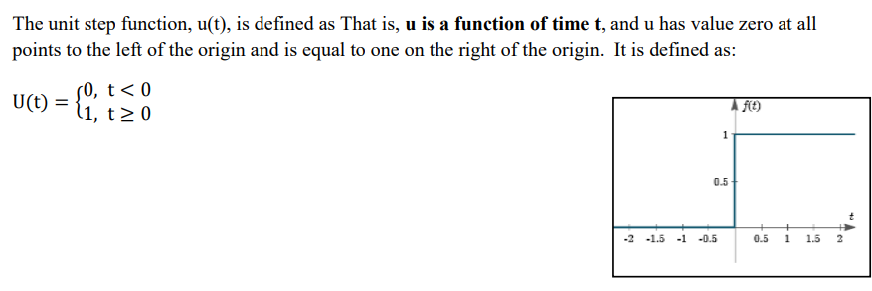

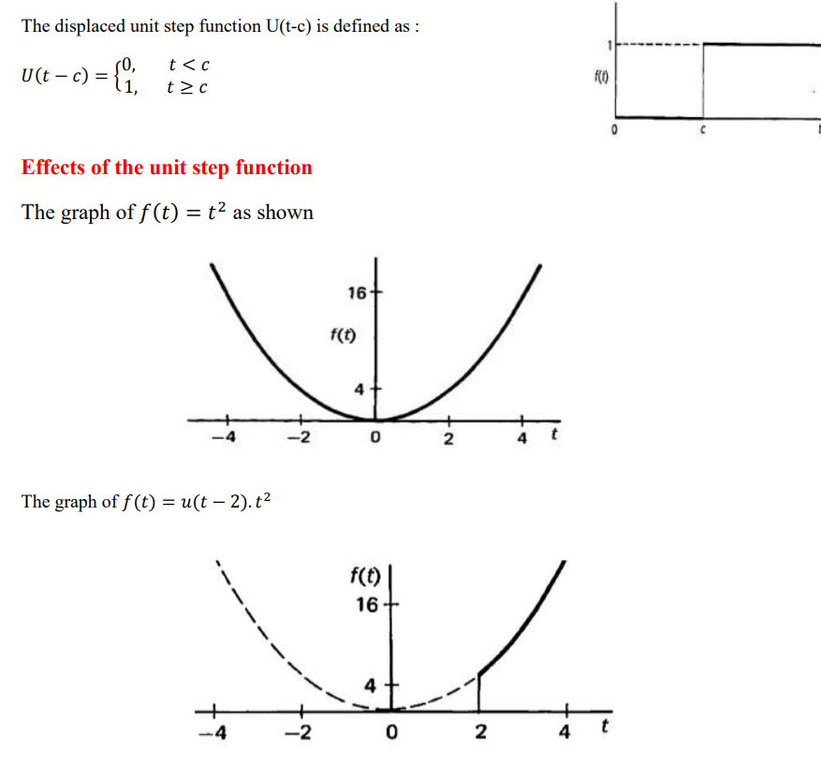 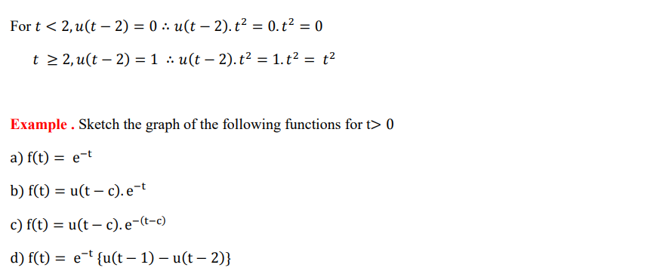

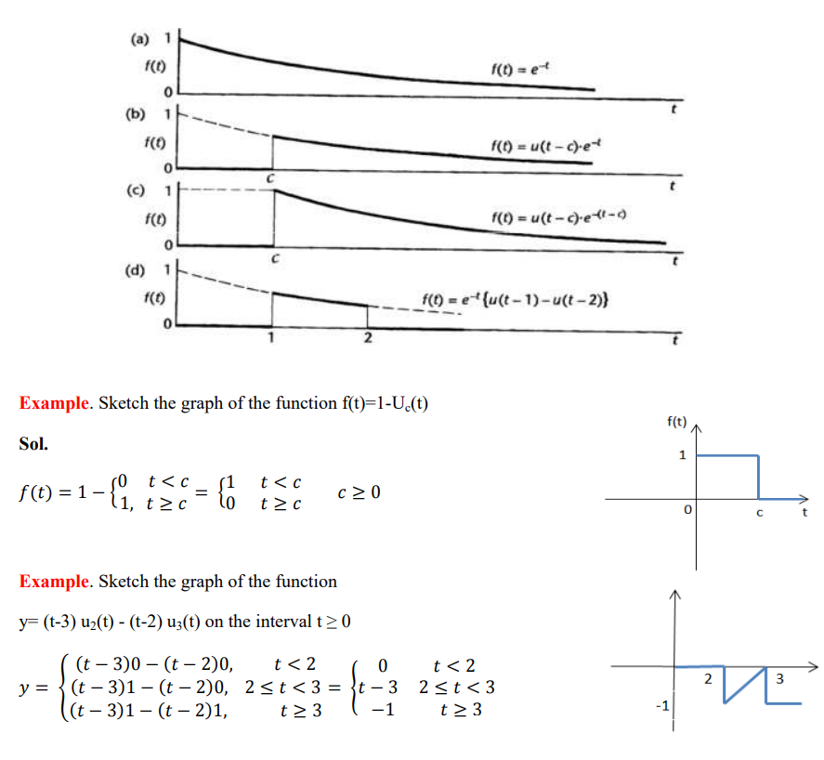

**1.2.1.3. Unit Impulse Function (Dirac delta function)**

