Tachymetric survey

Tachymetric surveying or rapid surveying, by which we mean measuring horizontal and vertical distances and water between two or more points without the need to use a measuring tape. It can also be used to calculate the levels of points without using a leveling device, by using a theodolite device, especially in rugged areas where a leveling device cannot be used

Tachymetric surveying devices There are several types of devices used in micrometric surveying, as shown below.

1. the regular devices, the leveling device and the theodolite device.
2. regular tachymetric
3. the support arms
4. electronic tachymetric
5. Total station.
6. **Conventional devices Level leveling device**

The leveling device is used to measure the horizontal distance between the point where the device is installed and any other point. At this point, the device is installed above any ground point such as point A and the ruler is placed above the observed point B and the readings of the upper, middle and lower ruler are recorded. These readings are called estimator readings.

**M**

**U**

AB

**L**

A

A

Horizontal Distance = H

U= Upper reading

M= Middle reading U

L= lower reading M

S= Upper reading- lower reading L

H= (K*S) +C, where K is constant =100, C= 0

**H= 100*S S=U-L**

**Example: Calculate the horizontal distance between the leveling device installed at point A and the observed point B if you know that the reading of the upper bar of the device is 2.173 m and the reading of the lower bar is 0.749 m.**

**Solution:**

**S=U-L**

**S=2.173-0.749=1.424m**

**H=100*S**

**H=100*1.424=142.4m**

Tachymetric surveying using the theodolite device in the theodolite device, tachymetric surveying is done in several ways, including:

1. Tachymetric surveying using the **shadow method** depends on reading the middle hair only.
2. Tachymetric surveying using the stedia sights method depends on reading the three Sights

**The method of the stedia sights**: In this method, the reading of the upper, middle and lower in the device, and the horizontal distances and levels are determined. The leveling device ruler is used with the device and the ruler is fixed on the unknown points of the level.

**If the vertical angle is an angle of elevation**

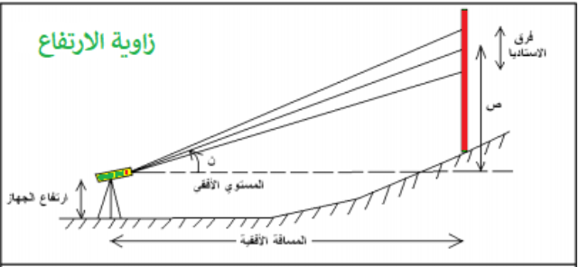

H=100*S

H=100*S*Cos2α

V=50*S*Sin2 α

Elev.B=Elev.A+i+V-R

**If the vertical angle is an angle of depression**

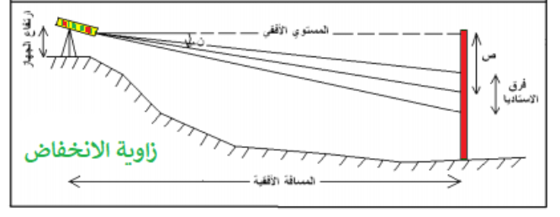

H=100*S*Cos2α

V=50*S*Sin2 α

Elev.B=Elev.A+i-V-R

**Example 2**: **A tachymetric survey was conducted between points (A, B, C) and the results were as shown below. Calculate the percentage slope of line (A), knowing that the level of point B is 20 meters and the points are on the same straight line.**

|  |  |  |  |  |  |  |
| --- | --- | --- | --- | --- | --- | --- |
| **Ins.Po.** | **Target** | **i** | **U** | **M** | **L** | α |
| **B** | **A** | **1.75m** | **2.174** | **1.565** | **0.956** | **-3◦30⸍** |
| **C** | **3.997** | **2.661** | **1.325** | **2◦55⸍** |

**Solution:**

**Elev. Of B=20m**

**Slope of AC= $\frac{Elev. of C-Elev.of A}{H1+H2}$ =**

For line AB:

S1=U-L

=2.174-0.956

=1.218m

H1= 100*S1*Cos2 α

H1= 100*1.218* Cos2 (**-3◦30⸍**)

H1=121.35

V=50*S*Sin2 α

V1= 50*1.218* Sin2 (**3◦30⸍)**

V=7.42m

Elev. of A = Elev.B + i-V-R

= 20+1.75-7.42-1.565

Elev. of A =12.765m

For line BC

S2=U-L

=3.997-1.325

=2.672m

H2= 100*S2*Cos2 α

H2= 100*2.672* Cos2 (2**◦**55**⸍**)

H1=266.51m

V=50*S2*Sin2 α2

V2= 50*2.672* Sin2 (2**◦**55**⸍**)

V2=13.60m

Elev. of C = Elev.B + i+V-R

Elev. of C =32.689m