Ministry of Higher Education and Scientific Research

Al-mustaqbal University

Faculty of Engineering and Engineering Technologies

Department / Computer Technology Engineering

***Communications Fundamentals***

***Second stage***

***Lecture (5)***

# +

# C:\Users\HP\Desktop\جامعة المستقبل.jfif

# 

# Introduction

Fourier analysis allows us to model periodic phenomena which appear frequently in engineering and elsewhere.

Related period functions may be complicated. The idea of Fourier analysis is to represent complicated periodic functions in terms of simple periodic functions, namely cosines and sines. The representations will be infinite series called **Fourier series**.

# Fourier series

Fourier series are infinite series that represent periodic functions in terms of cosines and sines. As such, Fourier series are of greatest importance to the engineer.

A function *f* (*x*) is called a **periodic function** if *f* (*x*) is defined for all real *x*, except possibly at some points, and if there is some positive number *p*, called a **period** of *f* (*x*), such that

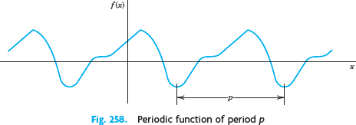

Familiar periodic functions are the cosine, sine, tangent, and cotangent. Examples of functions that are not periodic are *x, x*2*, x*3, *ex,* cosh *x and* ln *x*.

For any integer ***n* = 1, 2, 3, … *f* (*x + np*) = *f* (*x*), for all *x***

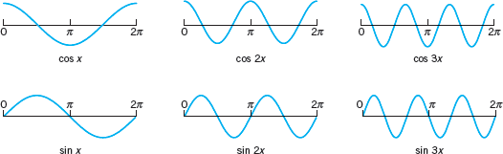How to represent various ***functions f (x) of period* 2*π*** in terms of the simple functions: 1, cos *x*, sin *x*, cos 2*x*, sin 2*x*, …, cos *nx*, sin *nx*, …(*Their periods are* 2*π*) ?

The series to be obtained will be a **trigonometric series**, that is, a series of the form

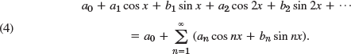

***a*0, *a*1, *b*1, *a*2, *b*2,** are the **coefficients** of the series.

Now suppose that *f* (*x*) is a given function of period **2π** and is such that it can be **represented** by a series (4), that is, (4) converges and, moreover, has the sum *f* (*x*). Then, using the equality sign, we write

and call (5) the **Fourier series** of *f* (*x*). In this case the coefficients of (5) are the so-called

**Fourier coefficients** of *f* (*x*), given by the **Euler formulas**

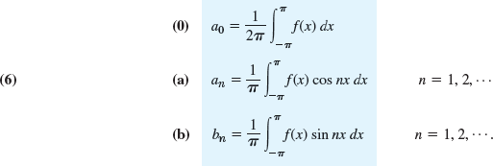

### Example:

Find the Fourier coefficients of the periodic function *f* (*x*) in Fig (*representing external periodic force acting on a mechanical system*). The formula is

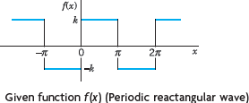

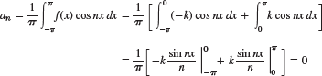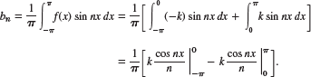



Then, **Fourier series** of ***f*(*x*)** becomes:

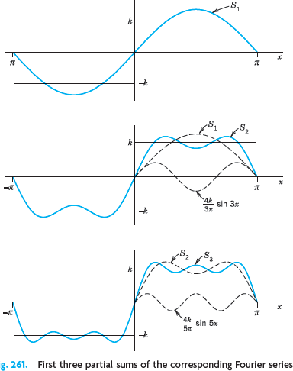



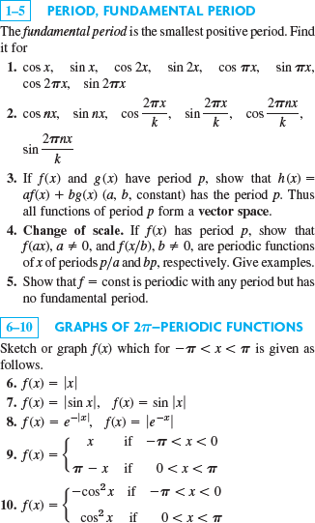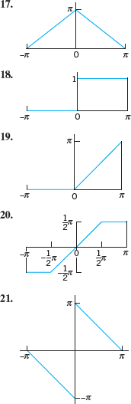

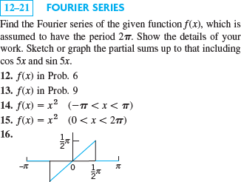

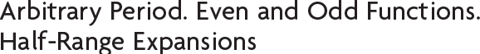

This section concerns three topics:

1. Transition from period 2π to any period 2*L*, for the function *f*, simply by a transformation of scale on the *x-*axis.
2. Simplifications. Only cosine terms if *f* is even (“Fourier cosine series”). Only sine terms if *f* is odd (“Fourier sine series”).
3. Expansion of *f* given for 0 ≤ *x* ≤ *L* in two Fourier series, one having only cosine terms and the other only sine terms (“half-range expansions”).

## From Period (2π) to any Period *p =* 2*L*

Periodic functions in applications may have any period, not just 2π. ***L*** may represent the length of beams in vibration, or rods in heat conduction.

The transition from period **2π** to be period ***p =* 2*L*** is effected by a suitable change of scale,

Fourier series of period ***p =* 2*L*** becomes



with the **Fourier coefficients** of *f*(*x*) given by the **Euler formulas:**

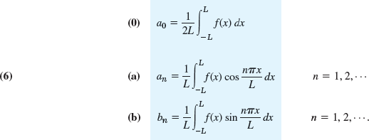

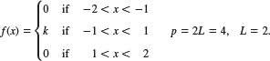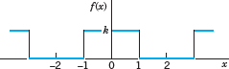Find the Fourier series of the function:

Solution:

*a0* = *k* / 2 (verify ?)



*an* = *0 if n = even.*

*an* = 2*k* / *nπ if n = 1, 5, 9, …*

*an* = – 2*k* / *nπ if n = 3, 7, 11, … bn* = 0 *if n = 1, 2, 3, …* (verify ?)

Then, Fourier series of period = 2*L* becomes



It is Fourier cosine series.

### Example (HW)

Find the Fourier series of the function:

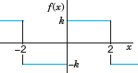

*Answer*:



## Simplifications: Even and Odd Functions

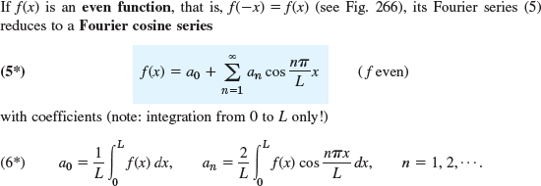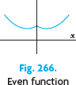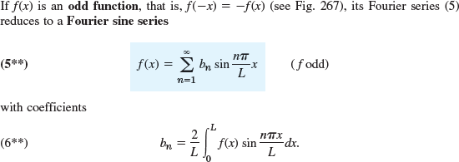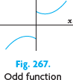

**Example:**

Find the Fourier series of the function (Fig. 268)

*f* (*x*) = *x* + π if – π < *x* < π and *f* (*x* + 2π) = *f* (*x*).

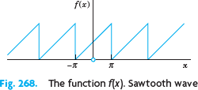

*a0* = π (verify)

*an* = 0 (verify)



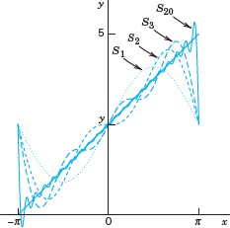

## Half-Range Expansions

Half-range expansions are Fourier series. We want to represent in *f*(*x*) in Fig. 270.0 by a Fourier series. We could extend *f*(*x*) as a function of period *L* and develop the extended function into a Fourier series.

If we use eq. (6*) we get (5*) [*see p.7*]. This is the **even periodic extension** *f*1 of *f* in Fig. 270a. If we use eq. (6**) we get (5**) [*see p.7*]. This is the **odd periodic extension** *f*2 of *f* in Fig. 270b.

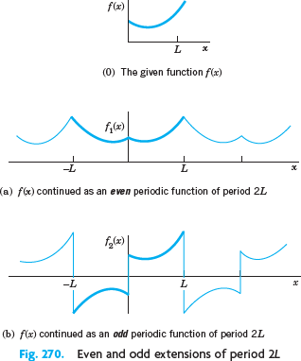

Both extensions have period 2*L*. This motivates the name **half-range expansions**:

*f* is given only on half the range, that is, on half the interval of periodicity of length 2*L*.

## Example:

Find the two half-range expansions of the function

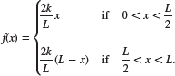

**1.**

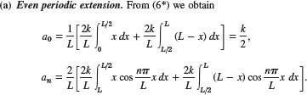

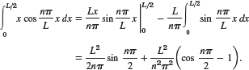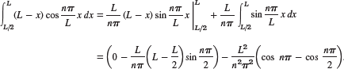

**2.**



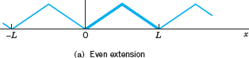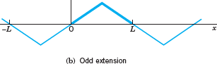



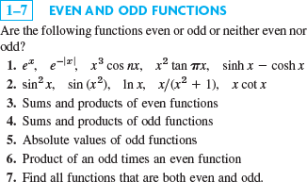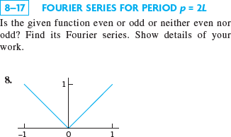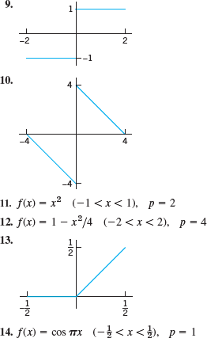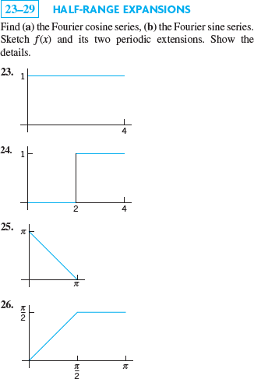

# Forced Oscillations

Fourier series have important applications for both ODEs and PDEs. All these applications will show our indebtedness to Euler’s and Fourier’s ingenious idea of splitting up periodic functions into the simplest ones possible.

We know that forced oscillations of a body of mass *m* on a spring of modulus *k* are governed by the ODE:



Where ***y = y*(*t*)** is the displacement from rest, ***c*** the damping constant, ***k*** the spring constant (spring modulus), and ***r* (*t*)** the external force depending on time ***t*.** Figure 274 shows the model

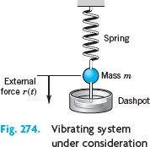

## Example:



Verify this Fourier cosine series of r(t) !

