**Al-mustaqbal University**

**College of Engineering and Engineering Technologies**

**Department of Computer Engineering Technologies**

***Communications Fundamentals***

***Second Stage***

***Tutorial Sheet (1)***

***Example (1):*** plot the following continuous-time signals.

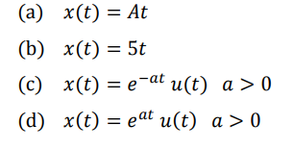

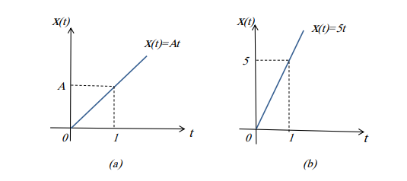

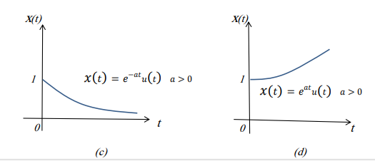

(1)

***Example (2):*** Test the periodicity of the following given functions and find their fundamental intervals:

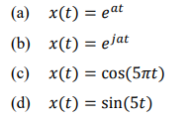

Sol:

1. By definition, a function is said to be periodic if:

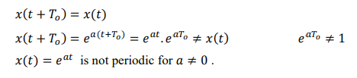

1. 

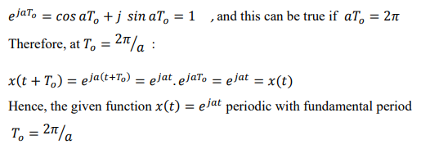

(2)

)c)

C:\Users\HP\Desktop\3.PNG

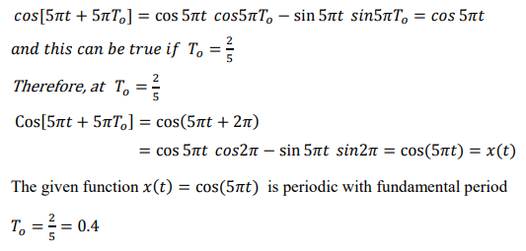

***(d)***

C:\Users\HP\Desktop\7.PNG

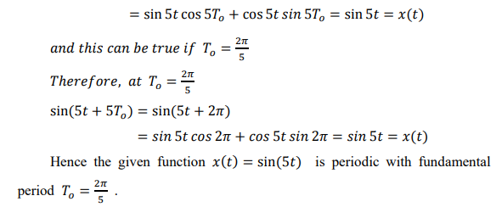

(3)

***Example (3):*** Are the following signals periodic? If a signal is periodic, determine its fundamental period.

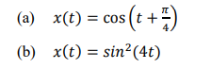

***Sol:***

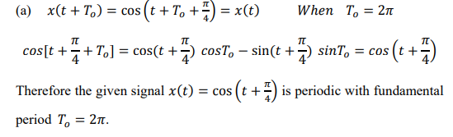

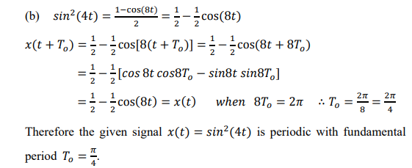

(4)

***Example (4):*** Identify whether the following signal is energy or power signal:



***Sol:***

Energy of real signal is given by:

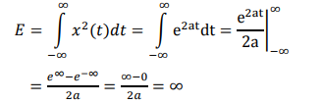

* E is not a finite value; hence the given signal is not an energy signal. To verify if it is a power signal or not: The average power of a real signal is given by:

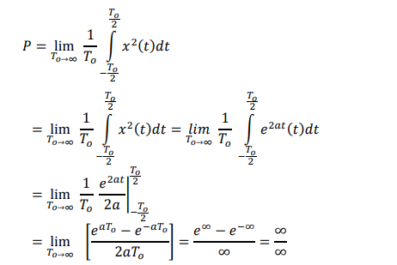

And this is an indeterminate form, therefore applying L’Hopital’s rule we get:

C:\Users\HP\Desktop\4.PNG

* P is not a finite value Therefore the given signal $e^{a}=a>1,$ is neither an energy signal nor a power signal.

(5)

***Example 5 :*** find energy for this signal equation

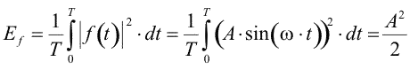

*Sol:*

***Example 6 :*** determine if the signal is Energy signals, Power signals, or neither, and evaluate *E* and *P* for each signal:

C:\Users\HP\Desktop\1.PNG

This is a periodic signal, so it must be a power signal. Let us prove it.

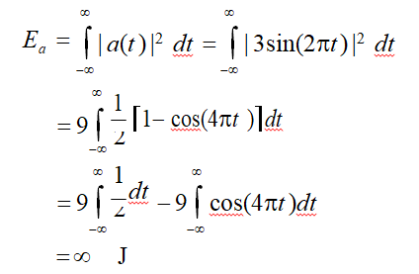

Notice that the evaluation of the last line in the above equation is infinite because of the first term. The second term has a value between –2 to 2 so it has no effect in the overall value of the energy.

Since *a*(*t*) is periodic with period T = 2/2 = 1 second, we get

(6)

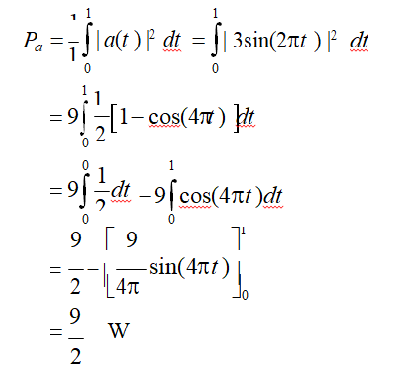

So, the energy of that signal is infinite and its average power is finite (9/2). This means that it is a power signal as expected. Notice that the average power of this signal is as expected (square of the amplitude divided by 2)

***Example 7:*** Classify the following signal as a power signal, energy signal, or neither and find its power or energyas appropriate x(t) = e−t;

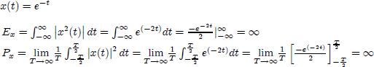Sol:

∴ Since this signal has infinite energy and power signals, it is neither an energy nor a power signal.

(7)

***Example 8*: Determine whether the following signal is periodic or not. If the signal is periodic, determine its fundamental periodic.**

***C:\Users\HP\Desktop\6.PNG***

***Sol:*** The signal is periodic if:

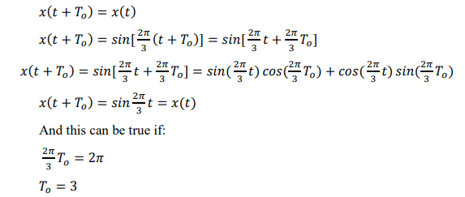

***C:\Users\HP\Desktop\8.PNG***

***Example 9:* Determine whether the following signal is energy signal, power signal, or neither.**

**C:\Users\HP\Desktop\1.PNG**

**Sol:**

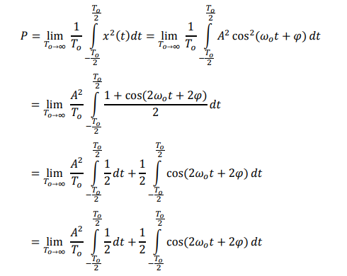

**(8)**

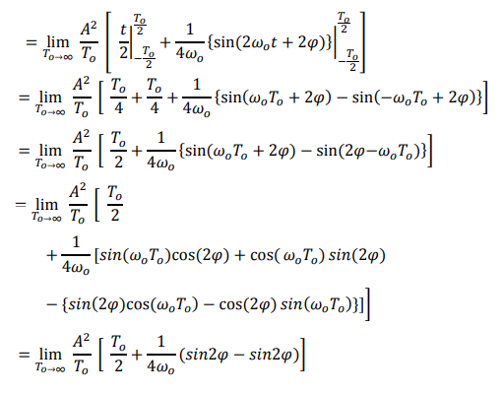

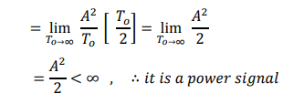

***(9)***

***Example 10:*Determine whether the rectangular signal shown in Figure below is energy signal, power signal, or neither.**

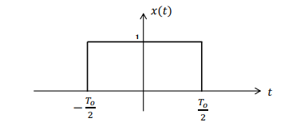

***Sol:***

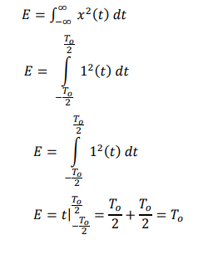

Since the energy is finite and nonzero, hence it is an energy signal. Now if we find the power of the signal we get the following :

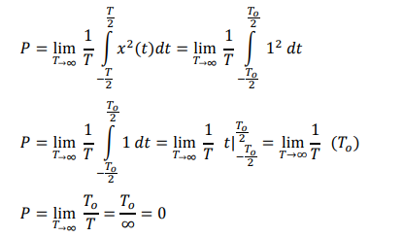

***(10)***