**Electronic Circuit**

**Lecture 6 ( $9^{th}$ Week)**

**Multiple BJT Networks**

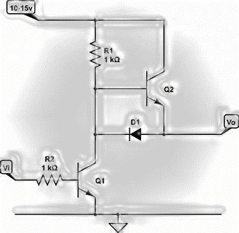

|  |  |
| --- | --- |
| Lecture Description | |
| **Target Audience** | The second stage for undergraduate students / Department of Medical Instrumentation Techniques Engineering |
| **General Objective** | studying **Multiple BJT Networks** is to understand how to design and analyze circuits that use more than one Bipolar Junction Transistor (BJT) in various configurations. |
| **Central Idea** | Multiple BJT Networks is to use Bipolar Junction Transistors (BJTs) in various interconnected configurations to create complex electronic circuits that provide specific characteristics, such as amplification, current control, and signal integration. |
| **Behavioral Objectives** | Upon completing this lecture, students will be able to:   * The different types of bipolar junction transistor (BJT) networks used in advanced circuits. * States the fundamental laws that govern the operation of these networks, such as Ohm's Law and Kirchhoff's laws of current and voltage. * Explains how transistors work in multi-layer networks, and how the characteristics of each layer affect the others. * Is able to analyze a circuit containing multiple BJT networks using analysis techniques. |
| **Time** | 2 hr. |
| **Academic Year** | 2024-2025 |

|  |  |
| --- | --- |
| وصف المحاضرة | |
| طلبة الدراسة الاولية من المرحلة الثانية /قسم هندسة تقنيات الأجهزة الطبية | **الفئة المستهدفة** |
| دراسة **شبكات الترانزستورات الثنائية القطب المتعددة هو** فهم كيفية تصميم وتحليل الدوائر التي تستخدم أكثر من ترانزستور واحد من نوع BJT في تكوينات متنوعة | **الهدف العام** |
| استخدام ترانزستورات الوصلة الثنائية (BJT) في تكوينات متعددة ومتداخلة لإنشاء دوائر إلكترونية معقدة توفر خصائص معينة، مثل التضخيم، والتحكم في التيار، وتكامل الإشارة | **الفكرة الرئيسية** |
| عند الانتهاء من هذه المحاضرة، سيتمكن الطالب من:   * أن الأنواع المختلفة من شبكات الترانزستور الثنائية القطب (BJT) المستخدمة في الدوائر المتقدمة. * يذكر القوانين الأساسية التي تحكم عمل هذه الشبكات، مثل قانون أوم وقانون كيرشوف للتيار والجهد * يشرح كيفية عمل الترانزستورات في شبكات متعددة الطبقات، وكيف تؤثر خصائص كل طبقة على الأخرى * يتمكن من تحليل دائرة تحتوي على شبكات متعددة من الترانزستورات الثنائية القطب باستخدام التحليل. | **الأهداف السلوكية** |
| 2 ساعة | **الوقت** |
| 2024-2025 | **السنة الدراسية** |

**4.5. Voltage Divider Bias Configuration**

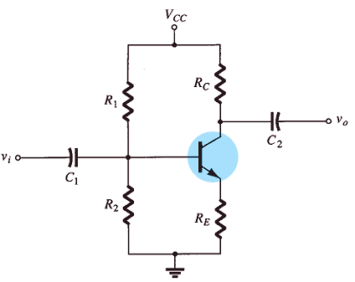

**Fig. (1). Voltage-divider bias configuration.**

When analyzed precisely, the sensitivity of the circuit to variations in beta is relatively low. If the circuit parameters are chosen appropriately, the resulting levels of $I_{CQ}$ and $V_{CEQ}$ ​ can be nearly independent of beta. Recall from earlier discussions that the Q-point is defined by specific levels of $I_{CQ}$ and $V_{CEQ}$ ​, as illustrated in Fig. (2). While the level of $I_{BQ}$ ​ will change with variations in beta, the operating point determined by $I_{CQ}$ ​ and $V_{CQ}$ can remain stable if the circuit parameters are correctly selected.

**Methods for Analyzing the Voltage-Divider Configuration:**

* There are two methods for analyzing the voltage-divider configuration:
  + **Exact Method**: This method can be applied to any voltage-divider configuration and provides precise results.
  + **Approximate Method**: This method can only be applied under specific conditions and allows for a quicker and simpler analysis.

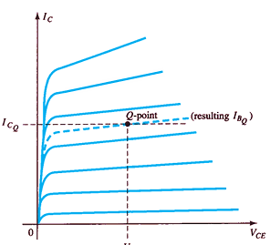

**Fig. (2). Defining the Q-point for the voltage-divider bias configuration.**

**Exact Method**

For the DC analysis, the network an be modified as depicted in Fig. (3). Subsequently, the input side of the network can be simplified further for DC analysis. Using this configuration, the Thevenin equivalent network for the portion of the circuit left of the base terminal can be determined as follows:

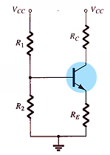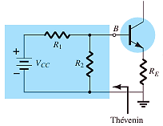

**Fig. (3). DC components of the voltage divider configuration and redrawing the input side of the network.**

|  |
| --- |
|  |

$R_{th}$ The voltage source is substituted with a short-circuit equivalent,

$$R_{th}=R_{1}\left\|R_{2}\right.$$

$E_{th}$ The voltage source $V_{CC}$ ​ is reintroduced to the network, and the open-circuit Thevenin voltage of Fig. 4. is determined as follows: using the voltage-divider rule, we get:

$$E_{th}=V_{R2}=\frac{R_{2}V_{CC}}{R_{1}+R_{2}}$$

|  |  |
| --- | --- |
|  |  |

**Fig. (4).** **Inserting the Thevenin equivalent circuit**

The Thevenin network is then redrawn. by first applying Kirchhoff’s voltage law in the clockwise direction for the loop indicated:

$$E_{th}-I_{B}R_{th}-V_{BE}-I_{E}R_{E}=0$$

Substituting $I_{E}=(β+1)I_{B}$ and solving for $I_{B}$ yields:

$$I_{B}=\frac{E_{th}-V_{BE}}{R_{th}+(β+1)R_{E}}$$

the remaining quantities of the network can be found in the same manner as developed for the emitter-bias configuration. That is:

$$V_{CE}=V_{CC}-I_{C}(R_{C}+R_{E})$$

**Example 1:** **Determine the dc bias voltage V CE and the current I C for the voltage divider configuration of Fig. (5).**

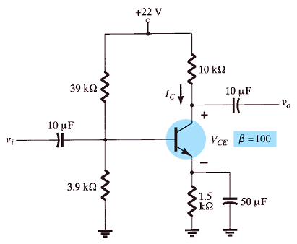

$$R_{th}=R_{1}\left\|R_{2}\right.$$

$$R_{th}=\frac{39 kΩ×3.9 kΩ}{39 kΩ+3.9 kΩ}=3.55 kΩ$$

$$E_{th}=\frac{R_{2}V_{CC}}{R_{1}+R_{2}}= \frac{3.9 kΩ ×22 V}{39 kΩ+3.9 kΩ}=2 V$$

$$I_{B}=\frac{E_{th}-V_{BE}}{R_{th}+\left(β+1\right)R_{E}}=\frac{2 V-0.7 V}{3.55+\left(100+1\right)}=8.38 μA$$

$$I_{C}=β I_{B}=100×8.38 μA=0.84 mA$$

$$V_{CE}=V_{CC}-I_{C}\left(R_{C}+R_{E}\right)=22 V-\left(0.84\right)\left(10+1.5\right)=22-9.66=12.34 V$$

**Approximate Method**

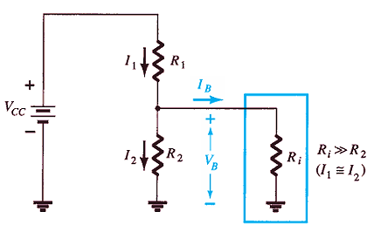

**Fig. (5). Partial-bias circuit for calculating the approximate base voltage $V_{B}$**

the key points for the input section of the voltage-divider configuration:

* The input section of the voltage-divider configuration can be modeled by a network similar to Fig. (5).
* $R_{i}$ Represents the equivalent resistance between the base and ground for the transistor, with an emitter resistor $R_{E}$ ​.
* The reflected resistance between the base and emitter is given by: $$R_{i}=(β+1)R_{E}$$
* When $R_{I}$ is significantly larger than the resistance $R_{2}$:
  + The base current $I_{B}$ ​ will be much smaller than $I_{2}$.
  + Current $I_{2}$ ​ will be approximately equal to $I_{1}$ ​ because current follows the path of least resistance.
* Assuming $I_{B}$ ​ is nearly 0 A compared to $I_{1}$ ​ and $I_{2}$ ​:
 $I_{1}=I_{2}$

 + Resistors $R_{1}$ and $R_{2}$ ​ can be treated as series elements.
* The voltage across $R_{2}$ ​ (also the base voltage) can be calculated using this series relationship.

It is determined using the voltage-divider rule, which is where the configuration gets its name.

$$V_{B}=\frac{R_{2}V_{CC}}{R_{1}+R_{2}}$$

Since $R_{I}=\left(β+1\right)R_{E}$ ​, the condition that determines whether the approximate approach can be applied is: $βR_{E}$ ​.

$βR_{E}≥10{ R}_{2}$

​

Once $V_{B}$ ​ is determined, the value of $V_{E}$ ​ can then be calculated:

$$V_{E}=V_{B}-V_{BE}$$

and the emitter current can be determined from

$$I_{E}=\frac{V_{E}}{R_{E}}$$

And, $I_{E}≅I_{CQ}$

The collector-to-emitter voltage is determined by:

$$V_{CE}=V_{CC}-I_{C}\left(R_{C}+R_{E}\right)$$

**Example 2:** Repeat the analysis of Fig. below using the approximate technique, and compare solutions for $I_{CQ}$ and $V_{CEQ}$.

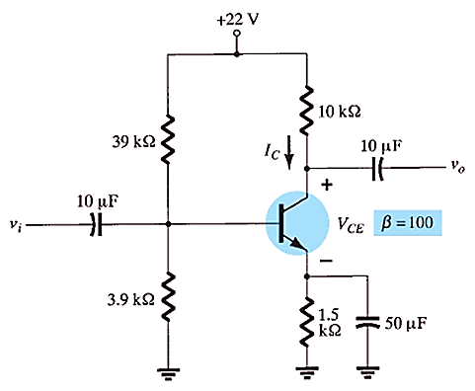

**Sol/**

$$βR_{E}≥10{ R}_{2}$$

(100 $×1.5 kΩ)≥10×3.9 kΩ$

150 k𝛀 $≥39 kΩ$

$$V_{B}=\frac{R_{2}V_{CC}}{R_{1}+R_{2}}=\frac{\left(3.9 kΩ ×22 V\right)}{39 kΩ+3.9 kΩ}=2 V$$

The main difference between the exact and approximate techniques lies in the effect of $R_{th}$ in the exact analysis, which separates $E_{th}$ ​ and $V_{B}.$

$$V_{E}=V_{B}-V_{BE}$$

$$V_{E}=2 V-0.7 V$$

$$V_{E}=1.3 V$$

$$I_{CQ}≅I_{E}=\frac{V_{E}}{R_{E}}=\frac{1.3 V}{1.5 KΩ}=0.867 mA$$

Compared to 0.84 mA with the exact analysis. Finally,

$$V_{CEQ}=V_{CC}-I_{C}\left(R_{C}+R_{E}\right)$$

$$V_{CEQ}=22 V-0.867\left(10+1.5\right)$$

$$V_{CEQ}=12.03 V$$

**4.6. Multiple BJT Networks**

So far, only single-stage BJT configurations have been introduced. This section will cover some popular networks using multiple transistors, demonstrating how the methods introduced in this chapter can be applied to networks with any number of components. The R-C coupling in Fig. (6). is one of the most common, where the collector output of one stage is directly connected to the base of the next stage using a coupling capacitor $C_{C}$ ​. The capacitor is selected to block DC between stages while acting as a short circuit for any AC signal. This network has two voltage-divider stages, but the same coupling can be applied between any configurations, such as fixed-bias or emitter-follower setups. Replacing $C_{C}$ and other capacitors with open-circuit equivalents yields the two bias arrangements shown in Fig. (7), allowing each stage to be analyzed separately without interference from the other. Of course, the 20 V DC supply must be applied to each isolated component.

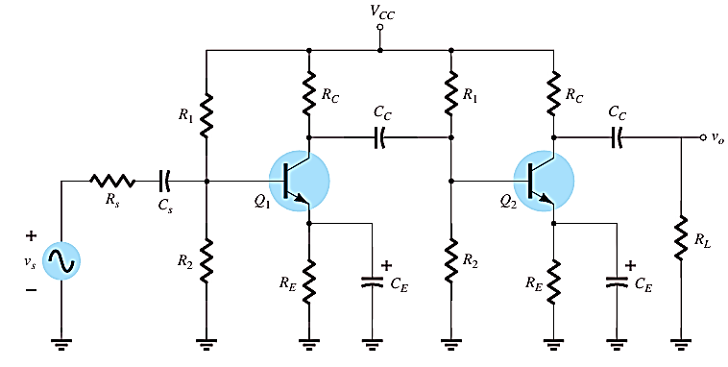

**Fig. (6). R–C coupled BJT amplifiers**

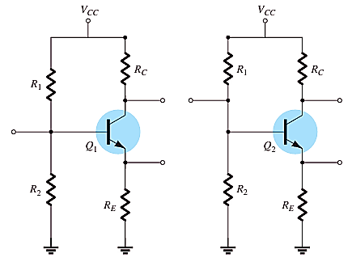

**Fig. (7). DC equivalent of Fig. (6).**

|  |  |
| --- | --- |
| For the dc analysis of Fig. (8). assuming a beta $β_{1}$ for the first transistor and $β_{2}$ for the second:  Assuming $β>>1$ for each transistor, we find the net beta for the configuration is: $$β_{D}=β_{1 }β_{2}$$ $$V_{BED}=V_{BE1}+V_{BE2}$$ $$I_{B1}=\frac{V_{CC}-V_{BED}}{R_{B}+\left(β_{D}+1\right)R_{E}}$$ $$I_{C2}≅I_{E2}=β_{D}I_{B1}$$ $$V_{E2}=I_{E1 }R_{E}$$ $$V_{C2}=V_{CC}$$ $$V_{CE2}=V_{CC}-V_{E2}$$ |  |
| **Fig.(8). DC equivalent Circuit** |

**Example 3:** **Determine the dc levels for the currents and voltages of the direct- coupled amplifier of Fig. (9).**

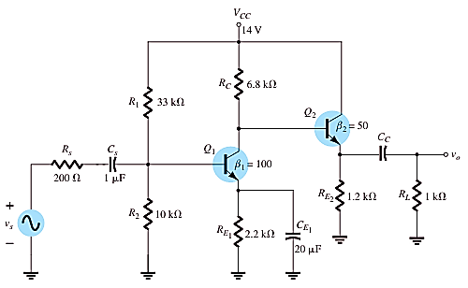

**Fig. (9). Direct- coupled amplifier.**

**Sol/**

|  |  |
| --- | --- |
|  |  |

**Summary:**

* Relies on dividing voltage using resistors.
* Resistors are connected in series to divide voltage between components.
* Used to set and adjust the appropriate voltage in electronic circuits.
* Commonly used in signal control and amplification circuits.
* Involves circuits with more than one BJT transistor working together.
* Used to enhance functional performance such as amplification or signal control.
* Can be in series, parallel, or multi-phase configurations.
* Improves frequency response and signal amplification efficiency.
* Increases control over current flow and isolates inputs from outputs.