

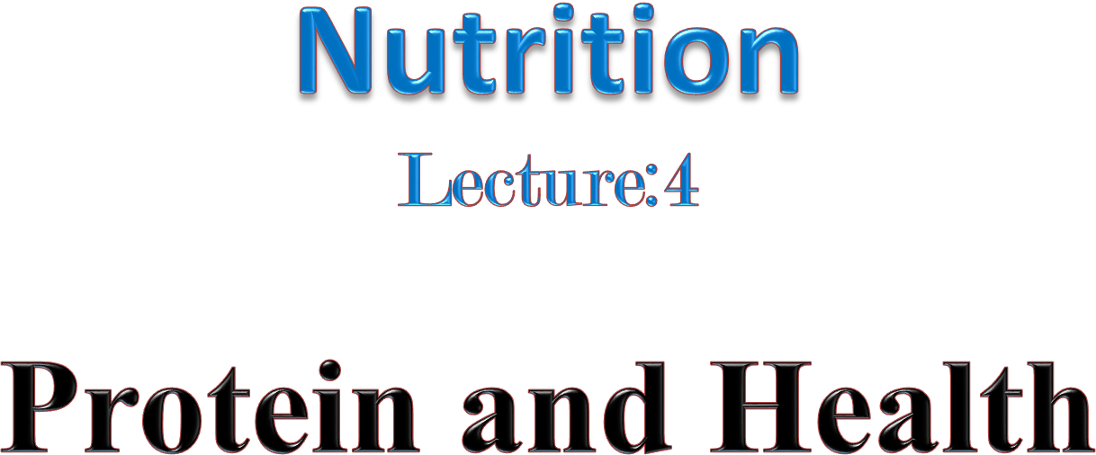

Professor Dr.fakhria jabber

2024-2025

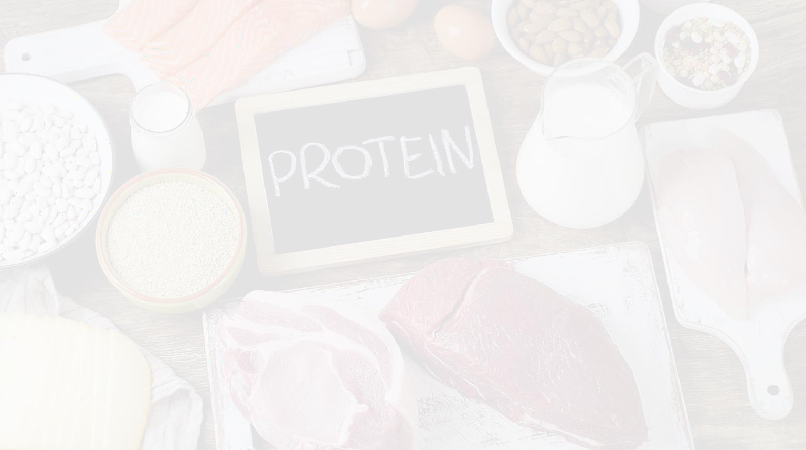

* Introduction
* Definitions, Composition of protein.
* Proteins and Amino Acids -Structure
* Classification of Protein
* Functions, Storage, Sources, and Utilization
* Recommended protein intake.
* Health effects of High protein diet.
* Protein in pregnancy.
* Disease associated with protein energy malnutrition

## Introduction

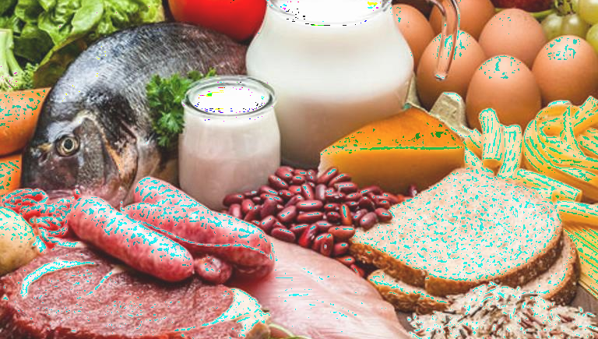

Next to water, protein is the most abundant component of the body. It accounts for about a sixth of the live body weight and a third of it is found in the muscles, a fifth in the bones and cartilage, a tenth in the skin and the remainder in other tissues and body fluids.

There are thousands of different specific proteins in the body, each having a unique structure and function. For this reason, the word protein implies not one but a large group of complex compounds. Proteins are present in all living tissues, both plant and animal.

*Composition of protein*

* Proteins are very large organic compounds. Proteins, like carbohydrates and fats, contain carbon, hydrogen and oxygen. In addition, proteins contain about 16 per cent nitrogen, which is their unique feature and distinguishes them from carbohydrates and fats. Some proteins also contain sulphur and sometimes phosphorus, iron and cobalt.
* Proteins are more complex than fats and carbohydrates, as the size of the molecule is large and there is a great variation in the units from which it is formed. Plants are the primary source of proteins in nature

**Proteins and Amino Acids -Structure**

***Proteins:*** are composed of carbon, hydrogen, oxygen, and nitrogen; they provide the foundation for every cell in the body. Proteins are broken down to amino acids by the body.

* All proteins in our body and food are built from basic units or compounds known as *amino acids*. Amino acids combine to form proteins by means of a peptide bond, which joins a carboxylic carbon of one amino acid with nitrogen of another.

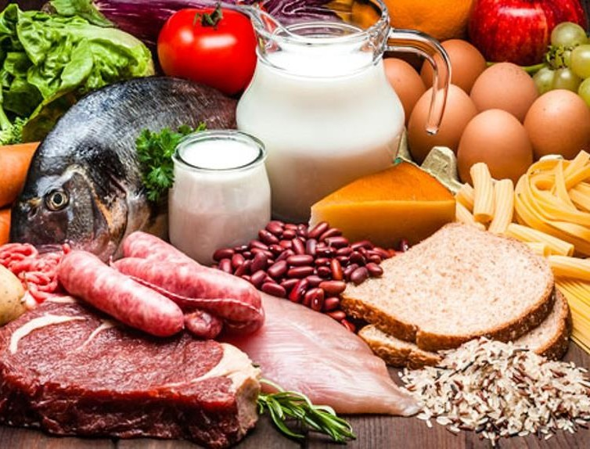

* + Amino acids are classified as essential e.a.a. (indispensable (IDAA))—that which cannot be produced by the body and must be obtained from food; and nonessential n.e.a.a. (dispensable (DAA))—that which can be produced by the body**.**

# Classification of Protein

1. More complex proteins have a tertiary structure in whcih the polypeptide chain is wound into a globular form.
2. Simple proteins yield only amino acids on hydrolysis. Albumins, globulins, glutelins, prolamins and albuminoids are simple proteins.
3. Conjugated proteins are combinations of simple proteins with non-protein substances. The combinations result in formations, which are functionally very important to the body.

### Functions

The main function of protein is to provide the body with the amino acids necessary for growth and maintenance of body tissues. Cells, enzymes, hormones, antibodies, muscles, blood, and all tissues and fluid except bile and urine require protein.

### Storage

Proteins in the form of amino acids are the building blocks of the body. Protein as such is not stored; therefore, a daily intake is required.

* **Sources**
* Animal sources of protein include milk and milk products, meat, fish, poultry, and eggs.
* Plant sources include breads and cereal products, legumes, nuts and seeds, and textured vegetable protein. Cereal grains are the primary source of protein for the majority of the world’s population.

**Utilization:** To be absorbed, proteins must be broken down to individual amino acids or small peptides (by-products of protein digestion composed of 2 to 10 amino acids).



The products of protein digestion are absorbed into the bloodstream as amino acids and are transported via the portal vein to the liver and then to all the body cells. Some amino acids stay in the liver to form liver tissue itself or to produce a wide variety of blood proteins. The remaining amino acids circulate in the bloodstream, from which they are rapidly removed and utilized by the tissues. When amino acids are broken down, the nitrogen containing part is split off from the carbon chain. Most of the nitrogen is converted to urea in the liver and excreted via the kidneys. Then the carbon-containing portion that remains is utilized for energy. Proteins provide 4 kcal per g, the same as carbohydrates.

# Recommended protein intake:

The Recommended Dietary Allowance (RDA) for protein is a modest 0.8 grams of protein per kilogram of body weight. The RDA is the amount of a nutrient you need to meet your basic nutritional requirements. In a sense, it’s the minimum amount you need to keep from getting sick — not the specific amount you are supposed to eat every day.

**Recommended protein intake:**

* 1. An average of ***15-20 %*** of total energy intake for adult male &female in form of essential

a.a. *(0.8 gm/kg IBW).*

* 1. For children require ***35%*** of total energy requirement in form of essential a.a. (*2.2*

*gm/kg) for <0.5months age.*

* 1. For infants 0.5months-1years = *1.6gm/kg.*
  2. It decrease with increasing of age *1.2-1g/kg (*till the age of 14years).
  3. For 15-18years *0.9gm/kg.*

***Note/ IBW= Ideal Body Weight***

**Calculating your daily requirement of protein:**

Multiply your IB wt. ( kg) x 0.8gm/kg

= gm of protein (RDA)

e.g. 63.5 kg x 0.8gm/kg = 50.8 gm prot. RDA

## VEGETARIANISM

VEGETARIANISM: RATIONALE AND CLASSIFICATION There are many reasons why individuals eliminate animal foods from their diets. The most common reasons are

1. economic concerns,
2. religious guidelines,
3. health considerations, and
4. concern for animal life.
   * When a vegetarian consumes no meat, fowl, or fish as food, the further restrictions on the remaining part of the diet can be classified as follows:
   * 1. Fruitarians: individuals who eat only fruit.
   * 2. Vegans: individuals who eat no animal flesh nor any food of animal origin. They are sometimes called strict vegetarians.
   * 3. Lacto-vegetarians: individuals who eat plant proteins, and also use milk.
   * 4. Ovo-vegetarians: individuals who eat plant proteins, as well as eggs.
   * 5. Lacto-ovo-vegetarians: individuals who eat both milk and eggs along with plant

proteins.

***Health effects of High protein diet:***

It increase deamination by the liver which increase keto acids& *ketosis*.

* + - The increased urea is excreted by the kidneys.
    - It should be ***not more than twice the RDA.***
    - If more it produce *rapid wt.*
    - high-protein diets discourage eating carbohydrate (starchy) foods. Since these foods reduce mutagenic

'*pre-cancerous*’ activity, high protein diets may INCREASE the risk of cancer of the digestive tract.

### Protein in pregnancy

* During pregnancy, the body needs more protein for tissue development and growth. Protein benefits both the mother and baby.
* The authors of one study suggest that people consume 0.55–0.69 grams per pound (1.2–1.52 grams per kg) of protein daily during pregnancy.
* Elsewhere, experts recommend consuming an extra 0.55 grams per pound (1.1 grams per kg) of protein per day during pregnancy.The recommended daily allowance for protein during breastfeeding is 0.59 grams per pound (1.3 grams per kg) per day, plus 25 additional grams.
* ***Dietary sources*** are the ideal way to obtain any nutrient. Good sources include: beans, peas, and lentils, eggs, lean meat, dairy products, nuts and seeds.
* Fish and seafood are also good sources. During pregnancy and lactation, choose fish that are low in mercury and high in omega-3 fatty acids, such as salmon, sardines, and anchovies. Ideally, you should get all your protein from food sources. In some cases, your healthcare provider may recommend supplements. However, there are no guidelines for supplementing with protein during pregnancy.

***Disease associated with protein energy malnutrition***

* **Protein Energy Malnutrition** (PEM) or Protein Calorie Malnutrition (PCM) is the name given to various degrees of nutritional disorders caused by inadequate quantities of protein and energy in the diet. This is one of the most widespread deficiency diseases in India.

1. **Kwashiorkor**: “the sickness a child develops when another baby is born”, in the language spoken in Ghana. Kwashiorkor occurs when there is not enough protein in the diet but calories or energy in the form of carbohydrates is available in sufficient quantity.
2. **Marasmus:** a condition occurs in children when both protein and energy are insufficient, over prolonged periods. In nutritional marasmus, there is also growth failure so that there is stunted growth.

