Stress :

body's response to any type of change or challenge that requires attention or action. It's a natural human reaction that helps us adapt to challenging situations.

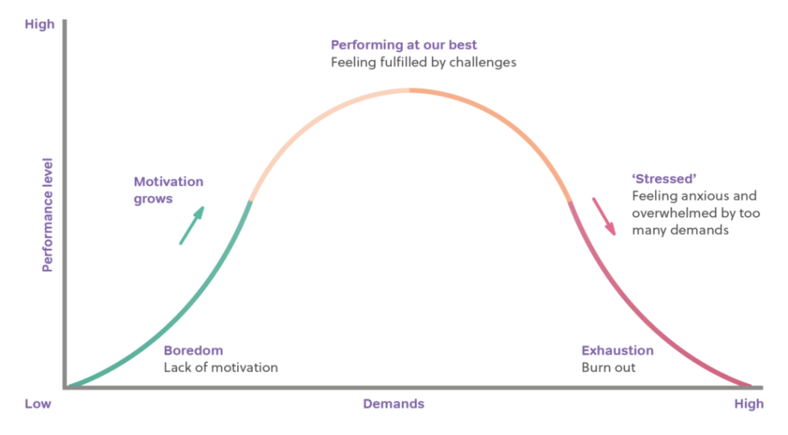

Symptoms of stress:
1. Nervousness
2. Inertia
3. Insomnia
4. Headache
5. Dizziness
6. Fainting
7. Nightmares
Chronic sources of stress:
- Pressure
- Frustration: delay, lack of resources, losses such as end of an affair, friendship, failure, guilt
- Individual differences in the reactivity of the autonomic nervous system.

Coping with stress:
1. Direct coping:
a. Confrontation: means facing the problem forthrightly acknowledging to oneself that there is a problem for which a solution must be found.
b. Compromise: person may decide to settle for less that he originally wanted when he cannot have everything he wants.
c. Withdrawal: the most effective way of coping with stress is to withdraw from the situation, when there is no way to change and compromise.
2. Defensive coping:
When it cannot identify the sources of stress, people make use of defensive mechanisms like denial, Regression, projection, reaction formation, displacement and sublimation.
Psychophysiology disorders
- Stress-related skin disorders may include allergy, eczema and Acne.
- Stress-related respiratory system disorders may include breathlessness hyperventilation, fever, asthma, sinusitis, emphysema, and bronchial spasms.
- Stress-related cardiovascular system disorders may include hypertension, migraine headaches, and coronary heart disease.
- Stress-related endocrine system disorders may include diabetes mellitus and adrenal dysfunction.
- Stress-related musculoskeletal system disorders may include backaches and muscle cramps.
- Stress-related gastrointestinal system disorders may include constipation, obesity, hyperacidity, duodenal ulcer, and anorexia.
- Stress-related genitourinary system disorders may include menstrual disturbances, impotence.

Stress management strategies:
- Progressive relaxation
- Meditation
- Exercise and stretching
- Stress desensitization
- Massage
- Psychotherapy
- Nutrition
- Laughter
- Play
- Music Factors related to the stress response:

- Biological :
- Evolutionary mechanisms for responding to stressors.
- Physiological responses of autonomic and endocrine system to situational stressors.
- Stress effect on immune system
- Individual differences in physiological reactivity to stressors (e.g. physiological toughness)
2. Psychological:
- Cognitive appraisal of environment demands, resources, potential consequences, and personal meaning of consequences.
- Personality factors, such as optimism and hardiness that affect responses to stressors.
- Coping strategies and the skill with which they are applied.
- Self-efficacy and expectations of available social support.
3. Environmental:
- Number, intensity, and duration of the stressful events.
- Predictability, controllability, and Chronicity of stressors.
- Availability of social support.
- Cultural factors that teach one how to respond to stressors.

Coping client with stress by the nurse:
- Balance your life activities with work and play, family and friends and time for yourself.
- Exercise your body every day or at least four times a week.
- Meditate to promote relaxation.
- Relax your body regularly.
- Slow down your pace of life.
- Make your goals realistic.
- Organize your life with priorities so that you will always accomplish what must be done at the right time.
- Develop healthy social relationships.
- Practice coping statement.

