***Lecture seven***



**Arteries:**

Arteries are high -pressure vessels that carry oxygenated blood from the Heart to the rest of the body, they have thick walls.

***Arterioles***:

Control blood flow and distribute blood in to the capillary beds. Their walls are composed primarily of smooth muscle.

They are the major sites of controllable resistance in the systemic circulation.

***Veins***:

Are low-pressure vessels that return blood back to the heart via the

Venae cava . They also act as expandable reservoirs –They passively relax or actively constrict under sympathetic adrenergic Stimulation.

***Venules:***

Are small veins that collect blood from the capillaries.

***Physics of blood Flow:***

All blood pumped by the **right side** of the heart passes through the pulmonary circulation to the **lungs** for O2 pickup and CO2 removal.

The blood pumped by the **left side** of the heart into the **systemic circulation** is distributed in various proportions to the systemic organs through a parallel arrangement of vessels that branch from the aorta (**Figure down**).

***This arrangement ensures that all organs receive blood of the same composition***.

The blood vessels transport and distribute blood pumped through them by the heart to meet the body’s needs for:

1. O2 and nutrient delivery.
2. Waste removal.
3. Hormonal signaling.

**The highly elastic arteries:**

A-Transport blood from the heart to the organs.

B-Serve as a pressure reservoir to continue driving blood forward when the heart is relaxing and filling.

The mean arterial blood pressure is closely regulated to ensure adequate blood delivery to the organs.

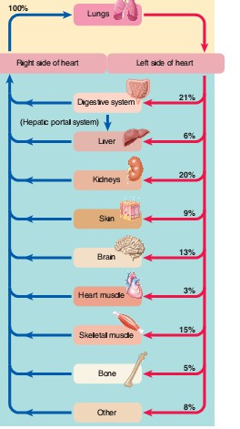

**Distribution of cardiac output (CO) at rest:**

Because reconditioning organs—**digestive organs, kidneys and skin**—receive blood flow in excess of their needs, ***they can withstand temporary reductions in blood flow*** much better than other organs can that do not have this extra margin of blood supply. ***The brain in particular suffers irreparableغير قابل للاصلاح damage when transiently deprivedحرمان بصورة عابرة of blood supply****.* After only **4 minutes without O2**, permanent brain damage occurs. Therefore, constant delivery of adequate blood to the brain, which can least tolerate disruptedتعطل blood supply, is a high priorityاولويه in the overall operation of the circulatory system .

**Pressure Gradient**:

**It's the difference in pressure between the beginning and the end of a vessel** .

**Resistance:**

**Is a measure of the hindrance مانعor opposition to blood flow through the vessel**.

**As resistance to flow increases*, it is more difficult for blood to pass through the vessel.***

***Blood resistant***:

Standard units of pressure.

Blood pressure almost always is **measured in millimeters** of **mercury (mm Hg)** because the mercury manometer has been used as the standard reference for measuring pressure. Actually.

B**lood pressure**:

***The force exerted by the blood against any unit area of the vessel wall.***



***System transports fluid.***

The lymphatic system transports fluid called lymph through special vessels called lymphatic capillaries and lymphatics.

This lymph eventually gets returned to the blood from where it originated.

***The primary function of this system is to:***

1. Drain from tissue spaces protein-containing fluid that escapes from the blood capillaries.
2. Transport fats from the digestive tract to the blood.

3-Develop immunities.

***Components of the lymphatic system ;***

1. Lymph vessels.
2. Lymph nodes.
3. Organs. (Tonsils, spleen, thymus gland, vermiform appendix and peyer patches) .

**lymphatic Vessels:**

Lymphatic vessels originate as blind-end tubes that begin in spaces between cells in most parts of the body .

The tubes, which are closed at one end, occur singly or in extensive plexuses and are called **lymphatic capillaries**.

***These vessels are not found in the:***

1. Central nervous system.
2. Red bone marrow.
3. Vascular tissue or portions of the spleen.

Lymphatic capillaries eventually unite to form larger and larger lymph vessels called lymphatic's.

***Lymphatic resemble veins in structure but have thinner walls and more valves***.

The large number of **valves *helps to ensure that the lymph will not back flow but go in one direction only***.

Along lymphatic there are lymph nodes found at ***various intervals***.

All the lymphatic of the body converge into one of two main channels:

1. Either the thoracic duct) the main collecting channel). Also known as the left lymphatic duct.
2. The right lymphatic duct.

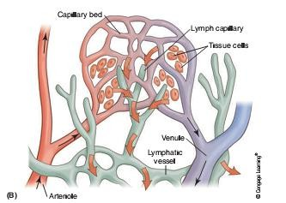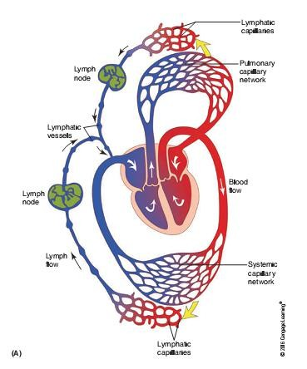

***The organs of the Lymphatic system:***

***Tonsils:***

**Are masses of lymphoid tissue embedded in mucous membrane .**

There are three groups of tonsils.

**A-** The **palatine tonsils** are the ones commonly removed in a tonsillectomy.

**B-** The **pharyngeal** tonsils. They are located close to the internal opening of the nasal cavity. When they become swollen, they can interfere with breathing.

**C-** The **lingual tonsils** are located on the back surface of the tongue at its base. *Tonsils are more functional in children*.

*As we age, the tonsils decrease in size and may even disappear in some individuals*.

***The spleen***:

Is oval in shape and is the single largest mass of lymphatic tissue in the body. It measures about **12 cm, or 5 inches, in length**.

It is found in the left upper corner of the abdominal cavity.

*It filters blood via the splenic artery and splenic vein*, which enter the spleen at a slightly concave border called the hilum.

***Functions:***

1. Phagocytizes bacteria.
2. Worn-out platelets and red blood cells. This action releases hemoglobin to be recycled. It also produces lymphocytes and plasma cells.
3. The spleen stores blood and functions as a blood reservoir.
4. During a hemorrhage, the spleen releases blood into the blood circulation route.

***The thymus gland:***

***Structure*:**

Is a blobbed mass of tissue located in the mediastinum along the trachea behind the sternum. Its role in the endocrine system**. It reaches maximum size during puberty and then decreases.** In older individuals, the thymus becomes small and is difficult to detect because it is replaced with fat and connective tissue. It is involved in immunity.

***Functions:***

1. The thymus is a site for lymphocyte production and maturation.
2. The thymus helps develop **T** lymphocytes in the fetus and in **infants** for a few months after birth.

***Peyer’spatches (also known as aggregated lymphatic follicles):***

Are found in the wall of the small intestine. They resemble tonsils.

*Their macrophages destroy bacteria. Bacteria are always present in large numbers in the intestine, and the macrophages prevent the bacteria from infecting and penetrating the walls of the intestine.*

***Vermiform appendix****:*

Is also involved in immunity; after birth, lymphoid tissue begins to develop in the appendix, reaching peak amounts around the age of **25** .

*The appendix assists in the maturing of* ***B*** *lymphocytes and produces immunoglobulin (IgA) antibodies*.

The lymphoid tissue of the appendix decreases in amount around the age of

**40 years**.