**Stress :**

body's response to any type of change or challenge that requires attention or action. It's a natural human reaction that helps us adapt to challenging situations.

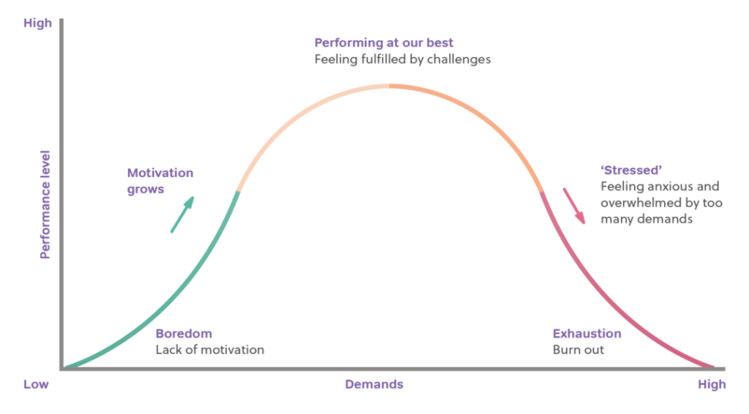

**Symptoms of stress:**

1. Nervousness

2. Inertia

3. Insomnia

4. Headache

5. Dizziness

6. Fainting

7. Nightmares

**Chronic sources of stress:**

1. Pressure
2. Frustration: delay, lack of resources, losses such as end of an affair, friendship, failure, guilt
3. Individual differences in the reactivity of the autonomic nervous system.

**Coping with stress:**

**1. Direct coping:**

a. Confrontation: means facing the problem forthrightly acknowledging to oneself that there is a problem for which a solution must be found.

b. Compromise: person may decide to settle for less that he originally wanted when he cannot have everything he wants.

c. Withdrawal: the most effective way of coping with stress is to withdraw from the situation, when there is no way to change and compromise.

**2. Defensive coping:**

When it cannot identify the sources of stress, people make use of defensive mechanisms like denial, Regression, projection, reaction formation, displacement and sublimation.

**Psychophysiology disorders**

1. Stress-related skin disorders may include allergy, eczema and Acne.
2. Stress-related respiratory system disorders may include breathlessness hyperventilation, fever, asthma, sinusitis, emphysema, and bronchial spasms.
3. Stress-related cardiovascular system disorders may include hypertension, migraine headaches, and coronary heart disease.
4. Stress-related endocrine system disorders may include diabetes mellitus and adrenal dysfunction.
5. Stress-related musculoskeletal system disorders may include backaches and muscle cramps.
6. Stress-related gastrointestinal system disorders may include constipation, obesity, hyperacidity, duodenal ulcer, and anorexia.
7. Stress-related genitourinary system disorders may include menstrual disturbances, impotence.

**Stress management strategies:**

1. Progressive relaxation
2. Meditation
3. Exercise and stretching
4. Stress desensitization
5. Massage
6. Psychotherapy
7. Nutrition
8. Laughter
9. Play
10. Music **Factors related to the stress response:**
11. **Biological :**

* Evolutionary mechanisms for responding to stressors.
* Physiological responses of autonomic and endocrine system to situational stressors.
* Stress effect on immune system
* Individual differences in physiological reactivity to stressors (e.g. physiological toughness**)**

**2. Psychological:**

* Cognitive appraisal of environment demands, resources, potential consequences, and personal meaning of consequences.
* Personality factors, such as optimism and hardiness that affect responses to stressors.
* Coping strategies and the skill with which they are applied.
* Self-efficacy and expectations of available social support.

**3. Environmental:**

* Number, intensity, and duration of the stressful events.
* Predictability, controllability, and Chronicity of stressors.
* Availability of social support.
* Cultural factors that teach one how to respond to stressors.

**Coping client with stress by the nurse:**

* Balance your life activities with work and play, family and friends and time for yourself.
* Exercise your body every day or at least four times a week.
* Meditate to promote relaxation.
* Relax your body regularly.
* Slow down your pace of life.
* Make your goals realistic.
* Organize your life with priorities so that you will always accomplish what must be done at the right time.
* Develop healthy social relationships.
* Practice coping statement.