Lec-5-

**Blood Physiology**

Blood is a necessity for the preservation of human life.[[1]](https://www.physio-pedia.com/Blood_Physiology#cite_note-1)[[2]](https://www.physio-pedia.com/Blood_Physiology#cite_note-2)

* Blood is critical for the transportation of nutrients, [hormones](https://www.physio-pedia.com/Hormones), gases and wastes around the body.
* It also has important [immunological](https://www.physio-pedia.com/Immune_System) functions.
* Blood is critical in the homeostatic regulation of pH, temperature and various other internal conditions. Blood is composed of plasma, [platelets](https://www.physio-pedia.com/Platelet), [leukocytes](https://www.physio-pedia.com/Leukocytes) (White Blood Cells) and erythrocytes[[3]](https://www.physio-pedia.com/Blood_Physiology" \l "cite_note-3).

The adult human has from 4 to 5 litres of blood formed of cells and plasma circulating the body in [vessels](https://www.physio-pedia.com/Cardiovascular_System)[[4]](https://www.physio-pedia.com/Blood_Physiology#cite_note-4)[[5]](https://www.physio-pedia.com/Blood_Physiology#cite_note-5)

* Plasma forms about 55% of the total blood volume.
* The other 45% comprises of a variety of different forms of cells[[6]](https://www.physio-pedia.com/Blood_Physiology" \l "cite_note-:1-6).
* The total blood volume forms about 7 to 8 % of the total human weight in normal healthy adult[[6]](https://www.physio-pedia.com/Blood_Physiology" \l "cite_note-:1-6).

[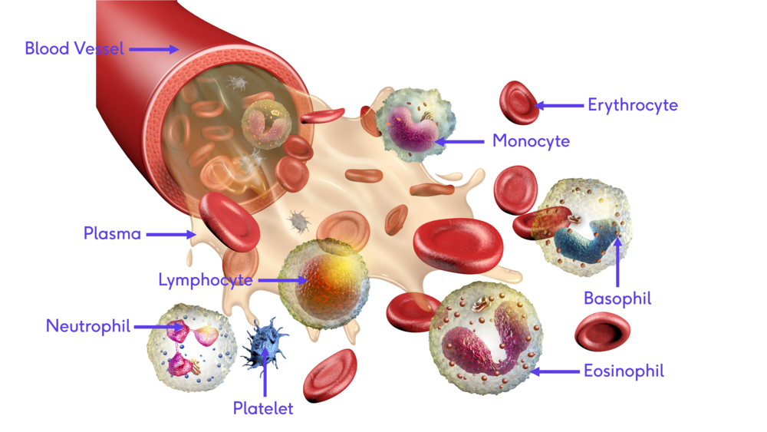](https://www.physio-pedia.com/File:Blood_with_description.png)

Blood Plasma

Blood Plasma is a light – yellowish liquid. It acts as the base of the blood. It is composed of 91% of water and 9% solids such as coagulants, plasma proteins, [electrolytes](https://www.physio-pedia.com/Electrolytes) and [immunoglobulins](https://www.physio-pedia.com/Immunoglobulins_(Ig)).[[7]](https://www.physio-pedia.com/Blood_Physiology#cite_note-:2-7)

In the embryonic stage blood plasma is formed from the mesenchymal cells. The albumin is formed first, followed by globulin and then other plasma proteins. In an adult, the reticuloendothelial cells in the [liver](https://www.physio-pedia.com/Liver_Disease) are responsible for plasma production; this process is aided by [bone marrow](https://www.physio-pedia.com/Bone_Marrow) and [spleen](https://www.physio-pedia.com/Ruptured_Spleen)[[7]](https://www.physio-pedia.com/Blood_Physiology#cite_note-:2-7).

Functions of Blood Plasma

Blood Plasma has various vital functions[[7]](https://www.physio-pedia.com/Blood_Physiology" \l "cite_note-:2-7),[[8]](https://www.physio-pedia.com/Blood_Physiology#cite_note-8)

1. Coagulation- Plasma contains fibrinogen and procoagulants such as thrombin and factor x
2. [Immune Defense](https://www.physio-pedia.com/Immune_System)- Plasma has Immunoglobulins (antibodies) that play a role in the body’s immunological defence process
3. Maintenance of osmotic pressure- The presence of plasma proteins such as Albumin which is vital for maintaining a balance of fluid, called oncotic pressure, in the blood (maintained at around 25 mmHg).
4. Acid-base balance- Plasma proteins helps in acid-base balance through buffering action.
5. Transportation of Nutrients-  Nutrients such as glucose, amino acids, liquids and vitamins are transported in the blood plasma from the digestive system to different body parts.
6. Transportation of [Respiratory](https://www.physio-pedia.com/Respiratory_System) Gases. Oxygen is carried to the body from the lungs and carbon dioxide back to the lungs for excretion.
7. Transportation of Hormones.
8. Excretion- Waste products from cellular metabolism are carried within the plasma and excreted via the [kidneys](https://www.physio-pedia.com/Chronic_Kidney_Disease), [lungs](https://www.physio-pedia.com/Lung_Anatomy) and [skin](https://www.physio-pedia.com/Skin)
9. [Temperature Regulation](https://www.physio-pedia.com/Vital_Signs)

The erythrocyte sedimentation rate (ESR) is used as a diagnostic tool. As fibrinogen increases in acute inflammatory conditions, the ESR will also increase.

Erythrocytes (RBCs)

Erythrocytes (known as Red Blood Cells (RBCs) are biconcave discoidal cells.[[9]](https://www.physio-pedia.com/Blood_Physiology#cite_note-9) RBCs lack a nucleus, contain haemoglobin (the red iron-rich protein that carries O2) and are surrounded by a membrane of lipids and proteins. The normal healthy adult produces 119 million red blood cells per second. It forms 44% of the total blood volume and a single RBC cell is sized 0.000007 m. They are produced by red [bone marrow](https://www.physio-pedia.com/Bone_Marrow) via a process called erythropoiesis.[[10]](https://www.physio-pedia.com/Blood_Physiology#cite_note-10)

Functions of Erythrocytes

A single Erythrocyte cell lives only for 120 days and in that duration, it performs successive roles[[11]](https://www.physio-pedia.com/Blood_Physiology" \l "cite_note-11)

1. Oxygen delivery from the lungs to the peripheral tissues.
2. Collect CO2 from peripheral cells and return it to the lungs.

RBCs contain haemoglobin with ferrous heme (Fe) which has an affinity for oxygen. When it arrives at deoxygenated cells the Fe looses its affinity for O2 (due to decreased partial pressure of O2 and low PH).

Leucocytes (WBCs)

Leucocytes are the cellular component of the blood that are also known as white blood cells (WBCs). WBCs have a nucleus and lack hemoglobin. WBCs form 1% of the total blood volume in healthy adults.[[6]](https://www.physio-pedia.com/Blood_Physiology#cite_note-:1-6) They are considered to be an important part of the [immune system](https://www.physio-pedia.com/Immune_System). The leucocytes are produced in the bone marrow in a process called Hematopoiesis[[12]](https://www.physio-pedia.com/Blood_Physiology" \l "cite_note-12) and normal WBCs count ranged between 4,000 and 10,000 cells/MCL18.

**Types and Function of**[**Leucocytes**](https://www.physio-pedia.com/Leukocytes)

There are several types of WBCs such as Neutrophils, Eosinophils, Basophils, Lymphocytes (B and T) and Monocytes[[13]](https://www.physio-pedia.com/Blood_Physiology#cite_note-:3-13).

**Neutrophils**

Neutrophils are WBCs that are released from the bone marrow.  They represent 50% of total WBCs count. Around 100 billion of the Neutrophils cells are produced every day and they are considered to be the first immune system cells. They are the major pathogen-fighting immune cells that migrate to sites of infection and then identify and kill bacteria and viruses. Neutrophils also send signals to alert other immune system cells.[[14]](https://www.physio-pedia.com/Blood_Physiology#cite_note-14)

**Monocytes**

Monocytes represent 5 to 12 % of the total WBCs count. They are considered to be the “garbage trucks” of the immune system and play an important function in cleaning dead cells and tissue regeneration.[[15]](https://www.physio-pedia.com/Blood_Physiology#cite_note-15)

**Eosinophils**

Eosinophils represent less than 5% of the total WBCs. They are found in large amounts in the digestive system. Eosinophils play an important role in dealing with invading bacteria and parasites, such as worms.[[16]](https://www.physio-pedia.com/Blood_Physiology#cite_note-16)

**Basophils**

Basophils represent 1% of the total WBCs count. These cells play a role in [asthma.](https://www.physio-pedia.com/Asthma) They stimulate histamine release, leading to the inflammation and bronchoconstriction that occurs in asthma.[[17]](https://www.physio-pedia.com/Blood_Physiology#cite_note-17)

[**Lymphocytes**](https://www.physio-pedia.com/Lymphocytes)

Lymphocytes produce antibodies that give immunity to the body if the body is exposed to the same infection again. It consists of two types of cells, T cells which have an invading function and B cells, which in contrast to other WBCs, are responsible for humoral immunity ie immunity associated with circulating antibodies, in contradistinction to cellular immunity[[18]](https://www.physio-pedia.com/Blood_Physiology#cite_note-18). These cells play an important role in developing a lot of the current [vaccine](https://www.physio-pedia.com/Vaccines)s.[[19]](https://www.physio-pedia.com/Blood_Physiology#cite_note-19)

**Pathophysiology of Leucocytes**

Elevated WBCs counts can indicate a variety of conditions. [Infection](https://www.physio-pedia.com/Infectious_Disease), inflammation, trauma, pregnancy, asthma, allergy, [cancers](https://www.physio-pedia.com/Oncology) such as [leukaemia](https://www.physio-pedia.com/Leukemia" \o "Leukemia) and even aggressive [exercises](https://www.physio-pedia.com/Exercise_Physiology) can result in elevated WBCs.[[20]](https://www.physio-pedia.com/Blood_Physiology#cite_note-20)

On the other hand, low WBCs counts can indicate severe infections, bone marrow damage, [autoimmune diseases](https://www.physio-pedia.com/Autoimmune_Disorders) (e.g. Systemic Lupus Erythematosus [SLE](https://www.physio-pedia.com/Systemic_Lupus_Erythematosus)) and splenic sequestration.[[13]](https://www.physio-pedia.com/Blood_Physiology#cite_note-:3-13)