**Communicable Disease Control**

**-------------------------------------------------------------------------------------------------------------**

* **A communicable disease:** A disease or illness in a susceptible host, caused by a potentially harmful infectious organism or its toxic byproduct.
* 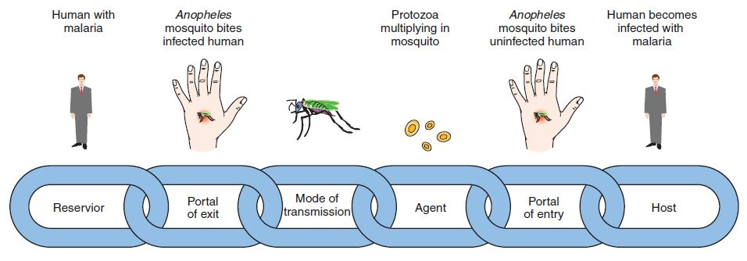**Chain of causation in infectious disease:**
* **Causality** refers to the relationship between a cause and its effect. A purpose of epidemiologic study has been to discover causal relationships to understand why conditions develop and offer effective prevention and protection**.**
* **Mode of transmission:**

1. ***Droplet contact route*** – coughing or sneezing on another individual
2. ***Direct physical contact route***
3. ***Indirect physical contact route***: touching a contaminated surface, including soil
4. ***Airborne route***
5. ***Fecal-oral route***
6. ***Transmission by insect or animal bite***

* **Communicable diseases classification in epidemiology:**

1. **Endemic:** when an infectious agent or disease has a constant presence within a defined geographic area.
2. **Epidemic:** occurrences of infectious agent or disease that clearly exceed the usual expected frequency of the disease in a particular population.
3. **Pandemic**: when an epidemic outbreak occurs worldwide.

* **Knowledge of communicable diseases is fundamental to the practice of community health nursing because:**

1. These diseases typically spread through communities of people.
2. Understanding of the basic concepts of communicable disease control, as well as the numerous issues arising in this area, helps a community health nurse to work effectively to prevent and control communicable disease.
3. It also helps nurses teach important and effective preventive measures to community members, advocate for those affected, and protect the well-being of uninfected persons (including the nurses themselves).

* **Levels of prevention:**

1. Primary prevention: aims to prevent disease or injury before it ever occurs.
2. Secondary prevention: aims to reduce the impact of a disease that has already occurred (early detection and treatment of a disease).
3. Tertiary prevention: aims to soften the impact of an ongoing illness that has long-term effects (rehabilitation).

* **Natural History of Disease and Levels of Prevention:**

Pre-pathogenesis

Pathogenesis

Post-pathogenesis

|  |  |  |  |
| --- | --- | --- | --- |
| **Exposure**  **Stage 1**  **Susceptibility**  **Healthy susceptible**  **Causative factors are present**  **Health promotion early prevention** | **Stage 2**  **Subclinical Disease**  **Non-symptomatic**  **Specific Prevention Early diagnosis** | **Stage 3**  **Clinical Disease**  **Symptomatic**  **Treatment** | **Stage 4**  **Resolution**  **Recovery,**  **Disability, or Death**  **Rehabilitation** |

**Timeline: Minutes/hours to days/weeks/months/years – dependent on pathogen**

**Tertiary prevention**

**Primary prevention**

**Secondary prevention**

* **Community health nursing using nursing process for communicable disease control:**

**Assessing determinants of health:**

1. Biological determinants.

2. Psychological determinants.

3. Environmental determinants.

4. Socio-cultural determinants.

5. Behavioral determinants.

6. Health system determinants.

Monitoring

Dealing with consequences

Preventing reinfection

Preventing future epidemic

Planning and applying health promotion and illness prevention strategies (e.g. immunization, conact investigation, pre and post exposure prophylaxis, pandemic preparedness).

Diagnosis varies:

1. May reflects needs of client, family & community.

2. May reflects potential for infection.

3. May reflects actual presence of disease.

4. May reflects presence of risk factors.

**References:**

Allender, J. A., Warner, K. D. and Rector, C. (2014) *Community and public health nursing: promoting the public’s health*. 8th ed. Hong Kong: Lippincott Williams & Wilkins.

Centers for Disease Control and Prevention. (2012c). *Epidemiology and prevention of vaccine preventable diseases: the Pink Book* (12th ed.). Washington, DC: Public Health Foundation.

Heymann, D. L. (Ed.). (2008). *Control of communicable diseases manual* (19th ed.). Washington, DC: American Public Health Association.

Hogben, M., & Leichliter, J. (2008). Social determinants and sexually transmitted disease disparities. *Sexually Transmitted Diseases, 35*(12), S13–S18.