**Polycystic Ovary Syndrome (PCOS)**

D. IFTIKHAR AL-DUJAIL

Polycystic ovary syndrome (PCOS) is a common condition that affects hormones. It causes irregular menstrual periods, excess hair growth, acne and infertility. Treatment for PCOS depends on if wish to become pregnant. People with PCOS may be at higher risk for certain health conditions, like diabetes and high blood pressure.

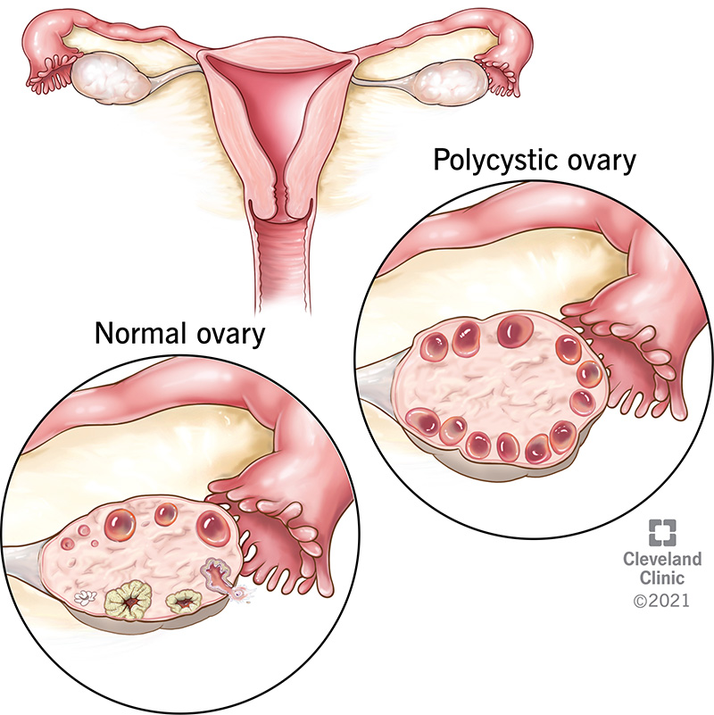A typical ovary compared to an ovary in a person with PCOS.

**What is polycystic ovarian syndrome?**

Polycystic ovary syndrome (PCOS) is a hormonal imbalance that occurs when  [ovaries](https://my.clevelandclinic.org/health/body/22999-ovaries) ( create excess hormones. If have PCOS, ovaries produce unusually high levels of hormones called [androgens](https://my.clevelandclinic.org/health/articles/22002-androgens). This causes reproductive hormones to become imbalanced. As a result, people with PCOS often have irregular [menstrual cycles](https://my.clevelandclinic.org/health/articles/10132-normal-menstruation), missed periods and unpredictable ovulation. Small follicle cysts (fluid-filled sacs with immature eggs) may be visible on ovaries on ultrasound due to lack of ovulation ([anovulation](https://my.clevelandclinic.org/health/diseases/21698-anovulation)). However, despite the name "polycystic," don’t need to have [cysts](https://my.clevelandclinic.org/health/diseases/9133-ovarian-cysts) on ovaries to have PCOS. The ovarian cysts aren’t dangerous or painful.

PCOS is one of the most common causes of [infertility](https://my.clevelandclinic.org/health/diseases/16083-infertility-causes) in women It can also increase risk of other health conditions. healthcare provider can treat PCOS based on symptoms and if wish to become pregnant.

**What age does PCOS start?**

Women and people can get PCOS any time after puberty. Most people are diagnosed in their 20s or 30s when they’re trying to get pregnant. may have a higher chance of getting PCOS if have obesity or if other people in biological family have PCOS.

**How common is PCOS?**

PCOS is very common — up to 15% of women and people of reproductive age have PCOS.

**Symptoms and Causes**

**What are the signs of polycystic ovary syndrome (PCOS)?**

The most common signs and symptoms of PCOS include:

* **Irregular periods:**[Abnormal menstruation](https://my.clevelandclinic.org/health/diseases/14633-abnormal-menstruation-periods) involves missing periods or not having a period at all. It may also involve heavy bleeding during periods.
* **Abnormal hair growth**: may grow excess facial hair or experience heavy hair growth on arms, chest and abdomen ([hirsutism](https://my.clevelandclinic.org/health/diseases/14523-excessive-hair-growth-hirsutism)). This affects up to 70% of people with PCOS.
* **Acne:**PCOS can cause [acne](https://my.clevelandclinic.org/health/diseases/12233-acne), especially on back, chest and face. This acne may continue past r teenage years and may be difficult to treat.
* **Obesity:** Between 40% and 80% of people with PCOS have [obesity](https://my.clevelandclinic.org/health/diseases/11209-weight-control-and-obesity) and have trouble maintaining a weight that’s healthy for them.
* **Darkening of the skin:**  may get patches of dark skin, especially in the folds of neck, armpits, groin (between the legs) and under breasts. This is known as [acanthosis nigricans](https://my.clevelandclinic.org/health/diseases/12168-acanthosis-nigricans).
* **Cysts:** Many people with PCOS have ovaries that appear larger or with many follicles (egg sac cysts) on ultrasound.
* **Skin tags:** Skin tags are little flaps of extra skin. They’re often found in armpits or on neck.
* **Thinning hair:** People with PCOS may [lose patches of hair](https://my.clevelandclinic.org/health/diseases/16921-hair-loss-in-women) on their head or start to bald.
* **Infertility:** PCOS is the most common cause of [infertility in people AFAB](https://my.clevelandclinic.org/health/diseases/17774-female-infertility). Not [ovulating](https://my.clevelandclinic.org/health/articles/11585-conception) regularly or frequently can result in not being able to conceive.

**Can PCOS but not have any symptoms?**

Yes, it’s possible to have PCOS and not have any symptoms. Many people don’t even realize they have the condition until they have trouble getting pregnant or are gaining weight for unknown reasons. It’s also possible to have mild PCOS, where the symptoms aren’t severe enough for to notice.

**What is the main cause of PCOS?**

The exact cause of PCOS is unknown. There’s evidence that genetics play a role. Several other factors, most importantly obesity, also play a role in causing PCOS:

* **Higher levels of male hormones called androgens:** High androgen levels prevent ovaries from releasing eggs, which causes irregular menstrual cycles. Irregular ovulation can also cause small, fluid-filled sacs to develop on ovaries. High androgen also causes acne and excess hair growth in women and people
* **Insulin resistance:** An increase in [insulin](https://my.clevelandclinic.org/health/articles/22601-insulin) levels causes ovaries to make and release male hormones (androgens). Increased male hormones suppress ovulation and contribute to other symptoms of PCOS. Insulin helps body process glucose (sugar) and use it for energy. Insulin resistance means body doesn’t process insulin correctly, leading to high glucose levels in blood. Not all individuals with insulin resistance have elevated glucose or diabetes, but insulin resistance can lead to diabetes. Having overweight or obesity can also contribute to insulin resistance. An elevated insulin level, even blood glucose is normal, can indicate insulin resistance.
* **Low**-**grade inflammation:**People with PCOS tend to have chronic low-grade inflammation. healthcare provider can perform blood tests that measure levels of [C-reactive protein](https://my.clevelandclinic.org/health/diagnostics/23056-c-reactive-protein-crp-test) (CRP) and white blood cells, which can indicate the level of inflammation in your body.

**Can PCOS cause a miscarriage?**

Having PCOS may increase risk for certain pregnancy complications, although most women and people with PCOS are able to successfully carry a pregnancy. Other complications of PCOS related to pregnancy include increased risk of:

* [Gestational diabetes](https://my.clevelandclinic.org/health/diseases/9012-gestational-diabetes), [preeclampsia](https://my.clevelandclinic.org/health/diseases/17952-preeclampsia) and [high blood pressure](https://my.clevelandclinic.org/health/diseases/4497-gestational-hypertension).
* [Preterm birth](https://my.clevelandclinic.org/health/diseases/21479-premature-birth) (birth before 37 weeks of pregnancy) or [C-section](https://my.clevelandclinic.org/health/treatments/7246-cesarean-birth-c-section) delivery due to obesity, diabetes or high blood pressure.

**Diagnosis and Tests**

**How is polycystic ovary syndrome (PCOS) diagnosed?**

In most cases, healthcare provider can diagnose PCOS after an examination and discussing symptoms. They may order blood tests or perform an ultrasound to help with the diagnosis.

healthcare provider will:

* Talk about symptoms and medical history.
* Ask about biological family’s medical history.
* Take weight and blood pressure.
* Perform a [physical exam](https://my.clevelandclinic.org/health/diagnostics/17366-physical-examination), looking specifically for excess facial hair, hair loss, acne, discolored skin and skin tags.
* Perform a [pelvic exam](https://my.clevelandclinic.org/health/diagnostics/17343-pelvic-exam) to look for other causes of abnormal bleeding.
* Order blood tests to check hormone levels and glucose levels.
* Perform a [pelvic ultrasound](https://my.clevelandclinic.org/health/diagnostics/4996-ultrasonography-test-in-obstetrics-and-gynecology-pelvic-or-pregnancy-ultrasound) to look at ovaries, check the thickness of uterine lining and look for other causes of abnormal bleeding.

**What are the three symptoms to diagnose PCOS?**

Typically, healthcare providers diagnose PCOS if have at least two of the three symptoms:

* Irregular or missed periods. Some people with PCOS have very heavy bleeding when they do have a period.
* Signs of excess androgens such as acne or excessive hair growth. Or a blood test confirming high androgen levels.
* Enlarged ovaries or polycystic appearance of ovaries on ultrasound. Many people don’t develop cysts.

**Management and Treatment**

**How is polycystic ovary syndrome treated?**

healthcare provider will determine treatment based on symptoms, medical history and other health conditions, and if want to get pregnant. Treatments can include medications, lifestyle changes or a combination of both.

**If you don’t plan to become pregnant, treatments include:**

* **Hormonal birth control:** Options include [birth control pills](https://my.clevelandclinic.org/health/drugs/3977-birth-control-the-pill), patches, shots, a [vaginal ring](https://my.clevelandclinic.org/health/articles/24157-vaginal-ring) or an [intrauterine device (IUD)](https://my.clevelandclinic.org/health/treatments/24441-intrauterine-device-iud). Hormonal birth control helps to regulate menstrual cycle, some forms will also improve acne and help with excess hair growth.
* **Insulin-sensitizing medicine:** Metformin is a drug used to treat diabetes. It works by helping body process insulin. Once insulin is under control, some people with PCOS see improvements in their menstrual cycles.
* **Medications to block androgens:**Some medications can block the effect of androgens. This helps control acne or hair growth. Talk to healthcare provider about whether such treatment is right .
* **Lifestyle changes:**Eating a nutritious diet and maintaining a body weight that’s healthy can have a positive effect on insulin levels.

**If want to become pregnant now or in the future, treatment for PCOS includes:**

* **Drugs to induce ovulation (releasing an egg)**: A successful pregnancy begins with ovulation. Certain drugs have been proven to induce ovulation in people with PCOS. The medications [clomiphene](https://my.clevelandclinic.org/health/drugs/19178-clomiphene-tablets) and [letrozole](https://my.clevelandclinic.org/health/drugs/18808-letrozole-tablets) are taken orally, while [gonadotropins](https://my.clevelandclinic.org/health/drugs/18559-human-chorionic-gonadotropin-hcg-injection) are given by injection.
* **Surgery**: A surgical procedure can help restore ovulation by removing tissue in ovaries that produces androgen hormones. With newer medications available, surgeons rarely perform this procedure.
* [**In vitro fertilization (IVF)**](https://my.clevelandclinic.org/health/treatments/22457-ivf): This is an option for people with PCOS when medication doesn’t help with ovulation. provider fertilizes egg with partner’s sperm in a lab before transferring it to uterus.

.

**Can get pregnant if have PCOS?**

Yes, can get pregnant if have PCOS. PCOS can make it hard to conceive while also increasing risk for certain pregnancy complications, but many people with PCOS do get pregnant on their own. healthcare provider will work with to develop a treatment plan to help ovulate treatment plan could include medication or assisted reproductive technologies like in vitro fertilization (IVF).

Talk to healthcare provider to make sure understand treatment plan and how can increase chances of a healthy pregnancy.

**Prevention**

**Can prevent PCOS or its effects?**

There’s no proven way to prevent PCOS, but can take small steps to reduce symptoms. For example, eating nutritious foods, exercising regularly and managing a healthy weight for body can help avoid the effects of PCOS.