Hamlet Summary: Act – II, Scene – 2 (The Castle of Elsinore – A Room):

Rosencrantz and Guildenstern, courtiers and friends of Hamlet are summoned by the King and the Queen to know about the changed behaviour of Hamlet. They express their concerns about the erratic behaviour of Hamlet which might have aroused due to the death of King Hamlet and ask the two with the best of their abilities to either cheer him up or discover the cause of his behaviour. As Rosencrantz and Guildenstern are sent off to perform their duties, Polonius enters with the announcement of the return of Cornelius and Voltimand. They provide good news to Fortinbras reproached any such attempt from the youth. However, as a token of friendship they ask to permit the passage of the Norwegian army through Denmark so that they could attack Poles. Claudius shows his consent towards the proposal and sends the two to the Norwegian kingdom to deliver the message of consent.

The two courtiers’ exit and polonuis at length explains the reason for Hamlet’s madness be his daughter – Ophelia. In order to test his theory, he asks the three of them to conceal themselves behind an arras and arrange a meeting between Hamlet and Ophelia at the same place. According to Polonius, this act would allow them to understand whether Hamlet is really mad due to love for Ophelia or is there any other reason and Claudius accepts for the plan explained by the Lord Chamberlain. Gertrude observes the approaching Hamlet and Polonius declares his interest to speak with him. Therefore, the King and the Queen exit.

As Polonius tries to have a conversation with Hamlet, he calls him with many titles such as fishmonger, etc. Although, the words of Hamlet are that of a lunatic; Polonius detects a great meaning within the insane words. So, he hurries away to grant the meeting between his daughter and Prince Hamlet.

Rosencrantz and Guildenstern come to meet the Prince and Hamlet feels happy to see the two. However, he understands that they are sent by the King and the Queen and forces them to reveal the truth, which they do. Rosencrantz offers to summon a theatrical troupe so that his mind can be diverted of the melancholy. Hamlet declares that he is not mad all the time and sometimes he is sane.

Polonius comes with the announcement of the arrival of the theatrical troupe; Hamlet accepts them and asks one of the players to give a speech on the fall of Troy and about the death of Priam and Hecuba, the King and Queen of Troy. Hamlet is mighty pleased with performance of the players and he announces that the players will performs “The Murder of Gonzago”, but with some additions made by him. Everyone leaves the room the room and Hamlet stands alone, who cursed himself for getting involved too much with the stirring speech of the player.

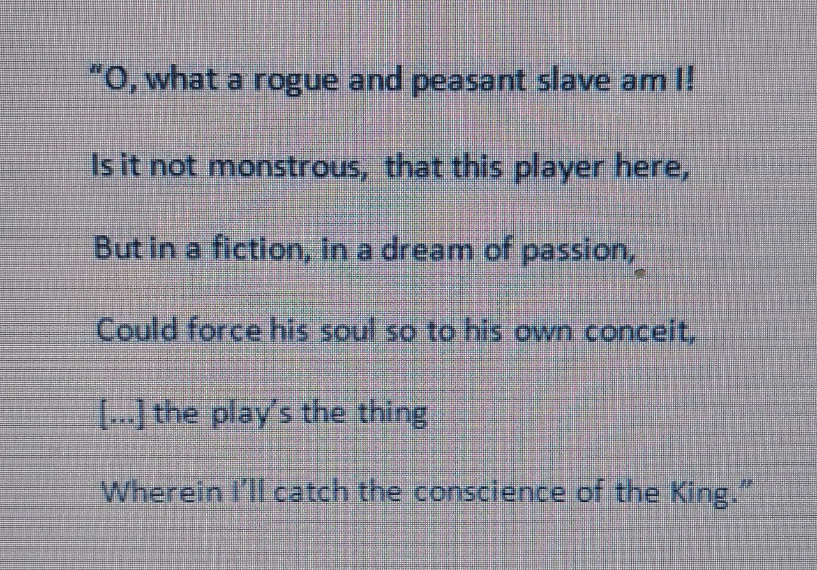

In the soliloquy, Hamlet thinks of himself as meek subduing in thought of grief when the player talks of Hecuba and he couldn’t restrain himself although he is fully aware that the characters in the speech are long dead and doesn’t have any relationship with him. However, he comes out of it and plans to use the play as a trap to find out of the psychology of the King. He intends to make the King and the Queen to watch the entire play so that he could observe the “conscience of the King”.