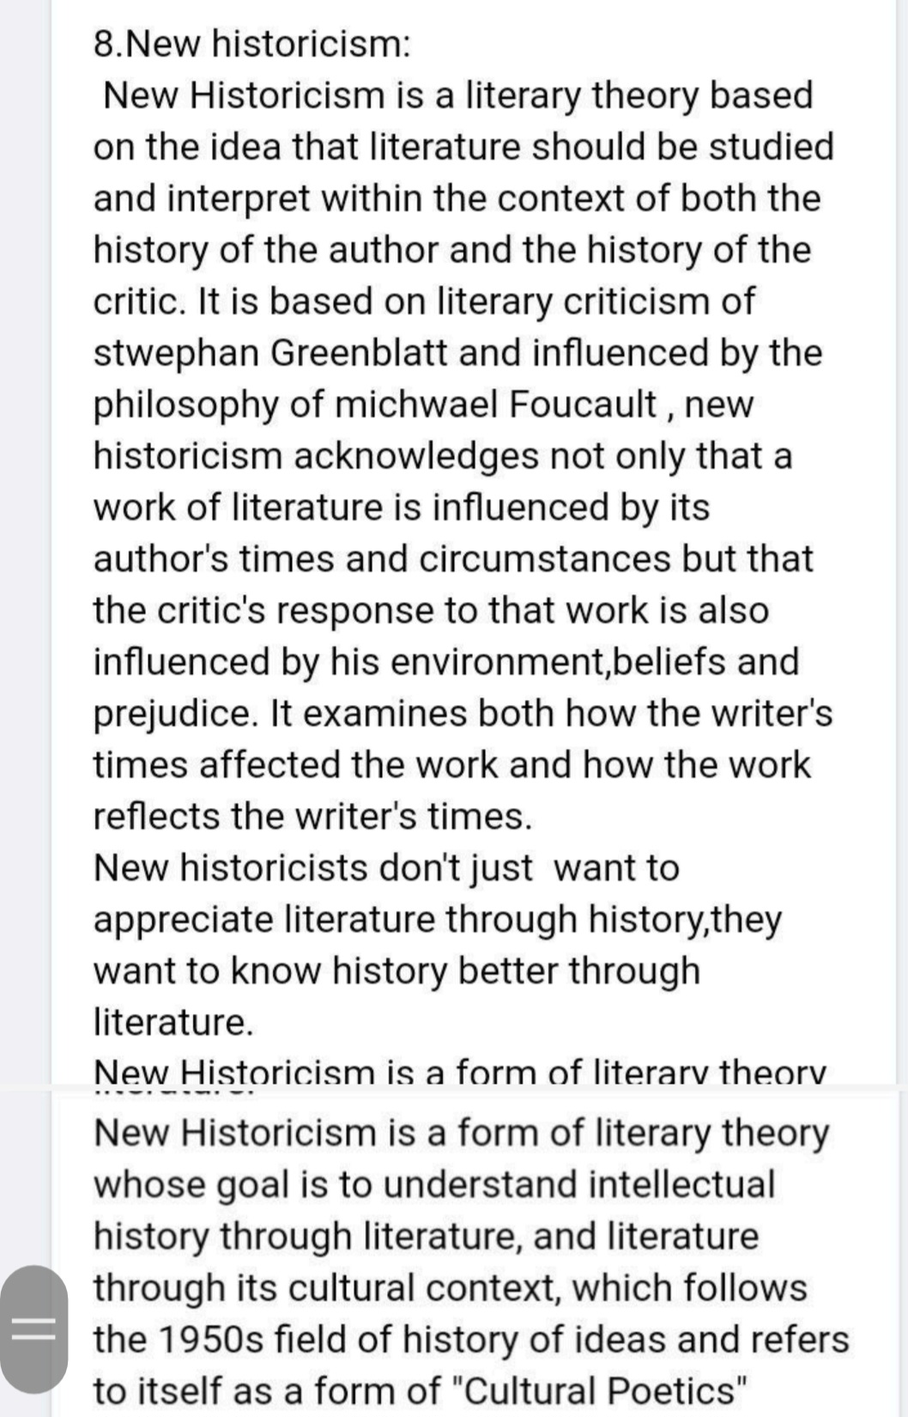

New Historicism as a theory is attributed to American theorist [Stephen Greenblatt](https://app.studysmarter.de/link-to?studyset=5668691&summary=36544471&language=en&amp_device_id=5ONPTURmRSyeKhXhPQvLz4). It involves analyzing a given text in the context of its historical background. This includes considering the **political**, **social**, and **economic** conditions of the time the writer lived in. New Historicists see history as central to any and all texts. The theory also considers the societal background of the critic or individual evaluating a text using New Historicism. New Historicism promotes **nuance يعزز الفروق الفردية** when studying a text. Society is constantly changing, and texts should be fairly viewed through the context of the society that produced them. New Historicism views the relationship as reciprocal. History can influence literature, and literature can influence history.