**VLSM Example 1:**

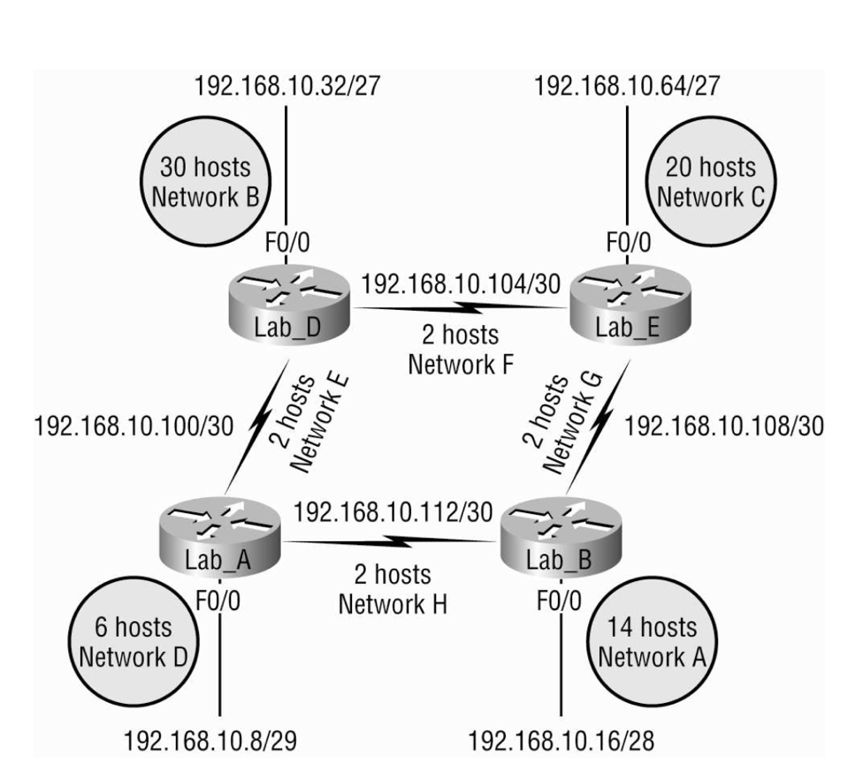

**Network A:**

* **IP Address**: **192.168.10.16/28**
* **Subnet Mask**: **255.255.255.240**
* **Block Size**: 16 (256 - 240 = 16)
* **Network Address**: **192.168.10.16**
* **Broadcast Address**: **192.168.10.31**
* **Usable Range**: **192.168.10.17 – 192.168.10.30**
* **Hosts**: 14 usable IPs

**2. Network B:**

* **IP Address**: **192.168.10.32/27**
* **Subnet Mask**: **255.255.255.224**
* **Block Size**: 32 (256 - 224 = 32)
* **Network Address**: **192.168.10.32**
* **Broadcast Address**: **192.168.10.63**
* **Usable Range**: **192.168.10.33 – 192.168.10.62**
* **Hosts**: 30 usable IPs

**3. Network C:**

* **IP Address**: **192.168.10.64/27**
* **Subnet Mask**: **255.255.255.224**
* **Block Size**: 32
* **Network Address**: **192.168.10.64**
* **Broadcast Address**: **192.168.10.95**
* **Usable Range**: **192.168.10.65 – 192.168.10.94**
* **Hosts**: 30 usable IPs

**4. Network D:**

* **IP Address**: **192.168.10.8/29**
* **Subnet Mask**: **255.255.255.248**
* **Block Size**: 8 (256 - 248 = 8)
* **Network Address**: **192.168.10.8**
* **Broadcast Address**: **192.168.10.15**
* **Usable Range**: **192.168.10.9 – 192.168.10.14**
* **Hosts**: 6 usable IPs

**5. Network E (Point-to-Point):**

* **IP Address**: **192.168.10.100/30**
* **Subnet Mask**: **255.255.255.252**
* **Block Size**: 4 (256 - 252 = 4)
* **Network Address**: **192.168.10.100**
* **Broadcast Address**: **192.168.10.103**
* **Usable Range**: **192.168.10.101 – 192.168.10.102**
* **Hosts**: 2 usable IPs

**6. Network F (Point-to-Point):**

* **IP Address**: **192.168.10.104/30**
* **Subnet Mask**: **255.255.255.252**
* **Block Size**: 4
* **Network Address**: **192.168.10.104**
* **Broadcast Address**: **192.168.10.107**
* **Usable Range**: **192.168.10.105 – 192.168.10.106**
* **Hosts**: 2 usable IPs

**7. Network G (Point-to-Point):**

* **IP Address**: **192.168.10.108/30**
* **Subnet Mask**: **255.255.255.252**
* **Block Size**: 4
* **Network Address**: **192.168.10.108**
* **Broadcast Address**: **192.168.10.111**
* **Usable Range**: **192.168.10.109 – 192.168.10.110**
* **Hosts**: 2 usable IPs

**8. Network H (Point-to-Point):**

* **IP Address**: **192.168.10.112/30**
* **Subnet Mask**: **255.255.255.252**
* **Block Size**: 4
* **Network Address**: **192.168.10.112**
* **Broadcast Address**: **192.168.10.115**
* **Usable Range**: **192.168.10.113 – 192.168.10.114**
* **Hosts**: 2 usable IPs

**VLSM Example 2:**

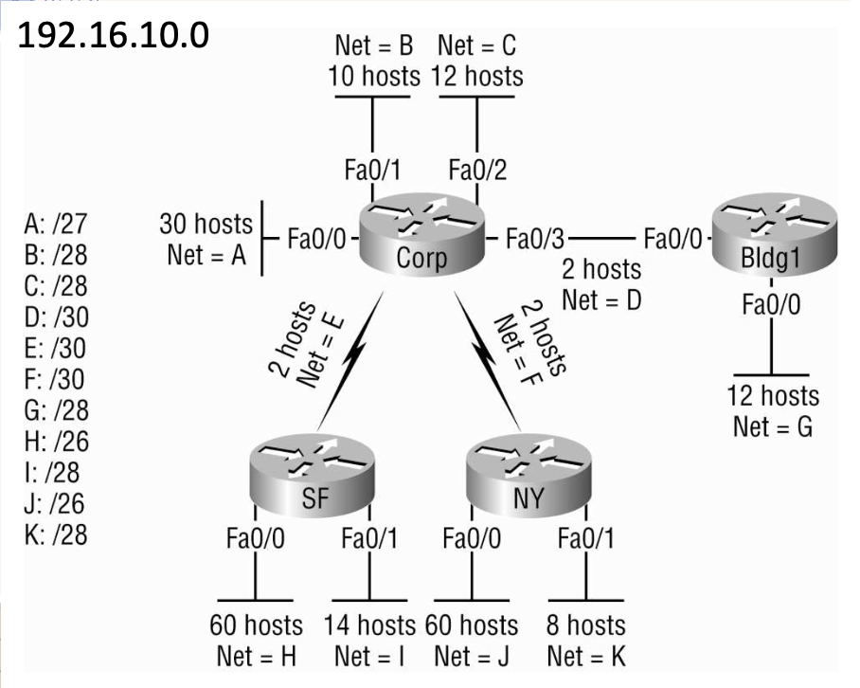

**1. Network A (/27)**

* **Subnet Mask**: 255.255.255.224
* **Hosts**: 30
* **Block Size**: 32
* **Range**:
  + **Network ID**: 192.168.10.0
  + **Usable IPs**: 192.168.10.1 to 192.168.10.30
  + **Broadcast Address**: 192.168.10.31

**2. Network B (/28)**

* **Subnet Mask**: 255.255.255.240
* **Hosts**: 10
* **Block Size**: 16
* **Range**:
  + **Network ID**: 192.168.10.32
  + **Usable IPs**: 192.168.10.33 to 192.168.10.46
  + **Broadcast Address**: 192.168.10.47

**3. Network C (/28)**

* **Subnet Mask**: 255.255.255.240
* **Hosts**: 12
* **Block Size**: 16
* **Range**:
  + **Network ID**: 192.168.10.48
  + **Usable IPs**: 192.168.10.49 to 192.168.10.62
  + **Broadcast Address**: 192.168.10.63

**4. Network D (/30)**

* **Subnet Mask**: 255.255.255.252
* **Hosts**: 2
* **Block Size**: 4
* **Range**:
  + **Network ID**: 192.168.10.64
  + **Usable IPs**: 192.168.10.65 to 192.168.10.66
  + **Broadcast Address**: 192.168.10.67

**5. Network E (/30)**

* **Subnet Mask**: 255.255.255.252
* **Hosts**: 2
* **Block Size**: 4
* **Range**:
  + **Network ID**: 192.168.10.68
  + **Usable IPs**: 192.168.10.69 to 192.168.10.70
  + **Broadcast Address**: 192.168.10.71

**6. Network F (/30)**

* **Subnet Mask**: 255.255.255.252
* **Hosts**: 2
* **Block Size**: 4
* **Range**:
  + **Network ID**: 192.168.10.72
  + **Usable IPs**: 192.168.10.73 to 192.168.10.74
  + **Broadcast Address**: 192.168.10.75

**7. Network G (/28)**

* **Subnet Mask**: 255.255.255.240
* **Hosts**: 12
* **Block Size**: 16
* **Range**:
  + **Network ID**: 192.168.10.76
  + **Usable IPs**: 192.168.10.77 to 192.168.10.90
  + **Broadcast Address**: 192.168.10.91

**8. Network H (/26)**

* **Subnet Mask**: 255.255.255.192
* **Hosts**: 60
* **Block Size**: 64
* **Range**:
  + **Network ID**: 192.168.10.92
  + **Usable IPs**: 192.168.10.93 to 192.168.10.126
  + **Broadcast Address**: 192.168.10.127

**9. Network I (/28)**

* **Subnet Mask**: 255.255.255.240
* **Hosts**: 14
* **Block Size**: 16
* **Range**:
  + **Network ID**: 192.168.10.128
  + **Usable IPs**: 192.168.10.129 to 192.168.10.142
  + **Broadcast Address**: 192.168.10.143

**10. Network J (/26)**

* **Subnet Mask**: 255.255.255.192
* **Hosts**: 60
* **Block Size**: 64
* **Range**:
  + **Network ID**: 192.168.10.144
  + **Usable IPs**: 192.168.10.145 to 192.168.10.190
  + **Broadcast Address**: 192.168.10.191

**11. Network K (/28)**

* **Subnet Mask**: 255.255.255.240
* **Hosts**: 8
* **Block Size**: 16
* **Range**:
  + **Network ID**: 192.168.10.192
  + **Usable IPs**: 192.168.10.193 to 192.168.10.206
  + **Broadcast Address**: 192.168.10.207