 

**Electromagnetic waves**

**Lecture 6**

**Electric field and flux density**

**Msc.Ammar karem**

**Tow stage**

**Department of medical physics**

**Al-Mustaqbal University**

* **Electric Flux Density (D)**

 In 1837,Michael Faraday performed the experiment on electric field . He showed that the electric field around a charge can be imagined interms of presence of the lines of force around it. He suggested that the electric field should be assumed to be composed of very small bunches containing afixed number of electric lines of force. Such a bunch or closed area is called a tube of flux. The total number of tubes of fulx in any particular electric field is called as the electric flux .

* Electric flux ($\vec{D}$) is defined as the measure of the number of electric field lines that penetrate a given area .
* 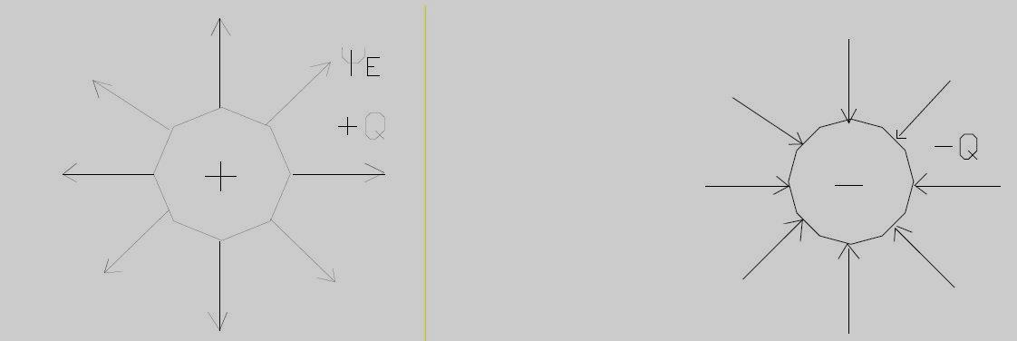If the lines are out of the charge, the charge will be positive, and if the lines are entering the charge, it will be negative
* Electric flux D originates on positive charge and terminates on negative charge. In the absence of negative charge, the flux 𝜑 terminates at infinity.
* The electric flux density 𝐃 is a vector field and is a member of the “flux density” class of vector fields, as opposed to the “force fields” class, which includes the electric field intensity 𝐄.

* **Relation Between $\vec{D}$ and $\vec{E}$ due to Point Charge**

If we now let the inner sphere become smaller and smaller, while still retaining a charge of 𝑄, it becomes a point charge in the limit, but the electric flux density at a point 𝑟 meters from the point charge is still given by

$\vec{D}=\frac{ψ}{A}$

$\vec{D}=\frac{ψ}{4πr^{2}}{\hat{a}}_{r}$ (1)

$\vec{D}=\frac{ψ}{4πr^{2}}{\hat{a}}_{r}cm^{-2}$

The expression for $\vec{E}$ on the surface at $r_{s}$ due to Q, is

$$\vec{E}=\frac{Q}{4πε_{°}r^{2}}{\hat{a}}_{r}$$

$$\frac{\vec{D}}{\vec{E}}=\frac{\frac{Q}{4πr^{2}}{\hat{a}}_{R}}{\frac{Q}{4π{ε_{°}r}^{2}}{\hat{a}}_{R}}=ε_{°}$$

In free space, therefore,

$\vec{D}=ε_{°}E$ (2)

Although (2) is applicable only to a vacuum, it is not restricted solely to the field of a point charge.

For a general volume charge distribution in free space,

$\vec{E}=\int{\frac{ρ_{v} dv}{4πε_{°}R^{2}}{\hat{a}}_{R}}$ (free space only) (3)

where this relationship was developed from the field of a single point charge. In a similar manner, (1) leads to

$\vec{D}=\int{\frac{ρ_{v} dv}{4πR^{2}}a_{R}}$ (4)

it might be well to point out now that, for a point charge embedded in an infinite ideal dielectric medium, Faraday’s results show that (1) is still applicable, and thus so is (4). Equation (3) is not applicable.

Because 𝐃 is directly proportional to E in free space, it does not seem that it should really be necessary to introduce a new symbol. We do so for a few reasons. First, 𝐃 is associated with the flux concept, which is an important new idea. Second, the 𝐃 fields we obtain will be a little simpler than the corresponding E fields, because does not appear.

* Cases of electric flux density

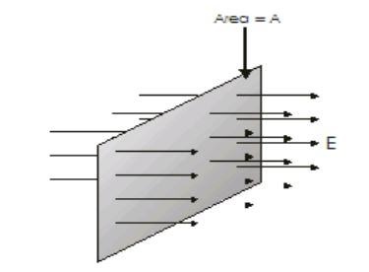**The first case**: the electric flux of a plane area perpendicular to a regular electric field

$$\vec{D}=\vec{E} . \vec{A} ({Nm^{2}}/C)$$

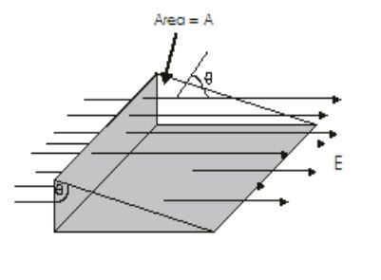  
**The second case** :the electric flux density has a maximum value when the surface is perpendicular to the field i.e. θ=0 and it has a minimum value when the surface is parallel to the field i.e. θ= 90

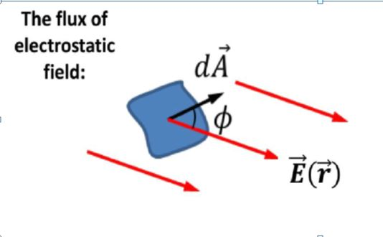**The third case**: the general case, the electric field is nonuniform over the surface

(Flux through closed surfaces)

$$D=\oint{\vec{E}\left(\vec{r}\right).d\vec{A}}$$

The integral is taken over the whole surface

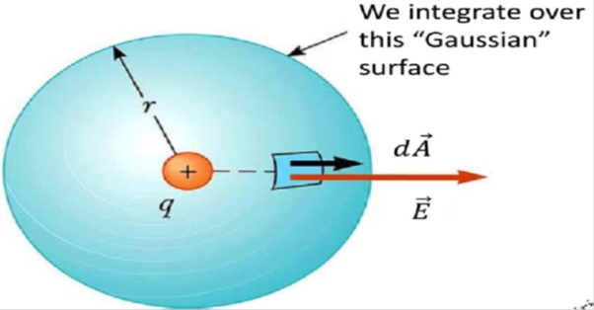**The fourth case**: the Electric Flux due to a point charge

In this case the value of flux is

$\vec{D}=\oint{\vec{E} .d\vec{A}}$ = $E\oint{d\vec{A}}\cos{θ}$ (θ=0)

$\vec{D}=\frac{q}{4πε_{°}r^{2}}\oint{d\vec{A}}=\frac{q}{4πε_{°}}$ $4πε_{°}r^{2}$

$\vec{D}=$ $\frac{q}{ε_{°}}$

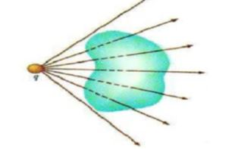

* The flux for point charge place outside the surface is equal to zero

$\vec{D}=0$

* The flux magnitudes for two surface same as in the down figure is taken same value.



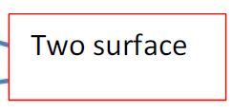



**Example:-** For calculate the flux of uniform electric field through the surface shown in the figure.

Solution :- By use the equation :

$$D=E\left(r\right). A . cos∅$$

$$∅={120}^{°}$$

$$cos\left({120}^{°}\right)=-0.5$$

$$A=4πr^{2}$$

$$D=2×4π\left(r^{2}\right)cos120$$

$$=2×4π×0.01×-0.5$$

= - 0.04 π $N .\frac{m^{2}}{c}$

= 0.1256 $N .\frac{m^{2}}{c}$

* **The electric flux concept is based on the following rules:**

1- Electric flux begins from (+ ve) charge and ends to (-ve) charge

2- Electric field at a point is tangent to the electric flux line passing with this point and out wide.

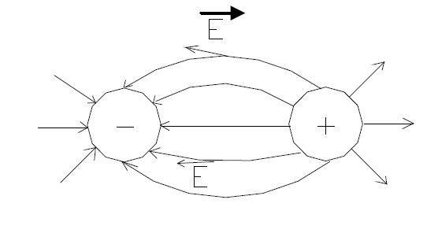

3- In the absence of (-ve) charge the electric flux terminates at infinity.

4- The magnitude of the electric field at a point is proportional to the magnitude of the electric flux density at this point.

5- The number of electric flux lines from a (+ ve) charge Q is equal to Q in SI unit

Example: - The adjacent figure shows a positive point charge of ($3μC$) placed at the center of a sphere of radius (20 cm) in the air. What is the electric flux across the surface of the ball?

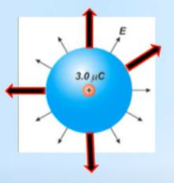 $\vec{D}=\vec{E} . \vec{A} cosθ$

$\vec{E}=\frac{Kq}{r^{2}}$, $\vec{A}= 4π r^{2}$, θ = 0

$\vec{D}=\frac{Kq}{r^{2}} 4π r^{2}$

$\vec{D}=9×{10}^{9}×3 ×{10}^{-6}×4π$

$\vec{D}=3.3 ×{10}^{5}$ ${Nm^{2}}/C$

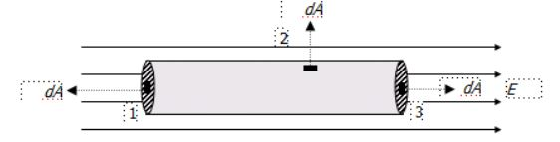Example: Calculate the total flux of a closed cylinder of radius R placed in a regular electric field.

$\vec{D}=\oint{\vec{E}.\vec{dA}}$ = ${\oint{\vec{E}.\vec{dA}} }_{(1)}+{\oint{\vec{E}.\vec{dA}}}_{(2)}+{\oint{\vec{E}.\vec{dA}}}_{(3)}$

$\vec{D}=\oint{\vec{E}.\vec{dA}}$ = ${\oint{\vec{E}.dAcos180} }_{(1)}+{\oint{\vec{E}.dA cos90}}_{(2)}+{\oint{\vec{E}.dA\cos{0}}}_{(3)}$

Since E is constant then

$\vec{D}=-EA+0+EA=zero$

**Homework :-**

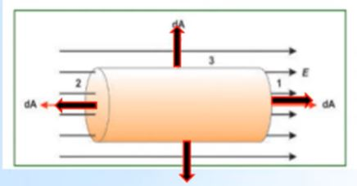The adjacent figure shows a cylinder of length (L) and base radius (r) placed in a regular electric field it intensity (E) in a direction parallel to the axis of the cylinder. What is the total electric flux across the surface of the cylinder?