 

**Electromagnetic waves**

**Lecture 7**

**Maxwell Equations**

**Ammar Karem**

**Tow stage**

**Department of medical physics**

**Al-Mustaqbal University**

**Maxwell’s equations**

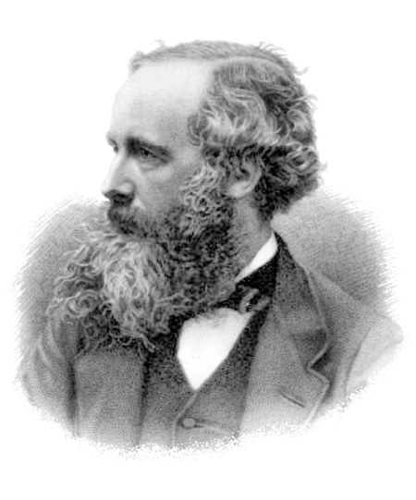

James Clerk Maxwell FRSE FRS (13 June 1831 – 5 November 1879) was a Scottish mathematician and scientist responsible for the classical theory of electromagnetic radiation, which was the first theory to describe electricity, magnetism and light as different manifestations of the same phenomenon. Maxwell's equations for electromagnetism have been called the "second great unification in physics". where the first one had been realised by Isaac Newton.

With the publication of "A Dynamical Theory of the Electromagnetic Field" in 1865, Maxwell demonstrated that electric and magnetic fields travel through space as waves moving at the speed of light. He proposed that light is an undulation in the same medium that is the cause of electric and magnetic phenomena. The unification of light and electrical phenomena led to his prediction of the existence of radio waves. Maxwell is also regarded as a founder of the modern field of electrical engineering.

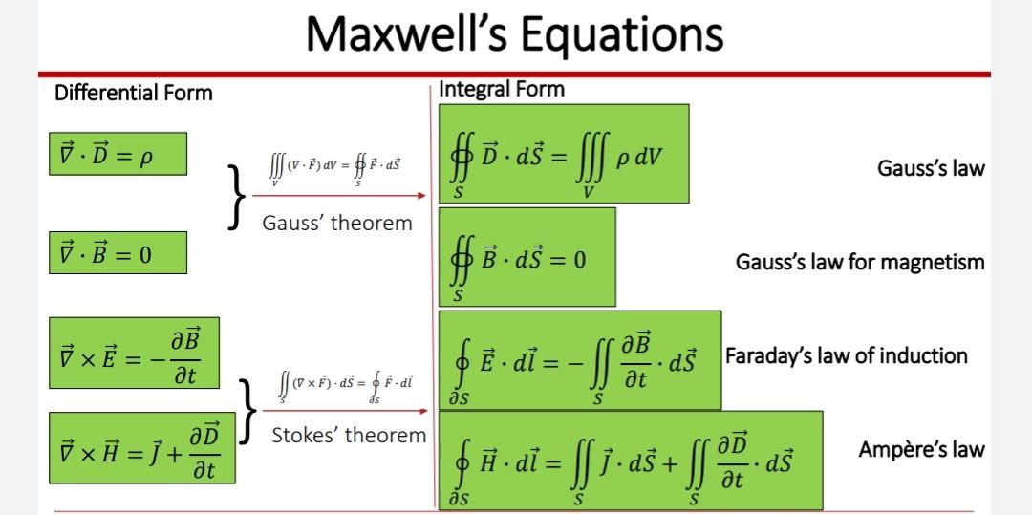

These relations consist of four expressions: one derived from (Ampere’s law), one from (Faraday’s law) and two derived from (Gauss’s law).

These equations are:

1. $∇ ×H=J+ \frac{∂D}{∂t}$…………..(1)
2. $∇ ×E=- \frac{∂B}{∂t}$…………….(2)
3. $∇ . D=ρ$……………(3)
4. $∇ . B=0$…………….(4)

Equation (1): it is the differential form of Maxwell’s equation as derived from (Ampere’s law).

Equation (2): it is the differential form of Maxwell’s equation as derived from (Faraday’s law).

Equation (3): it is the differential form of Maxwell’s equation electric field equation as derived from (Gauss’s law).

Equation (4): it is the differential form of Maxwell’s equation magnetic field equation as derived from (Gauss’s law).

Where:

$\vec{B}$: The magnetic flux density vector in (𝜔/ $m^{2}$) or T.

$\vec{H}$: The magnetic field intensity vector in (A/m).

$\vec{E}$: The electric field intensity vector in (Ѵ/m).

$\vec{D}$: The electric flux density vector in (c/m2) or (electric displacement vector).

* For electrostatic model the fundamental differential equations are given by:

$\vec{∇} × \vec{E}=0$………………(1)

$\vec{∇} . \vec{D}=ρ$……………...(2)

- For linear and isotropic media. E and D are related by the relation:

$\vec{D}= ε \vec{E}$………………(3)

Where:

ε = permittivity of medium (F/m).

* For magneto static model the fundamental differential equations are given by:

$\vec{∇} . \vec{B}=0$…………….(4)

$\vec{∇} × \vec{H}=J$……………(5)

- For linear and isotropic media. B and H are related by the relation:

$\vec{B}= μ \vec{H}$……………(6)

Where:

***ρ*** : is the density of free charge in (c/ $m^{2}$)

J: is the density of free current in (A/ $m^{2}$).

$∇$: is the operator and define in Cartesian coordinates.

$\vec{∇}=\frac{∂}{∂x}i+ \frac{∂}{∂y}j+\frac{∂}{∂z}k$……………….(7)

- When applied on U is defined (gradient potential) and written as:

$∇U=\frac{∂u}{∂x}i+ \frac{∂u}{∂y}j+\frac{∂u}{∂z}k$………………….(8)

- The gradient potential in negative sign represents the electric field and given by:

E=- $∇U$…………………….(9)

- The divergence of $\vec{E}$ is given by:

$\vec{∇}\vec{E}=\frac{∂Ex}{∂x}+ \frac{∂Ey}{∂y}+\frac{∂Ez}{∂z}$……………….(10)

* Drive the second of Maxwell’s equation

Faraday experiment law has been used to obtain the second of Maxwell’s equation in differential form.

- From Faraday law we have

$ε= \frac{∂∅}{∂t}$ 1)...................

Equation (1) It means that the change in magnetic flux through an electric circuit is accompanied by an electromotive force

But

$ε =\oint{E.dl}$………..(2)

$∅= \int{B . ds}$………..(3)

Sub.(3) In (1)

If the electric circuit is fixed in its position, then the derivative with respect to time can be transferred within the integral and becomes a partial derivative.

$ε= -\frac{d}{dt} \int{B . ds} → ε= -\int{\frac{∂B}{∂t}} . ds$…………..(4)

By equal equation (4) and equation (2) we get:

$\oint{E.dl}$ = $-\int{\frac{∂B}{∂t}} . ds$…………..(5)

By using stokes theorem:

$\oint{E.dl}$ = $\int{∇×E} . ds$…………..(6)

By equal equation (5) and equation (6) we get:

$\int{∇×E} . ds$ = $-\int{\frac{∂B}{∂t}} . ds$

$∴ ∇×E= -\frac{∂B}{∂t}$

* This equation is the differential form of (Faraday’s law).

*Deriving the speed of light from Maxwell's equations

Assuming that light propagates in a vacuum where there are no electric charges, ie

$ρ=0$, J=0

So the four equations become as follows

$∇ ×H=μ_{°}ϵ_{°} \frac{∂D}{∂t}$

$∇ ×E=- \frac{∂B}{∂t}$

$∇ . D=0$

$∇ . B=0$

$∇ ×\left(∇ ×E \right)= - \frac{∂∇ × B}{∂t}$

$∇ ×\left(∇ ×E \right)= - ∇^{2}E+ ∇ . (∇ . E)$

${ ∇}^{2} E= μ_{°}ϵ_{°}\frac{∂^{2}E}{∂t^{2}}$

$\frac{∂^{2}E}{∂x^{2}}=μ_{°}ϵ_{°}\frac{∂^{2}E}{∂t^{2}}$

$E= E_{°}\sin{(2π \frac{x-vt}{λ})}$

$\frac{∂^{2}E}{∂x^{2}}= - E_{°}{(\frac{2π}{λ})}^{2}\sin{(2π \frac{x-vt}{λ})}$

$\frac{∂^{2}E}{∂t^{2}}= - E_{°}{(\frac{2πv}{λ})}^{2}\sin{(2π \frac{x-vt}{λ})}$

$v^{2}= \frac{1}{μ_{°}ϵ_{°}}$

_______________________________________________________________________

*Maxwell theory is based on two main principles:

1- A time-varying electric field in space produces a magnetic field perpendicular to it that is in phase .

2- The time-varying magnetic field space produces an electric field that is also perpendicular to it and in the same phase .

Based on these two principles , the electric and magnetic fields spread in space from one point to another they are compatible , in phase , and perpendicular to their line of propagation , forming what is called an electromagnetic wave .