Radiology

# Lec. 2 X – Ray Films

**Dental x- ray film**: Is a recording media on which image of the object was made by exposing this film to X- ray.

# Types of X- ray film

1. Intra oral X- ray film.
2. Extra oral X- ray film.

# Intra oral X- ray film

It is named so because it is placed inside the mouth during x ray exposure.

Intra oral x ray film packet contains:

*Outer plastic wrapper. *Lead foil. *Black paper. *X ray film.

The **outer plastic cover** protect the film from light and moisture. There are two sides ; the exposure side facing the x ray tube and non-exposure side away from x ray beam.

There is a small dot on the one of the corners which used for film orientation. **A thin sheet of lead** is usually placed behind the film to prevent most of secondary radiation that originated in the tissue of the patient behind the film from reaching it ( so it minimizes the film fog).

Also the lead foil absorbs x ray that have passed through the object and the film so it reduces the exposure of the tissues behind the film. The foil has a design of herring bone pattern.

**Black paper:** surrounding the film to protect the emulsion from light as the silver halide crystals are sensitive to light.

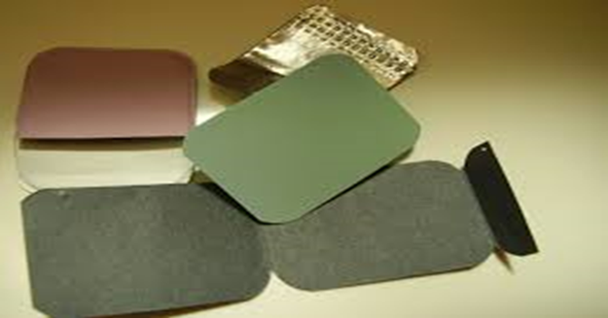.

**Chemical composition of X- ray film:**

It consists of a sensitized emulsion present on both sides of transparent base.

The base is the foundation of the radiographic film , made from cellulose acetate. Its primary purpose is to provide a rigid structure onto which the emulsion can be coated. Its flexible and fracture resistant to allow easy handling but rigid enough to be placed on the viewer.

The emulsion is the heart of the x-ray film , it’s the material with which the x-ray or light photons interact and forming the image. It consists of homogenous mixture of silver halides crystals (mainly silver bromides) suspended in gelatin. The silver bromide crystals are sensitive to both light and X- ray photons.

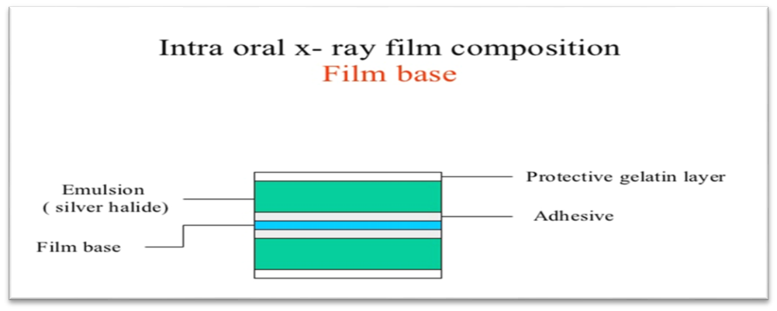

# Intra oral film types

Classified on numerical basis into:

# A - Type I

Called **periapical** film used to examine the apical area of the tooth and the surrounding structures (record the crowns, roots, and surrounding bone). Film packs come in three sizes

* Size 0 for small children (22 mm × 35 mm)
* Size 1, which is relatively narrow and used for views of the anterior teeth (24 mm

× 40 mm)

* Size 2, the standard film size used for adults (30.5 mm 40.5×mm) So the available sizes are (1.0, 1.1 and 1.2)

**B – Type II**

Is called **bitewing** film it used to detect the inter proximal caries and the height of alveolar bone between 2 adjacent teeth. Bite-wing films often have a paper tab projecting from the middle of the film on which the patient bites to support the film.

Size 2 film is normally used in adults; the smaller size 1 is preferred in children. In small children, size 0 may be used. A relatively long size 3 is also available. So the size include (2.0, 2.1, 2.2 and 2.3)

**C – Type III**

Is called **occlusal** film that used to demonstrate area larger in dimension than area appearing in periapical film. the size is (3.4) only.

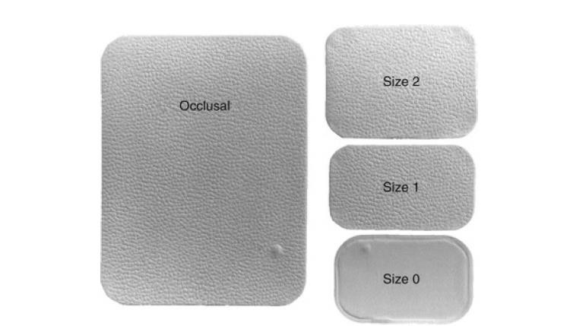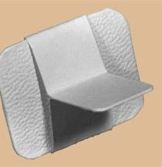

# Intra oral film speed

Fig 4: types of x-ray films

Speed means the sensitivity of X- ray film silver bromide crystals (Ag Br) to X- ray photon.

There is direct relation between the speed of the film and the size of the crystals, the larger crystal size the faster film speed. the faster mean it need less amount of radiation to produce radiographic image so less radiation dose absorbed by patient.

The classification of film speed based on alphabetical basis so from A to F, film speed A is the slowest while speed F is the faster one. Only films with a D or faster speed rating are appropriate for intraoral radiography.

# Extra oral film

The purpose of using such film is to make a radiographic image able to examine an area in and around the jaw that can't be seen by intra oral film, such as panoramic , cephalometric and other skull radiograph

# Types of extra oral film

1. Screen
2. Non screen

* **Non screen film (direct exposure film)**

1. Film emulsion is more sensitive to X- ray than to light.
2. The film has double emulsion like intra oral film but the emulsion is thicker.
3. this type of extra oral film requires more radiation dose than the screen film; however its resolution is higher
4. The size of the film used include: 5×7 and 8×10 inches.

* **Screen film (indirect exposure film)**

1. Film emulsion is more sensitive to visible light and more specifically to blue light in the visible light spectrum.
2. The size include: - 5×7, 8×10 and 10×12 inches.
3. Screen film has 3 types:- slow or detail screen, medium or par – speed screen and fast or high – speed screen.

The screen film placed between 2 fluorescent screen ( intensifying screens) in cassette. This fluorescent screen is a device that converts the x ray into a visible light; it is made from (tiny calcium tungestate crystals). Each x ray photon absorbed by the screen will produce many light photons which will effect a large area of the film , thus the amount of radiation to the patient is reduced.

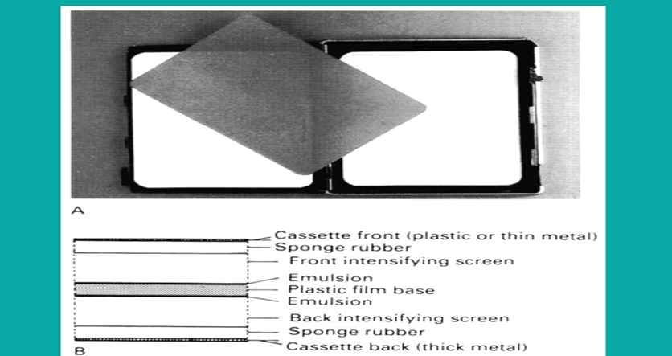

# Film properties

* 1. **Density**: Is the degree of blackness present in the processed film it measures in terms of light transmission on a percentage or logarithmic scale.

Film density used in diagnostic radiograph is ranged from 0.25 to 2.

Film density measured by sensitometer or densitometer, and its relationship with radiation exposure is represented by H & D curve (Hurter and Driffield).

# Factors affect film density

1. Exposure time: increase exposure time increases the film density.
2. Milliampere: increase milliampere value (mA) cause increasing film density.
3. Kiolvoltage: increase Kilovoltage value (kV) cause increasing film density.
4. Developing time: developing time usually range from 4 – 5 minutes. increase developing time cause increasing film density.
5. Distance: increase the distance between x- ray tube and the film during exposure cause decrease film density.
   1. **Contrast:** It means the differences in density between neighboring region on the radiograph.

# Type of contrast:

1. Long – scale or low contrast:- when many grey scale can be seen between totally white and totally black areas of the radiograph.
2. Short – scale or high contrast:- when few grey scale can be seen between totally white and totally black areas of the radiograph.

The stepwedge or penetrometer: Is an object used to show the radiographic contrast

.it's usually made of aluminum and is constructed so that there is a constant increase in thickness of aluminum between the X- ray tube and the film.

# Factors affect contrast

1. Kilovoltage: high Kvp results in low contrast
2. Processing solution temperature:high solution temperature results in high contrast.

* 1. **Details or definition**: Is the ability to reproduce sharp outlines of the object.

# Factors affect details

1. Focal spot size: size of focal spot must be as small as possible in order to produce sharp image.
2. Film grain size (film crystals): increase the size of film grain produce less sharp image.
3. Movement of patient head or X- ray tube or the film during exposure causes unsharp image.
4. Target object distance: which should be as great as possible, otherwise the image will be un sharp.
5. Object film distance: should be as small as possible to produce sharp image.
6. Screen – film contacts: poor contact cause un sharp image.
   * **What will happen during exposure of X- ray film exposure to radiation?**

# Latent image formation

Latent image is the invisible image produced on the film after exposure and prior to development; to convert it into visible image the film should be processed

The Ag Br crystals in the film emulsion are changed whenever they absorb X- ray photons, the result of absorption is precipitation of speck of silver in each exposed Ag Br crystal to X- ray.

# Film processing

Its either manual or automatic processing.

Processing cycle include: Developing, rising, fixing, washing and drying.

* + **Developing:** is the stage of processing during which the latent image is converted to a visible image.

1. ray film is placed in alkaline developer solution (4-5 minutes) ,the action of developing agents are on exposed Ag Br crystals to **continue the process of precipitating the specks of silver until all silver is deposit at the site of crystal and the bromine is released into the developing solution causing softening of the X- ray film emulsion .**
   * **Rinsing:** by water for 30s to terminates the developer action and remove chemicals from emulsion.
   * **Fixing:** by using a fixer solution for 10-15 minutes. its action is:
2. Re harden the film emulsion
3. Removed all the unexposed or undeveloped crystals.

After fixing the film washed in running water & finally drying.

* In automatic processing ;following exposure, the film is unwrapped and immediately loaded into the automatic processor. The unit consists of rollers and compartments filled with chemical solutions through which the film advances.

At the end of the processing cycle, the film is released. The cycle duration varies from 4 – 6 minutes.

# Dark Room

The darkroom or processing room is a place where handling and processing of radiographic films can be carried out safely and efficiently without hazard of producing film fog by accidental exposure to light or x-ray

* + **Illumination of dark room**

1. A ceiling light to provide ordinary illumination in the darkroom , its switch must be placed high enough on the wall to prevent the operator from accidentally turning it on during processing .
2. Safelight , : it is low intensity illumination of relatively long wavelength (red) that doesn’t rapidly affect open film but permit one to see well enough to work in the area. A frosted 15 watt bulb or a clear 7.5 watt bulb is the light of choice and should be mounted 4 feet above the surface where opened films are handled
3. Red warning light which is placed outside the entrance to the room , it should be wired so that it is illuminated whenever the safelight is turned on

# Film storage

1.Film must be stored away from excessive heat and humidity. 2.Chemicals must not be allowed to come in contact with stored films.

1. Objects should not be placed on top of stored films because pressure can cause film artifacts.
2. The boxes of stored films should be lead lined or made of steel to prevent stray radiation from fogging the films.

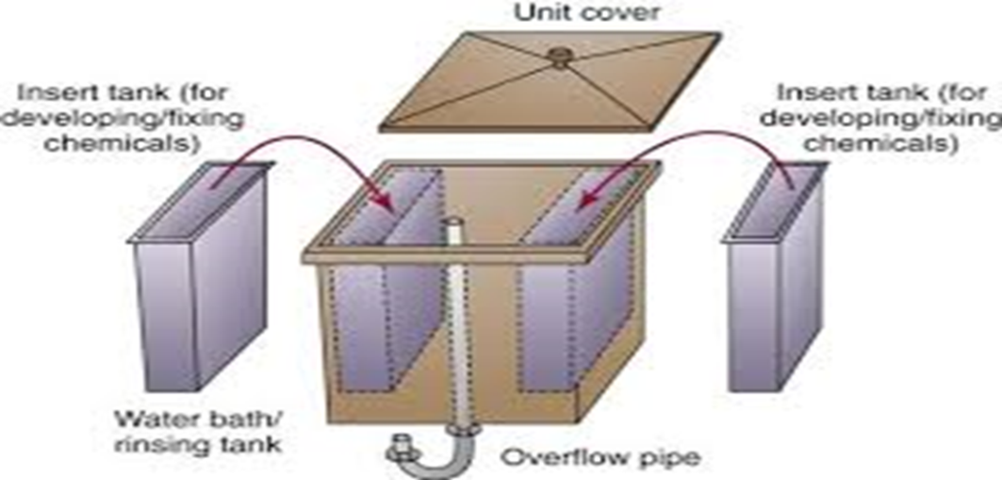

Manual processing

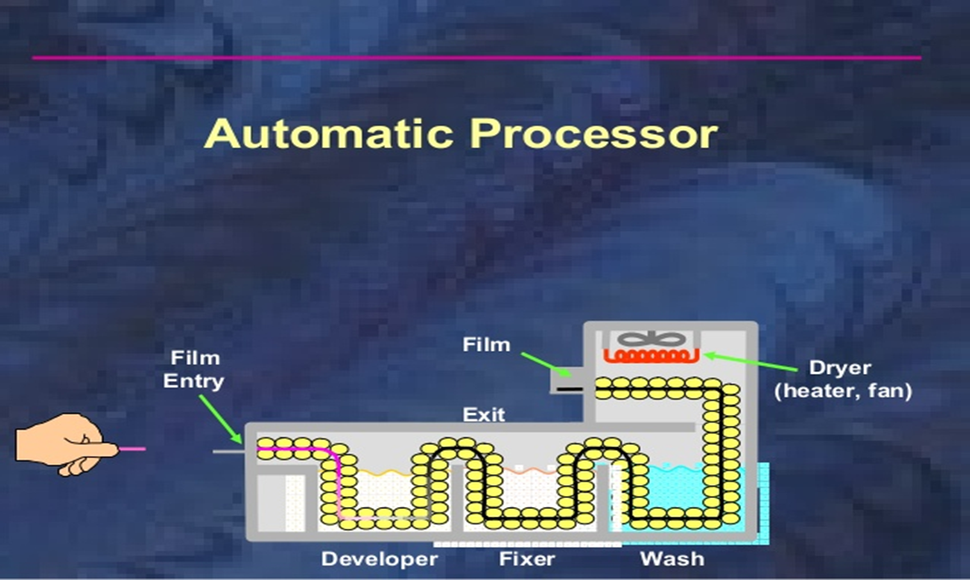

# Testing for safe lighting (Penny Test) للاطلاع فقط

1. Turn off all the lights including the safe light, wait for 5 minutes to obtain a fair degree of dark adaptation of the eyes; then look for any light leak that should be obliterated.
2. A film exposed in a normal manner , taken from its wrapper in a total darkness and placed on a work bench directly under the safe light. A small coin is placed on it, and then safe lights are turned on. The film is left in this condition for 2-5 minutes. The film then processed, if the image of the coin is seen, the darkroom is not light safe so the safe light must be rectified.

