**Common disease of the teeth and supporting structures**

A radiograph is only one part of the diagnostic process. Usually one cannot make diagnosis from a radiograph only, the correct diagnosis is made when the clinician collect the diagnostic information and analyzed them collectively

The followings are the most common disease of the teeth and supporting structures

**\*\*Dental caries**:

Occlusal, buccal and lingual caries are reasonably easy to detect clinically, **interproximal** and **recurrent** caries are much more difficult to detect with only clinical examination.

The carious process causes tooth **demineralization**, the demineralized area allows greater passage of x ray and appears darker on the film than the unaffected portion and can be detected radiographically.

**1.Interproximal caries:**

The intraoral film notably **bitewing** and periapical radiograph made with **paralleling** technique are extremely useful in detecting interproximal carious lesions. The first evidence of interproximal carious lesion consists of an extremely small notching in the enamel surface at the interproximal contact point.

As the carious lesion in the enamel increased in size, it will take a triangular pattern with its base toward the outer surface of the tooth and with somewhat flattened apex toward the dentinoenamel junction. After reaching the DEJ , the carious lesion spread along the dentino enamel junction forming a second triangle with the base toward the DEJ and the apex toward the pulp and this is happened due to the path of the dentinal tubules .

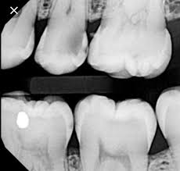 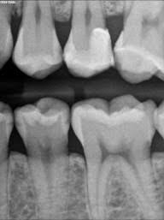 enamel and dentine within enamel only

**2.Occlusal caries:**

When the caries within enamel only , it cannot be seen on radiograph but can be detected clinically. As the caries extends into the dentine , it can be seen as a thin radiolucent line under the enamel.

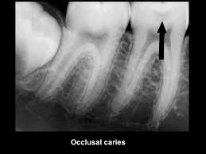

**3. Buccal and lingual caries:**

Small lesions appear round; as they enlarged, they become elliptical or semi lunar with sharp well defined borders. It is difficult to differentiate between buccal and lingual caries also it may be confused with pulp exposure even the lesion may be relatively superficial

l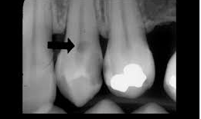

**4. Cemental caries (root caries)**

It doesn’t occur in area covered by well attached gingiva, it is saucer shaped lesion . Its prevalence is approximately 40%-50% in aged populations. It may be confused with cervical burnout.

**Cervical burnout:** radiolucent band running across the tooth in area not covered by enamel or alveolar bone (neck of the tooth ) because it absorbs less x ray than areas below and above.

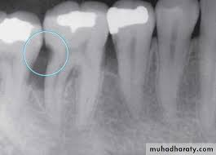 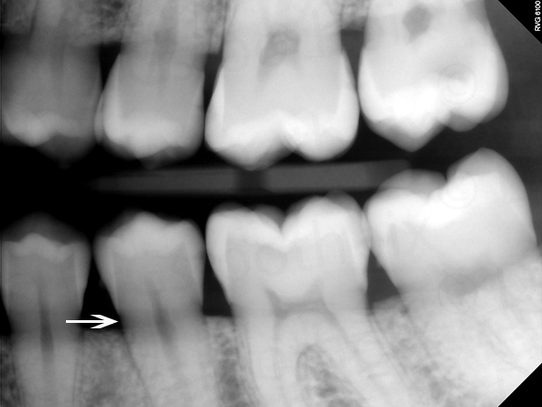

**Cemental caries cervical burn out**

**5.Recurrent or secondary caries:**

Recurrent caries occur immediately next to the restoration. It results from **poor adaptation of a restoration, which allows marginal leakage or the caries may remain if the original lesion is not completely removed or it may occur after cracking of restoration**. The radiographic appearance depends on the amount of decalcification present and whether a restoration obscuring the lesion or not

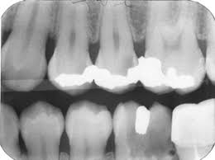

**\*\*Periodontal disease:**

Several disorders related to the periodontium are collectively known as periodontal disease. The most common of these are gingivitis (limited to the marginal gingiva) and periodontitis (loss of alveolar bone also occur). Radiographic examination play an important role in the evaluation of patients with periodontal disease. .

**Radiographic feature of healthy periodontium:**

A healthy periodontium can be regarded as periodontal tissue exhibiting no evidence of disease. The only reliable radiographic feature is the relationship between the alveolar crest and the cemento–enamel junction (CEJ). If this distance is within normal limits (0.5-2 mm) and there are no clinical signs of loss of attachment, then it can be said that there has been no periodontitis.

**Radiographic feature of periodontal disease:**

**\*\* Acute and chronic gingivitis:**

Radiograph provide no direct evidence of the soft tissue involvement in gingivitis. However in severe cases of acute ulcerative gingivitis , destruction of underlying crestal bone may be observed.

**\*\*Periodontitis:**

It is the name given to the periodontal disease when the superficial inflammation in the gingival tissue extends into the underlying alveolar bone and there has been loss of attachment.

In a healthy periodontium; crestal bone should be parallel with a line drawn from the CEJof one tooth to that of the adjacent tooth and should be located about (0.5-2 mm) from this line. Bone loss may occur in a horizontal or vertical direction, also there is furcation involvement. So we have :

1.Horizontal bone loss: when the loss occur on a plane that is parallel with a line joining CEJ of the two adjacent teeth .

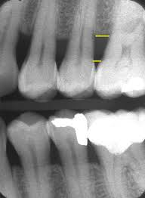

2. Vertical bone loss: when there is greater bone loss in one tooth side than on the adjacent side, so the bone level is not parallel with a line joining CEJ. Sometimes vertical loss may be sever, extending from the alveolar crest to the tooth apex causing pulp necrosis and this condition named perio-endo lesion.

.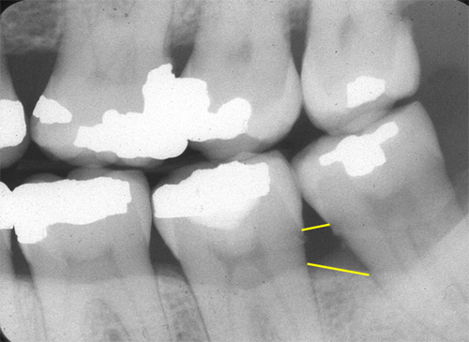

3. furcation involvement: it describes the bone loss in the furcation area of the roots which is evidence of advanced disease in this zone and mostly occur in molar teeth.

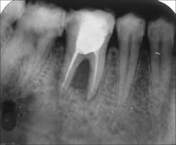

**\*Root end changes:\***

**A**. Hypercementosis: clubbing of root ( radiopacity related to the root surface).

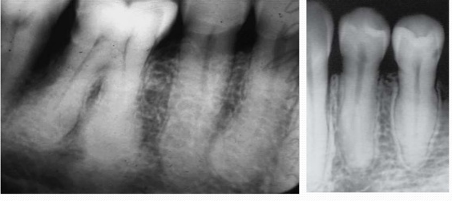

**B**. Ankylosis: it is a condition where the tooth root and bone become fused with absence of periodontal ligament space .

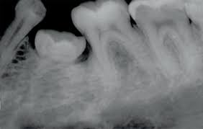

**C**. Root resorption: have different calcifications:

According to the site of resorption, classified into:

1.Internal. 2. External.

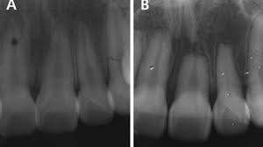

**\* inflammatory lesions of the jaws:\***

Inflammatory lesions are one of the most common pathologic condition of the jaws.

When the initial source of inflammation is a necrotic pulp and the bony lesion is restricted to **the region of the tooth apex**, the condition is called **a periapical inflammatory lesion.**

When the infection spreads in the **bone** marrow and is no longer contained, it is called **osteomyelitis.**

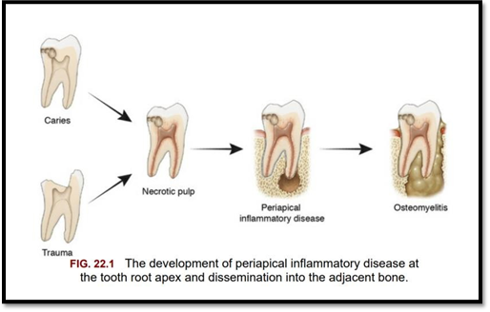

**Radiographic feature of common periapical inflammatory lesion:**

The radiographic feature of periaical inflammatory lesions vary depending on the time coarse of the lesion.

**A-Early periapical inflammatory lesions**

The earliest detectable change is widening of the periodontal ligament space at the apex of the tooth. At this early stage no evidence may be seen of a sclerotic bone reaction.

**B- periapical granuloma:**

It is a mass of inflamed granulation tissue at the apex of a non-vital tooth.it may give rise to periapical cyst or abscess. It is asymptomatic but has a previous history of sensitivity to heat and cold. Radiographically: granuloma is the most common periapical radiolucencies encountered in dental practice the lesion is not fully dark but it has greyish appearance with well-defined borders , there is a loss of lamina dura in relation with the affected tooth , the size of radiolucency is less than 1.5 cm in diameter if the size larger so it consider periapical cyst.

**C- periapical abcess:**

- Acute periaical abscess: **:** The tooth is painful, tender to percussion with systemic manifestation such as fever, swelling and lymphadenitis. Radiographically: acute abscess shows No radiographic changes, but in some cases we may see a widening of the apical PDL space.

- Chronic periapical abscess: It may develop from acute abscess or from a granuloma. It is usually asymptomatic because the pus drain through the sinus at the apical region or through the PDL space . Radiographically: It requires 10 days or more for an infection to erode bone and cause radiolucencent appearence with ill-defined margin, it is difficult to differentiate it from granuloma or cyst

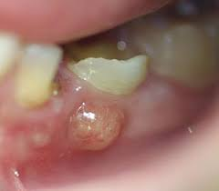 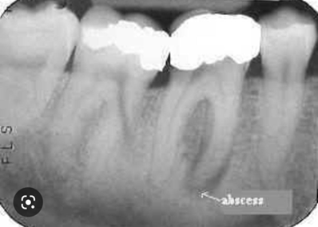

**C- periapical cyct ( radicular cyst):** It develops over a long period of time in pre-existing granuloma. This cyst is asymptomatic, unless secondary infection is occurring. Radiographically: identical with granuloma but may be of greater size. Due to longer duration, it may exhibits a thin radiopaque line around the periphery of radiolucent area which represented bone reaction to the slowly expanding mass.

**D. Condensing ostitis:** band of radio-opacity associated with the tooth apex reflected the bone defense mechanism .

**Differential diagnosis of periapical radiolucency:**

1.Superimposition of radiolucent normal anatomical structure like mental foramen.

2. incomplete root formation (as in children)

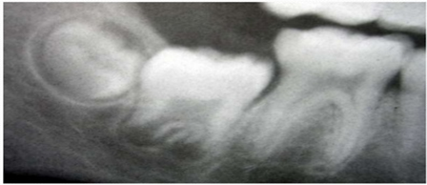

3. periapical cyst, granuloma and abscess.

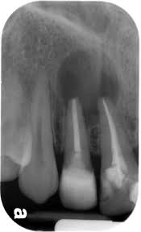  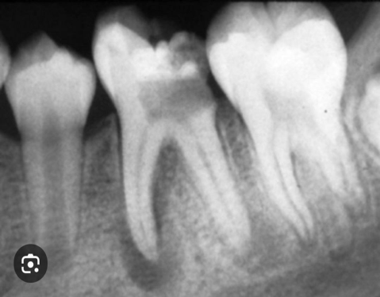

**Granuloma abscess cyst**

4. first stage of fibro-osseous lesions:

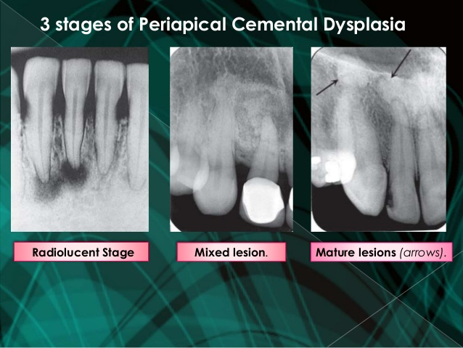

**Osteomyelitis**:

The inflammatory process may spread through the bone to involve the marrow, cortex, cancellous portion and periosteum.

**Clinical Features**

Osteomyelitis of the maxilla is much less frequent than that of the mandible because the maxillary blood supply is far more extensive.

Clinically, patients present with facial swelling, localized pain and tenderness to percussion , low-grade fever, draining sinus tracts, suppuration, dental loss and **sequestrum** (i.e. necrotic bone fragment) formation

**Radiographic Features.**

Acute osteomyelitis: Very early in the disease no radiographic changes are identified.

The first radiographic evidence of the acute form of osteomyelitis is slight decreased density of the involved bone. There is loss of sharpness of the existing trabeculae. With time bone destruction becomes more profound, resulting in an area of radiolucency .

**Sequestra** may be present but usually more clearly seen in chronic form of the disease. It can be identified by closely inspecting a region of bone resorption ( radiolucency) for an island of non vital bone.

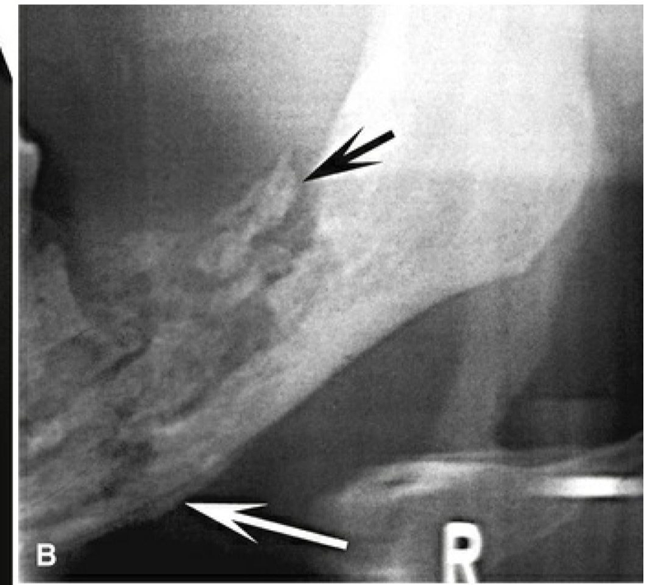

**\*\*Jaw fracture:**

The following signs may indicate the presence of fracture:

1.The presence of sharply defined radiolucent line which represents the fracture line.

2.A change in the normal anatomical shape. For example a fracture of the mandible may show asymmetry between the left and right sides or a sharp change in occlusal plane.

3.A defect in the outer cortical boundary such as step like defect.

4.An increase in the density of the bone, which may be caused by the overlapping of the two fragments of the bon

