

تطبيقات الحاسوب   
STAAD.pro advanced CONNECT Edition

Sally Selan Hussein

STAADPro is a general purpose structural analysis and design program with applications primarily in:

* the building industry
* commercial buildings
* bridges and highway structures
* industrial structures
* chemical plant structures
* dams
* retaining walls
* foundations, culverts and other embedded structures, etc.

* It was designed by **Engineering Research** in the late 1970s, and they continued to develop and improve it until today, making it one of the most widely used programs by companies and engineering offices.
* STAADpro is an advanced version of STAAD III program.
* The name "Staad" is an abbrviation for **Structural Analysis And Design**.

The program consists of the following facilities to enable this task:

**1. Graphical model generation utilities** as well as **text editor based commands** for creating the mathematical model

* Beam and column members are represented using lines.
* Walls, slabs and panel type entities are represented using triangular and quadrilateral finite elements.
* Solid blocks are represented using brick elements

The program consists of the following facilities to enable this task:

**1. Graphical model generation utilities** as well as **text editor based commands** for creating the mathematical model

* Beam and column members are represented using lines.
* Walls, slabs and panel type entities are represented using triangular and quadrilateral finite elements.
* Solid blocks are represented using brick elements

STAADpro facilities

**These utilities allow you to:**

Create the geometry

Assign materials like steel, concrete, aluminum

Specify supports

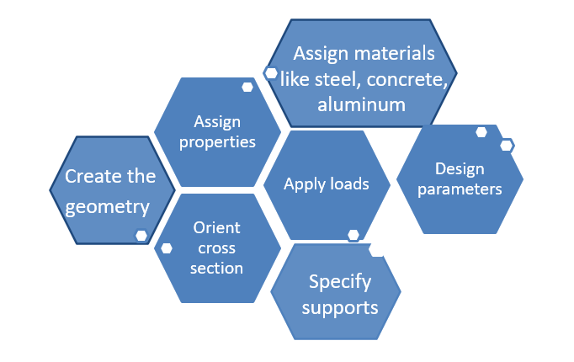

**2. Analysis engines** for performing:

* linear elastic
* finite element analysis
* frequency extraction and dynamic response (spectrum, time history, steady state, etc.).

**3. Design engines** for

* code checking and optimization of steel, aluminum and timber members.
* Reinforcement calculations for concrete beams, columns, slabs and shear walls.
* Design of shear and moment connections for steel members.

The analysis and design procedure in STAADpro

**1. Model Creation (Modeling):**

* In this stage, you create the structural model of the system you want to analyze.
* This involves defining the geometry, material properties, support conditions, and loads applied to the structure.
* The modeling phase is essential as it sets up the initial representation of the structure for analysis.

**2. Model Analysis (Solving):**

* Once the model is created, you perform various types of analyses, such as static analysis, dynamic analysis, or finite element analysis, depending on your project's requirements.
* During this phase, the software calculates the response of the structure to the applied loads, considering factors like stress, deformation, and stability.
* The analysis phase helps in understanding how the structure behaves under different conditions.

**3. Results Display and Verification:**

* After completing the analysis, you can visualize and interpret the results obtained from the software.
* STAAD Pro provides various tools for displaying results, including graphical representations, tables, and reports.
* This stage is crucial for verifying whether the design meets the desired safety and performance criteria.
* It allows engineers to make informed decisions and make any necessary modifications to the structure's design.