# •

Staad Pro Program

Sally Selan Hussein

# اﻻﺣﺪاﺛﯿﺎت اﻻﺳﻄﻮاﻧﯿﺔ اﻟﻤﻌﻜﻮﺳﺔ ) Coordinate Cylindrical Reverse

**(System :**  ﯾﺴﺘﺨﺪم اﻻﯾﻌﺎز اﻟﺘﺎﻟﻲ ﻟﺘﻌﺮﯾﻒ اﺣﺪاﺛﯿﺎت ﻧﻘﺎط اﻟﻮﺻﻞ

Reverse Cylindrical Coordinate Joint ﻋﻨﺪﻣﺎ ﯾﺤﺘﻮي اﻟﻤﻨﺸﺄ ﻋﻠﻰ ﻣﻮاﻗﻊ

R و اﻻﺣﺪاﺛﻲ Z

X ﺑﻨﺼﻒ اﻟﻘﻄﺮ

X-Z ﺑﺤﯿﺚ ﯾﺘﻢ اﺳﺘﺒﺪال اﻻﺣﺪاﺛﻲ

ﻣﻘﻮﺳﺔ ﺑﺎﻟﻤﺴﺘﻮي

ﺑﺰاوﯾﺔ اﻟﺪوران Ɵ ﻣﻊ ﺑﻘﺎء اﻻﺣﺪاﺛﻲ Y وﻣﺜﺎل ذﻟﻚ

Joint Coordinate Cylindrical Reverse 1 4 00; 2 4 0 30 ;; 3 4 0 60 ; 4 4 0 90

**Y**

Ɵ + ve

**O**

**Y**

**X**

**R**

**Z**

**-2 اﻻﺣﺪاﺛﯿﺎت اﻟﻤﺤﻠﯿﺔ System Coordinate :Local** ھﻲ ﻋﺒﺎرة ﻋﻦ ﻣﺤﺎور ﺗﺴﺘﺨﺪم

ﻟﻐﺮض ﺗﺤﺪﯾﺪ ﻣﻮاﺻﻔﺎت اﺑﻌﺎد ﻣﻨﺸﺄ وﯾﻜﻮن اﻻﺗﺠﺎه X داﺋﻤﺎ ﺑﺎﺗﺠﺎه طﻮل اﻟﻌﻨﺼﺮ اﻣﺎ ﺑﺎﻟﻨﺴﺒﺔ

ﻟﻼﺣﺪاﺛﯿﯿﻦ y,z ﻓﯿﺘﻢ ﺗﺤﺪﯾﺪ اﺗﺠﺎھﻤﺎ ﺑﺎﺳﺘﺨﺪام ﻗﺎﻋﺪة اﻟﻜﻒ اﻟﯿﻤﻨﻰ .

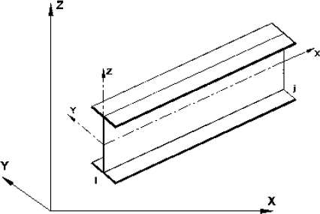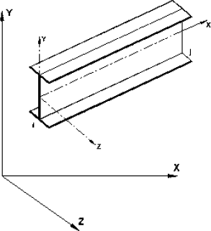

وﺑﻌﺪھﺎ ﻧﻀﻐﻂ ﻋﻠﻰ (New) ﺣﯿﺚ ﺳﻨﺒﺪأ ﺑﺎﺧﺘﯿﺎر اﻟﻤﻨﺸﺎً

ﯾﺘﻢ ﺗﺸﻐﯿﻞ ﺑﺮﻧﺎﻣﺞ ال Pro Staad

اﻟﺬي ﻧﺮﯾﺪ ﻋﻤﻞ ﻧﻤﺬﺟﺘﺔ . ﻛﻤﺎ وﯾﻤﻜﻦ ﺗﻐﯿﺮ اﻟﻮﺣﺪات ﻣﻦ – configure – File

او Metric

Unit Base وﻧﺨﺘﺎر اﻣﺎ

program configuration وﺑﻌﺪھﺎ ﻧﻀﻐﻂ ﻋﻠﻰ

English .

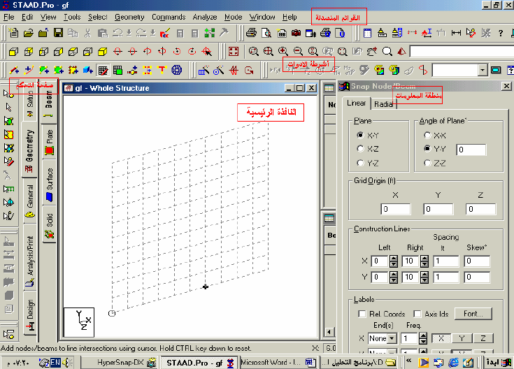

واﺟﮭﺔ اﻟﺮﻧﺎﻣﺞ اﻟﺮﺋﯿﺴﯿﺔ

next ﺗﻈﮭﺮ ﻧﺎﻓﺬه ﺗﺤﺘﻮي ﻋﻠﻰ اﻻواﻣﺮ اﻟﺘﺎﻟﯿﺔ :

ﺑﻌﺪ اﻟﻀﻐﻂ ﻋﻠﻰ

(Member

)اﺿﺎﻓﺔ ﻋﻨﺎﺻﺮ ھﯿﻜﻠﯿﺔ

Add Beam -

- Plate Add ) اﺿﺎﻓﺔ ﻋﻨﺎﺻﺮ ﺻﻔﯿﺤﯿﺔ (

- Solid Add ) اﺿﺎﻓﺔ ﻋﻨﺎﺻﺮ ﺣﺠﻤﯿﺔ ( - wizard structure Open )ﺗﻤﻜﯿﻦ اﻟﺪﺧﻮل اﻟﻰ ﻣﻜﺘﺒﺔ اﻟﻘﻮاﻟﺐ اﻻﻧﺸﺎﺋﯿﺔ اﻟﺠﺎھﺰة ﻓﻲ

اﻟﺒﺮﻧﺎﻣﺞ (

- Editior Staad Open ) ﻣﺤﺮر اﻻواﻣﺮ (

- information Job Edit ) ادﺧﺎل ﻣﻌﻠﻮﻣﺎت اﻟﻤﻨﺸﺄ و اﻟﺘﺎرﯾﺦ و اﺳﻢ ﺻﺎﺣﺐ اﻟﻌﻤﻞ

(اﻟﺦ....

ﻣﻌﻠﻮﻣﺎت ﺣﻮل اﻟﻌﻨﺎﺻﺮ اﻟﻤﺴﺘﺨﺪﻣﺔ ﻓﻲ اﻟﺒﺮﻧﺎﻣﺞ :

-1 ﻋﻨﺎﺻﺮ ھﯿﻜﻠﯿﺔ ) Element (Beam : ﺗﺘﺎﻟﻒ ھﺬه اﻟﻌﻨﺎﺻﺮ ﻣﻦ ﻋﻘﺪﺗﯿﻦ ﻓﻲ اﻟﺒﺪاﯾﺔ وﻧﮭﺎﯾﺔ

اﻟﻌﻨﺼﺮ ﺣﯿﺚ ﺗﻤﻠﻚ ﻛﻞ ﻋﻘﺪة ﺳﺖ درﺟﺎت ﻣﻦ اﻟﺤﺮﯾﺔ ) ﺛﻼﺛﺔ اﻧﺘﻘﺎﻟﯿﺔ و ﺛﻼﺛﺔ دوراﻧﯿﺔ ( . ﯾﻤﻜﻦ ان

T او ﯾﻤﻜﻦ ﺗﻤﺜﯿﻠﮭﺎ ﺑﻤﻘﺎطﻊ ﻓﻮﻻذ

ﺗﻤﺜﻞ ھﺬه اﻟﻌﻨﺎﺻﺮ ﺑﻤﻘﺎطﻊ ﻣﺨﺘﻠﻔﺔ ﻛﺎن ﺗﻜﻮن ﻣﺴﺘﻄﯿﻠﺔ اوﺷﻜﻞ

ﺟﺎھﺰة وﻣﻌﺮﻓﺔ ﻣﻦ ﻗﺒﻞ اﻟﺒﺮﻧﺎﻣﺞ ﻟﺘﻤﺜﯿﻞ اﻟﺠﺴﻮر ) (Beam و اﻻﻋﻤﺪة (Column) .

-2 ﻋﻨﺎﺻﺮ ﺻﻔﺎﺋﺤﯿﺔ Element) (Plate :ﯾﻤﻜﻦ ان ﯾﺘﺄﻟﻒ ھﺬا اﻟﻌﻨﺼﺮ ﻣﻦ ﺛﻼث ﻋﻘﺪ )ﻋﻨﺼﺮ

ﺛﻼﺛﻲ( او ارﺑﻊ ﻋﻘﺪ )ﻋﻨﺼﺮ رﺑﺎﻋﻲ ( . وﯾﻤﻜﻦ ان ﯾﺎﺧﺬ ھﺬا اﻟﻌﻨﺼﺮ ﺳﻤﺎﻛﺎت ﻣﺨﺘﻠﻔﺔ ﻓﻲ اﻟﻌﻘﺪ . ﺗﻤﻠﻚ ﻛﻞ ﻋﻘﺪة ﺳﺖ درﺟﺎت ﺣﺮﯾﺔ freedom) of degree (6 )ﺛﻼﺛﺔ اﻧﺘﻘﺎﻟﯿﺔ و ﺛﻼﺛﺔ دوراﻧﯿﺔ( ﯾﺴﺘﺨﺪم ھﺬا اﻟﻌﻨﺼﺮ ﻟﻨﻤﺬﺟﺔ اﻟﻤﻨﺸﺄت اﻟﺴﻄﺤﯿﺔ ﻛﺎﻟﺠﺪران واﻟﺴﻘﻮف وارﺿﯿﺎت اﻟﻄﻮاﺑﻖ واﻻﺳﺲ

ﻋﻨﺪ ادﺧﺎل ﻋﻘﺪ اﻟﻌﻨﺼﺮ ﯾﺠﺐ ان ﺗﻜﻮن ﺑﺎﺗﺠﺎه واﺣﺪ اﻣﺎ ﺑﺎﺗﺠﺎه ﻋﻘﺎرب اﻟﺴﺎﻋﺔ او ﻋﻜﺴﮭﺎ . وﯾﻔﻀﻞ ان ﺗﻜﻮن ﻧﺴﺒﺔ اﻟﻄﻮل اﻟﻜﺒﯿﺮ اﻟﻰ اﻟﺼﻐﯿﺮ ﻟﻠﻌﻨﺼﺮ اﻟﻮاﺣﺪ (1:1) و ان ﻻ ﺗﺰﯾﺪ ﻋﻦ :4) (1 ز ﻛﺬﻟﻠﻚ ان ﻻﺗﻜﻮن اﻟﻌﻨﺎﺻﺮ ﻣﺸﻮھﮫ اي ﯾﺠﺐ ان ﻻ ﺗﻜﻮن اﻟﺰواﯾﺔ اﻛﺒﺮ ﻣﻦ 90 ﻟﺤﺎﻓﺘﻲ ﻋﻨﺼﺮﯾﻦ

ﻣﺘﺠﺎورﯾﻦ وﯾﺠﺐ ان ﻻ ﺗﺘﻌﺪى 180 درﺟﺔ ﺑﺎي ﺣﺎل ﻣﻦ اﻻﺣﻮال .

-3 اﻟﻌﻨﺼﺮ اﻟﺤﺠﻤﻲ )ٍElement (Solid :ﺗﺒﺮز ﻓﻌﺎﻟﯿﺔ ھﺬا اﻟﻌﻨﺼﺮ ﻓﻲ ﺣﻞ اﻟﻤﺴﺎﺋﻞ اﻻﻧﺸﺎﺋﯿﺔ اﻟﺘﻲ ﺗﻜﻮن ﻓﯿﮭﺎ ﺗﻮزﯾﻌﺎت اﻻﺟﮭﺎدات ﺛﻼﺛﯿﺔ اﻻﺑﻌﺎد . ﺣﯿﺚ ﯾﻤﻜﻦ ان ﺗﺴﺘﻌﻤﻞ ﻓﻲ ﺗﻤﺜﯿﻞ اﻟﺴﺪود واﻟﺘﺮﺑﺔ و اﻟﻄﺒﻘﺎت اﻟﺼﺨﺮﯾﺔ واﻟﻘﻮاﻋﺪ اﻻﺳﺎﺳﺎت اذ ﯾﻜﻮن اﻟﻌﻨﺼﺮ اﻟﺤﺠﻤﻲ اداة ﻓﻌﺎﻟﺔ ﻓﻲ ﺗﺤﻠﯿﻞ

اﻟﺠﮭﺎدات ﻓﻲ ھﺬه اﻟﻤﺴﺎﺋﻞ وﺗﻤﻠﻚ ﻛﻞ ﻋﻘﺪة ﺛﻼث درﺟﺎت ﺣﺮﯾﺔ freedom) of (3degree

dﯾﺘﻜﻮن اﻟﻌﻨﺼﺮ اﻟﺤﺠﻤﻲ ﻣﻦ ﺛﻤﺎن ﻋﻘﺪ nodes) (8 ﻛﻤﺎ ﻓﻲ اﻟﺸﻜﻞ ﯾﻤﻜﻦ ان ﺗﻨﻄﺒﻖ ﺑﻌﺾ اﻟﻌﻘﺪ ﻋﻠﻰ ﺑﻌﻀﮭﺎ nodes) (collapsing

ﻣﻮﻟﺪة ﺑﺬﻟﻚ ﻋﻨﺎﺻﺮ ﺣﺠﻤﯿﺔ ﻣﻨﺤﺪرة ﻣﺆﻟﻔﺔ ﻣﻦ 4) اﻟﻰ 7 ﻋﻘﺪ( وﻓﻖ اﻟﺘﻄﺎﺑﻖ اﻟﺤﺎﺻﻞ ﺑﯿﻦ اﻟﻌﻘﺪ

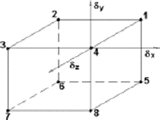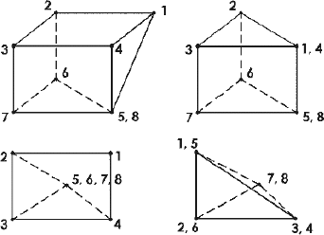

ﺧﻼﻓﺎ ﻟﻠﻌﻨﺎﺻﺮ اﻟﮭﯿﻜﻠﯿﺔ و اﻟﺼﻔﺎﺋﺤﯿﺔ ﻻﯾﺤﺘﺎج اﻟﻌﻨﺼﺮ اﻟﺤﺠﻤﻲ اﻟﻰ ﺗﺤﺪﯾﺪ ﺛﻮاﺑﺖ ھﻨﺪﺳﯿﺔ )اﻟﺴﻤﻚ ,اﻟﻤﻘﻄﻊ,ﻋﺰوم, ﻣﺴﺎﺣﺔ اﻟﻤﻘﻄﻊ اﻟﺦ( وﻟﻜﻨﺔ ﯾﺘﻄﻠﺐ ﺗﺤﺪﯾﺪ ﺧﻮاص ﻓﯿﺰﯾﺎوﯾﺔ ﻟﻠﻤﺎدة ﻛﻤﻌﺎﻣﻞ

اﻟﻤﺮوﻧﺔ و ﻧﺒﺴﺒﺔ ﺑﻮاﺳﻮن و اﻟﻜﺜﺎﻓﺔ .