

تطبيقات الحاسوب   
STAAD.pro advanced CONNECT Edition

Sally Selan Hussein

The main components of the start page

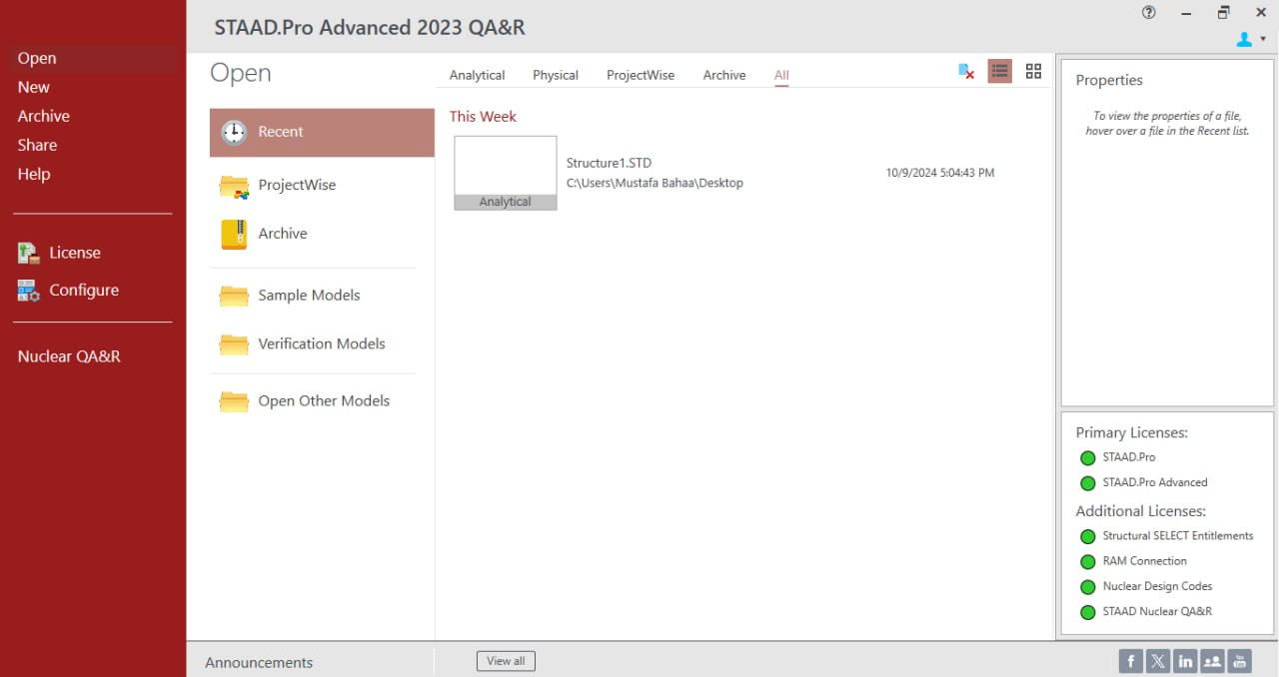

**Section1:** includes several commands related to files, licensing, and configuring input settings for the program as fallowing:

1- **Open** (To open any previous project that has been worked on, the details of previous projects are displayed in the section ( 2)

2- **New** ( There are seven step to make a new project )

1. click on the new item. Then, enter the following information:

2. File Name: Storage Shed_1.std

3. Location: (navigate to the dataset folder that was supplied with this training)

4. Type: Analytical

5. Units: Metric

6. Job Info: Optional input for job information

7. Then, click on the Create button.

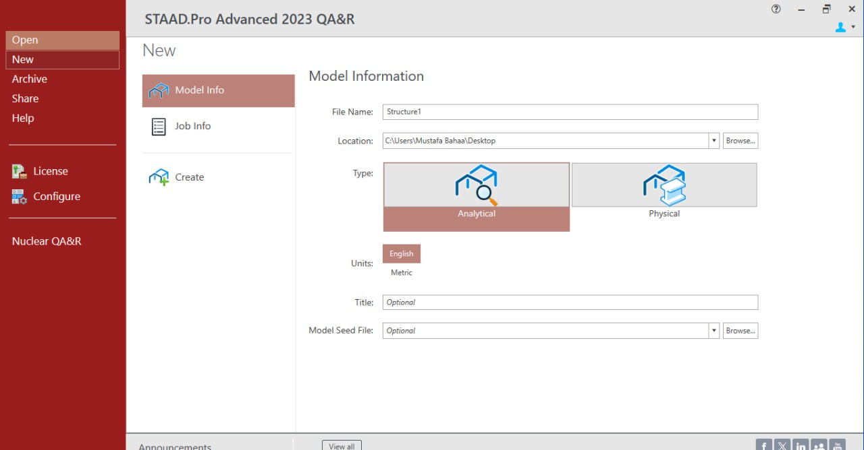

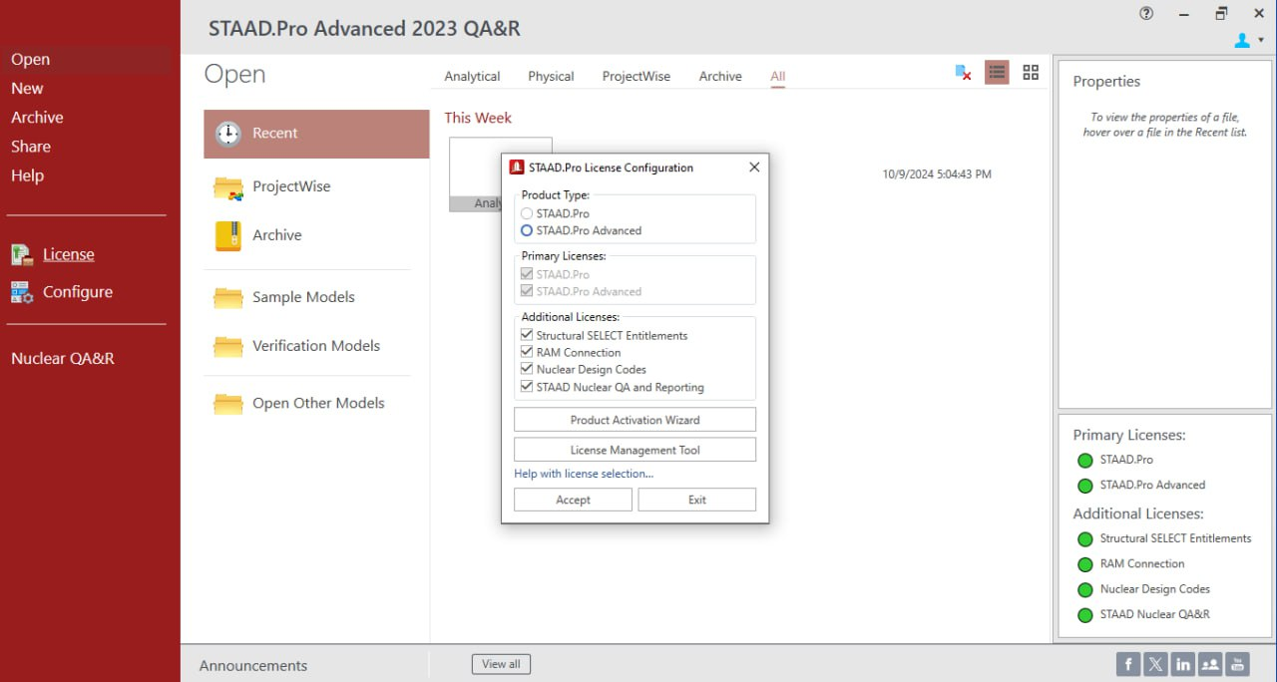

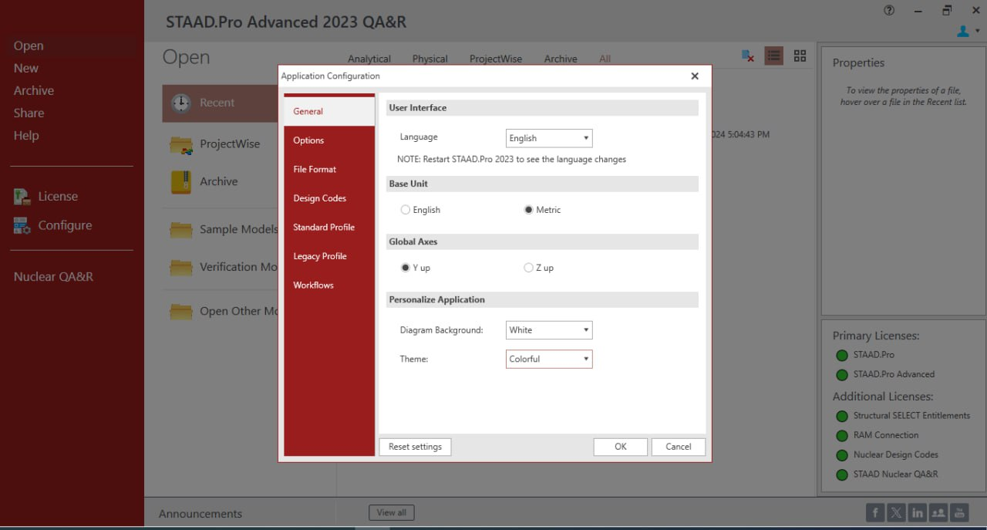

A- Language

B- Base unite (matric or English)

C- Global axis the default orientation of the global coordinate system is that the Y axis points in the vertical direction and a plan view is represented by the XZ plane.

You do have an option to specify the vertical axis as the Z axis, but this option will eliminate the ability to use some other functions in the program, such as the wind load generator)

D- Diagram background

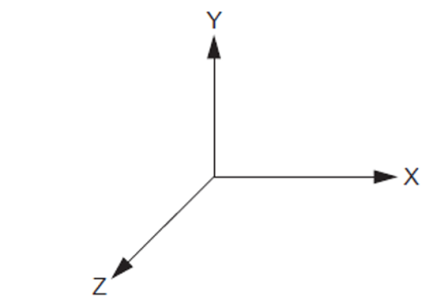

F- Default design codes

E- Theme

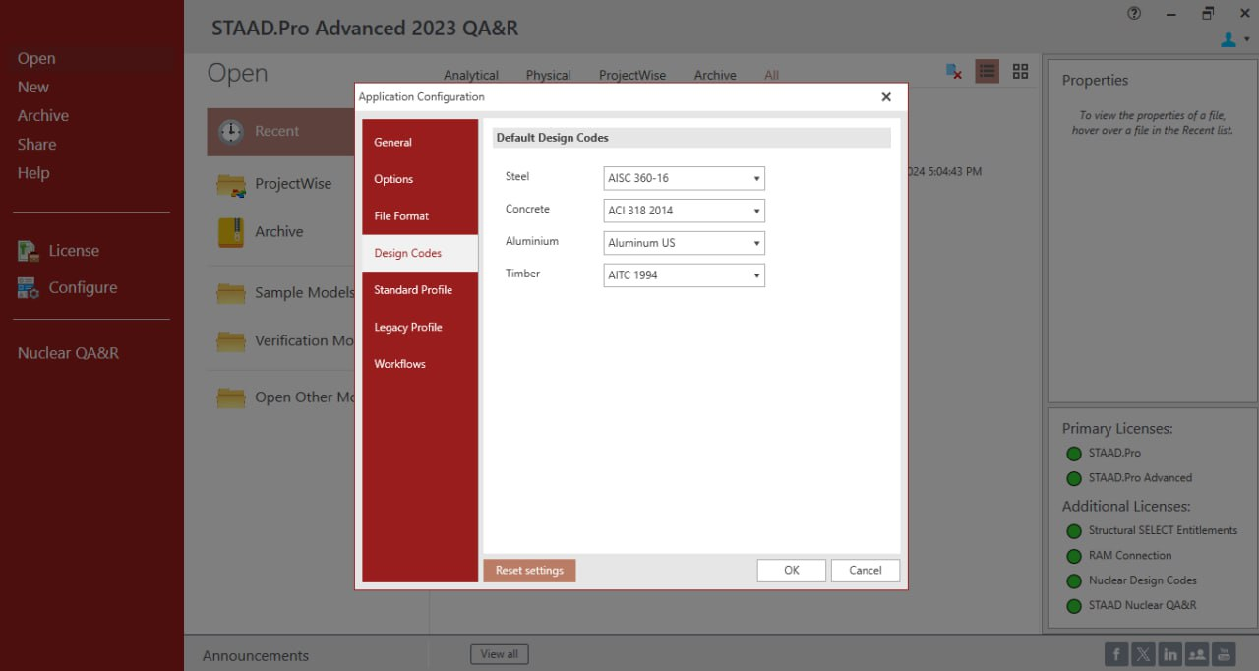

* **Section 2:** The display in this section changes depending on the command selected in the first section.
* If the command is to *open* a project, it will show recent projects that have been worked on and provide options to import projects from the computer.
* It also indicates the type of project, whether it's (analytical, physical, project wise or all)

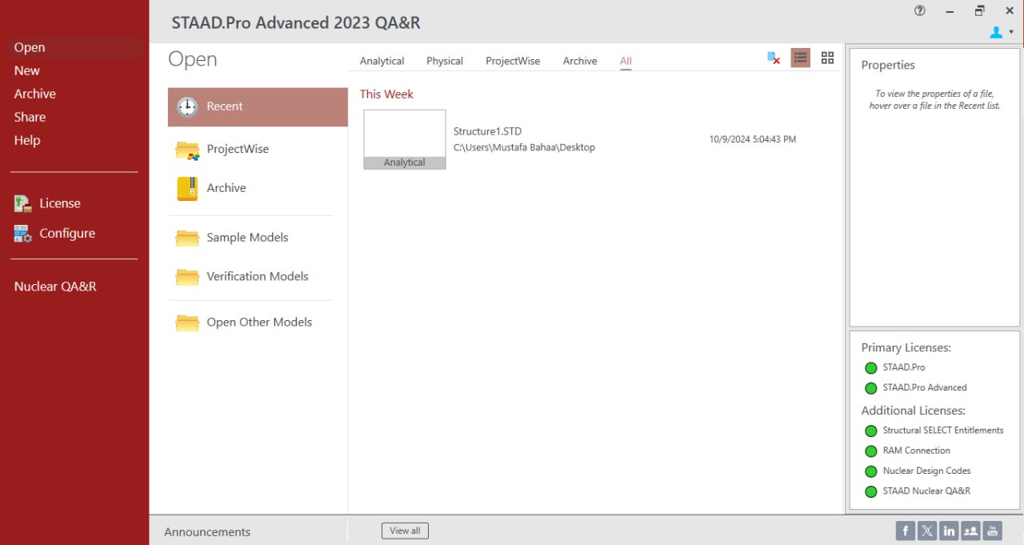



Section 3: display some details related to the information of previously worked-on projects. In addition to the licenses information