**Ministry of Higher Education and**

**Scientific Research**

**Al-Mustaqbal University**

**Department of Medical Physics**

**Computed Tomography and Image Quality**

*Lecture 7*

By

Dr. Duaa Jafer Al-Fayadh

1. – 2025

**1. Introduction**

After its clinical introduction in 1971, computed tomography (CT) developed from an X ray modality that was limited to axial imaging of the brain in neuroradiology into a versatile 3-D whole body imaging modality for a wide range of applications, **including oncology, vascular radiology, cardiology, traumatology and interventional radiology**. CT is **applied** for diagnosis and follow-up studies of patients, for planning of radiotherapy, and even for screening of healthy subpopulations with specific risk factors.

**2. Principles of CT**

**2.1. X ray projection, attenuation and acquisition of transmission profiles**

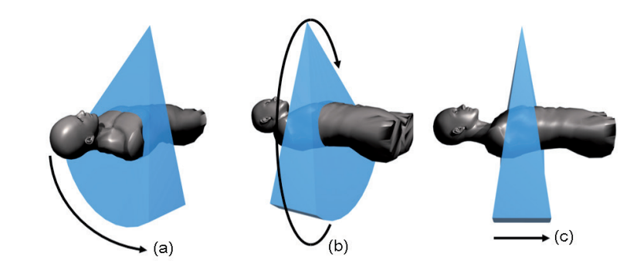 The process of CT image acquisition involves the measurement of X ray transmission profiles through a patient for a large number of views. A profile from each view is achieved primarily by using a detector arc generally consisting of 800–900 detector elements (dels), referred to as a detector row. By rotation of the X ray tube and detector row around the patient, a large number of views can be obtained. The use of tens or even hundreds of detector rows aligned along the axis of rotation allows even more rapid acquisition (Fig.1). The acquired transmission profiles are used to reconstruct the CT image, composed of a matrix of picture elements (pixels)

**Fig 1. CT image acquisition showing the transmission of X rays through the patient by using a detector row (a), with rotation of the X ray tube and detector (b) and by multiple detector (c).**

- The values that are assigned to the pixels in a CT image are associated with the average linear attenuation coefficient µ (m-1) of the tissue represented within that pixel.

-The linear attenuation coefficient (µ) depends on the composition of the material, the density of the material, and the photon energy as seen in Beer’s law:

……………………………………..(1)

where *I(x)* is the intensity of the attenuated X ray beam*, I0* the unattenuated X ray beam and x the thickness of the material.

note that beer’s law only describes the attenuation of the primary beam and does not take into account the intensity of scattered radiation that is generated. for use in polyenergetic X ray beams, beer’s law should strictly be integrated over all photon energies in the X ray spectrum. however, in the back projection methodologies (see below) developed for ct reconstruction algorithms, this is generally not implemented; instead, typically, a pragmatic solution is to assume where beer’s law can be applied using one value representing the average photon energy of the X ray spectrum. this assumption causes inaccuracies in the reconstruction and leads to the beam hardening artefact. as an X ray beam is transmitted through the patient, different tissues are encountered with different linear attenuation coefficients. if the pathway through the patient ranges from 0 to d, then the intensity of the attenuated X ray beam, transmitted a distance d, can be expressed as

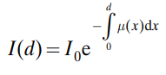……………………..(2)

since a CT image is composed of a matrix of pixels, the scanned patient can also be regarded as being made up of a matrix of different linear attenuation coefficient volume elements (voxels). Fig. 2 shows a simplified 4 × 4 matrix representing the measurement of transmission along one line. for such a discretization, the equation for the attenuation can be expressed as:

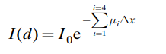…………………………(3)

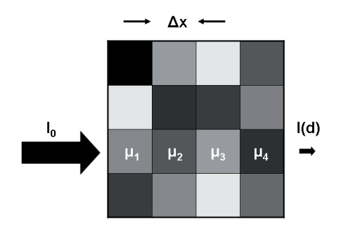

Fig.2. The principle of attenuation of an X ray beam in a simplified 4 × 4 matrix. Each element in the matrix can, in principle, have a different value of the associated linear attenuation coefficient.

from the above, it can be seen that the basic data needed for ct are the intensities of the attenuated and unattenuated X ray beams, respectively *I(d)*and *I0* , and that these can be measured. image reconstruction techniques can then be applied to derive the matrix of linear attenuation coefficients, which is the basis of the ct image.

**2.2. Hounsfield units**

In the CT image, the matrix of reconstructed linear attenuation coefficients (*μ*material) is transformed into a corresponding matrix of hounsfield units (HUmaterial), where the HU scale is expressed relative to the linear attenuation coefficient of water at room temperature (*μwater*):

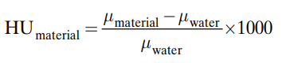……………………..(4)

It can be seen that HUwater = 0 (μmaterial = μwater), HUair = –1000 (μmaterial = 0) and HU = 1 is associated with 0.1% of the linear attenuation coefficient of water. Table 1 shows typical values for body tissues. From the definition of the HU, it follows that for all substances except water and air, variations of the HU values occur when they are determined at different tube voltages. The reason is that, as a function of photon energy, different substances exhibit a non-linear relationship of their linear attenuation coefficient relative to that of water. This effect is most notable for substances that have a relatively high effective atomic number, such as contrast enhanced blood and bone.

TABLE 1. Typical HU values and ranges of values for different tissues and materialsa

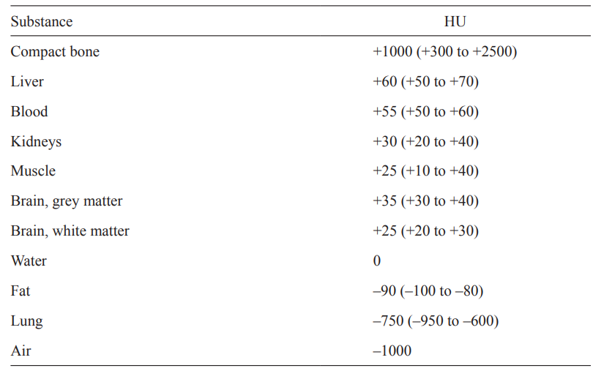

a The actual value of the HU depends on the composition of the tissue or material, the tube voltage and the temperature.

**3. Computed tomography image quality**

**3.1 Image quality**

-Excellent **low-contrast resolution** of computed tomography distinguishes **computed tomography** from **radiography** and **planigraphy**.

- **Low-contrast resolution** is the ability to detect structures that offer only **a small difference in signal** (expressed in Hounsfield units) compared to their direct environment.

- **Image noise** is the main limitation for **low-contrast resolution**.

- **Image noise** may be decreased either by increasing tube current (mA) at the cost of patient exposure, or by increasing the reconstructed slice thickness, at the cost of spatial resolution.

- In addition, **low-contrast resolution** depends on tube voltage, beam filtration and reconstruction algorithm.

The Example - A contrast enhanced CT scan of the liver.

• The 100% image corresponds with the actual clinical acquisition.

• Simulated noise has been added to the raw data to simulate image quality for acquisitions that are performed at 75%, 50% and 25% of the clinically used tube current. The appearance of the low contrast lesions in the liver becomes worse at lower tube currents due to increased noise in the images.

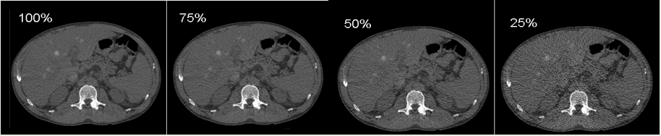

-Physicists usually assess low-contrast resolution with phantoms that contain different sized low-contrast inserts.

-The main acquisition parameters in computed tomography are tube voltage, tube current and rotation time.

- A relatively high tube voltage (120 kV - 140 kV) is used in computed tomography to achieve good X-ray transmission and sufficient detector signal

- 80 – 100 kV may be used for special applications such as contrast enhanced studies and pediatric CT.