**GENERAL ANATOMY ORAL CAVITY**

**LEC.6**

**The Lips**

The lips are two fleshy folds that surround the oral orifice They are covered on the outside by skin and

are lined on the inside by mucous membrane. The substance of the lips is made up by the orbicularis oris muscle and the muscles that radiate from the lips into the face.

The submandibular duct of the submandibular gland opens onto the floor of the mouth on the summit of a small papilla on either side of the frenulum of the tongue The sublingual gland projects up into the mouth, producing a low fold of mucous membrane, the **sublingual fold.** Numerousducts of the gland open on the summit of the fold.

**Mucous Membrane of the Mouth**

In the vestibule, the mucous membrane is tethered to the buccinator muscle by elastic fibers in the submucosa

that prevent redundant folds of mucous membrane from being bitten between the teeth when the jaws are closed.

The mucous membrane of the gingiva, or gum, is stronglyattached to the alveolar periosteum.

The mouth extends from the lips to the **palatoglossal arches.** The

**palatoglossal arches** (anterior pillars) are ridges of mucous membrane raised

up by the **palatoglossus muscles**. The roof is **the hard palate** and the floor

is the **mylohyoid muscle**. Rising from the floor of the mouth, the **tongue**

occupies much of the oral cavity. The *red margin* of the lips, is **devoid of**

**hair**, **highly sensitive** and has a **rich capillary blood supply**.

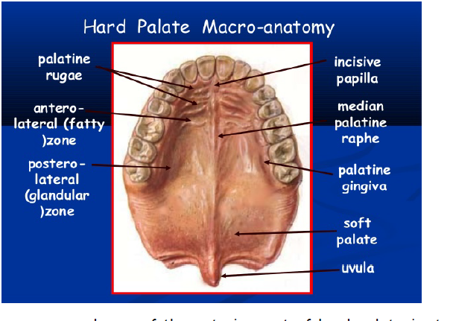

The mucous membrane of the anterior part of hard palate is strongly

united with the **periosteum**. From a little **incisive papilla** overlying the

**incisive foramen** a narrow low ridge, the **median palatine raphe**, runs

anteroposteriorly. **Palatine rugae** are short horizontal folds of mucous

membrane, located on each sides of the anterior parts of median palatine

raphe. Over the horizontal plate of the palatine bone mucous membrane and

periosteum are separated by a mass of mucous glands tissue.

**Nerve supply:**

Much of the mucous membrane of the cheeks and lips is supplied by

the ***buccal* branch of the *mandibular nerve***, ***mental* branch of the *inferior***

***alveolar*** and the ***infraorbital* branch of the *maxillary nerve***; the last two

also supply the red margin of the lower and upper lips respectively.

The upper gums are supplied by the ***superior alveolar*, *greater***

***palatine* and *nasopalatine nerves* (maxillary)**, while the lower receive

their innervation from the ***inferior alveolar*, *buccal , mental* and *lingual***

***nerves*** (mandibular). The buccal nerve does not usually innervate the upper gums.

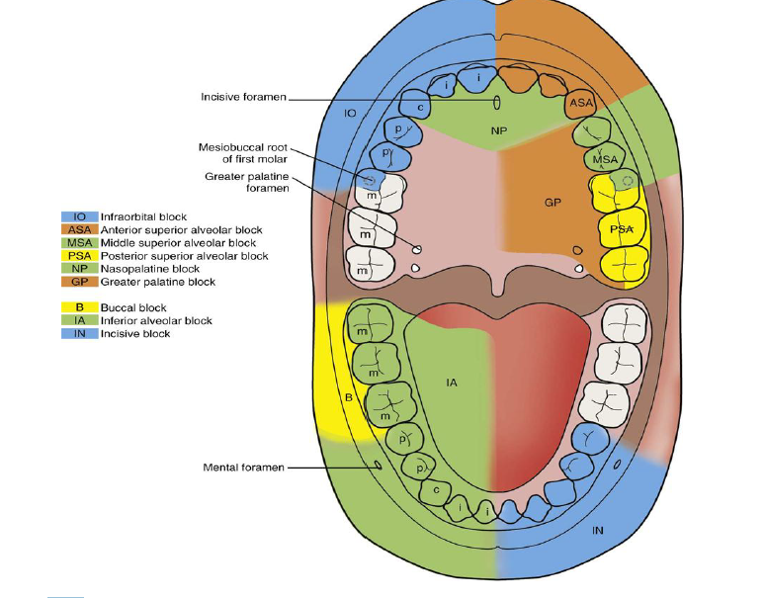

The upper teeth are supplied by the **superior alveolar nerves[ anterior, middle and posterior]**.

In the lower jaw the molars and premolars are supplied by the main

trunk of the **inferior alveolar nerve**, whose terminal **incisor branch** supplies

the **canine and incisors**, overlapping to the opposite central incisor.

**The Tongue**

The tongue is a mass of skeletal muscle covered by mucous membrane,

and with a midline **fibrous septum** separating the two muscular halves. It

consist of **body and root**. The **anterior two-thirds, or oral part**, of the

dorsum faces upwards towards the **hard palate**, and the **posterior onethird,**

**or pharyngeal part**, faces backwards towards the **oropharynx.** The

**tip** is the most anterior and mobile part.

The oral part **of the dorsum** of the tongue is covered by mucous

membrane into which the underlying muscles are inserted. The surface is

roughened by the presence of three types of **papillae**: **filiform, fungiform**

**and vallate**.

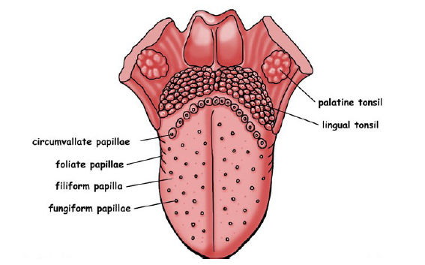

The ***vallate papillae*** are about a dozen in number and are arranged in

the form of a V with the apex pointing backwards, just in front of shallow

groove, the ***sulcus terminalis***, which marks the junction of the **oral and**

**pharyngeal** parts of the tongue.

On the undersurface behind the tip there is a rather **large mixed gland,**

**the *lingual gland***, on each side of the midline. From each gland small ducts

open on the undersurface of the tongue.

The **posterior third of the dorsum** of the tongue slopes downwards

from the **sulcus terminalis** as the anterior wall of the **oropharynx**. At the

apex of the sulcus is a small depression, the ***foramen caecum***. The mucous

membrane has a **nodular appearance** due to underlying masses of **mucous**

**and serous** glands and aggregations of **‘lingual tonsil’**.

A small midline septum of mucous membrane **(lingual frenulum)** unites

the inferior surface of the tongue to the floor of the mouth. Lateral to this,

the **deep lingual vein** can usually be seen through the mucosa**.**

**Muscles**

The muscles of the tongue are divided into **intrinsic** and **extrinsic**

groups; the *intrinsic muscles* are wholly within the tongue and not attached

to bone, while the *extrinsic muscles* have a bony attachment. There are four

muscles in each group in each half of the tongue, with a midline **fibrous**

**septum** dividing the organ into two symmetrical halves.

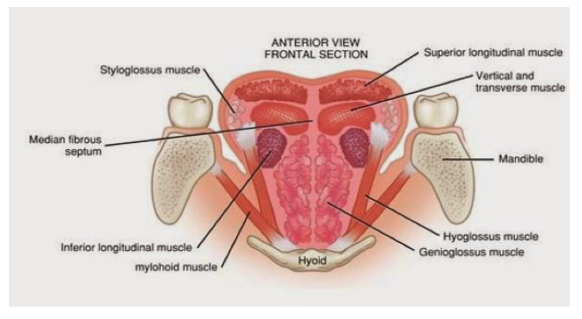

The muscles of the intrinsic group are the ***superior* and *inferior***

***longitudinal*, *transverse* and *vertical*,** and the extrinsic group comprises

**genioglossus** (which is the largest of all the muscles and makes up the bulk

of the tongue), **hyoglossus, styloglossus and palatogloss.**

**Genioglossus** arises from the **superior mental spine** (genial tubercle)

of the mandible, the fibers radiate backwards in a fan-shaped manner to be

inserted into the mucous membrane of the tongue, with the lowest fibers

passing backward and downward to the hyoid body.

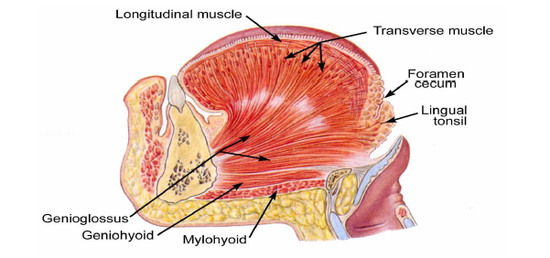

**Hyoglossus** arises from the **length of the greater horn** of the hyoid

bone and from **its body**. It extends upwards as a quadrilateral sheet, its

upper border interdigitating at right angles with the fibers of **styloglossus**,

and is attached to the **side of the tongue**. Superficial (lateral) to the muscle

from above downwards lie the **lingual nerve, submandibular duct**, and the

**hypoglossal nerve** with its accompanying **veins,** while passing deep to its

posterior border from above downwards are the **glossopharyngeal nerve,**

**stylohyoid ligament** and the **lingual artery** with its accompanying **veins**

lying on the anterior fibers of the **middle constrictor**.

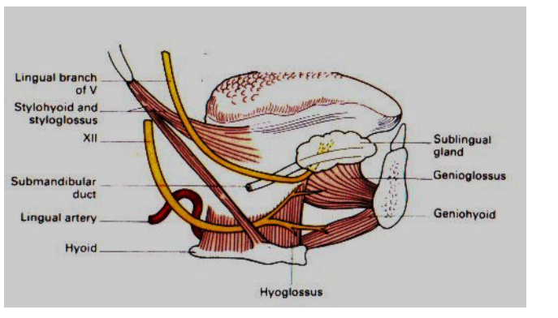

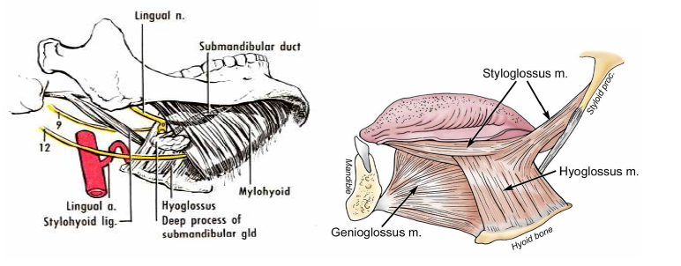

**Styloglossus** arises from the front of the lower part of the **styloid process**

and the upper part of the **stylohyoid ligament**. It passes forwards below the

**superior constrictor** to be inserted into the **side of the tongue**,

interdigitating with the upper fibers of **hyoglossus**.

**Palatoglossus** descends from the undersurface of the palatine aponeurosis to

the side of the tongue, forming with its fellow of the opposite side the

palatoglossal arch. It is described with the soft palate.

**Movements of the Tongue**

**Protrusion**, The genioglossus muscles on both sides. **Retraction,** Styloglossus

and hyoglossus muscles on both sides. **Depression,** Hyoglossus muscles on

both sides. **Retraction and elevation of the posterior third,** Styloglossus

and palatoglossus muscles on both sides. **Shape changes,** Intrinsic muscles.

**Palatoglossus:** Pulls up the root of tongue.

**Blood supply**

The tongue is supplied by the **lingual artery**, which runs above the

**greater horn** of the hyoid bone deep to hyoglossus and passes forwards to

the tip. Beneath hyoglossus it gives off **dorsal lingual** branches into the

posterior part. At the anterior border of hyoglossus it gives a branch to the

**sublingual gland** and the **floor of the mouth**. There are small contributions

from the **tonsillar** branch of the **facial artery** and from the **ascending**

**pharyngeal artery**. The fibrous septum dividing the two halves of the tongue

prevents any significant anastomosis of blood vessels across the midline.

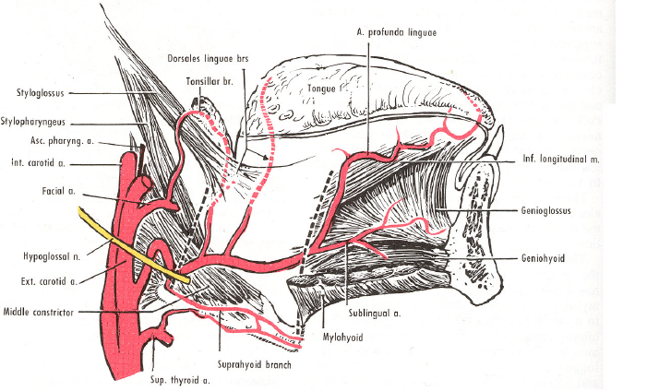

**VENOUS DRAINAGE**

**The arrangement of the vena comitantes/veins of the tongue is**

**variable. Two venae comitantes accompany the lingual artery, and one**

**vena comitantes accompanies the hypoglossal nerve. The deep lingual**

**vein is the largest and principle vein of the tongue. It is visible on the**

**inferior surface of the tongue. It runs backwards and cross the**

**genioglossus and the hyoglossus below the hypoglossal nerve. These veins**

**unite at the posterior border of the hyoglossus to form the lingual vein**

**which ends in the internal jugular vein. Sometimes, these veins drain**

**independently into the jugular veins.**

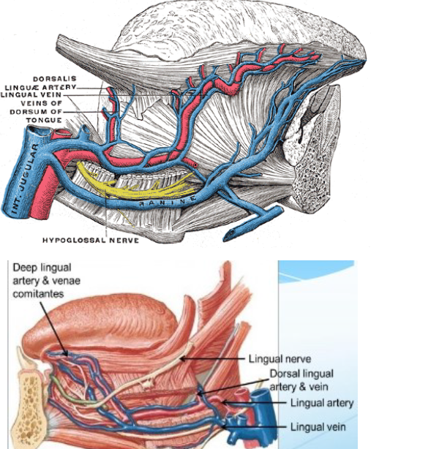

**NERVE SUPPLY**

**Motor Nerves:** All the intrinsic and extrinsic muscles except the

palatoglossus, are supplied by the **hypoglossal nerve**, The palatoglossus is

supplied by the **pharyngeal plexus**.

**Sensory nerves**: The **lingual nerves** is the nerve of **general sensation** and

the **chorda tympani** is the nerve of **taste for the anterior two-thirds** of the

tongue except vallate papillae. The **glossopharyngeal nerve** is the nerve for

both **general sensation and taste for the posterior one-third of the tongue**

including the **circumvallate papillae**. The **posterior most part of the**

**tongue** is supplied by the **vagus** nerve through the **internal laryngeal**

branch.

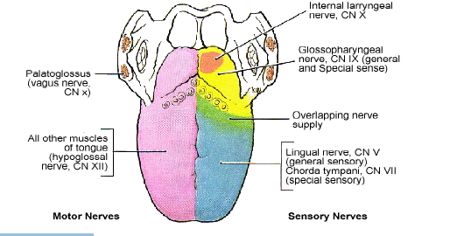

**Lymph drainage:**

The tip drain to **submental lymph nodes**. Marginal lymphatics from the

rest of the anterior part tend to drain to ipsilateral **submandibular lymph**

**nodes.** Central lymphatics from the anterior part descend between the

genioglossi and drain to **deep cervical nodes** of either side. The posterior

part drains directly and frequently bilaterally to **deep cervical nodes**.

