GENERL ANATOMY

م.د علي سلمان جاسم المعموري

LEC. 2

The orbital region

The orbits are a pair of bony cavities that contain the eyeballs; their associated muscles, nerves, vessels, and fat; and most of the lacrimal apparatus. The orbital opening is guarded by two thin, movable folds, the eyelids.

**Eyelids**

The eyelids protect the eye from injury and excessive light by their closure (Fig. 1).

The upper eyelid is larger and more mobile than the lower, and they meet each other at the medial and lateral angles. The palpebral fissure is the elliptical opening between the eyelids and is the entrance into the conjunctival sac. The superficial surface of the eyelids is covered by skin, and the deep surface is covered by a mucous membrane called the conjunctiva.

The eyelashes are short, curved hairs on the free edges of the eyelids (Figs. 1 & 2).

They are arranged in double or triple rows at the mucocutaneous junction. The

sebaceous glands (glands of Zeis) open directly into the eyelash follicles. The ciliary glands (glands of Moll) are modified sweat glands that open separately between adjacent lashes. The tarsal glands (Meibomian glands) are long, modified sebaceous glands that pour their oily secretion onto the margin of the lid; their openings lie behind the eyelashes (Fig. 1). This oily material prevents the overflow of tears and helps make the closed eyelids airtight. Near the medial angle of the eye a small elevation, the papilla lacrimalis, is present. On the summit of the papilla is a small hole, the punctum lacrimale, which leads into the canaliculus lacrimalis (Figs. 1 & 2). The punctum and canaliculus carry tears down into the nose.

The conjunctiva is a thin mucous membrane that lines the eyelids and is reflected at the superior and inferior fornices onto the anterior surface of the eyeball

(Fig. 1). The conjunctiva thus forms a potential space, the conjunctival sac, which is open at the palpebral fissure. Beneath the eyelid is a groove, the subtarsal sulcus, which tends to trap small foreign particles introduced into the conjunctival sac and is thus clinically important. The framework of the eyelids is formed by a fibrous sheet, the orbital septum, which thickened at the margins of the lids to form the superior and inferior tarsal plates. The lateral ends of the plates are attached by the lateral palpebral ligament to a bony tubercle just within the orbital margin. The medial ends of the plates are attached by the medial palpebral ligament to the crest of the lacrimal bone (Fig. 1).

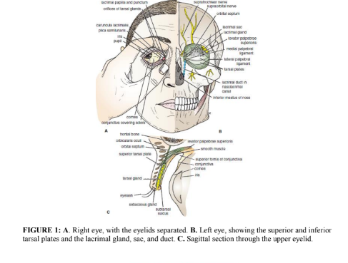

Movements of the Eyelids:

The eyelids are closed by the contraction of the orbicularis oculi and the relaxation of the levator palpebrae superioris muscles. The eye is opened by the levator palpebrae superioris raising the upper lid. On looking upward, the levator palpebrae superioris contracts, and the upper lid moves with the eyeball. On looking downward, both lids move, the upper lid continues to cover the upper part of the cornea, and the lower lid is pulled downward slightly by the conjunctiva, which is attached to the sclera and the lower lid. The origins and insertions of the muscles of the eyelids are summarized in Table 1:

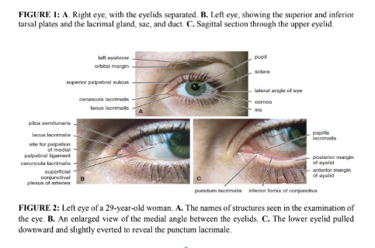

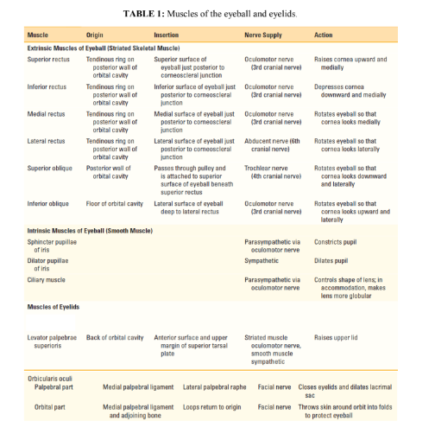

**Lacrimal Apparatus:**

• **Lacrimal Gland**

The lacrimal gland consists of a large orbital part and a small palpebral part, which

are continuous with each other around the lateral edge of the aponeurosis of the levator palpebrae superioris. It is situated above the eyeball and opens by 12 ducts into the lateral part of the superior fornix of the conjunctiva. The parasympathetic secretomotor nerve supply is derived from the lacrimal nucleus of the facial nerve.

The sympathetic postganglionic nerve supply is from the internal carotid plexus and travels in the deep petrosal nerve, the nerve of the pterygoid canal, the maxillary nerve, the zygomatic nerve, the zygomaticotemporal nerve, and finally the lacrimal nerve.

• **Lacrimal Ducts:**

The tears circulate across the cornea and enter the canaliculi lacrimales through the puncta lacrimalis. The canaliculi lacrimales open into the lacrimal sac (Fig. 1), which lies behind the medial palpebral ligament. The nasolacrimal duct emerges from the lower end of the lacrimal sac (Fig. 1). It descends downward in a bony canal and opens into the inferior meatus of the nose. The opening is guarded by a fold of mucous membrane known as the lacrimal fold. This prevents air from being forced up the duct into the lacrimal sac on blowing the nose.

**Openings into the Orbital Cavity:**

Orbital opening: Lies anteriorly. About one sixth of the eye is exposed; the remainder is protected by the walls of the orbit.

Supraorbital notch (Foramen): It is situated on the superior orbital margin (Fig. 3)

and transmits the supraorbital nerve and blood vessels.

Infraorbital groove and canal: Situated on the floor of the orbit in the orbital plate of the maxilla (Fig. 4); they transmit the infraorbital nerve and blood vessels.

Nasolacrimal canal: Located anteriorly on the medial wall; it communicates with the inferior meatus of the nose (Fig. 1). It transmits the nasolacrimal duct.

Superior orbital fissure: Located posteriorly between the greater and lesser wings of the sphenoid (Fig. 3); it communicates with the middle cranial fossa. It transmits the lacrimal nerve, the frontal nerve, the trochlear nerve, the oculomotor nerve (upper and lower divisions), the abducent nerve, the nasociliary nerve, and the superior ophthalmic vein.

Inferior orbital fissure: Located posteriorly between the maxilla and the greater wing of the sphenoid (Fig. 3); it communicates with the pterygopalatine fossa. It transmits the maxillary nerve and its zygomatic branch, the inferior ophthalmic vein, and sympathetic nerves.

Optic canal: Located posteriorly in the lesser wing of the sphenoid (Fig. 3); it

communicates with the middle cranial fossa. It transmits the optic nerve and the

ophthalmic artery.

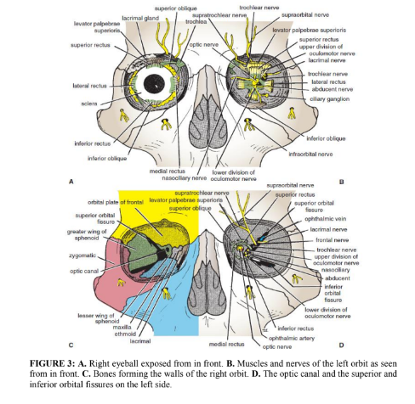

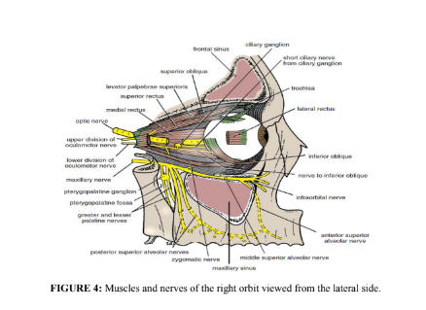

**Nerves of the Orbit:**

➢ Optic Nerve

The nerve is surrounded by sheaths of pia mater, arachnoid mater, and dura mater.

It pierces the sclera at a point medial to the posterior pole of the eyeball. Here, the meninges fuse with the sclera; a rise in pressure of the cerebrospinal fluid (CSF) within the cranial cavity therefore is transmitted to the back of the eyeball.

➢ Lacrimal Nerve

The lacrimal nerve arises from the ophthalmic division of the trigeminal nerve. It

is joined by a branch of the zygomaticotemporal nerve, which later leaves it to enter the lacrimal gland (parasympathetic secretomotor fibers). The lacrimal nerve ends by supplying the skin of the lateral part of the upper lid.

➢ Frontal Nerve

The frontal nerve arises from the ophthalmic division of the trigeminal nerve. It

divides into the supratrochlear and supraorbital nerves that supply the skin of

the forehead; the supraorbital nerve also supplies the mucous membrane of the

frontal air sinus.

➢ Trochlear Nerve

It supplies the superior oblique muscle (Fig. 5).

➢ Oculomotor Nerve

The superior ramus of the oculomotor nerve supplies the superior rectus muscle,

then pierces it, and supplies the levator palpebrae superioris muscle (Fig. 3).

The inferior ramus of the oculomotor nerve supplies the inferior rectus, the medial rectus, and the inferior oblique muscles. The nerve to the inferior oblique gives off a branch (Fig. 4) that passes to the ciliary ganglion and carries parasympathetic fibers to the sphincter pupillae and the ciliary muscle.

➢ Abducent Nerve

It supplies the lateral rectus muscle.

➢ Nasociliary Nerve

The nasociliary nerve arises from the ophthalmic division of the trigeminal nerve;

it has the following branches:

✓ The communicating branch to the ciliary ganglion is a sensory nerve. The

sensory fibers from the eyeball pass to the ciliary ganglion via the short ciliary

nerves and then join the nasociliary nerve by means of the communicating

branch.

✓ The long ciliary nerves, two or three in number, contain sympathetic fibers for

the dilator pupillae muscle.

✓ The anterior ethmoidal nerve appears on the face as the external nasal branch

at the lower border of the nasal bone and supplies the skin of the nose down as

far as the tip.

✓ The posterior ethmoidal nerve supplies the ethmoidal and sphenoidal air

sinuses (Fig. 5).

✓ The infratrochlear nerve supplies the skin of the medial part of the upper eyelid

and the adjacent part of the nose (Fig. 1).

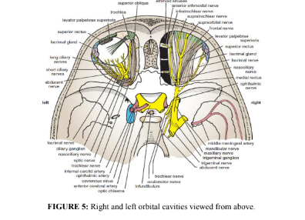

**Blood and Lymph Vessels of the Orbit:**

➢ Ophthalmic Artery

The ophthalmic artery is a branch of the internal carotid artery. It enters the orbit

through the optic canal with the optic nerve (Fig. 5). It has the following branches:

✓ The central artery of the retina enters the eyeball at the center of the optic disc.

Here, it divides into branches, which may be studied in a patient through an

ophthalmoscope. The branches are end arteries.

✓ The muscular branches.

✓ The ciliary arteries can be divided into anterior and posterior groups.

✓ The lacrimal artery to the lacrimal gland.

✓ The supratrochlear and supraorbital arteries are distributed to the skin of the

forehead.

➢ **Ophthalmic Veins:**

The superior ophthalmic vein communicates in front with the facial vein. The

inferior ophthalmic vein communicates through the inferior orbital fissure with the pterygoid venous plexus. Both veins pass backward through the superior orbital fissure and drain into the cavernous sinus.

➢ **Lymph Vessels:**

No lymph vessels or nodes are present in the orbital cavity.

**Structure of the Eye:**

The eyeball (Fig. 6) is embedded in orbital fat but is separated from it by the fascial sheath of the eyeball. The eyeball consists of three coats, which are the fibrous coat, the vascular pigmented coat, and the nervous coat.

1. Fibrous Coat

The fibrous coat is made up of a posterior opaque part, the sclera, and an anterior

transparent part, the cornea (Fig. 6). The sclera is directly continuous in front with the cornea at the corneoscleral junction, or limbus. The transparent cornea is largely responsible for the refraction of the light entering the eye (Fig. 6). The cornea is avascular and devoid of lymphatic drainage. It is nourished by diffusion from the aqueous humor and from the capillaries at its edge.

2. Vascular Pigmented Coat

The vascular pigmented coat consists, from behind forward, of the choroid, the ciliary body, and the iris. The choroid is composed of an outer pigmented layer and an inner, highly vascular layer. The ciliary body is composed of the ciliary ring, the ciliary processes, and the ciliary muscle. Contraction of the ciliary muscle pulls the ciliary body forward. This relieves the tension in the suspensory ligament, and the elastic lens becomes more convex.

The iris is a thin, contractile, pigmented diaphragm with a central aperture, the pupil (Fig. 6). It is suspended in the aqueous humor between the cornea and the lens. The muscle fibers of the iris are involuntary and consist of circular and radiating fibers. The circular fibers form the sphincter pupillae while the radial fibers form the dilator pupillae. The sphincter pupillae constricts the pupil in the presence of bright light and during accommodation. The dilator pupillae dilates the pupil in the presence of low light intensity or in the presence of excessive sympathetic activity such as occurs in fright.

3. Nervous Coat: The Retina

The retina consists of an outer pigmented layer and an inner nervous layer. Its outer surface is in contact with the choroid, and its inner surface is in contact with the vitreous body (Fig. 6). The posterior three quarters of the retina is the receptor organ.

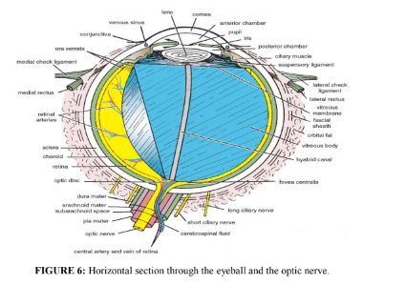

**Clinical Notes:**

➢ Eye Trauma

Blowout fractures of the orbital floor involving the maxillary sinus commonly occur as a result of blunt force to the face. If the force is applied to the eye, the orbital fat explodes inferiorly into the maxillary sinus, fracturing the orbital floor. Not only can blowout fractures cause displacement of the eyeball, with resulting symptoms of double vision (diplopia), but also the fracture can injure the infraorbital nerve, producing loss of sensation of the skin of the cheek and the gum on that side.

Entrapment of the inferior rectus muscle in the fracture may limit upward gaze.

➢ Pupillary Reflexes

The pupillary reflexes, that is the reaction of the pupils to light and accommodation, depend on the integrity of nervous pathways.

In the direct light reflex, the normal pupil reflexly contracts when a light is shone into the patient’s eye.

The consensual light reflex is tested by shining the light in one eye and noting the

contraction of the pupil in the opposite eye. This reflex is possible because the afferent pathway travels to the parasympathetic nuclei of both oculomotor nerves.

The accommodation reflex is the contraction of the pupil that occurs when a person suddenly focuses on a near object after having focused on a distant object.

Reference

1. Snell RS. Clinical Anatomy by Regions. 9th edition. Philadelphia, PA:

Lippincott Williams & Wilkins, 2012.