Lec.1 general surgery

Metabolic Response to Injury

BASIC CONCEPTS IN HOMEOSTASIS:

Homeostasis is the state of steady internal, physical, and chemical conditions

maintained by living systems. This is the condition of optimal functioning for the

organism and includes many variables, such as body temperature and fluid balance,

being kept within certain pre-set limits (homeostatic range)

Resuscitation, surgical intervention and critical care can return the severely injured

patient to a situation in which homeostasis becomes possible once again.

MEDIATORS OF THE METABOLIC RESPONSE TO INJURY

The classical neuroendocrine pathways of the stress response are bi phasic

Acute phase

consist of Corticotrophin releasing factor (CRF) released from the hypothalamus

increases adrenocorticotrophic hormone (ACTH) release from the anterior pituitary

ACTH then acts on the adrenal to increase the secretion of cortisol. Hypothalamic

activation of the sympathetic nervous system causes release of adrenalin and also

stimulates release of glucagon. Intravenous infusion of a cocktail of these ‘counter-

regulatory’ hormones (glucagon, glucocorticoids and catecholamines) reproduces

many aspects of the metabolic response to injury.

Chronic phase: associated with hypothalamic suppression and low serum levels of

the respective target organ hormones. Changes contribute to chronic wasting

The innate immune system (principally macrophages) interacts in a complex manner

with the adaptive immune system (T cells, B cells) in co-generating the metabolic

response to injury

Proinflammatory cytokines including interleukin-1 (IL-1), tumor necrosis factor

alpha (TNF_), IL-6 and IL-8 are produced within the first 24 hours and act directly

on the hypothalamus to cause pyrexia. Such cytokines also augment the

hypothalamic stress response and act directly on skeletal muscle to induce

proteolysis while inducing acute phase protein production in the liver Proinflammatory cytokines also play a complex role in the development of

peripheral insulin resistance

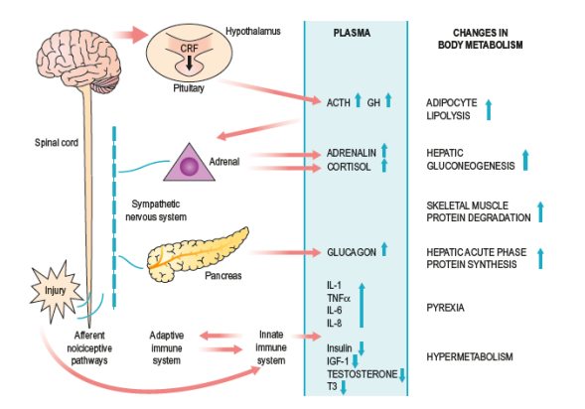Within hours of the upregulation of proinflammatory cytokines, endogenous cytokine antagonists enter the circulation (e.g. interleukin-1 receptor antagonist (IL-

Ra) and TNF soluble receptors (TNF-sR-55 and 75)) and act to control the

proinflammatory response

changes include the development of a Th2-type counter-inflammatory response

(regulated by IL-4, -5, -9 and -13 and transforming growth factor beta (TGF_))

which, if accentuated and prolonged in critical illness, is characterized as the CARS

compensatory anti-inflammatory response syndrome and results in

immunosuppression and an increased susceptibility to opportunistic nosocomial)

infection.

**Physiological response to injury ((THE ‘EBB AND FLOW’ MODEL)))**

In the natural world, if an animal is injured, it displays a characteristic response,

which includes immobility, anorexia and catabolism.

The ebb phase begins at the time of injury and lasts for approximately 24–48 hours

It may be attenuated by proper resuscitation, but not completely abolished

The ebb phase is characterized by hypovolemia, decreased basal metabolic rate,

reduced cardiac output, hypothermia and lactic acidosis. The predominant hormones

regulating the ebb phase are catecholamines, cortisol and aldosteroneFollowing resuscitation, the ebb phase evolves into a hypermetabolic **flow phase**,

This phase involves the mobilization of body energy stores for recovery and repair,

and the subsequent replacement of lost or damaged tissue. It is characterized by

tissue oedema (from vasodilatation and increased capillary leakage), increased basal

metabolic rate (hypermetabolism), increased cardiac output, raised body

temperature, leukocytosis, increased oxygen consumption and increased

gluconeogenesis. The flow phase may be subdivided into an initial catabolic phase,

lasting approximately 3–10 days, followed by an anabolic phase, which may last for

weeks if extensive recovery and repair are required 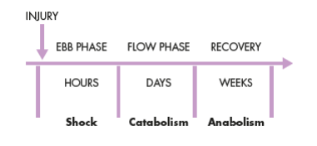following serious injury During the catabolic phase, the increased production of counter-regulatory hormones

(including catecholamines, cortisol, insulin and glucagon) and inflammatory

cytokines (e.g. IL-1, IL-6 and TNF_) results in significant fat and protein

mobilization, leading to significant weight loss and increased urinary nitrogen

excretion. The increased production of insulin at this time is associated with

significant insulin resistance and, therefore, injured patients often exhibit poor

glycemic control.

Insulin resistance

Following surgery or trauma, postoperative hyperglycemia develops as a result of

increased glucose production combined with decreased glucose uptake in peripheral

tissues. Decreased glucose uptake is a result of insulin resistance which is transiently

induced within the stressed patient. Suggested mechanisms for this phenomenon

include the action of proinflammatory cytokines and the decreased responsiveness

of insulin-regulated glucose transporter proteins. The degree of insulin resistance is

proportional to the magnitude of the injurious process.

Following routine upper abdominal surgery, insulin resistance may persist for

approximately 2 weeks.

Postoperative patients with insulin resistance behave in a similar manner to

individuals with type II diabetes mellitus. The mainstay of management of insulin

resistance is intravenous insulin infusion.

AVOIDABLE FACTORS THAT COMPOUND THE RESPONSE TO

INJURY

1-hemorrhage

During simple hemorrhage, pressure receptors in the carotid artery and aortic arch,

and volume receptors in the wall of the left atrium, initiate afferent nerve input to

the central nervous system (CNS), resulting in the release of both aldosterone and

antidiuretic hormone (ADH). Pain can also stimulate ADH release. ADH acts

directly on the kidney to cause fluid retention.

Decreased pulse pressure stimulates the juxtaglomerular apparatus in the kidney and

directly activates the renin–angiotensin system, which in turn increases aldosterone

release.

Hypothermia 2-

Hypothermia results in increased elaboration of adrenal steroids and catecholamines.

When compared with normothermic controls, even mild hypothermia results in a

two- to three-fold increase in postoperative cardiac arrhythmias and increased

catabolism.

3-Tissue oedema

During systemic inflammation, fluid, plasma proteins, leukocytes, macrophages and

electrolytes leave the vascular space and accumulate in the tissues. This can diminish

the alveolar diffusion of oxygen and may lead to reduced renal function.

Increased capillary leak is mediated by a wide variety of mediators including

cytokines, prostanoids, bradykinin and nitric oxide. Vasodilatation implies that

intravascular volume decreases, which induces shock if inadequate resuscitation is

not undertaken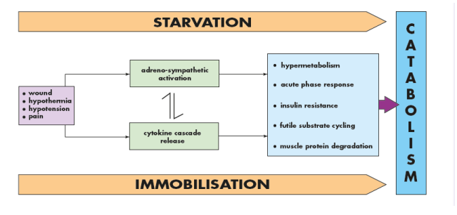Systemic inflammation and tissue response

3-Under-perfusion

The vascular endothelium controls vasomotor tone and microvascular flow, and

regulates trafficking of nutrients and biologically active molecules. When

endothelial activation is excessive, compromised microcirculation and subsequent

cellular hypoxia contribute to the risk of organ failure. Maintaining normoglycemia

with insulin infusion during critical illness has been proposed to protect the

endothelium and prevent organ failure via preservation of the microcirculation in

vital organs.

Starvation 4-

During starvation, the body is faced with an obligate need to generate glucose to

sustain cerebral energy metabolism (100 g of glucose per day). This is achieved in

the first 24 hours by mobilizing glycogen stores and thereafter by hepatic

gluconeogenesis from amino acids, glycerol and lactate. The energy metabolism of

other tissues is sustained by mobilizing fat from adipose tissue.

Such fat mobilization is mainly dependent on a fall in circulating insulin levels.

Eventually, accelerated loss of lean tissue (the main source of amino acids for

hepatic gluconeogenesis) is reduced as a result of the liver converting free fatty acids

into ketone bodies, which can serve as a substitute for glucose for cerebral energy

metabolism

Avoiding unnecessary fasting in the first instance and early oral/enteral/parenteral

nutrition form the platform for avoiding loss of body mass as a result of the varying

degrees of starvation observed in surgical patients. Modern guidelines on fasting

prior to anesthesia allow intake of clear fluids up to 2 hours before surgery.

Immobility 6-

Immobility has long been recognized as a potent stimulus for inducing muscle

wasting. Inactivity impairs the normal meal-derived amino acid stimulation of

protein synthesis in skeletal muscle. Avoidance of unnecessary bed rest and active

early mobilization are essential measures to avoid muscle wasting as a consequence

of immobility.