GENERAL ANATOMY

Lec.4

م.د.علي سلمان المعموري

**Mandibular nerve**

The mandibular nerve (CN V3) is the inferior and largest division of the trigeminal

nerve (Fig. 1A). It is formed by the union of sensory fibers from the sensory ganglion

and the motor root of CN V in the foramen ovale in the greater wing of the sphenoid,

through which the trunk of CN V3 emerges from the cranium to enter the infratemporal

fossa. It then divides into a small anterior and a large posterior division. The

mandibular nerve has three major cutaneous branches (auriculotemporal, buccal, and

mental nerves); it also supplies motor fibers to the muscles of mastication (Fig. 1B). It

is the only division of CN V that carries motor fibers.

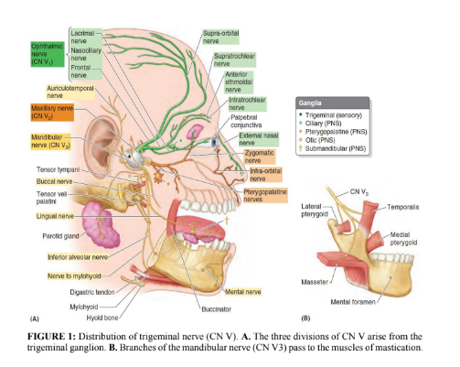

Branches of the Mandibular Nerve (See Table 1)

➢ The Main Trunk

-1Meningeal branch (recurrent branch, nervus spinosus), it runs back into the

middle cranial fossa through the foramen spinosum. It supplies the dura mater

and the mucous lining of the mastoid air cells.

-2Nerve to the medial pterygoid muscle, which supplies not only the medial

pterygoid, but also the tensor tympani and tensor veli palatini muscles.

➢ The Anterior Division

-1Masseteric nerve to the masseter muscle (Figs. 1B & 2) and TMJ.

-2Deep temporal nerves to the temporalis muscle (Fig. 2) and TMJ.

-3Nerve to the lateral pterygoid muscle (Fig. 1B)

-4Buccal nerve to the skin and the mucous membrane of the cheek (Fig. 2). The

buccal nerve does not supply the buccinator muscle (which is supplied by the

facial nerve), and it is the only sensory branch of the anterior division of the

mandibular nerve.

➢ The Posterior Division

-1Auriculotemporal nerve, which supplies the skin of the auricle, the external

auditory meatus, the temporomandibular joint, and the scalp (Fig. 1A). This

nerve also conveys postganglionic parasympathetic secretomotor fibers from the

otic ganglion to the parotid salivary gland.

-2Lingual nerve, which descends in front of and medial to the inferior alveolar

nerve and enters the mouth. It then runs forward on the side of the tongue and

crosses the submandibular duct. In its course, it is joined by the chorda tympani

nerve (Fig. 2), and it supplies the mucous membrane of the anterior two thirds

of the tongue and the floor of the mouth. It also gives off preganglionic

parasympathetic secretomotor fibers to the submandibular ganglion.

-3Inferior alveolar nerve, which enters the mandibular canal to supply the teeth

of the lower jaw and emerges through the mental foramen (mental nerve) to

supply the skin of the chin. Before entering the canal, it gives off

-4 the mylohyoid nerve, which supplies the mylohyoid muscle and the anterior belly of the

digastric muscle (Fig. 2). Communicating branch, which frequently runs from the inferior alveolar nerve

to the lingual nerve.

The branches of the posterior division of the mandibular nerve are sensory

except the nerve to the mylohyoid muscle.

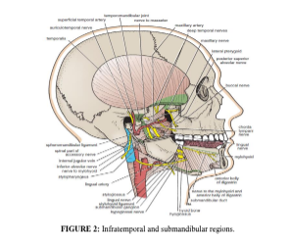

Otic Ganglion

The otic ganglion (Fig. 3) is a parasympathetic ganglion that is located medial to the

mandibular nerve just below the skull, and it is adherent to the nerve to the medial

pterygoid muscle. The preganglionic fibers originate in the glossopharyngeal nerve,

and they reach the ganglion via the lesser petrosal nerve. The postganglionic

secretomotor fibers reach the parotid salivary gland via the auriculotemporal nerve.

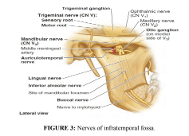

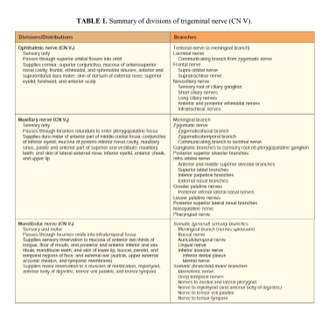

Clinical Notes

➢ Injury to the lingual nerve

The lingual nerve passes forward into the submandibular region from the

infratemporal fossa by running beneath the origin of the superior constrictor

muscle, which is attached to the posterior border of the mylohyoid line on the

mandible. Here, it is closely related to the last molar tooth and is liable to be

damaged in cases of clumsy extraction of an impacted third molar.

➢ Lesions of mandibular division of trigeminal nerve will cause unilateral

paralysis of muscles of mastication followed by atrophy; results in a sunken-in

appearance along ramus of mandible and above the zygomatic arch.

References

1. Snell RS. Clinical Anatomy by Regions. 9th edition. Philadelphia, PA:

Lippincott Williams & Wilkins, 2012.

2. Keith LM: Clinically Oriented Anatomy, 7th edition. Wolters Kluwer, 2014.

QUESTONS

1- The mandibular nerve has three major cutaneous branches:

a. auriculotemporal nerve.

b. buccal nerve.

c. mental nerve.

d.All of the above.

d

2- The anterior division of mandibular nerve supplied the followings muscle except one:

a.the masseter muscle.

b. the temporalis muscle.

c the buccinator muscle.

d. the lateral pterygoid muscle.

C

3- The uriculotemporal nerve supplies(except one):

a. the skin of the auricle.

b. the temporomandibular joint.

c- skin of the external nose.

d. part of the scalp.

C