 

CEMENTOGENESIS

&

CEMENTUM STRUCTURE

Prof. Dr.Muna Merza

Lecture 10

Cementum

Cementum is the mineralized dental tissue covering the anatomic roots of human teeth.

It begins at the cervical portion of the tooth at the cementoenamel junction and continues to the apex.

Cementumn furnishes a medium for the attachment of collagen fibers that bind the tooth to surrounding structures. Unlike bone, human cementum is avascular and non-innervated.

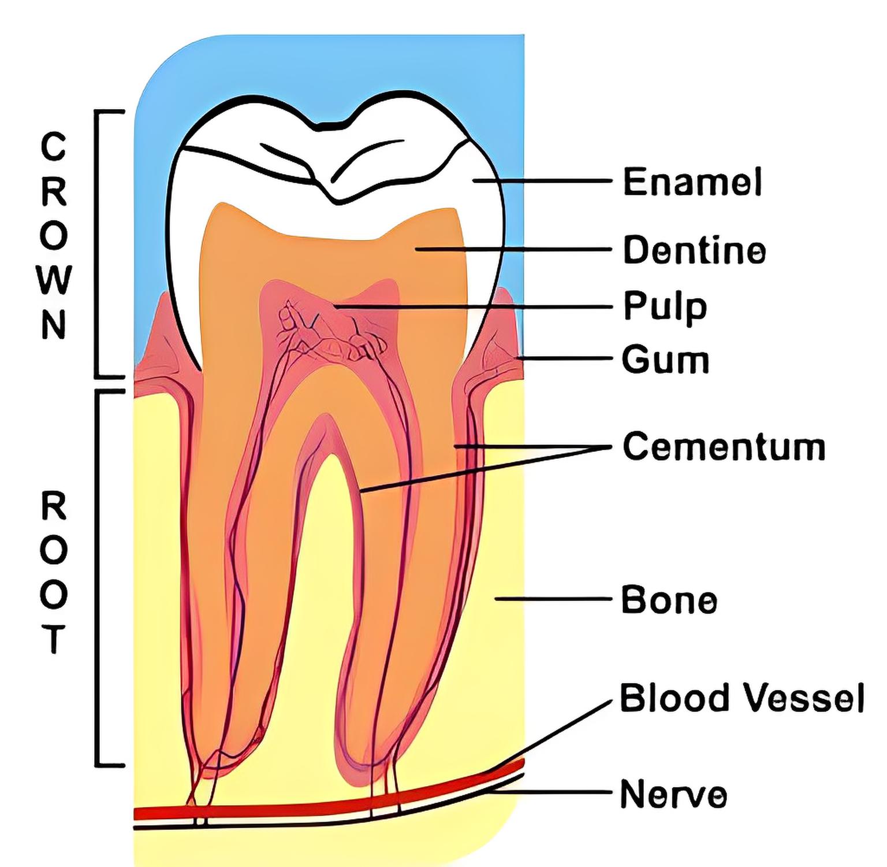

Cementum is thinnest at the cementoenamel junction and thickest toward the apex . The apical foramen is surrounded by cementum. Like dentin, cementum can form throughout the life of a tooth.

**Physical Characteristics**

The hardness of fully mineralized cementum Is less than that of dentin. Cementum is light yellow in color and can be distinguished from enamel by its lack of brightness and its darker color. Cementum is somewhat lighter in color than dentin.

**Chemical Composition**

Cementum from fully formed permanent teeth contains about 45-50% inorganic substances and 50 to 55% organic material and water. The inorganic portion consists mainly of calcium and phosphate in the form of hydroxyapatite.Cementum has the highest fluoride content of all the mineralized tissues.

The organic portion of cementum consists Primarily of type I collagen and Polysaccharides (proteoglycans).

**Protein**

The non-collagenous proteins play important roles in matrix deposition, initiation and Control of mineralization and matrix remodeling

**Cementogenesis**

The iner and outer enamel epithelium proliferate downwards as a double layered sheet of flat epithelial cells, called the root sheath of Hertwig, This root sheath induces the cells of the dental papilla to differentiate into odontoblasts. These cells secrete the organic matrix of first formed root predentin consisting of ground substance and collagen fibrils.

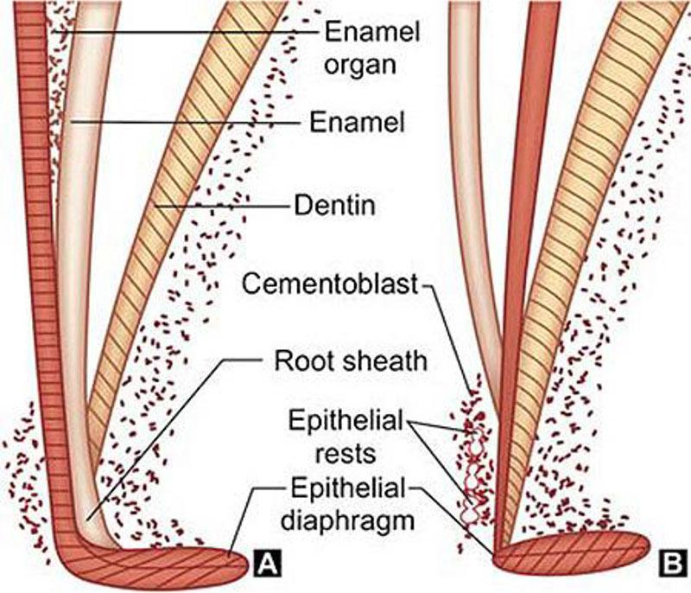\

Subsequently, breaks occur in the epithelial root sheath allowing the newly formed dentin to come in direct contact with the cells of the dental follicle.

Cells derived from connective tissue are called cementoblast. They are responsible for The formation of cementum. Cementoblasts synthesize collagen and protein polysaccharides, which make up the organic matrix of cementum.

Sheath cells that migrate toward the dental sac become the epithelial rests of Malassez found in the periodontal ligament of fully developed teeth.

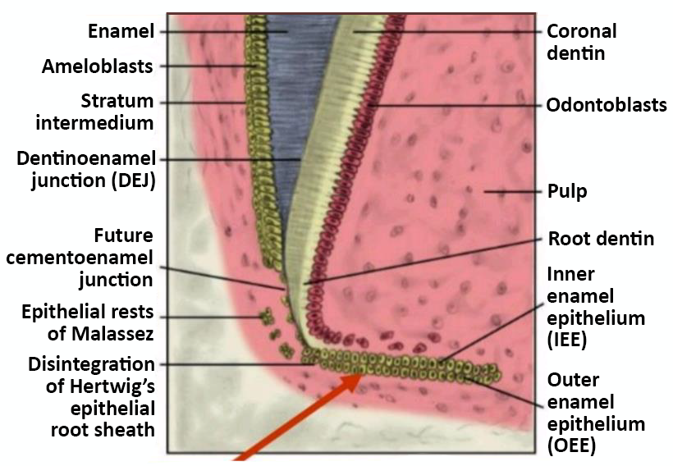

Cementoid Tissue: Under normal conditions growth of cementum is a measured process, and as a new layer of cementoid is formed, the old one calcifies.

Incremental lines: are seen in cementum during the process of Cementogenesis, there are periods of rest and periods of activity. The periods of rest are associated with these lines. The lines are closer in acellular cementum as this cementum is formed slowly.

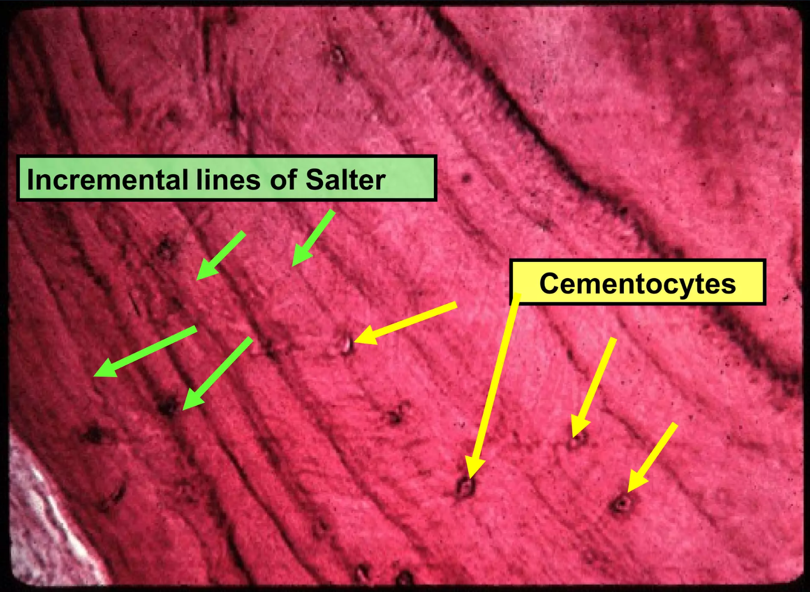

Connective tissue fibers from the periodontal ligament pass between the cementoblasts into the cementum. These fibers are embedded in the cementum and serve to attach the tooth to the surrounding bone. Their embedded portions are known as Sharpey's fibers. Each Sharpey's fiber is composed of numerous collagen fibrils that pass well into the cementum.

**Cementum Structure**

Light microscopic observations reveal two basic types of cementum on the basis of presence or absence of cementocytes

1.Cellular cementum

2.Acellular cementum

It can also be classified on the basis of the type of fibers (intrinsic/ extrinsic fibers) presence or their absence (afibrillar cementum).

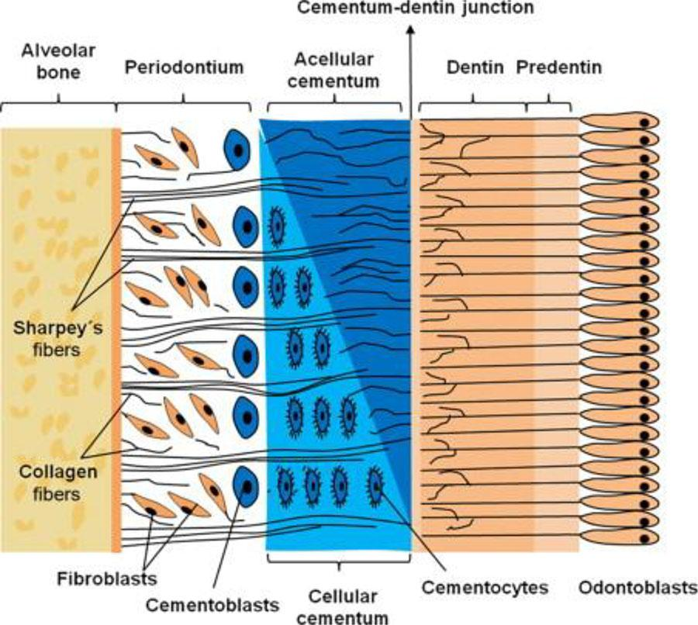

**The intrinsic fibers** produced by the **Cementoblast** are smaller (1-2 micrometers in diameter) and are usually oriented **parallel** to the surface.

**The extrinsic fibers** produced by **fibroblast** are larger bundles (5-7 micrometers In diameter) and are usually oriented **perpendicular** to the surface and they are known as Sharpey's fibers.

**Types of cementum**

1. Acellular extrinsic fiber cementum (AEFC)is regarded as primary cementum, because it forms first. It extends from cervical margin to apical 1/3rd. It is the only type of cementum seen in single rooted teeth.
2. Cellular intrinsic fiber cementum (CIFC)
3. acellular afibrillar cementum .
4. acellular Intrinsic fibercementum
5. cellular and acellular mixed fiber Cementum (containing both intrinsic and extrinsic fibers)

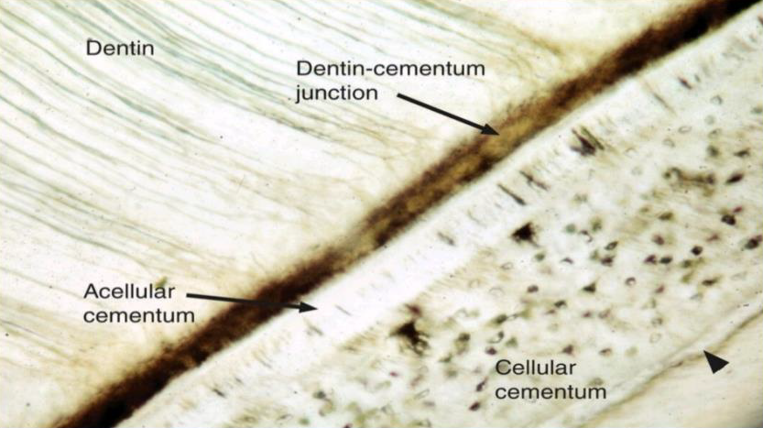

**Cellular Cementum** is also known as secondary cementum,because it forms later than primary cementum. It is foremed after the formation of acellular cementum, and it is less mineralized

Some cementoblasts get entrapped and are called Cementocytes.

The cellular cementum found in the apical third is mainly of two types,

1. Cellular mixed fiber cementum which forms the bulk of secondary cementum and occupies the apical interradicular regions

2. CIFC which is present in the middle and apical third. These types are mainly involved in the adaptation and repair of cementum.

|  |  |
| --- | --- |
| **Differences between Acellular Cementum and Cellular Cementum** | |
| **Acellular Cementum** | **Cellular Cementum** |
| Embedded cementocytes are absent | Embedded cementocytes are present |
| Deposition rate is slower | Deposition rate is faster |
| It is the first formed layer | Formed after acellular cementum |
| Width is more or less constant | Width can be highly variable |
| Found more at cervical third of tooth | Mainly seen at apical third |
| Also called as primary cementum | Also called as secondary cementum |
| Sharpey's fibers are well mineralized | Sharpey's fibers are partially mineralized |
| Incremental lines are regular | Incremental lines are irregular |
|