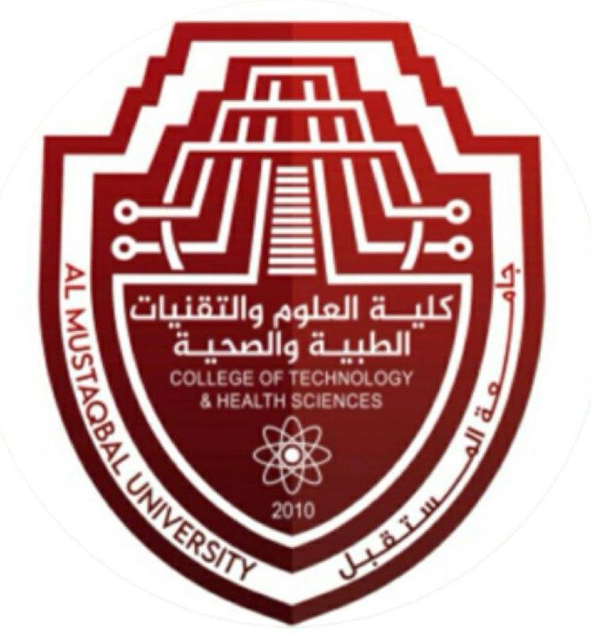 

**Oral Pathology**

Prof. Dr.Muna Merza

**Lecture 12 Developmental Disturbances of the Teeth**

**Lec. 12 ORAL PATHOLOGY Dr. Muna**

**Developmental Disturbances of Teeth**

**Developmental disturbances in teeth are of 5 types based on the feature of the tooth they affect:**

1-Size of Teeth

2-Shape of Teeth

3-Number of Teeth

4-Structure of Teeth

5-Growth (Eruption) of Teeth

**1-Size of Teeth:**

1-Microdontia

2-Macrodontia

**2-Shape of Teeth:**

**1-** Germination 2-Fusion 3-Concrescence 4-Di laceration

5-Talon cusp 6-Dens in Dente 7-Dens Evaginatus

8-Taurodontism 9-Supernumerary Roots

**3-Number of Teeth:**

1.Hypodontia 2.Anodontia 3.Supernumerary Teeth

4.Pre-Deciduous Teeth 5.Post-Permanent Teeth

**4-Structure of Teeth:**

1.Amelogenesis Imperfecta 2.Dentinogenesis Imperfecta

3.Environmental Enamel Hypoplasia 4.Dentin Dysplasia

5.Regional Odontodysplasia 6.Dentin Hypocalcification

**5-Growth (or) Eruption of Teeth:**

1.Premature Eruption 2.Delayed Eruption

3.Eruption Sequestrum 4.Multiple Unerupted Teeth

5.Embedded and Impacted Teeth 6.Ankylosed and Deciduous Teeth.

**\*1-Size of teeth**

**A-Microdontia:** It is defined as the size of teeth which is smaller than normal (or) outside the normal range of teeth size.

Microdontia is divided into 3 types:

1-True Generalized

2-Relatively Generalized

3-Involving a Single Tooth

**1-True Generalized:**

All the teeth are smaller than normal.

Teeth are well formed but small in size.

*Incidence*: Very Rare.

True Generalized *etiology:* Pituitary dwarfism, Downs Syndrome.

**2-Relative Generalized type:**Teeth are normal or slightly smaller than normal teeth within the range of size of teeth, but the jaw size is slightly larger than the normal giving an Impression of Microdontia.

*Etiology:* Inheritance of Jaw size from one parent and the teeth from another parent may lead to this condition.

**3-Involving a Single Tooth:**It is also called as localized

Microdontia, affecting commonly the Maxillary lateral incisor

and the Third Molar.

*Aetiology:*1-Supernumerary teeth 2-Facial Hemi atrophy.

**Common Form in laterals:** The mesial and distal surfaces converge to the top forming a cone shaped crown with the roots being shorter than normal.

**2-Shape of Teeth:**

1**.** Gemination: partial development of two teeth from single

tooth bud following incomplete division.

2.Fusion: is the union between dentin and or enamel of two or more separate developing teeth

**3-Number of Teeth:**

**1.**Hypodontia: congenital absence of teeth (when there is missing 6teeth or fewer) more common in permanent

**2.**Anodontia: rare genetic disorder congenital absence of all primary or permanent teeth associated with skin and nerve syndrome

Treatment replacement of missing teeth by denture or dental implant

**Common missing teeth** :

1-wisdom teeth

2- upper lateral incisor

3- lower second premolar

**4-Structure of Teeth:**

Amelogenesis Imperfecta **:**inherited developmental

abnormalities classified into:

1-hypominerilized type

2-hypoplastic type

Dentinogenesis Imperfecta :autosomal dominant disorder affected both primary and permanent teeth ,teeth may have normal color following they become translucent and finally gray or brownish with bluish reflection from enamel, although enamel structure are normal it is rapidly attrition and lost